Clarifications 1
# | Question | Answer
1 | Bid bond amount and validity period. | N/A
2 | is there an advance payment? | N/A
3 | Electronically with your financial and technical offers in separate emails to tenders@goal.ie and in the subject field state:  - ADD-ZZ1-26993 & ADD-ZZ1-27041 for IT equipment’s.  - Name of your firm with the title of the attachment  - Number of emails that are sent e.g. 1 of 3, 2 of 3, 3 of 3.  What does separate email mean??  b) & c) are not clear. | Yes, Technical and Financial proposals should be separated and should mentioned the reference clearly on the subject.
4 | 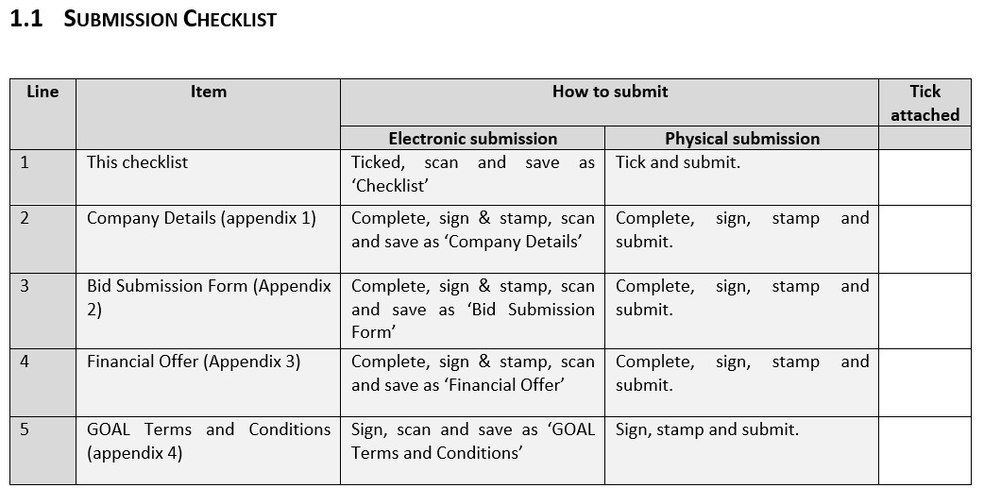  Is this table to be attached? | Yes

