Invitation for Tender (ITT) for Water sanitation construction work
REF: SOM-BOF-6989
GOAL is completely against fraud, bribery and corruption

GOAL does not ask for money for bids. If approached for money or other favours, of if you have any suspicions of attempted fraud, bribery or corruption please report immediately to email speakup@goal.ie

Please provide as much detail as possible with any reports

About GOAL
Established in 1977, GOAL is an international humanitarian and development agency committed to working with communities to achieve sustainable and innovative early response in crises and to assist them to build lasting solutions to mitigate poverty and vulnerability. GOAL has worked in over 60 countries and responded to almost every major humanitarian disaster. We are currently operational in 13 countries globally. For more information on GOAL and its operations please visit https://www.goalglobal.org/bids
GOAL has been working in Ethiopia since 1984, implementing a range of multi-sectoral development and humanitarian programmes responding to sudden-onset and protracted crises. Since 2017, GOAL has been one of the primary humanitarian agencies responding to the displacement crises in Ethiopia, operating a large-scale multi-sectoral response across more than 11 Zones in Oromiya, Somali, SNNP, Benishangul-Gumuz and Amhara. Interventions include: the treatment of acute malnutrition, mobile health activities, ensuring access to sanitation and water supply facilities, distribution of cash, shelter and non-food items, and psychosocial support.
GOAL Ethiopia supports several Water and Sanitation and Health (WASH) projects in various parts of the country providing clean water including small scale construction projects. One of our objectives is to enter into agreements with potential contractors to further strengthen the implementation of our WASH activities.

Proposed Timelines

Line | Item | Date
1 | Bids Shared | August 17, 2022
2 | Closing date for clarifications | August 30, 2022, 04:30 PM GMT +3 East African Time
3 | Closing date and time for receipt of Bids | September 07, 2022, 02:00 PM GMT +3 East African Time
4 | Bid Opening Location | Addis Ababa, GOAL Ethiopia Head Office
5 | Bid Opening Date and time | September 07, 2022, 03:00 PM GMT +3 East African Time

3. Overview of requirements

Specification for Construction Works
GOAL Ethiopia, an International Humanitarian Organization, invites eligible bidders to submit their offer in sealed envelops for Pipeline expansion and improvement work from water source for Mirkalif kebele, Warder woreda and Borehole rehabilitation, one cattle trough construction and PEWs for Shahda-Buhodle kebele, Danot woreda (Lot 1), Rehabilitation and pipeline expansion work from borehole source for Bokh town and Mirkan kebele, Bokh woreda (Lot 2) and Pipeline expansion and improvement work from water source for Gelladi woreda/town (Lot 3) of Dollo Zone in Somali Regional State.
These construction works are divided into three LOTS as follows:
CODE | Summary of Main Activities | Location
LOT 1 | - Pipeline expansion and improvement work from water source  - Borehole rehabilitation, one cattle trough construction and PEWs | Dollo Zone  - Mirkalif kebele, Warder woreda  - Shahda-Buhodle kebele, Danot woreda
LOT 2 | Rehabilitation and pipeline expansion work from borehole source | Dollo Zone  - Bokh Town, and  - Mirkan kebele, Bokh woreda
LOT 3 | Pipeline expansion and improvement work from water source | Dollo Zone  - Gelladi woreda/town

Contractors must have Category GC/WWGC/BC, six (6) & above certifications to be eligible to bid on this bid. Prospective contractors must also be able to complete the construction works within one hundred five (105) calendar days and the winning bidder(s) will be required to enter to a contract agreement with GOAL Ethiopia. Contractors may bid for one or all LOTs.

The service being offered must be in line with the following requirements
GOAL would like to see the following issues addressed in the response:

3.2.1 Technical proposal (completion of Appendix 2)
The bidder is required to show their methodology, equipment, personnel, work schedule and attach related work experience in the technical offer document which will enable them to complete the works with efficiency. These include the following:
- Schedule Form 1 (for Lots 1, 2 & 3 depending on lots bid on) – Bidders Visit to Work Sites (SF1)
- Schedule Form 2 - Summary of similar works carried out (SF2)
- Schedule Form 3 (for Lots 1, 2 & 3) - Schedule of Intended Work Programme (SF3)
- Schedule Form 4 for Lots 1, 2 & 3) - Methodology of Work – one-page summary (SF4)
- The bidder shall incorporate in the work methodology the specific sites as well as the type of work he is bidding for
- The contractor must be aware of the regulations when working with governmental departments. Please describe in your methodology how you will work with the government departments as well as the experience you have in working in Somali region.
- Supply of construction materials borehole source rehabilitation and incinerators construction
- Methodology of performing construction activities for the borehole source rehabilitation and incinerators construction (including masonry, brick works, concrete, pipe laying and plumbing works, reinforced concrete, plastering and pointing works). Please describe how you will perform these activities.
- A short description of the team that will manage these works should be included. Also, the experience of the staff in such construction works should be also mentioned as well as their CVs.
Methodology should include description of construction equipment (e.g., concrete mixer, hand compactor, dump trucks, vibrator, pick up and dewatering pump).
- About clearing construction sites after completion of work and disposing all surplus excavated and wastage construction materials in environmentally friendly manner and contractor should be able to do the work as well as leave a decent place after the works.
    - Financial Proposal (completion of Appendix 3)
The bidder should fill in their price in the Bill of Quantities (BOQ) for each lot they are bidding for – as well as the summary costs using some or all the following forms:
- Summary of BOQ for Lot 1
  - BOQ for Mirkalif kebele, Warder woreda (Lot 1)
  - BOQ for Shahda-Buhodle kebele, Danot woreda (Lot 1)
- Summary of BOQ for Lot 2
- BOQ for Bokh Town (Lot 2)
- BOQ for Mirkan kebele (Lot 2)
- Summary of BOQ for Lot 3
  - BOQ for Gelladi woreda/town (Lot 3)

3.2.3 All other documents submitted as per Section 6 of this document

Terms of the Procurement

Procurement Process

This competition is being conducted under GOALs Invitation for Tender (ITT) Procedure.

The Contracting Authority for this procurement is GOAL

This procurement is funded by USAID/BHA and the bid and any contracts or agreements that may arise from it are bound by the regulations of that donor.

Clarifications and Query Handling

GOAL has taken care to be as clear as possible in the language and terms it has used in compiling this ITT. Where any ambiguity or confusion arises from the meaning or interpretation of any word or term used in this document or any other document relating to this bid, the meaning and interpretation attributed to that word or term by GOAL will be final. GOAL will not accept responsibility for any misunderstanding of this document or any others relating to this bid.

Requests for additional information or clarifications can be made up to the deadline noted in section 2 above, and no later. Any queries about this ITT should be addressed in writing to GOAL via email on clarifications@goal.ie until the August 30, 2022, 04:30 PM GMT +3 East African Time Please include the reference number SOM-BOF-6989 and words “clarification required” in the subject liner.

Conditions of Bid Submission

The ITT must be completed in English.

Bidders must respond to all requirements set out in this ITT and complete their offer in the Response Format.

Failure to submit bids in the required format will, in almost all circumstances, result in the rejection of the bid. Failure to resubmit a correctly formatted bid within 3 (three) working days of such a request will result in disqualification.

Bidders must disclose all relevant information to ensure that all bids are fairly and legally evaluated. Additionally, bidders must provide details of any implications they know or believe their response will have on the successful operation of the contract or on the normal day-to-day operations with GOAL. Any attempt to withhold any information that the bidder knows to be relevant or to mislead GOAL and/or its evaluation team in any way will result in the disqualification of the bid.

Bidders must detail all costs identified in this ITT in Ethiopian Birr (ETB). Additionally, bids must detail any other costs whatsoever that could be incurred by GOAL in the usage of services and/or the availing of options that may not be explicitly identified/requested in this ITT’s attention is drawn to the fact that, in the event of a Contract/ Framework Agreement being awarded to them, the attempted imposition of undeclared costs will be considered a condition for default.

Any conflicts of interest (including any family relations to GOAL staff) involving a bidder must be fully disclosed to GOAL particularly where there is a conflict of interest in relation to any recommendations or proposals put forward by the bidder.

GOAL will not be liable in respect of any costs incurred by respondents in the preparation and submission of bids or any associated work effort.

GOAL will conduct this bid, including the evaluation of responses and final awards in accordance with the detail set out at in the Evaluation process. Bids will be opened by at least three designated officers of GOAL.

GOAL is not bound to accept the lowest, or any bid submitted.

GOAL reserves the right to split the award of this contract between different bidders in any combination it deems appropriate, at its sole discretion.

The Supplier shall seek written approval from GOAL before entering into any sub-contracts for the purpose of fulfilling this contract. Full details of the proposed subcontracting company and the nature of their services shall be included in the written request for approval. Written requests for approval must be submitted to GOAL.

GOAL reserves the right to refuse any subcontractor that is proposed by the Supplier.

GOAL reserves the right to negotiate with the Supplier who has submitted the lowest Bid that fully meets the technical requirements, for the purpose of seeking revisions of such Bid to enhance its technical aspects and/or to reduce the price.

Information supplied by respondents will be treated as contractually binding. However, GOAL reserves the right to seek clarification or verification of any such information.

GOAL reserves the right to terminate this competition at any stage.

Unsuccessful bidders will be notified.

GOAL’s standard payment terms are by bank transfer within 30 days after satisfactory implementation and receipt of documents in order. Satisfactory implementation is decided solely by GOAL.

This document is not construed in any way as an offer to contract.

GOAL and all contracted suppliers must act in all its procurement and other activities in full compliance with donor requirements. Any contract(s) that arise from this ITT may be financed by multiple donors and those donors and/or their agents have rights of access to GOAL and/or any of its suppliers or contractors for audit purposes. These donors may also have additional regulations that it is not practical to list here. Submission of an offer under this ITT assumes Service Provider acceptance of these conditions.

Terrorism and Sanctions: GOAL does not engage in transactions with any terrorist group or individual or entity involved with or associated with terrorism or individuals or entities that have active exclusion orders and/or sanctions against them. GOAL shall therefore not knowingly purchase supplies or services from companies that are associated in any way with terrorism and/or are the subject of any relevant international exclusion orders and/or sanctions. If you submit a bid based on this request, it shall constitute a guarantee that neither your company nor any affiliate or a subsidiary controlled by your company are associated with any known terrorist group or is/are the subject of any relevant international exclusion order and/or sanctions. A contract clause confirming this may be included in an eventual purchase order based on this request.

Quality Control
3rd party companies may be contracted by GOAL to carry out random quality inspections of work carried out by the contracted party. The cost of the quality control inspections will be covered by GOAL.
In cases of supplier’s quality default, in addition to Liquidated Damages, section XVII of GOAL Standard Terms and Conditions, the costs of the quality inspections and loading surveyor will be charged to the Service Provider.
Sub-contracting: note section II in GOAL Standard Terms and Conditions. GOAL may choose to visit vendors, including sub-contractors (if any) as per of the evaluation process.

Submission of Bids
Bids must be delivered in one of the following two ways:
- Electronically with your financial and technical offers in separate emails to tenders@goal.ie and in the subject field state:
  - Pipeline expansion and improvement work from water source (Lot 1, 2 and 3)
  - Name of your firm with the title of the attachment
  - Number of emails that are sent e.g., 1 of 3, 2 of 3, 3 of 3.
All documents attached to emails must be in PDF or scan form. Any excel or word documents must be accompanied by a PDF or scan version of the document. Documents submitted solely in excel, word or other ‘soft copy’ format shall lead to the bid being rejected.
- If electronic bid submission is not possible, please submit in a sealed envelope marked:
Pipeline expansion and improvement work from water source (Lot 1,2 and 3)– not to be opened before deadline September 7, 2022, 04:00 PM GMT +3 East African Time by the ITT committed with all documents including your financial and technical offers to the Private Bid Box at:
GOAL Ethiopia, Yeka Sub City, Woreda 9, H. No. 508 (Next compound to Kotebe Health Centre)
P. O. Box 5504, TEL. 011-6-47-81-16/17, FAX 011-6-478118, Addis Ababa, Ethiopia. The Bidder shall prepare two copies of the Bid, clearly marking each “Original Bid” and “Copy of Bid” as appropriate. In the event of any discrepancy between them, the original shall govern.
Envelopes may be sent through postal/courier services or delivered by hand; and will be accepted during normal working hours in GOAL Ethiopia (8:00AM – 4:30 PM). Please note that the GOAL office will not be open during weekends or public holidays.

- All bids whether electronic or in hard copy should comprise all the documents requested in Section 6 of this ITT – a check list has been given to assist bidders in providing this complete application.
- Proof of sending is not proof of reception, either electronically or with post/courier/other physical service. Late delivery will result in your bid being rejected. Envelopes found open at the bid opening will be rejected. All information provided must be perfectly legible.

Bid Opening Meeting
Bids will be opened as per Section 2 Proposed Timelines above at the following location:
GOAL Ethiopia head office, Addis Ababa, Yeka Sub city, Woreda 9, H. No. 508, Next compound to Kotebe, Woreda 9 Health Centre.
One authorised representative of each bidder may attend the opening of the bids. Companies wishing to attend are requested to notify their intention by sending an e-mail at least 48 hours in advance to the following e-mail address: tenders@goal.ie . This notification must be signed by an authorised officer of the bidder and specify the name of the person who will attend the opening of the bids on the bidder's behalf.
Suppliers are invited to attend the Bid Opening Meeting at their own cost.

Evaluation Process

Evaluation stages
Phase # | Evaluation Process Stage | The basic requirements with which proposals must comply with
The first phase of evaluation of the responses will determine whether the bid has been submitted in line with the administrative instructions and meets the essential criteria. Only those bids meeting the essential criteria will go forward to the second phase of the evaluation.
1 | Administrative instructions | - Closing Date: Proposals must have met the deadline stated in section 2 of these Instructions to Bidders, or such revised deadline as may be notified to Bidders by GOAL. Bidders must note that GOAL is prohibited from accepting any proposals after that deadline.  - Submission Method: Proposals must be delivered in the method specified in section 4.5 of this document. GOAL will not accept responsibility for bids delivered by any other method. Responses delivered in any other method may be rejected.  - Format and Structure of the Proposals: Proposals must conform to the Response Format laid out in section 6 of these Instructions to Bidders or such revised format and structure as may be notified to Bidders by GOAL. Failure to comply with the prescribed format and structure may result in your response being rejected at this stage.  - Confirmation of validity of your proposal: The Bidders must confirm that the period of validity of their proposal is not less than 90 (ninety) days.
2 | Essential Criteria | - GC/WWGC/BC, six (6) & above certificate, for similar works type - certificate of competency should be attached.  - Contractors shall attach at least one previous good work performance letter from GO/NGO from the past 3 years in similar types of works.  - All works must be completed within 105 days.  - Confirmation letter about the site visit from GOAL Office
The second stage of the evaluation will involve an assessment of the Bidder’s personal and legal circumstances, economic and financial standing, to fulfil the obligations of the contract
3 | Legal, Economic & Financial Criteria | - Relevant and Valid Business licenses to operate in Ethiopia  - VAT registration
Each proposal that conforms to the Essential and Qualification Criteria will be evaluated according to the Award Criteria given below by GOAL.
4 | Award Criteria | Bids will be awarded marks under each of the award criteria listed in this section to determine the most economically advantageous bids.  - Price (35%)  - Technical/Quality (65%) determined by:  - Work plan (Implementation plan). Please complete the SF3.  - At least one page of Proposed Methodology for the works. Methodology of performing construction activities for the borehole source rehabilitation and incinerators construction (including masonry, brick works, concrete, pipe laying and plumbing works, reinforced concrete, plastering and pointing works).  Methodology should also include:  - Description of how you will perform these activities including clearing construction site. Please complete the SF4.  - A short description of the team that will manage these works should be included.  - Methodology should also include a description of how you will be collaborating with government departments.  - Previous work Experience. (The bidder that will submit more than one letter, will be awarded with extra marks)
5 | Post selection | References and other checks are found to be clear, and quality is assessed.
Bidders will be considered for participation in the Contract subject to the following qualification process:

Bid Evaluation
GOAL will convene an evaluation team which may include members of the Finance, Logistics, Programmes, Donor Compliance, and Internal Audit, as well as 3rd Party technical input.
During the evaluation period clarifications may be sought by e-mail from Bidders. Clarifications may include testimonials from customers in support of aspects of a bid, whether such aspects are contained in the original submission or in subsequent responses to requests for clarification. Deadlines will be imposed for the receipt of

such clarifications and failure to meet these deadlines may result in the disqualification of the Bid or loss of marks. Responses to requests for clarification shall not materially change any of the elements of the proposals submitted. Unsolicited communications from Bidders will not be entertained during the evaluation period.

Award Criteria

Price
All prices must be in Ethiopian Birr (ETB) and a comprehensive and clear breakdown of prices must be shown as part of the financial offer – any transport fees, taxes, customs charges, component parts, packing fees etc. must be shown separately. In this ITT the prices offered in the BOQ forms provided constitute the financial offer.
Marks for cost will be awarded on the inverse proportion principle (shown below):
Score^{vendor} = 35 x (price^{min} / price^{vendor})
Maximum points for Price that will be awarded are 35%.
All financial offers must be made on the basis of ‘best and final offer’.

Technical/Quality
Maximum points that will be awarded according to the Table in section 5 of this document, are 65%.

Summary of Award Criteria
No | Qualitative award criteria | Weighting (maximum points)
1. | Price (from BOQ amounts) | 35
2. | Previous work Experience (The bidder that will submit more than one letter, will be awarded with extra marks) | 65
3. | Workplan (Timeline and order of works)
4. | Methodology
 | Total number of points | 100

Award of contract
As per section 5.3.3 above and following the analysis of bids against the award criteria laid out above in sections 5.1 and 5.3, contracts may be awarded to one supplier or divided between multiple suppliers at GOAL’s discretion. For such purposes, GOAL uses a Value for Money approach, which may include (but is not limited to) price, quality, lead time, context and risk analysis of the supply chain environment pertaining to the contract delivery.

Response Format

Introduction
All proposals must conform to the response format laid out below. Where a bid does not conform to the required format the Bidder may be requested to resubmit it in the correct format, on the understanding that the resubmission cannot contain any material change from the original. Failure to resubmit in the correct format within 3 (three) working days may result in disqualification.
By responding to this ITT, each Bidder is required to accept the terms and conditions of this ITT and to acknowledge and confirm their acceptance by returning a signed copy with its response. Should a Bidder not comply with these requirements, GOAL may, at their sole discretion, reject the response.
If the Bidder wishes to supplement their Response to any section of the ITT specifications with a reference to further supporting material, this reference must be clearly identified, including section and page number.

Other Documents Required

Audited Accounts
Bidders need to submit an audited account regarding their past performance which details that the auditing is accomplished by certified accountants or mandated body to perform auditing. Audited accounts from 2021, 2020 and preferably 2019 in addition are required.

Appendices
This is to remind all bidders that Appendix 1 needs to be completed IN FULL. Appendix 2 is your technical offer and relevant forms completed depending on the Lots the company has bid on – similarly with Appendix 3 as the Financial offer. Appendix 4 are the plans/drawings that must be followed. Appendix 5 Standard Terms and Conditions need to be initialled or signed and returned with your application.

Submission Checklist
Line | Item | How to submit |  | Tick attached
 |  | Electronic submission | Physical submission
1 | This checklist | Ticked, scan and save as ‘Checklist’ | Tick and submit.
2 | Company Details (appendix 1) – this includes Declaration of Finance and Tax | Complete, sign & stamp, scan and save as ‘Company Details’ | Complete, sign, stamp and submit.
3 | Technical Offer (Appendix 2)  Comprising of: | Complete, sign & stamp, scan and save as ‘Technical Offer’ | Complete, sign, stamp and submit.
a) | SF3A Workplan – Lots 1, 2 & 3 | Complete, scan and save as individual forms (SF1A etc) OR scan all forms into one PDF and save as ‘Technical Offer Standard Forms’ | Complete and submit
b) | SF4A Methodology – Lots 1, 2 &3 |  | Complete and submit
4 | Financial Offer (Appendix 3) Comprising of: | Complete, sign & stamp, scan and save as ‘Financial Offer’ | Complete, sign, stamp and submit.
a) | Summary of BOQ for Lot 1 | Complete, sign & stamp, scan and save as ‘BOQ Lot 1’ | Complete, sign, stamp and submit.
 | BOQ for Mirkalif kebele, Warder woreda (Lot 1)
 | BOQ for Shahda-Buhodle kebele, Danot woreda (Lot 1)
b) | Summary of BOQ for Lot 2 | Complete, sign & stamp, scan and save as ‘BOQ Lot 2’ | Complete, sign, stamp and submit.
 | BOQ for Bokh Town (Lot 2)
 | BOQ for Mirkan kebele (Lot 2)
C) | Summary of BOQ for Lot 3 | Complete, sign & stamp, scan and save as ‘BOQ Lot 3’ | Complete, sign, stamp and submit.
 | BOQ for Gelladi woreda/town (Lot 3)
5 | GOAL Terms and Conditions (Appendix 5) signed | Sign, scan and save as ‘GOAL Terms and Conditions’ | Sign, stamp and submit.
6 | Company Registration Certificate | Scan and save as ‘Com Reg Cert’ | Copy and submit
7 | Business license | Scan and save as ‘Trade Licence’ | Copy and submit
8 | only GC/WWGC/BC, six (6) & above certificate for similar works type – certificate. | Scan and save as ‘Works level Cert’ | Copy and submit
9 | TIN Certificate | Scan and save as ‘TIN Cert’ | Copy and submit
10 | VAT registration Certificate | Scan and save as ‘VAT Cert’ | Copy and submit

Appendix 1 – Company details

Contact Details
This section must include the following information regarding the Individual or Company and any partners or sub-contractors:

Name of the prime Bidder
Registered address of the prime Bidder
Company Name
Address
Previous Name(s) if applicable
Registered Address if different from above
Registration Number
Telephone
E-mail address
Website address
Year Established
Legal Form. Tick the relevant box | Company  Partnership |  | Joint Venture  Other (specify):
VAT/TVA/Tax Registration Number
Directors names and titles and any other key personnel
Please state name of any other persons/organisations (except bidder) who will benefit from this contract
Parent company
Ownership
Do you have associated companies? Tick relevant box. If YES – provide details for each company in the form of additional table as per Contact Details | Yes No
 | Primary Contact | Secondary Contact
Name
Current Position in the Organisation:
No. of years working with the Organisation:
Email address
Telephone
Mobile
Other Relevant Skills:
Institution (Date from – to)
Degrees or Diplomas

Professional or Corporate Memberships
These are with external professional bodies that your company is registered with (please note this is not the company/ business registration details). Please attach copies of any relevant certificates or memberships and use more lines if necessary:
No | Name of the body | Year of registration | Membership Number
1
2
3
4

Profile
Bidders should note that the information requested below will be required under the Essential Criteria. In total the answers to these questions should take no more than 2 pages
No | Description | Response
1 | An outline of the scope of business activities, and in particular details of relevant experience regarding contracts of this nature
2 | Provide details of two contracts of a similar nature carried out in the last two years (please state customer name, delivery location, value of contract, and dates)
3 | The number of years the Bidder has been in business in its present form
4 | A statement of overall turnover and turnover in respect to the goods and services offered under the proposed agreement for the last three years as per the following table:
 | Year | Overall Turnover in Ethiopian Birr (ETB) | Offered of Similar Works Turnover in Ethiopian Birr (ETB)
 | 2021
 | 2020
 | 2019
5 | Where the Supplier proposes to use subcontractors or resellers/ distributors in the execution of the agreement this section should include details of the quality assurance mechanisms used by the Supplier to monitor the activities of its subcontractors or resellers/ distributors. Suppliers should note that commitment to quality, as evidenced by the existence of such quality control procedures, will be used as a Qualification Criteria
6 | Any other relevant information

References
At least 2 (two) relevant references who may be contacted on a confidential basis to verify satisfactory execution of contracts must be supplied. These references may not be GOAL personnel or related to a GOAL contract. Respondents should supply this information for each of the references in the following format:
1 | Name
 | Organisation
 | Address
 | Phone
 | Fax
 | Email
 | Nature of supply
 | Approximate value of contract
2 | Name
 | Organisation
 | Address
 | Phone
 | Fax
 | Email
 | Nature of supply
 | Approximate value of contract
3 | Name
 | Organisation
 | Address
 | Phone
 | Fax
 | Email
 | Nature of supply
 | Approximate value of contract
4 | Name
 | Organisation
 | Address
 | Phone
 | Fax
 | Email
 | Nature of supply
 | Approximate value of contract

By including the above information, bidders confirm that they have consent from the data subject to share this information with GOAL for the purpose of providing a reference, to allow GOAL to analyse offers and award a contract under this bid; and that the data subject understands that the personal data may be shared internally within GOAL and externally if required by law and donor regulations; and may be stored for a period of up to 7 years from the award of contract.

Declaration re Personal and Legal circumstances

THIS FORM MUST BE COMPLETED AND SIGNED BY A DULY AUTHORISED OFFICER OF THE BIDDERS’ ORGANISATION. Please tick Yes or No as appropriate to the following statements relating to the current status of your organisation |  |  | Yes | No
1 | The Bidder is bankrupt or is being wound up or its affairs are being administered by the court or has entered into an arrangement with creditors or has suspended business activities or is in any analogous situation arising from a similar procedure under national laws and regulations
2 | The Bidder is the subject of proceedings for a declaration of bankruptcy, for an order for compulsory winding up or administration by the court or for an arrangement with creditors or of any other similar proceedings under national laws and regulations
3 | The Bidder, a director or Partner, has been convicted of an offence concerning his professional conduct by a judgement which has the force of res judicata or been guilty of grave professional misconduct in the course of their business
4 | The Bidder has not fulfilled its obligations relating to the payment of taxes or social security contributions in Ireland or any other State in which the bidder is located
5 | The Bidder, a director or Partner has been found guilty of fraud
6 | The Bidder, a director or Partner has been found guilty of money laundering
7 | The Bidder, a director or Partner has been found guilty of corruption
8 | The Bidder, a director or Partner has been convicted of being a member of a criminal organisation
9 | The Bidder, a director or Partner is under investigation, or has been sanctioned within the preceding three (3) years by any national authority of a United Nations Member State for engaging or having engaged in proscribed practices, including but not limited to: corruption, fraud, coercion, collusion, obstruction, or any other unethical practice.
10 | The Bidder has been guilty of serious misrepresentation in providing information to a public buying agency
11 | The Bidder has contrived to misrepresent its Health & Safety information, Quality Assurance information, or any other information relevant to this application
12 | The Bidder has colluded between themselves and other bidders (a bidding ring), and/or the Bidder has had improper contact or discussions with any member of GOAL staff and/or members of their family
13 | The Bidder is fully compliant with the minimum terms and conditions of the Employment Law and with all other relevant employment legislation, as well as all relevant Health & Safety Regulations in the countries of registration and operations
14 | The Bidder has procedures in place to ensure that subcontractors, if any are used for this contract, apply the same standards.
15 | Consistent with numerous United Nations Security Council resolutions including S/RES/1269 (1999), S/RES/1368 (2001) and S/RES/1373 (2001), GOAL is firmly committed to the international fight against terrorism, and in particular, against the financing of terrorism. It is the policy of GOAL to seek to ensure that none of its funds are used, directly or indirectly, to provide support to individuals or entities associated with terrorism. In accordance with this policy, the Bidder undertakes to use all reasonable efforts to ensure that it does not provide support to individuals or entities associated with terrorism.
I certify that the information provided above is accurate and complete to the best of my knowledge and belief.
I understand that the provision of inaccurate or misleading information in this declaration may lead to my organisation being excluded from participation in future bids.
Date
Name
Position
Telephone number
Signature and full name

self-declaration of finance and tax
            - Turnover history

Turnover figures entered into the table must be the total sales value before any deductions
‘Turnover of related products’ is for companies that provide items or services in multiple sectors. Please enter information on turnover of items or services that are similar in nature to the items or services requested under this bid.

Trading year | Total turnover | Turnover of related works
2020
2019
2018
Include a short narrative below to explain any trends year to year

- GOAL operates within the law of the country of operation and within international legal requirements. GOAL expects all companies to fulfil their legal obligations, including meeting their tax liabilities and duties in accordance with the relevant tax legislation. Please comment below if you feel there are any matters you need to bring to GOAL’s attention.

Please continue on a separate sheet if necessary.

I certify that the information provided above is accurate and complete to the best of my knowledge and belief. I understand that the provision of inaccurate or misleading information in this declaration may lead to my organisation being excluded from participation in future bids.

Signed: (Director) _________________________________________
Date: _________________________________________
Print Name: _________________________________________
Company Name: _________________________________________
Address: _________________________________________

Appendix 2 - Technical Offer

Name of Company: ______________________________________________

Indicate with YES/NO which LOTS the bid documentation is provided for:

CODE | Summary of Main Activities | Location | Yes/No
LOT 1 | 1. Pipeline expansion and improvement work from water source  2. Borehole rehabilitation, one cattle trough construction and PEWs | Dollo Zone  - Mirkalif kebele, Warder woreda  - Shahda-Buhodle kebele, Danot woreda
LOT 2 | Rehabilitation and pipeline expansion work from borehole source | Dollo Zone  - Bokh Town, and  - Mirkan kebele, Bokh woreda
LOT 3 | Pipeline expansion and improvement work from water source | Dollo Zone  - Gelladi woreda/town

“By submitted this offer, I confirm that all data subjects have specifically consented to the use and storage of their data by GOAL for the purpose of analysing the offers and awarding a contract under this bid; and further understood that the personal data may be shared internally within GOAL and externally if required by law and donor regulations; and may be stored for a period of up to 7 years from the award of contract.”

Signed: (Director) _________________________________________
Date: _________________________________________
Print Name: _________________________________________
Company Name: _________________________________________
Address: _________________________________________

SCHEDULE OF FORMS (STANDARD FORMAT)
CERTIFICATE OF BIDDER’S VISIT TO THE WORK SITES
SCHEDULE FORM 1A [SF1A]
LOTs 1 & 2
for Pipeline expansion and improvement work from water source for Mirkalif kebele, Warder woreda and Borehole rehabilitation, one cattle trough construction and PEWs for Shahda-Buhodle kebele, Danot woreda (Lot 1), Rehabilitation and pipeline expansion work from borehole source for Bokh town and Mirkan kebele, Bokh woreda (Lot 2) and Pipeline expansion and improvement work from water source for Gelladi woreda/town (Lot 3) of Dollo Zone in Somali Regional State.
No. |  | LOT 1 | LOT 2 | LOT 3
1 | Date/ Duration of Visit | Mirkalf Keble, Warder Woreda  Shahda -Buhodle Kebele, Danot Woreda | Bokh Town  Mirakan Kebele, bokh Woreda | Glladi woreda/Town
2 | Site (s) Visited
3 | Visitor’s Name (CONTRACTOR)  Name:  Signature:
4 | Visitor’s Guide (Client/EMPLOYER)  Name:  Signature:  Stamp:
5. | Remarks

Name of Bidder’s representative visiting site: ___________________________________
Signature: ___________________________________
Official Seal: _________________________________
DATE: ______________________________________

SUMMARY OF EXECUTED WORKS CARRIED OUT BY THE BIDDER
SCHEDULE FORM 2 [SF2]
For All Lots

NO. | Type of construction work | Employer/Client | Value of Contract  (in Birr) | Duration  (weeks) | Dates  (From-to) | Please put YES if the construction is done by your own company or NO if it is outsourced. | Reason for not the construction is done by your company/ Reason for outsourced.
1
2
3
4
5

Date:___________________________ Signature:_______________________

Company: _________________________Official Seal: _______________________

SCHEDULE OF INTENDED WORK PROGRAM
SCHEDULE FORM 3A [SF3].
For All Lots *-105
Lot Number: 1, 2 and 3 (use separate form if bidding on both lots)
 | WORK ITEM | Duration in Days | Weeks
 |  |  | 1 | 2 | 3 | 4 | 5 | 6 | 7 | 8 | 9 | 10 | 11 | 12 | 13 | 14 | 15
1 | Advance processing, Site Handing over
2 | Mobilization
3
4
5
6
7
8
9
10 | Handing Over

Note: Use bars to fill chart
Based on the dates given in Section 2 of the ITT please estimate:
Earliest possible Contract signing date
Earliest possible actual work commencement date
Time required for the execution of the WORKS

Date of WORKS commencement is 2 days after ‘’order to commence’’ is received by the CONTRACTOR.

SIGNATURE: ____________________ OFFICIAL SEAL: _____________________

DATE: ____________________

AT LEAST ONE PAGER METHODOLOGY OF WORK
SCHEDULE 4B[SF4B]
For All Lots

Date: ___________________________ Signature: ______________________

Official Seal: _______________________

Appendix 3 - Financial Offer

BILL OF QUANTITIES AND
SPECIFICATIONS

Summary of Bill of Quantities and Specifications for Lot 1, Pipeline expansion and improvement work from water source for Mirkalif kebele, Warder woreda and Borehole rehabilitation, one cattle trough construction and PEWs for Shahda-Buhodle kebele, Danot woreda

Project Price Summary

- BOQ for Mirkalif kebele, Warder woreda, ETB_________________

- BOQ for Shahda-Buhodle kebele, Danot woreda, ETB _______________

Total for (Lot 1), ETB ____________________________________________________

Rebate (____%), ETB _____________________________________________________

Total after Rebate, ETB __________________________________________________

15% VAT, ETB __________________________________________________________

Grand Total after Rebate and VAT for (Lot 1), ETB _________________________________________________________________________

 | I BOQ for Mirkalif kebele, Warder woreda
 | A. FOR WATER FILLING STATION FOR WATER TANKERS
 | Item No. | Description of work | Unit | Qty |  | Rate (ETB) |  | Amount (ETB)
 | 1 | EARTH WORK
 | 1.1 | Site clearing up to a depth of 20cm to remove top vegetative soil | M² | 100
 | 1.2 | Excavation of soil for an average depth of 10 cm | M³ | 10
 | 1.3 | Cart away surplus excavated material for an average distance 100m away from the site | M³ | 20
 | 1.4 | Backfill using 8 cm size native stone to 10 cm depth | M³ | 10.00
 |  | Sub Total (1) |  |  |  |  |  | -
 | 2 | STEEL WORK
 | 2.1 | HE 200 steel profile frame (L=900cm) with steel plates , cost including providing steel profiles, welding, installation as shown on the drawing and painting with 2 coats of red oxide and 2 coats of oil based paint | LS | 2.00
 |  | Sub Total (2) |  |  |  |  |  | -
 | 3 | CONCRETE WORK
 | 3.1 | C20 grade concrete foundation | M³ | 1.00
 | 3.2 | Reinforcement bars supply, cut, bend and place in position for the apron and trench as shown on the drawing
 | 3.21 | Dia 10 mm | KG | 60.739
 | 3.1 | C20 grade concrete bollard | M³ | 0.33
 | 3.2 | Reinforcement bars supply, cut, bend and place in position for the apron and trench as shown on the drawing
 | 3.21 | Dia 8 mm | KG | 15.445
 |  | Sub Total (3) |  |  |  |  |  | -
 | 4 | FINISHING WORK
 | 4.1 | Apply minimum 10mm thick plastering to foundation with 1:2 mix cement sand mortar | M² | 4
 | 4.2 | Paint concrete foundation and bollards, 2 coats of oil based paint, yellow and black color strips | M² | 5.6
 |  | Sub Total (4) |  |  |  |  |  | -
 | 5 | FORMWORK
 | 5.1 | Supply and prepare 25mm thick wooden formwork with eucalyptus pole bracing in body of tap stand. Cost include supply of all necessary materials and placing in position. | M² | 4
 |  | Sub Total (5) |  |  |  |  |  | -
 | 6 | PIPE
 | 6.1 | Supply and install GI pipe with valves and fixable food grade hose | LS | 2
 |  | Sub Total (6) |  |  |  |  |  | -
 |  | Total |  |  |  |  |  | -
 |  | Vat (15%) |  |  |  |  |  | -
 |  | Grand total |  |  |  |  |  | -
 | B | CATTLE THRUOGH
 | 1.1 | Earth work
 | 1.1.1 | Site clearing up to a depth of 20cm to remove top vegetative soil | m² | 80
 | 1.1.2 | Excavation work for foundation up to a depth of 50 cm to reduce level for placing hard core | m³ | 10
 | 1.1.3 | Carting away of excavated soil to adistance not exceeding 500meter | m³ | 10
 | 1.1.4 | Filling and spread under hard core with selected site material & compact in layers not exceeding to a thickness of 15cm as per the recommendation of the supervising Engineer | m² | 20
 |  | Sub Total (1) |  |  |  |  |  | 0.00
 | 1.2 | Masonry work
 | 1.2.1 | 40 cm thick basaltic or equivalent stone Hard core well rolled, consolidated & blinded with crushed stone | m³ | 8
 | 1.2.2 | Dressed stone masonry wall 40cm height bedded with cement Sand mortar 1:3in ratio | m³ | 5
 | 1.2.3 | 200mm thick and 100cm wide cemented stone pitch pavement blinded & pointed with cement sand mortar 1:3 in ratio | m² | 41
 |  | Sub Total (2) |  |  |  |  |  | 0.00
 | 1.3 | Concrete work
 | 1.3.1 | 5cm thick lean concrete | m² | 20
 | 1.3.2 | 10 cm thick mass concrete 1:2:4 in bottom slab | m³ | 2
 | 1.3.3 | Apply three coats of plaster in cement mortar 1:2 up to fine finish for the internal surfaces & top rim of the cattle trough including the bottom surface | m² | 28
 | 1.3.4 | Reinforcement bars supply, cut, bend and place in position for the cattle trough's slab and walls as shown on the drawing
 |  | a) Dia 8 mm | kg | 117.200
 | 1.3.5 | Point external dressed stone masonry walls | m² | 20
 |  | Sub Total (3) |  |  |  |  |  | 0.00
 | 1.4 | Manhole
 | 1.4.1 | Construction of masonry Gate valve chamber (60X60 X60cm) with cover | No | 1
 |  | Sub Total (4) |  |  |  |  |  | 0.00
 | 1.5 | FORMWORK
 | 1.5.1 | Supply and prepare 25mm thick wooden formwork for walls. Cost include supply of all necessary materials and placing in position. | M² | 10
 |  | Sub Total (5)
 | 1.6 | Plumbing work
 | 1.6.1 | Supply and install inlet & drainage GI pipes 2'' in diameter cost includes all necessary fittings (gate valve, union, nipple, elbow, coupling, reducer) & valves and water meter 2'' in diameter | Ls | 1
 |  | Sub Total (6) |  |  |  |  |  | 0.00
 |  | Total |  |  |  |  |  | 0.00
 |  | Vat (15%) |  |  |  |  |  | -
 |  | Grand total |  |  |  |  |  | 0.00
 | C. Pipeline work for Shahda-Buhodle network
 | S.No | Description | Unit | Qty |  | Rate (ETB) |  | Amount (ETB)
 |  | 1. Excavation and Earth work
 | 1.1 | Trench excavation in hard soil and rock formation to an average depth of 60cm and width of 60cm | m³ | 57.6
 | 1.2 | Backfill and compact all excavated materials | m³ | 57.6
 |  | Sub total (1) |  |  |  |  |  | -
 |  | 2. Pipe line installation
 | 2.1 | Supply, join and laying of pipe and fittings
 | 2.2 | G.I.S pipe, class-B Ø=2" | m | 40
 | 2.3 | G.I.S couples 2" | Pcs | 8
 | 2.4 | G.I.S nipple Ø=2" | Pcs | 7
 | 2.5 | G.I.S gate valve Ø=2" | Pcs | 4
 | 2.6 | Water meter Ø=2" | Pcs | 1
 | 2.7 | G.I.S elbow 90 degree, Ø=2" | Pcs | 10
 | 2.8 | G.I.S elbow 90 degree, Ø=1" | Pcs | 3
 | 2.9 | G.I.S union Ø=2" | Pcs | 5
 | 2.10 | G.I.S plug Ø=2" | Pcs | 3
 | 2.11 | G.I.S reducer Ø=2" - Ø=1" | Pcs | 3
 | 2.12 | Check valve Ø=2" | Pcs | 1
 | 2.13 | G.I.S cross tee Ø=2" | Pcs | 1
 | 2.14 | Tee Ø=2" | Pcs | 2
 | 2.15 | Faucet Ø=1" | Pcs | 2
 | 2.16 | Supply and install HDPE reducer, PN16, 63mm- 32mm | Pcs | 2
 | 2.17 | HDPE pipe , PN16 and OD 63mm | m | 120
 | 2.19 | HDPE coupling with PN16 diameter 63mm | Pcs | 8
 | 2.20 | HDPE female adapter with PN16 and OD 63mm | Pcs | 4
 | 2.21 | Supply and install HDPE socket ,PN16, OD 63mm | Pcs | 4
 |  | Sub total (2) |  |  |  |  |  | -
 |  | Total |  |  |  |  |  | -
 |  | Vat 15% |  |  |  |  |  | -
 |  | Grand Total |  |  |  |  |  | -
 | IV. Elevated tanker seat construction, tanker supply and installation
 | S/ No | Description of Work | Unit | Qty |  | Unit Rate |  | Total Amount
 |  | 1. Excavation and Earth Work
 | 1.1 | Site clearing up to a depth of 20 cm to remove the top vegetative soil | M² | 7
 | 1.2 | Pit excavation for footing up to 1.5m from the reduced level. | M³ | 17.4
 | 1.3 | Back fill with granular material from quarry | M³ | 1.7
 | 1.4 | Cart away surplus excavated materials | M³ | 17.1
 |  | Sub Total (1) | Birr |  |  |  |  | 0.00
 |  | 2. Masonry Work
 | 2.1 | 25cm thick hard-core filling, well rolled and consolidated with crushed stone | M³ | 1.6
 | 2.2 | 40 cm thick basaltic or trachytic stone masonry bedded with (1:3) mortar above ground level | M³ | 2.4
 |  | Sub Total (2) | Birr |  |  |  |  | 0.00
 |  | 3. Concrete Work
 | 3.1 | 5cm thick lean concrete (1:3:6) for footing
 |  | A) Under footing | M² | 1.96
 |  | B) Under masonry wall | M² | 3.2
 | 3.2 | 30 cm thick RCC (1:2:4) footing | M³ | 2.52
 | 3.3 | 20cm X 20cm reinforced concrete for four horizontal beam construction for tying the six columns with a concrete quality of C-20, 1:2:4 | M³ | 3.2
 | 3.4 | Six (30cm X 30cm) reinforced concrete for column construction with a concrete quality of C-20, 1:2:4 | M³ | 3.24
 | 3.5 | 20cm thick reinforced concrete for suspended slab construction with a concrete quality of C-20, 1:2:4 | M³ | 4.08
 | 3.6 | Provide steel reinforcement according to drawing (C/C 15cm) cut, bend & placed in position, unit price shall include cutting, bending and placing in position & tying wires
 |  | a) Ø 14 mm deformed bar | Kg | 308.63
 |  | b) Ø 12 mm deformed bar | Kg | 186.93
 |  | c) Ø 10 mm deformed bar | Kg | 347.99
 |  | d) Ø 6 mm plain bar | Kg | 80
 | 3.7 | Provide, Cut and fix in position sawn zigba formwork or equivalent
 |  | a) For footing pads | M² | 2.44
 |  | b) For footing columns | M² | 43.2
 |  | c) For grade beams | M² | 48
 |  | d) For Suspended slab | M² | 22
 |  | Sub Total (3) | Birr |  |  |  |  | 0.00
 |  | 4. Finishing Work
 | 4.1 | 3 cm thick cement screed over the RCC slab | M² | 22
 | 4.2 | Ditto, but plastering for the columns | M² | 43.2
 | 4.3 | Ditto, but plastering for the beams | M² | 56
 |  | Sub Total (4) | Birr |  |  |  |  | 0.00
 |  | 5. Supply and installation of fibre glass tanker
 | 5.1 | Provide and fix 25,000 lit capacity horizontal fibre glass water tank of good quality as approved by the site engineer. Price includes all the required accessories and all plumbing works. Use a crane or appropriate lifting mechanism to install the tanker | Pcs | 1
 | 5.2 | Install & fix all necessary 1" class "B" GS pipes & fittings with all necessary accessories, gate valves, float Valves asper the drawings and site engineer. Price includes fixing In-let, out-let, Vent pipe, drainpipes, & over-flow system of the tanker | Ls | 1
 | 5.3 | Construct a hollow concrete block manhole, supply & Install lockable steel manhole cover with all fixing hinges & accessories with lock gate | No | 1
 | 5.4 | Supply and install an external ladder made of class "B" G S Pipe of DN 25 mm length 6 m having extra 1.0 m high handle at the top for external Ladder | No | 1
 | 5.4 | Install and fix quality water meter DN 80 mm at the outlet of the tanker with appropriate fittings and gate Valve | No | 1
 |  | Sub Total (5) | Birr
 |  | Total | Birr
 |  | Vat 15%
 |  | Grand Total

II. • BOQ for Shahda-Buhodle kebele, Danot woreda
A. Elevated tanker seat construction, tanker supply and installation for Mirkalif kebele
S/ No | Description of Work | Unit | Qty | Unit Rate | Total Amount
 | 1. Excavation and Earth Work
1.1 | Site clearing up to a depth of 20 cm to remove the top vegetative soil | M² | 7
1.2 | Pit excavation for footing up to 1.5m from the reduced level. | M³ | 17.4
1.3 | Back fill with granular material from quarry | M³ | 1.7
1.4 | Cart away surplus excavated materials | M³ | 17.1
 | Sub Total (1) | Birr
 | 2. Masonry Work
2.1 | 25cm thick hard-core filling, well rolled and consolidated with crushed stone | M³ | 1.6
2.2 | 40 cm thick basaltic or trachytic stone masonry bedded with (1:3) mortar above ground level | M³ | 2.4
 | Sub Total (2) | Birr
 | 3. Concrete Work
3.1 | 5cm thick lean concrete (1:3:6) for footing
 | A) Under footing | M² | 1.96
 | B) Under masonry wall | M² | 3.2
3.2 | 30 cm thick RCC (1:2:4) footing | M³ | 2.52
3.3 | 20cm X 20cm reinforced concrete for four horizontal beam construction for tying the six columns with a concrete quality of C-20, 1:2:4 | M³ | 3.2
3.4 | Six (30cm X 30cm) reinforced concrete for column construction with a concrete quality of C-20, 1:2:4 | M³ | 3.24
3.5 | 20cm thick reinforced concrete for suspended slab construction with a concrete quality of C-20, 1:2:4 | M³ | 4.08
3.6 | Provide steel reinforcement according to drawing (C/C 15cm) cut, bend & placed in position, unit price shall include cutting, bending and placing in position & tying wires
 | a) Ø 14 mm deformed bar | Kg | 308.63
 | b) Ø 12 mm deformed bar | Kg | 186.93
 | c) Ø 10 mm deformed bar | Kg | 347.99
 | d) Ø 6 mm plain bar | Kg | 80
3.7 | Provide, Cut and fix in position sawn zigba formwork or equivalent
 | a) For footing pads | M² | 2.44
 | b) For footing columns | M² | 43.2
 | c) For grade beams | M² | 48
 | d) For Suspended slab | M² | 22
 | Sub Total (3) | Birr
 | 4. Finishing Work
4.1 | 3 cm thick cement screed over the RCC slab | M² | 22
4.2 | Ditto, but plastering for the columns | M² | 43.2
4.3 | Ditto, but plastering for the beams | M² | 56
 | Sub Total (4) | Birr
 | 5. Supply and installation of fiber glass tanker
5.1 | Provide and fix 25,000 lit capacity horizontal fibre glass water tank of good quality as approved by the site engineer. Price includes all the required accessories and all plumbing works. Use a crane or appropriate lifting mechanism to install the tanker | Pcs | 1
5.2 | Install & fix all necessary 1" class "B" GS pipes & fittings with all necessary accessories, gate valves, float Valves asper the drawings and site engineer. Price includes fixing In-let, out-let, Vent pipe, drainpipes, & over-flow system of the tanker | Ls | 1
5.3 | Construct a hollow concrete block manhole, supply & install lockable steel manhole cover with all fixing hinges & accessories with lock gate | No | 1
5.4 | Supply and install an external ladder made of class "B" G S Pipe of DN 25 mm length 6 m having extra 1.0 m high handle at the top for external Ladder | No | 1
5.4 | Install and fix quality water meter DN 80 mm at the outlet of the tanker with appropriate fittings and gate Valve | No | 1
 | Sub Total (5) | Birr
 | Total | Birr
 | Vat 15%
 | Grand Total
B. Pipe line work for Mirkalif network
S.No | Description | Unit | Quantity | Rate (ETB) | Amount (ETB)
 | 1. Excavation and Earth work
1.1 | Trench excavation in hard soil and rock formation to an average depth of 60cm and width of 60cm | m³ | 252.0
1.2 | Backfill and compact all excavated materials | m³ | 252.0
 | Sub total (1)
 | 2. Pipe line installation
2.1 | Supply, join and laying of pipe and fittings
2.2 | G.I.S pipe, class-B Ø=2" | m | 40
2.3 | G.I.S pipe, class-B Ø=1 1/2" | m | 10
2.4 | G.I.S couples 2" | Pcs | 4
2.5 | G.I.S nipple Ø=2" | Pcs | 10
2.6 | G.I.S nipple Ø=1 1/2" | Pcs | 10
2.7 | G.I.S gate valve Ø=1 1/2" | Pcs | 6
2.8 | Water meter Ø=1 1/2" | Pcs | 1
2.9 | G.I.S elbow 90 degree, Ø=2" | Pcs | 6
2.10 | G.I.S elbow 90 degree, Ø=1 1/2" | Pcs | 10
2.11 | G.I.S union Ø=2" | Pcs | 2
2.12 | G.I.S union Ø=1 1/2" | Pcs | 2
2.13 | G.I.S plug Ø=2" | Pcs | 2
2.14 | G.I.S plug Ø=1 1/2" | Pcs | 2
2.15 | G.I.S reducer Ø=2 1/2" - Ø=2" | Pcs | 3
2.16 | G.I.S reducer Ø=2" - Ø=1 1/2" | Pcs | 3
2.17 | G.I.S reducer Ø=1 1/2" - Ø=1" | Pcs | 1
2.18 | Check valve Ø=2" | Pcs | 1
2.19 | G.I.S cross tee Ø=2" | Pcs | 2
2.20 | G.I.S cross tee Ø=1 1/2" | Pcs | 3
2.21 | G.I.S tee Ø=2" | Pcs | 2
2.22 | G.I.S tee Ø=1 1/2" | Pcs | 2
2.23 | Supply and install HDPE reducer ,PN16, 75mm- 63mm | Pcs | 2
2.24 | Supply and install HDPE reducer ,PN16, 63mm- 50mm | Pcs | 2
2.25 | HDPE pipe , PN16 and OD 63mm | m | 320
2.26 | HDPE pipe , PN16 and OD 50mm | m | 320
2.27 | HDPE coupling with PN16 diameter 63mm | Pcs | 2
2.28 | HDPE female adapter with PN16 and OD 63mm | Pcs | 6
2.29 | HDPE female adapter with PN16 and OD 50mm | Pcs | 4
2.30 | Supply and install HDPE socket ,PN16, OD 63mm | Pcs | 2
 | Sub total (2)
 | Total
 | Vat 15%
 | Grand Total
C. Minor waterpoint rehabilitation for mirkalif kebele
S.No | Description | Unit | Quantity | Rate (ETB) | Amount (ETB)
1 | Manhole
1.1 | Construction of masonary gate valve chamber (60X60 X60cm) with cover | No | 1
 | Sub Total (1)
2 | Plumbing work
2.1 | Supply and install inlet & drainage GI pipes 1 1/2'' in diameter cost includes all necessary fittings (gate valve, union, nipple, elbow, coupling, reducer) & valves and water meter 1 1/2'' in diameter and including 6x3/4" faucets, 3/4"nipples and reducers for each waterpoint | Ls | 1
 | Sub Total (2)
3 | Fence installation
3.1 | Fencing around the compound of the waterpoint with 100mm treated/impregnated wooden post spaced at 130cm c/c, height 200cm above ground level with 80cm deep concrete foundation and bracing diagonals at the corners. The fence shall be constructed with 3mm barbed wire hori | m | 40
 | Sub Total (3)
 | Total for one waterpoint
 | Total for four waterpoint
 | Vat (15%)
 | Grand total

I confirm that my bid has a validity of 90 days.
I confirm that the proposal and the costs provided to accompany it are an accurate reflection of the costs that will be charged to GOAL according to the information provided in this request for quotation; and that there are no other costs associated with using the service that my company offers. I also confirm that I have the authority to sign on behalf of the company that is bidding.
Signed:
Print name: |  | Position:
Company Name: |  | Date:
Address:

Summary of Bill of Quantities and Specifications for Lot 2, Rehabilitation and pipeline expansion work from borehole source for Bokh town and Mirkan kebele, Bokh woreda

Project Price Summary

- BOQ for Bokh Town ETB__________________________
- BOQ for Mirkan kebele ETB__________________________

Total for (Lot 2), ETB _________________________________________________

Rebate (____%), ETB ____________________________________________________

Total after Rebate, ETB _________________________________________________

15% VAT, ETB __________________________________________________________

Grand Total after Rebate and VAT for (Lot 2), ETB __________________

I. BOQ for Shahda-Buhodle kebele, Danot woreda
A. Pipe line work for Bokh network

S.No | Description | Unit | Qty | Rate (ETB) | Amount (ETB)
 | 1. Excavation and Earth work
1.1 | Trench excavation in hard soil and rock formation to an average depth of 60cm and width of 60cm | m³ | 378.0
1.2 | Backfill and compact all excavated materials | m³ | 378.0
 | Sub total
 | 2. Pipe line installation
2.1 | Supply, join and laying of pipe and fittings
2.2 | G.I.S pipe, class-B and 2" in diameter | m | 30
2.3 | 90-degree elbow Ø=2" | Pcs | 6
2.4 | Gate valve Ø=2" | Pcs | 2
2.5 | Water meter Ø=2" | Pcs | 1
2.6 | Union Ø=2" | Pcs | 8
2.7 | Union Ø=1 1/2" | Pcs | 2
2.8 | Nipples Ø=2" | Pcs | 15
2.9 | Nipples Ø=3/4" | Pcs | 24
2.10 | Tee Ø=2" | Pcs | 2
2.11 | Cross tee Ø=2" | Pcs | 2
2.12 | Reducer Ø= 1 1/2" - Ø=1" | Pcs | 5
2.13 | Reducer Ø= 2" - Ø=1 1/2" | Pcs | 10
2.14 | Coupling Ø= 3/4" | Pcs | 2
2.15 | Faucet Ø=3/4" | Pcs | 24
2.16 | Check valve Ø=2" | Pcs | 1
2.17 | HDPE pipe , PN16 and OD 63mm | m | 1050
2.18 | Supply and install HDPE socket ,PN16, OD 63mm | Pcs | 2
2.19 | HDPE female adapter with PN16 and OD 63mm | Pcs | 25
2.20 | Supply and install HDPE fitting-elbow,PN16, OD 63mm | Pcs | 2
2.21 | Supply and install HDPE socket ,PN16, OD 63mm | Pcs | 2
 | Sub total
 | Total Cost (ETB)
 | Vat 15%
 | Total after VAT (ETB)
B. Waterpoint rehabilitation
S.No | Description | Unit | Qty | Rate (ETB) | Amount (ETB)
1.1 | Earth work
1.1.1 | Site clearing up to a depth of 20cm to remove top vegetative soil | m² | 56
1.1.2 | Excavation work for foundation up to a depth of 30 cm to reduce level for placing hard core | m³ | 11.55
1.1.3 | Carting away of excavated soil to a distance not exceeding 500meter | m³ | 11.55
1.1.4 | Filling and spread under hard core with selected site material & compact in layers not exceeding to a thickness of 15cm as per the recommendation of the supervising Engineer | m² | 14
 | Sub Total (1)
1.2 | Masonry work
1.2.1 | 30cm thick basaltic or equivalent stone Hard core well rolled, consolidated & blinded with crushed stone | m³ | 7.5
1.2.2 | Dressed stone masonry wall 30cm height bedded with cement Sand mortar 1:3in ratio | m³ | 7.5
1.2.3 | 200mm thick and 100cm wide cemented stone pitch pavement blinded & pointed with cement sand mortar 1:3 in ratio | m² | 50
 | Sub Total (2)
1.3 | Concrete work
1.3.1 | 5cm thick lean concrete | m² | 28
1.3.2 | 10 cm thick mass concrete 1:2:4 in bottom slab | m³ | 25
1.3.3 | Apply three coats of plaster in cement mortar 1:2 up to fine finish for the surface of the waterpoint including the drainage | m² | 10
1.3.5 | Point external dressed stone masonry walls | m² | 12
 | Sub Total (3)
1.4 | Manhole
1.4.1 | Construction of masonry gate valve chamber (60X60 X60cm) with cover | No | 1
 | Sub Total (4)
1.5 | Plumbing work
1.5.1 | Supply and install inlet & drainage GI pipes 1 1/2'' in diameter cost includes all necessary fittings (gate valve, union, nipple, elbow, coupling, reducer) & valves and water meter 1 1/2'' in diameter and including 6x3/4" faucets, 3/4"nipples and reducers for each waterpoint | Ls | 1
 | Sub Total (5)
1.6 | Fence installation
1.6.1 | Fencing around the compound of the waterpoint with 100mm treated/impregnated wooden post spaced at 130cm c/c, height 200cm above ground level with 80cm deep concrete foundation and bracing diagonals at the corners. The fence shall be constructed with 3mm barbed wire hori | m | 36
 | Sub Total (6)
 | Total for one waterpoint
 | Total for three waterpoint
 | Vat (15%)
 | Grand total

II. BOQ for Mirkan kebele
A. Pipe line work for Mirkan network
S.No | Description | Unit | Qty | Rate (ETB) | Amount (ETB)
 | 1. Excavation and Earth work
1.1 | Trench excavation in hard soil and rock formation to an average depth of 60cm and width of 60cm | m³ | 428.4
1.2 | Backfill and compact all excavated materials | m³ | 428.4
 | Sub total (1)
 | 2. Pipe line installation
2.1 | Supply, join and laying of pipe and fittings
2.2 | G.I.S pipe, class-B Ø=1" | m | 30
2.3 | G.I.S couples 2" | Pcs | 4
2.4 | G.I.S nipple Ø=2" | Pcs | 5
2.5 | G.I.S nipple Ø=1" | Pcs | 8
2.6 | G.I.S nipple Ø=1 1/2" | Pcs | 10
2.7 | G.I.S nipple Ø=3/4" | Pcs | 20
2.8 | G.I.S gate valve Ø=1" | Pcs | 4
2.9 | Water meter Ø=1" | Pcs | 4
2.10 | Water meter Ø=2" | Pcs | 1
2.11 | G.I.S elbow 90 degree, Ø=2" | Pcs | 4
2.12 | G.I.S elbow 90 degree, Ø=1 1/2" | Pcs | 3
2.13 | G.I.S elbow 90 degree, Ø=1" | Pcs | 8
2.14 | G.I.S union Ø=2" | Pcs | 10
2.15 | G.I.S union Ø=1" | Pcs | 6
2.16 | G.I.S union Ø=1 1/2" | Pcs | 10
2.17 | G.I.S plug Ø=1 1/2" | Pcs | 5
2.18 | G.I.S plug Ø=3/4" | Pcs | 8
2.19 | G.I.S reducer Ø=1 1/2" - Ø=3/4" | Pcs | 5
2.20 | G.I.S reducer Ø=2" - Ø=1" | Pcs | 6
2.21 | G.I.S reducer Ø=1 1/2" - Ø=1" | Pcs | 6
2.22 | Check valve Ø=2" | Pcs | 1
2.23 | G.I.S cross tee Ø=2" | Pcs | 3
2.24 | G.I.S cross tee Ø=1" | Pcs | 6
2.25 | Faucet Ø=3/4" | Pcs | 24
2.26 | Supply and install HDPE reducer ,PN16, 63mm- 32mm | Pcs | 5
2.27 | HDPE pipe , PN16 and OD 63mm | m | 400
2.28 | HDPE pipe , PN16 and OD 32mm | m | 790
2.29 | HDPE coupling with PN16 diameter 63mm | Pcs | 8
2.30 | HDPE female adapter with PN16 and OD 63mm | Pcs | 5
2.31 | Supply and install HDPE socket ,PN16, OD 63mm | Pcs | 2
 | Sub total (2)
 | Total
 | Vat 15%
 | Grand Total

B. Waterpoint rehabilitation for Mirkan
S.No | Description | Unit | Qty | Rate (ETB) | Amount (ETB)
1.1 | Earth work
1.1.1 | Site clearing up to a depth of 20cm to remove top vegetative soil | m² | 10
1.1.2 | Excavation work for foundation up to a depth of 30 cm to reduce level for placing hard core | m³ | 5
1.1.3 | Carting away of excavated soil to a distance not exceeding 500meter | m³ | 5
1.1.4 | Filling and spread under hard core with selected site material & compact in layers not exceeding to a thickness of 15cm as per the recommendation of the supervising Engineer | m² | 4
 | Sub Total (1)
1.2 | Masonry work
1.2.1 | 30cm thick basaltic or equivalent stone Hard core well rolled, consolidated & blinded with crushed stone | m³ | 5
1.2.2 | Dressed stone masonry wall 30cm height bedded with cement Sand mortar 1:3in ratio | m³ | 5
1.2.3 | 200mm thick and 100cm wide cemented stone pitch pavement blinded & pointed with cement sand mortar 1:3 in ratio | m² | 15
 | Sub Total (2)
1.3 | Concrete work
1.3.1 | 5cm thick lean concrete | m² | 10
1.3.2 | 10 cm thick mass concrete 1:2:4 in bottom slab | m³ | 15
1.3.3 | Apply three coats of plaster in cement mortar 1:2 up to fine finish for the surface of the waterpoint including the drainage | m² | 15
1.3.5 | Point external dressed stone masonry walls | m² | 10
 | Sub Total (3)
1.4 | Manhole
1.4.1 | Construction of masonry gate valve chamber (60X60 X60cm) with cover | No | 1
 | Sub Total (4)
1.5 | Plumbing work
1.5.1 | Supply and install inlet & drainage GI pipes 1 1/2'' in diameter cost includes all necessary fittings (gate valve, union, nipple, elbow, coupling, reducer) & valves and water meter 1 1/2'' in diameter and including 6x3/4" faucets, 3/4"nipples and reducers for each waterpoint | Ls | 1
 | Sub Total (5)
1.6 | Fence installation
1.6.1 | Fencing around the compound of the waterpoint with 100mm treated/impregnated wooden post spaced at 130cm c/c, height 200cm above ground level with 80cm deep concrete foundation and bracing diagonals at the corners. The fence shall be constructed with 3mm barbed wire | m | 36
 | Sub Total (6)
 | Total for one waterpoint
 | Total for three waterpoint
 | Vat (15%)
 | Grand total

I confirm that my bid has a validity of 90 days.
I confirm that the proposal and the costs provided to accompany it are an accurate reflection of the costs that will be charged to GOAL according to the information provided in this request for quotation; and that there are no other costs associated with using the service that my company offers. I also confirm that I have the authority to sign on behalf of the company that is bidding.
Signed:
Print name: |  | Position:
Company Name: |  | Date:
Address:

Summary of Bill of Quantities and Specifications for Lot 3, Pipeline expansion and improvement work from water source for Gelladi woreda/town

Project Price Summary

- BOQ for Gelladi woreda/town ETB__________________________

Total for (Lot 3), ETB _________________________________________________

Rebate (____%), ETB ____________________________________________________

Total after Rebate, ETB _________________________________________________

15% VAT, ETB __________________________________________________________

Grand Total after Rebate and VAT for (Lot 3), ETB __________________

I. BOQ for Gelladi woreda/town
A. Pipe line work for Gelladi network
S.No | Description | Unit | Quantity | Rate (ETB) | Amount (ETB)
 | 1. Excavation and Earth work
1.1 | Trench excavation in hard soil and rock formation to an average depth of 60cm and width of 60cm | m³ | 1040
1.2 | Backfill and compact all excavated materials | m³ | 1040
 | Sub total (1)
 | 2. Pipe line installation
2.1 | Supply, join and laying of pipe and fittings
2.2 | G.I.S pipe, class-B and 2" in diameter | m | 15
2.3 | G.I.S couples 2" | Pc | 4
2.4 | G.I.S nipple 2" | pc | 3
2.5 | G.I.S Union, 2" | Pc | 4
2.6 | G.I.S elbow 90-degree, 2" | Pc | 4
2.7 | G.I.S reducer 2" to 1 1/2" | Pc | 1
2.8 | HDPE pipe, PN16 and OD 63mm | m | 2890
2.9 | Supply and install HDPE socket, PN16, OD 63mm | Pc | 5
2.10 | Supply and install HDPE reducer, PN16, 90mm- 63mm | Pc | 5
2.14 | Supply and install HDPE fitting-elbow, PN16, OD 63mm | Pc | 5
2.15 | Supply and install HDPE socket, PN16, OD 63mm | Pc | 5
 | Sub total (2)
 | Total Cost (ETB)
 | Vat 15%
 | Grand Total including VAT

I confirm that my bid has a validity of 90 days.
I confirm that the proposal and the costs provided to accompany it are an accurate reflection of the costs that will be charged to GOAL according to the information provided in this request for quotation; and that there are no other costs associated with using the service that my company offers. I also confirm that I have the authority to sign on behalf of the company that is bidding.
Signed:
Print name: |  | Position:
Company Name: |  | Date:
Address:

Appendix 4:

DRAWINGS

4.1 ELEVATED Tank Seat
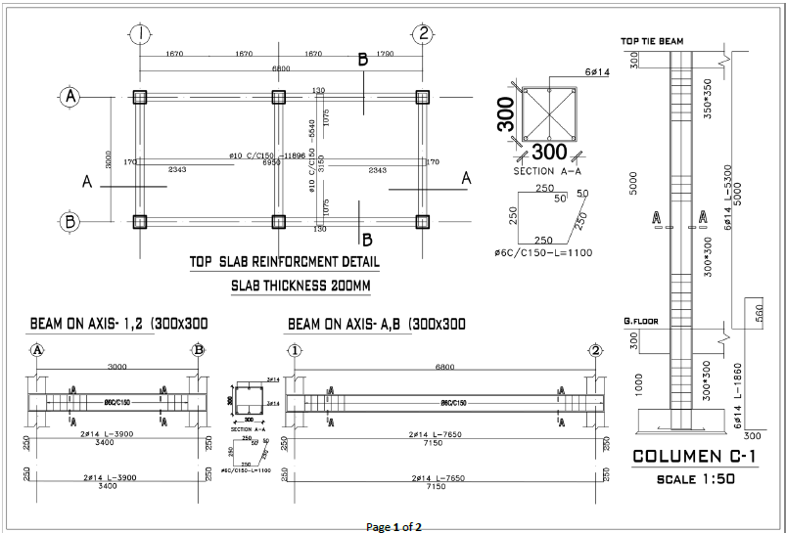

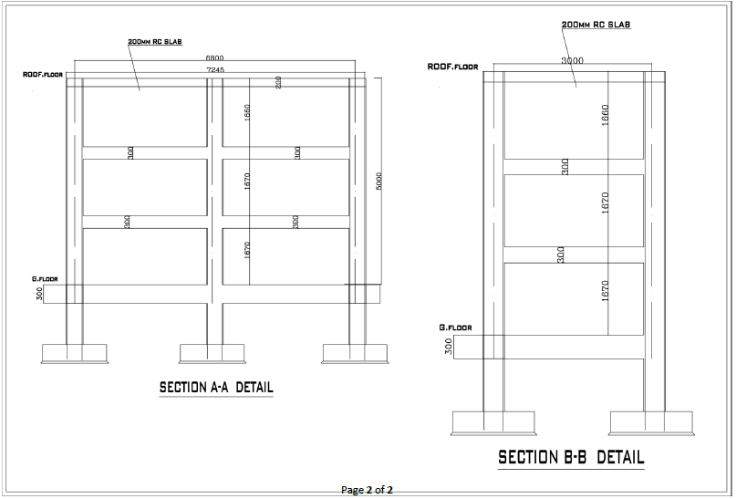

4.2 Public Fountain

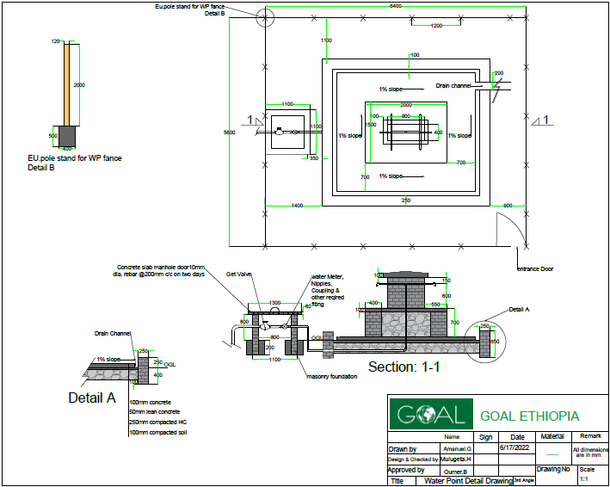

4.3 CATTLE TROUGH
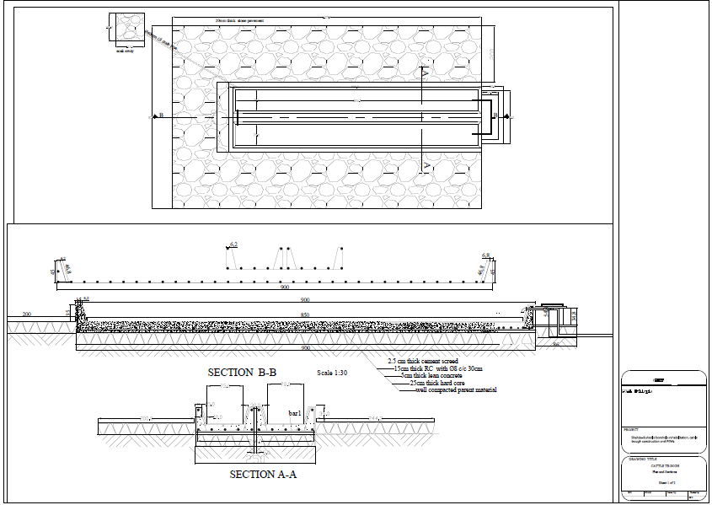
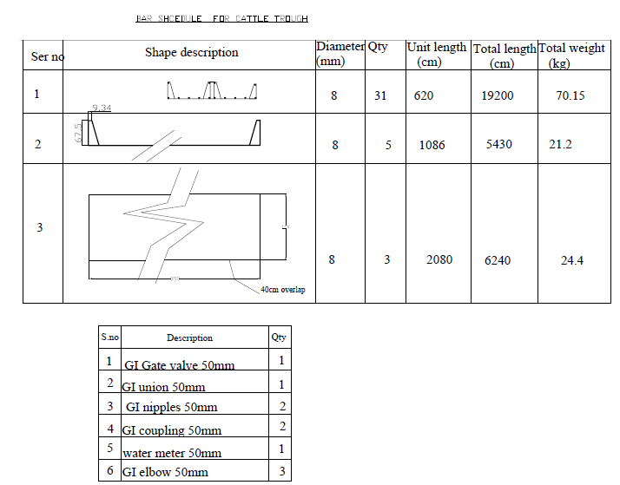

4.4 WATER FILLING STATION FOR TANKERS

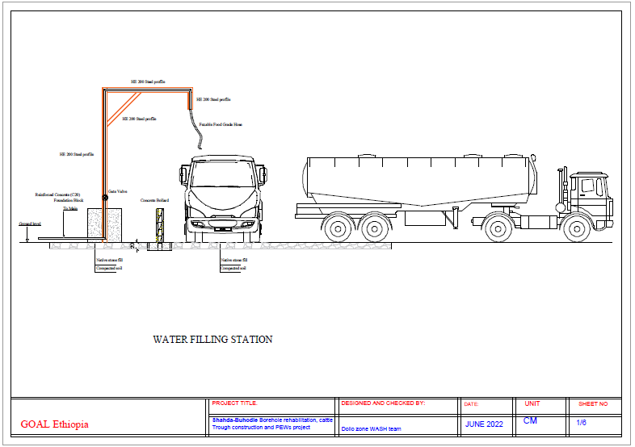

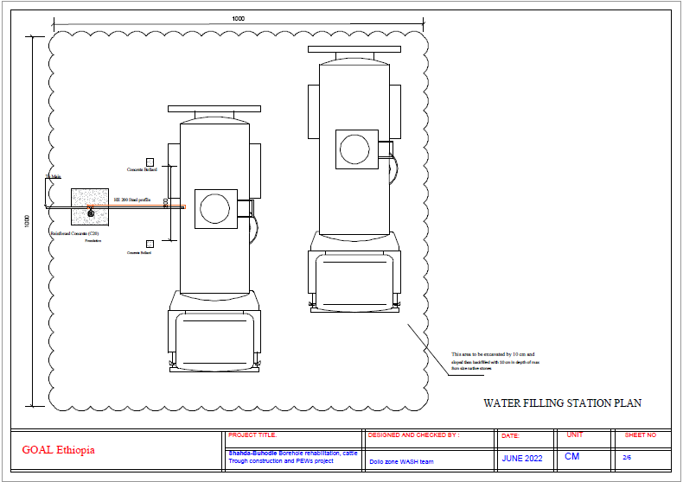

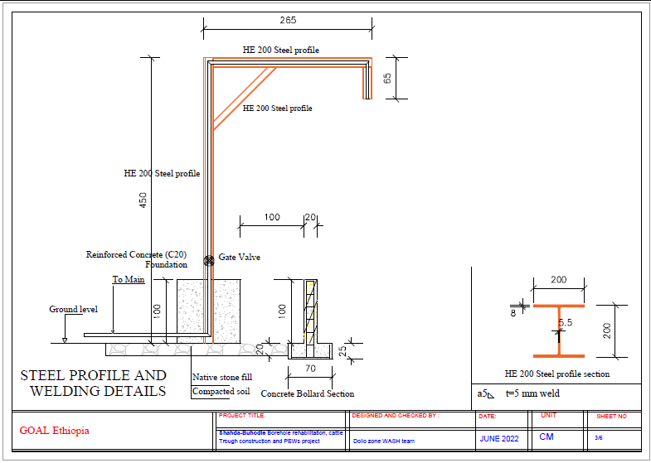

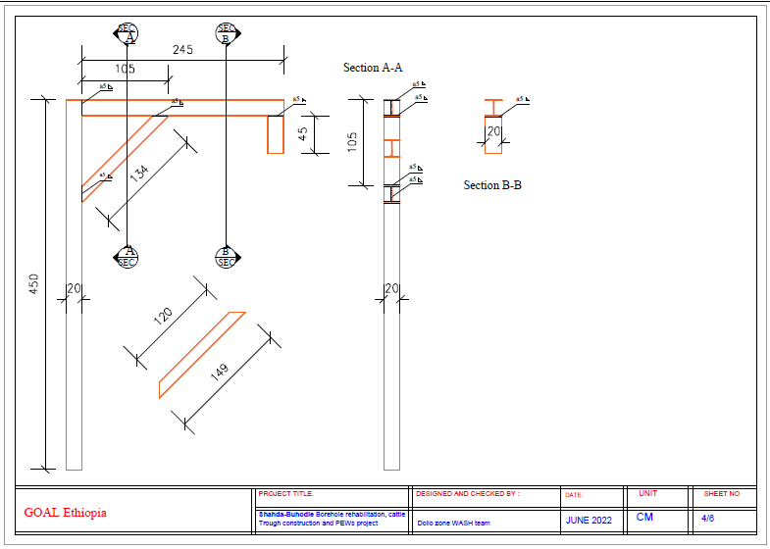

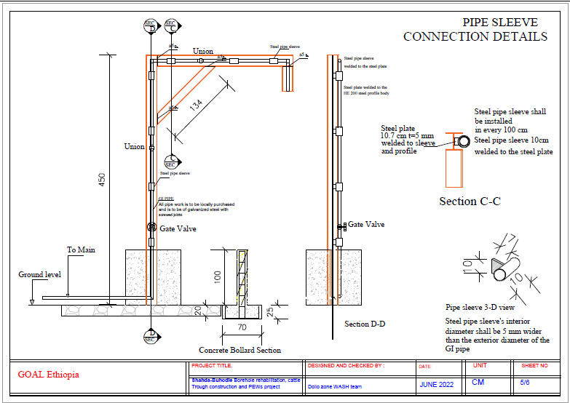

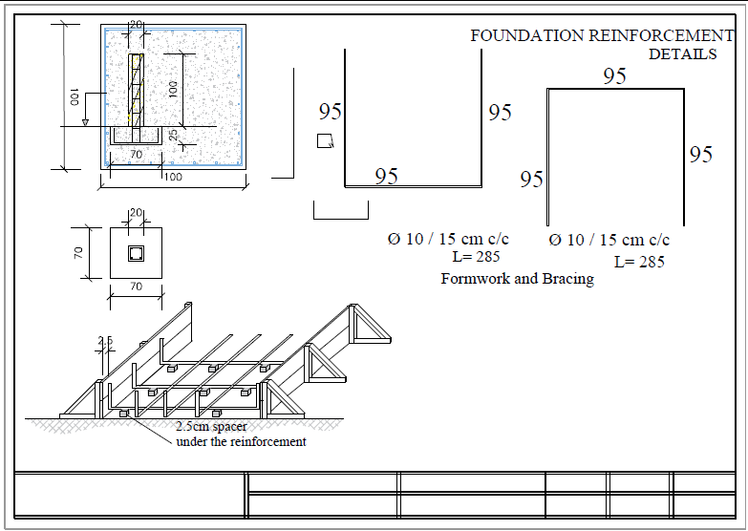

APPENDIX 5 - GOAL TERMS AND CONDITIONS
- LEGAL STATUS
The Vendor shall be considered as having the legal status of an independent contractor vis-à-vis GOAL. The Vendor, its personnel and sub-contractors shall not be considered in any respect as being the employees of GOAL. The Vendor shall be fully responsible for all work and services performed by its employees, and for all acts and omissions of such employees.
II. SUB-CONTRACTING
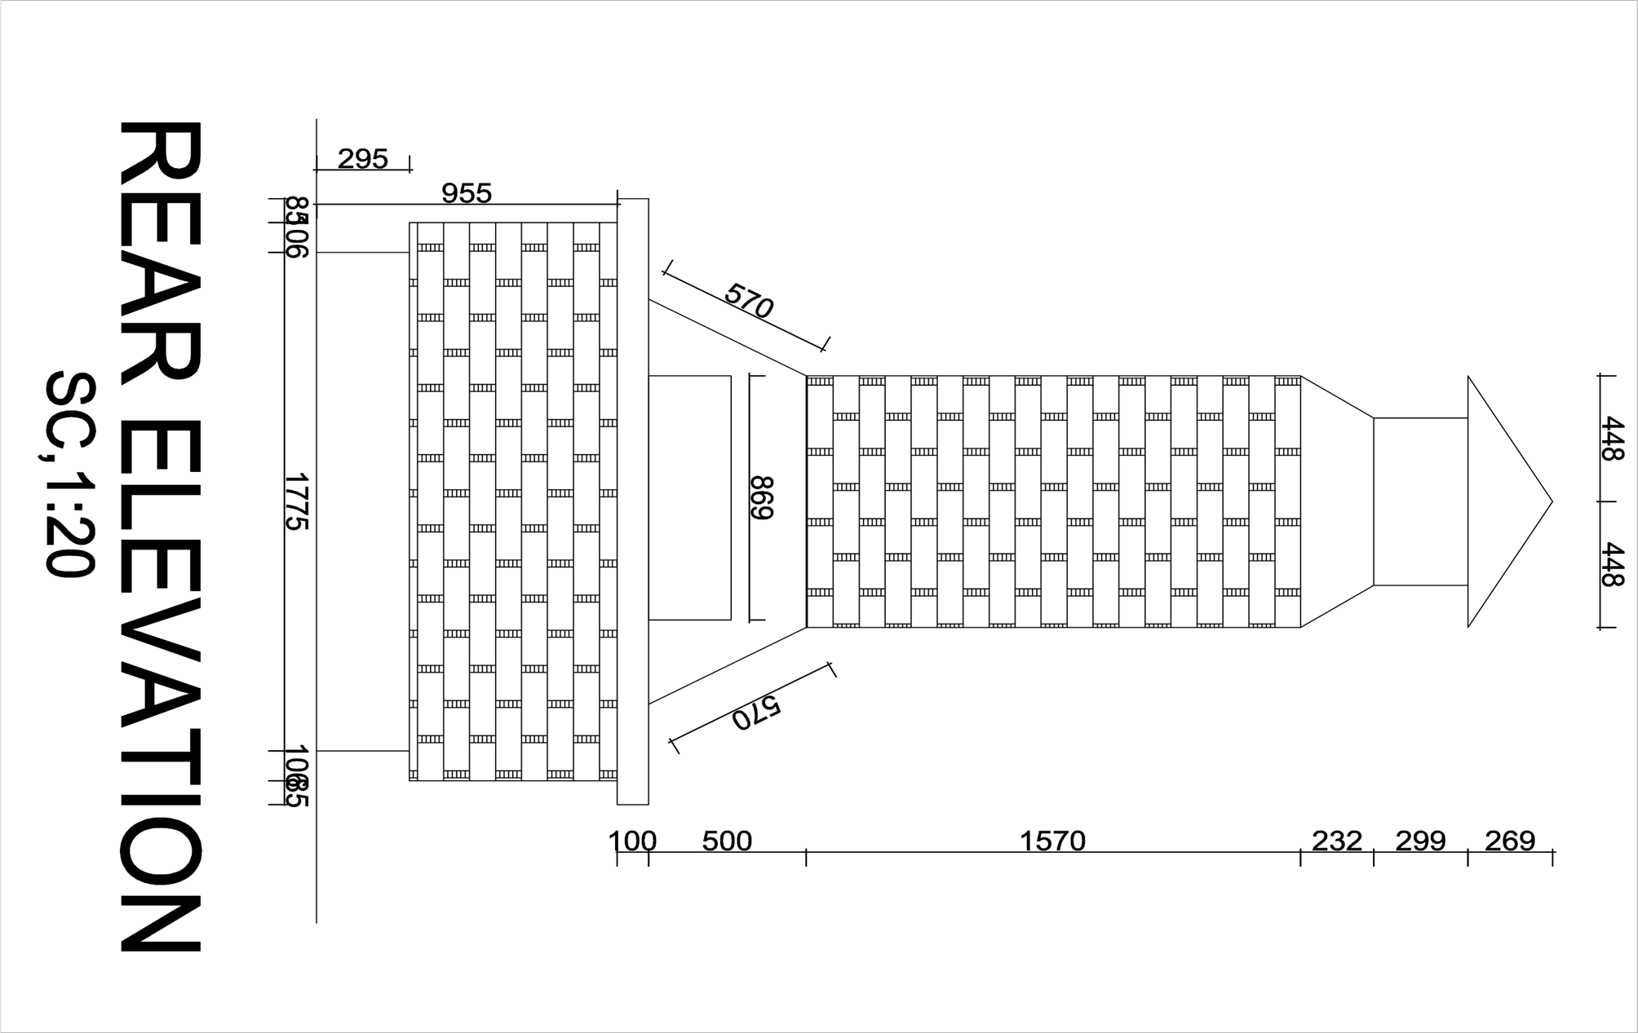
In the event the Vendor requires the services of a sub-contractor, the Vendor shall obtain the prior wrITTen approval of GOAL for all sub-contractors. The Vendor shall be fully responsible for all work and services performed by its sub-contractors and vendors, and for all acts and omissions of such sub-contractors and vendors. The approval of GOAL of a sub-contractor shall not relieve the Vendor of any of its obligations under this Contract. The terms of any sub-contract shall be subject to and conform with the provisions of this Contract.
III. OBLIGATIONS
The Vendor shall neither seek nor accept instructions from any authority external to GOAL. Vendors may not communicate at any time to any other person, government or authority external to GOAL any information known to them by reason of their association with GOAL which has not been made public, except in the course of their duties or by authorization of the GOAL: nor shall Vendors at any time use such information to private advantage. These obligations do not lapse upon termination/expiration of their agreement with GOAL.
IV. ACCEPTANCE AND ACKNOWLEDGEMENT
Initiation of performance under this contract by the vendor shall constitute acceptance of the contract, including all terms and conditions herein contained or otherwise incorporated by reference.
V. WARRANTY
The Vendor warrants the goods furnished under this Contract to conform to the specifications and to be free from damage and defects in workmanship or materials. This warranty is without prejudice to any further guarantees that the Vendor provides to purchasers. Such guarantees shall apply to the goods subject to this Contract.
VI. INSPECTION
The duly accredited representatives of GOAL or the donor shall have the right to inspect the goods called for under this Contract at Vendor’s stores, during manufacture, in the ports or places of shipment, and the Vendor shall provide all facilitates for such inspection. GOAL may issue a wrITTen waiver of inspection at its discretion. Any inspection carried out by representatives of GOAL or the donor or any waiver thereof shall not prejudice the implementation of the other relevant provisions of this Contract concerning obligations subscribed by the Vendor, such as warranty or specifications.
VII. EXPORT LICENCE
The Contract is subject to the obtaining of any export licence or other governmental authorisation that may be required. It shall be the responsibility of the Vendor to obtain such licence or authorisation. GOAL may, at its discretion, use its best endeavours to assist.
VIII. OFFICIALS NOT TO BENEFIT
The Vendor represents and warrants that no official of GOAL has been, or shall be, offered by the Vendor any direct or indirect benefit arising from this Contract or the award thereof. The Vendor agrees that breach of this provision is breach of an essential term of this Contract.

IX FORCE MAJEURE
For the purposes of this Contract, force majeure means any act of God, act of war, civil disturbance, explosion, fire, any law or action taken by a government or public authority or other exceptional event which is unforeseeable in the circumstances, which cannot be overcome and which prevents, hinders or delays either party from performing any of its obligations under this Contract. As soon as possible and in any event within five (5) working days after the occurrence of a force majeure event, the affected party shall give notice and full particulars to the other party in writing. The affected party shall not be in breach of this Contract nor liable for delay in performing its obligations under this does Contract if and to the extent that such delay is directly caused by the force majeure event provided that such party uses best endeavour to limit the effect of the force majeure event on the performance of its obligations. If such a period of delay or non-performance by the Vendor continues for ten (10) working days, GOAL may terminate this agreement by giving five (5) days' wrITTen notice to the Vendor.
X. DEFAULT
In case of default by the Vendor, including, but not limited to, failure or refusal to make deliveries within the limit specified, GOAL may procure the goods or services from other sources, and hold the Vendor responsible for any excess cost occasioned thereby. Furthermore, GOAL may, by wrITTen notice, terminate the right of the Vendor to proceed with deliveries or such part or parts thereof as to which there has been default.
XI. REJECTION
In the case of goods or services purchased based on specifications or scope of works, GOAL shall have the right to reject the goods or services or any part thereof if they do not conform to specifications or the scope of works.
XII. AMENDMENTS
No change in or modification of this Contract shall be made except by prior agreement between the Responsible Buyer in GOAL and the Vendor.
XIII. ASSIGNMENTS
The Vendor shall not assign, transfer, pledge or make other disposition of this Contract or any part thereof or of any of the Vendor’s rights, claims or obligations under this Contract except with the prior wrITTen consent of GOAL.
XIV. INDEMNIFICATION
The Vendor agrees to indemnify, hold and save GOAL harmless and defend at its own expense GOAL, its officers, agents and employees from and against all suits, claims, demands and liability of whatever nature or kind, including costs and expenses thereof and liability arising there from, with respect to, arising from or attributable to acts or omissions of the Vendor or its employees or sub-contractors in or relating to the performance of this Contract. This provision shall extend to, but shall not be limited to, claims and liability in the nature of product liability claims.
GOAL will promptly notify the Vendor of any such suit, claim, proceeding, demand or liability within a reasonable period of time after having received wrITTen notice thereof, and will reasonably co-operate with the Vendor, at the Vendor’s expense, in the investigation, defence or settlement thereof, subject to the privileges and immunities of GOAL.
The Vendor shall not permit any lien, attachment or other encumbrance by any person or entity to remain on file in any public or official office or on file with GOAL against any monies due or to become due for any work done or materials furnished under this Contract, or by reason of any other claim or demand against the Vendor.

XV. DISPUTES - ARBITRATION
Any claim or controversy arising out of or relating to this or any contract resulting here from, or to the breach, termination or invalidity thereof, shall be, unless settled amicably through negotiation, submITTed to arbitration in accordance with Ethiopian law.
XVI. USE OF NAME, EMBLEM OR OFFICIAL SEAL
Unless authorised in writing by GOAL, the Vendor shall not advertise or otherwise make public the fact that he is a Vendor to GOAL or use the name, emblem or official seal of GOAL or any abbreviation of the name of GOAL for advertising purposes or for any other purposes.
XVII. LIQUIDATED DAMAGES
Late delivery, or dispatch outside the agreed shipping schedule, shall be subject, without notice, to an assessment of liquidated damages equivalent to 1 percent of the Contract value per day or part thereof. GOAL has the right to deduct this amount from the Vendor’s outstanding invoices, if any. This remedy is without prejudice to any others that may be available to GOAL, including cancellation, for the Vendor’s non-performance, breach or violation of any term or condition of the Contract.
Acceptance of goods delivered late shall not be deemed a waiver of GOAL’s rights to hold the Vendor liable for any loss and/or damage resulted therefrom, nor shall it act as a modification of the vendor’s obligation to make future deliveries in accordance with the delivery schedule.
XVIII. ANTI-BRIBERY/CORRUPTION
The Vendor shall comply with all applicable laws, statutes and regulations relating to anti-bribery and anti-corruption including but not limited to the UK Bribery Act 2010 and the the United States Foreign Corrupt Practices Act 1977 (“Relevant Requirements”).
The Vendor shall have and maintain in place throughout the term of any contract with GOAL its own policies and procedures to ensure compliance with the Relevant Requirements.
No monies are payable to GOAL by the Vendor in association with the execution of this contract. If the Vendor is approached by a GOAL member of staff for a payment, commission, ‘kickback’ or associated payment or any other advantage of any kind, they are obliged to report the request or payment directly to GOAL’s Country Director within thirty-six hours. Failure to report any request for payment by a GOAL member of staff or actual payment by the Vendor to a GOAL member of staff to the GOAL Country Director shall result in the immediate termination of any contract and may result in disqualification of the Vendor from participation in future contracts with GOAL.
XIX. ANTI-PERSONNEL MINES
The Vendor guarantees that it is not engaged in the sale or manufacture, either directly or indirectly, of anti-personnel mines or any components produced primarily for the operation thereof. Any breach of this representation and warranty shall entitle GOAL to terminate this Contract immediately upon notice to the Vendor, at no cost to GOAL.
XX. ETHICAL PROCUREMENT
The Vendor represents and warrants that neither it, nor any of its vendors is engaged in any practice inconsistent with the following code of conduct for vendors: Employment is freely chosen, freedom of association and the right to collective bargaining are respected, working conditions are safe and hygienic, no child labour/protection of children is ensured, living wages are paid, working hours are not excessive, no discrimination is practiced, regular employment is provided, no harsh or inhumane treatment is allowed, any harm to the environment shall be avoided or limited. Any breach of this representation and warranty shall entitle GOAL to terminate this Contract immediately upon notice to the Vendor, at no cost to GOAL.
XXI. VENDOR INELIGIBILITY
Candidates that fall into any of the following categories are ineligible to participate in GOAL procurement processes: (a) They are bankrupt or being wound up, are having their affairs administered by the courts, have entered into an arrangement with creditors, have suspended business activities, are the subject of proceedings concerning those matters, or are in any analogous situation arising from a similar procedure provided for in national legislation or regulations; (b) They have been convicted of an offence concerning their professional conduct by a judgement that has the force of res judicata; (c) They have been guilty of grave professional misconduct proven by any means that the contracting authority can justify; (d) They have not fulfilled obligations relating to the payment of social security contributions or the payment of taxes in accordance with the legal provisions of the country in which they are established or with those of the country of the contracting authority or those of the country where the contract is to be performed; (e) They have been the subject of a judgement that has the force of res judicata for fraud, corruption, involvement in a criminal organisation or any other illegal activity; (f) Following another procurement procedure or grant award procedure, they have been declared to be in serious breach of contract for failure to comply with their contractual obligations;
XXII. VENDOR EXCLUSION
Negotiation with vendors or potential vendors may be severed at any stage during a procurement process if it is found that they meet either of the following exclusion criteria: (a) Are subject to a conflict of interest; (b) Are guilty of misrepresentation in supplying the information required by GOAL as a condition of participation in the contract procedure, or fail to supply all of the information requested.
XXIII. PRIOR NEGOTIATIONS SUPERSEDED BY CONTRACT
This Contract supersedes all communications, representations, arrangements, negotiations, requests for proposals and proposals related to the subject matter of this Contract.
XXIV. INTELLECTUAL PROPERTY INFRINGEMENT
The Vendor warrants that the use or supply by GOAL of the goods sold under this Contract does not infringe on any patent, design, tradename or trademark. In addition, the Vendor shall, pursuant to this warranty, indemnify, defend and hold GOAL harmless from any actions or claims brought against GOAL pertaining to the alleged infringement of a patent, design, trade-name or trade-mark arising in connection with the goods sold under this Contract.
XXV. TITLE RIGHTS
GOAL shall be entitled to all property rights including but not limited to patents, copyrights and trademarks, with regard to material which bears a direct relation to, or is made in consequence of, the services provided to the organisation by the Vendor. At the request of GOAL, the Vendor shall take all necessary steps, execute all necessary documents and generally assist in securing such property rights transferring them to the organisation in compliance with the requirements of the applicable law.
Title to any equipment and supplies which may be furnished by GOAL and any such equipment shall be returned to GOAL at the conclusion of this Contract or when no longer needed by the Vendor. Such equipment, when returned to GOAL, shall be in the same condition as when delivered to the Vendor, subject to normal wear and tear.
XXVI. PACKING
The Vendor shall pack the goods with new, sound materials and with every care, in accordance with the normal commercial standards of export packing for the type of goods specified herein. Such packing materials used must be adequate to safeguard the goods while in transit. The Vendor shall be responsible for any damage or loss that can be shown to have resulted from faulty or inadequate packing.
XXVII. INSURANCE
The vendor shall provide and thereafter maintain for the duration of this contract and any extension thereof all appropriate workmen’s compensation insurance or its equivalent with respect to its employees to cover claims for personal injury and death in connection with this contract. The vendor shall, upon request, furnish proof to the satisfaction of the GOAL, of such liability insurance. The vendor shall further provide such health and medical insurance for its agents and employees, as the vendor may consider advisable.
The Vendor shall have in force and maintain in force during the term of this Contract adequate public liability insurance, product liability insurance and other insurance policies required in connection with its business and in respect of the products and/or services supplied by the Vendor.
XXVIII. TERMINATION OF CONTRACT
Termination without default: Either party may terminate this Contract by giving notice in writing to the other party in accordance with this clause XXVIII. The required period of notice shall be five (5) working days in the case of contracts for a total period of less than two months or fifteen (15) working days in the case of contracts for a longer period. In addition, GOAL may terminate this Contract with immediate effect by giving notice in writing to the Vendor if there is a discontinuation or termination (in whole or in part) of donor funding related to this Contract. In the event of the Contract being terminated in accordance with this sub-clause, the Vendor shall be compensated on a pro rata basis for no more than the actual amount of work performed to the satisfaction of GOAL. Additional costs incurred by GOAL resulting from the termination of the Contract by the Vendor may be withheld from any amount otherwise due to the Vendor from GOAL.
Termination with default: Without prejudice to GOAL’s right to terminate this Contract with immediate effect provided for elsewhere in this Contract, GOAL may terminate this Contract with immediate effect without compensation by giving notice in writing to the Vendor where the Vendor: (i) commits a material breach of this Contract which cannot be remedied or has not been remedied within a period of seven (7) days after being notified in writing by GOAL; (ii) ceases to carry on the whole or a substantial part of its business, becomes unable to pay its debts as they fall due, becomes insolvent, enters into any compromise or arrangement with its creditors (other than in the context of solvent reconstruction or amalgamation), is the subject of a resolution to wind up or winding up proceedings, has an administrator, examiner or receiver appointed in respect of some or all of its assets, or being an individual, is the subject of a bankruptcy petition, or any event occurs, or proceeding are taken, with respect to the Vendor in any jurisdiction to which it is subject that has an effect equivalent or similar to any of the foregoing; (iii) commits an offence under anti-terrorism, anti-bribery/corruption or anti-money laundering legislation in any jurisdiction or is involved in organised crime or illegal activity; or (v) undergoes a change of control. GOAL’s termination of this Contract for default whether under this or another provision of this Contract shall be without prejudice to GOAL’s other rights, including but not limited to the right to claim for costs and losses incurred.
XXIX. ASSIGNMENT OF PERSONNEL
The Contractor shall not assign any persons other than those accepted by GOAL for work performed under this Contract.
XXX. OVERRIDING CLAUSE
In the event of any conflict or inconsistencies between these Terms and Conditions or any other document which forms part of the Contract, the contract shall prevail except where they have been amended (by specific reference to the relevant clause and paragraph of these Terms and Conditions) as provided for herein.

XXXI. WITHHOLDING TAX
GOAL reserves the right to deduct withholding tax from the vendor's invoice if so required by law. This will apply unless the vendor has supplied in advance the required documentation proving its exemption from withholding tax (e.g. withholding tax exemption certificate).
- ACCESS TO DOCUMENTATION
GOAL, its donors or any of their duly authorized representatives, shall have access to any books, documents, papers, and records of the vendor which are directly pertinent to the specific program for the purpose of making audits, examinations, excerpts and transcriptions

Signed:
Print name: |  | Position:
Company Name: |  | Date:
Address:

