TERMS OF REFERENCE (TOR)
Project Area: Harare & Bulawayo
Prepared By: Joselyn Ziwa
Donor/Cost Centre: ZGS
Account Codes: TBA
Title/Name of Activity: Construction of a total of 82 Group Hand Washing Facilities (GHWF), 41 in Harare, 41 in Bulawayo.

Introduction
Schools are risky centers of COVID-19 transmissions as shown by recorded infections amongst pupils. In addition, risks of water borne diseases including cholera and typhoid have been exacerbated by potable water interruptions in communities and inadequate adherence to recommended WASH practices. Schools in Zimbabwe re-opened on 7 February 2022, and this underscores the need to intensify interventions on WASH in schools (WinS) and surrounding communities to protect the wellbeing of learners and facilitate continuity of education. Schools bring together large numbers of children in close contact and as such, there is need to motivate social behavior change among children to adhere to recommended COVID-19 protocols and Water, Sanitation and Hygiene (WASH) behaviors.

During emergencies, hygiene promotion and particularly handwashing with soap to prevent or mitigate water, sanitation, and hygiene related diseases has been recognized as a cornerstone of humanitarian response, a practice and link that is missing with most schools in Zimbabwe. GOAL with support from the UNICEF fund, will support the construction of 82 Group Hand Washing Stations to identified schools, forty-one (41) in Bulawayo and forty-one (41) in Harare Metropolitan Provinces. The schools have been identified by the local Education authorities in the two provinces. The construction of the Group Hand Washing Facilities aims to fill the above-mentioned gaps in schools in Harare and Bulawayo by enabling adequate hand washing to reduce the risk of COVID 19 and other diarrheal diseases that are caused by lack or inadequate hand washing practices.

Objectives

- To support the government efforts to prevent the spread of COVID-19 by providing durable Group Hand Washing Facilities in schools in Harare and Bulawayo.
- To enable adequate hand washing in schools to reduce the risk of COVID 19 and other diarrheal diseases in schools.

1. Scope of work

Fix and supply for the construction of a total of eighty-two (82) Group Hand Washing Facilities (GHWFs), forty-one (41) in Harare and forty-one (41) in Bulawayo. The interested bidders are required to submit separate bids for Bulawayo and Harare. The contractor will supply the construction materials for the GHWFs as stated on 7.7: Bill of quantities and do the actual works of construction of the GHWFs to completion. The GHWFs will be spread over the identified schools (one structure per school), whose list shall be provided by GOAL Zimbabwe. This will cover the overall works to be carried out, which will comprise of fix and supply of materials, provision of labour and the completion of civil works for each Group Handwashing Facility.

2. Specifications

The Group Hand Washing Facilities will have the following specifications
- Easy to operate and maintain
- Accessible to all users (Age and disability appropriateness- height should be 500mm-700mm for younger learners and for wheelchair users ˂850mm)
- Sufficient hand washing points, i.e., facilities to service at least 10 pupils at the same time.
- Should be painted a color as agreed by the school authorities to improve aesthetics.
- There should be adequate drainage around the facility.
- Handsfree for the learners i.e centrally operated polyvinyl chloride (PVC) pipe as conduit for water with small holes for discharge of water as well as conservation of water.
- Simple brickwork trough design.
- Adapted to the terrain and existing water availability/infrastructure.
3. Essential Criteria:
The service provider shall;
- Be a registered Company as per Zimbabwean laws.
- Provide at least 3 references where similar works have been conducted.
- Provide details of the staff compliment and teams to conduct the works.
- Provide a workplan for the activities indicating the estimated time frames.

4. General Guidance:
- The school must identify an appropriate space/terrain for construction of the GHWF.
- The school shall be responsible for providing the source of water supply. Where water is piped, the handwashing facility should be constructed to ensure adequate pressure to enable water to flow into the storage tank and to the end of the Group Hand Washing Facility (GHWF).
- The handwashing basin must be slightly inclined to one side to enable all wastewater to drain into the soak away pit.
- The handwashing trough/basin shall be large enough to avoid splashing.
- Use PVC pipe (32mm PVC schedule 40) for water distribution, which does not corrode, is easy and cheap to replace.
- The Group Hand Washing Facility (GHWF) should be easy to operate by school personnel and repairs can be done easily by school community builders/plumbers.
- In line with COVID 19 prevention measures, social distancing of 1 m between the water outlets must be maintained.
- A storage tank (1000 litres) shall be installed on handwashing facility to allow water to be fetched from water sources that are not directly connected to this system and ensure handwashing is possible even if there is a cut off to water supply for directly connected to water source handwashing facility.
- The storage tank (1000 litres ) is closed to avoid the intrusion of dust and debris, even learners.
- If directly connected to the water supply, a float valve is recommended for the tank to avoid overflowing when full.
- One washing point should be set aside for students with disability
- All installations should be fixed to avoid theft.
- Site clearance, rehabilitation and environmental restoration shall be the responsibility of the contractor.
5. Construction works
- Use of construction materials- bricks, stones, sand, cement as per provided specifications.
- Use of standard plumbing materials as per provided specifications.
- Brickwork basin, slightly inclined (1:60 fall/slope) to easily allow water to flow and drain into a soak pit through PVC pipe DN 50
- Use a nail of 8-10 cm length with a shank diameter of 1.6mm for PVC perforation or where available a drill with a similar drill bit diameter can be used.
- Holes/perforations should be made underneath the PVC pipe in such a way that water will trickle at an angle away from the pipe but within the trough.
- Install 2 ball valves on the PVC pipe (one main valve between water storage tank and first perforation and the other one as faucet for the disabled children at the end) to allow for regulating the flow of water along the pipeline.
- One space with one dedicated washing point (with singular valve) is constructed for students with disabilities. The platform for the tap for persons with disability should be constructed so there is no barrier/step for a wheelchair. Additionally, the platform should be constructed so that a child on a wheelchair does not get wet when washing their hands.

6. Design Drawings and illustrations
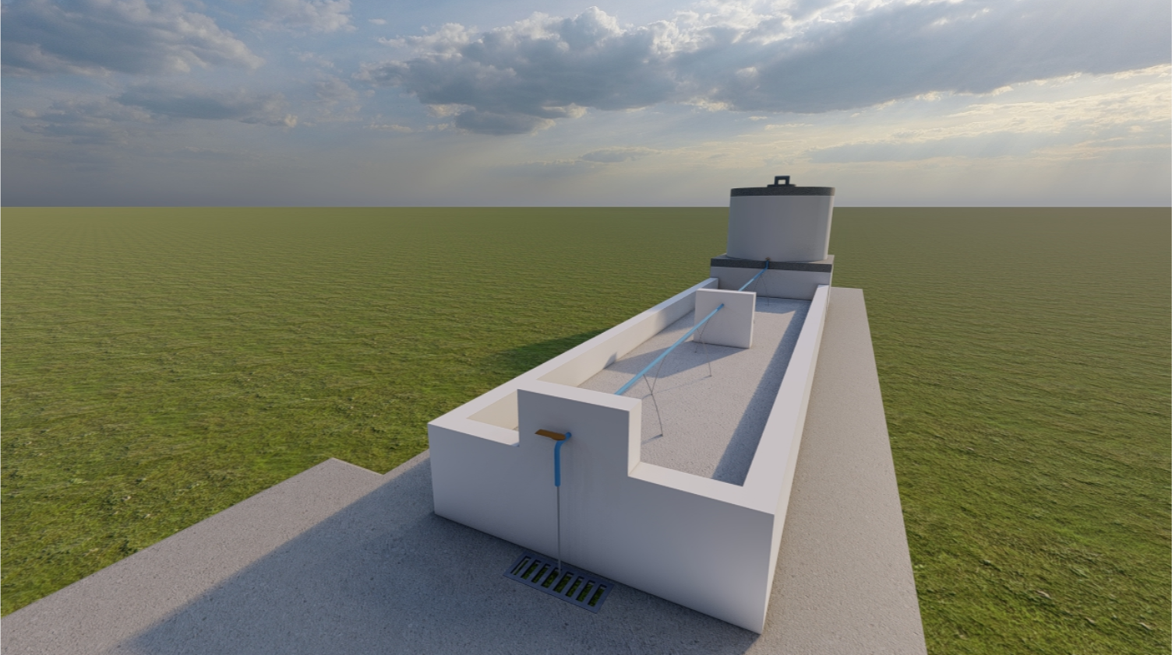

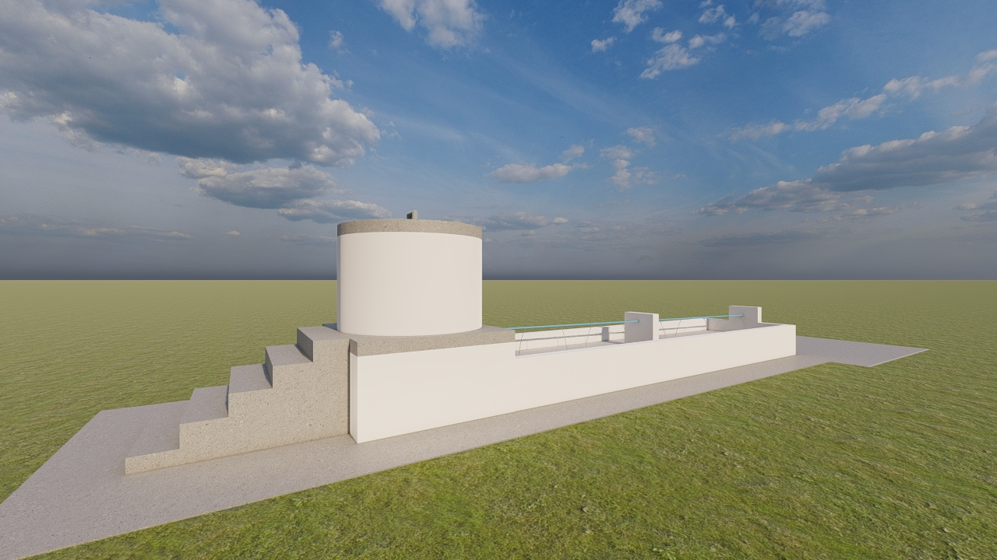

7. Construction Steps
7.1. Setting out
- Identify a site measuring 10m long x 3m wide closer to the school latrines
- With reference to the plan, using builders’ lines (strings), pegs, a steel square and a tap measure draw lines using a pick to mark the foundations to be excavated
- Ash can be added to the lines to make them more visible as shown on the picture below.
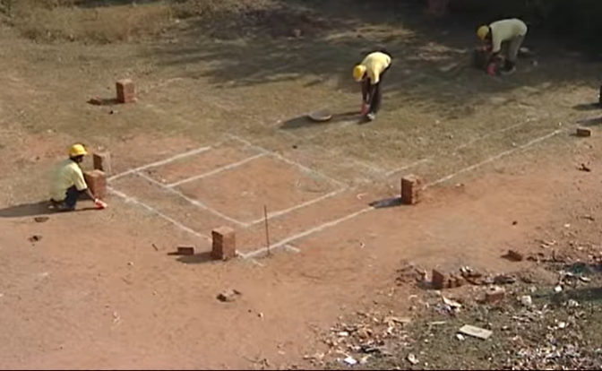
- A representative from GOAL and the Local Authority shall approve this stage once it has been completed before the contractor moves onto the next stage.
7.2. Trenching and footing
- Using a pick and a shovel, excavate trenches that are 575mm wide and 500mm deep following the set-out foundations for the main handwashing basin. For the water storage tank and stand, excavate trenches that are 690mm wide and 500mm deep.
- Ensure straightness and plumbness of the excavated trenches
- Prepare a concrete footing mixture (1 part cement: 2 parts river sand: 4 parts coarse aggregate/concrete stones)
- Pour mixture into the excavated trenches ensuring that it is compacted and leveled off. The footing should be 230mm thick.
- Pour water and allow the footing to cure for at least 1 day
- A representative from GOAL and the Local Authority shall approve this stage once it has been completed before the contractor moves onto the next stage.
7.3. Foundation
- Cement mortar mixture for brickwork should be 1 part cement to 6 parts pit sand.
- Using burnt standard clay bricks, construct a half brick wall (115mm) ensuring it is positioned at the center on top of the footing along all trenches. However, for the tank stand area, construct a 1 brick wall (230mm)
- Add brick force after every 2 courses to strengthen the structure
- Build until you get to the ground level and continue above ground level by 300mm
- Fill the box with rubble, excavated soil and small stones up to the last course of bricks, pour water and compact to form a hard core leaving a space of 150mm to the top of the last course of brickwork.
- Prepare a concrete mixture (1 part cement: 2 parts river sand: 4 parts coarse aggregate/concrete stones) and pour it over the hardcore, compact it and level it off to a thickness of about 150mm ensuring a gradient of 0.60 towards the wastewater disposal end.
- Pour water daily over the concrete surface and allow to cure for at least 3 days.
- Backfill space between the wall and the trench and compact it.
- A representative from GOAL and the Local Authority shall approve this stage once it has been completed before the contractor moves onto the next stage.
7.4. Brickwall (Basin)
- Continue building the 115mm walls above the concrete surface to a height of 845mm above ground level
- Continue adding brick force after every 2 courses to strengthen the structure
- Plaster the wall using a strong mixture (1 part cement: 4 parts pit sand)
- For both the internal and external plastering mortar, mix with impermo (1kg of impermo to 50kgs of cement) to prevent water leakage.
- Complete the flooring of the structure using a cement mortar mixture of 1 part cement to 3 parts river sand whilst maintaining the 0.60 slope. The impermo should be added to the mixture as above. Space between walls and floor should be coved to enable ease of cleaning of the structure.
- Holes of about 34mm diameter should be left just below the last course of bricks of the walls to allow for the insertion of the 32mm schedule 40 PVC pipe
- A representative from GOAL and the Local Authority shall approve this stage once it has been completed before the contractor moves onto the next stage.

7.5. Storage (Tank stand and tank-1000 liters – preferable JOJO)
- Construct the 230mm brick wall for the tank stand from the concrete footing to a height of 850mm above ground level using the same brickwork cement mortar mixture as above.
- Add brick force after every 2 courses to strengthen the structure
- Fill the 850mm deep box with rubble, excavated soil and small stones up to the last course of bricks. Pour water and compact to form a hard core leaving a space of 150mm from the top of the last course of brickwork
- Prepare a concrete mixture (1 part cement: 2 parts river sand: 4 parts coarse aggregate/concrete stones) and pour it over the hardcore. Compact it and level it off to a thickness of about 150mm.
- Install the 1000 litres JOJO tank in a secure way with anti-theft components, ensuring all connections are properly done.
- A representative from GOAL and the Local Authority shall approve this stage once it has been completed before the contractor moves onto the next stage.
7.6. Drainage (Soak-pit and apron)
- The floor of the handwashing basin should have a slope of 0.60 to allow for wastewater to drain towards the gulley and the soak pit.
- A concrete apron (50cm from the walls of the handwashing facility) should be constructed around the handwashing facility to allow for proper drainage of rainwater and spillages from the handwashing activities.
- A soak pit measuring 700mm long x 1000mm wide x 1000mm deep should be excavated. It should be filled with stones and covered with a plastic sheeting on top before being covered with a layer of soil.
- A representative from GOAL and the Local Authority shall approve this stage once it has been completed by the contractor.
8. Additional Specifications
- GOAL shall attach two local builders for orientation on the modalities of the construction of the Group Hand Washing Facilities as the Contractors implements the construction.
- The contractor should produce an activity plan or Gantt chart for the works
- The contractor should indicate the number of teams available for the works

9. Duration of project activity

The construction for the Group Hand Washing Facilities will commence during the period September to November 2022 in Harare and Bulawayo Provinces.

