Annexe B - Scope of Work

Purpose
The Goal IT Department require an IT Services provider to support the service and supply of IT equipment for business use.
This is in line with the agreed organisational strategic plan and the IT strategic plan.
GOAL will enter into a three-year framework agreement with the preferred supplier to provide stability and predictability in this area. The FWA will set prices for the FWA duration (initially for 1 year with the possibility to review on an annual basis up to a maximum of 3 years). Prices and the quality of the service received will be reviewed jointly on an annual basis by GOAL and framework suppliers to make sure it’s satisfactory and within current market value.

Deliverables
GOAL is seeking to contract service providers, suppliers who has the capacity to fulfil the requirements of this ITT and have the delivery capability to deliver to GOALS’ offices worldwide (see annex A).
The selected supplier/s will deliver support in the below key areas:
HARDWARE
PERIPHERALS
TELECOMS
SECURITY DEVICES & LICENSING

Proposal Submission requirements
The selected supplier/s will deliver support in the below key areas:
1. Contractors may submit tenders for either lot or all lots. Each lot will be evaluated separately. Complete the pricing schedule for all items in a minimum of one single Lot by including your price for each item in the Lot(s) being tendered for.
2. Tenderers must set out a delivery lead time in working days to cover all quantities and delivery per Lot(s) being tendered for. For evaluation purposes the delivery location will be GOAL HQ Carnegie House Dun Laoghaire, Co Dublin and all country offices (Annex A). For evaluating bids, please do not provide shipment costs, only shipment times.
3. Tenderers must specify their warranty period to cover for all items per Lot(s) being tendered for.
4. Please provide a detailed description of the customer service and support you will offer to GOAL for each of the Lot(s) being tendered for.
TECHNICAL PROPOSAL
TECHNICAL PROPOSAL 30 MARKS
 | Sub Criteria | Maximum Marks | Minimum Marks required to Pass *
1 | Delivery time for Ireland | 10 | 4
2 | Delivery time for Country offices | 10 | 4
3 | Customer Service and Support | 10 | 4
4 | Added Value points for IT Sustainability | 5 | -
 | Total Marks Available | 35 | -

*All tenders that achieve the Minimum Marks required to Pass for the above sub-criteria will be eligible to proceed to be evaluated under Award Criteria Price.
Tenderers who fail to achieve ANY minimum Mark required to Pass as set out in the table above will be eliminated from the competition.
How Tenderers marks will be allocated:
1. Delivery time for Ireland
Tenderers must set out a delivery lead time in working days, for the delivery of IT equipment to GOAL from the date of receipt of an order (where the order is placed before 12.00pm on a particular working day) to the delivery date of the IT equipment to GOAL head office in Dublin. Only ONE (1) lead time to cover all quantities and delivery per Lot. Tenderers quoting more than one (1) delivery lead time, or who do not quote a delivery lead time for any Lot(s) in the Tender Response Document, will be automatically allocated the marks relating to the longest lead time.
Delivery Lead Time | Marks
Between 0 – 10 working days | 10 (Excellent)
Between 11 – 20 working days | 8 (Good)
Between 21 – 30 working days | 6 (Satisfactory)
Between 31 – 40 working days | 4 (Fair)
40+ working days | 2 (Poor)

Using the minimum rule suppliers must score for delivery of these items. Failure to score satisfactory or higher will result in elimination.

Please include your response in the table below:
Lots | Delivery Lead Time in working day(s)
LOT 1
LOT 2
LOT 3
LOT 4
LOT 5

2. Delivery time for Country Offices
Tenderers must set out a delivery lead time in working days, for the delivery of IT equipment to GOAL from the date of receipt of an order (where the order is placed before 12.00pm on a particular working day) to the delivery date of the IT equipment to GOAL head office in Dublin. Only ONE (1) lead time to cover all quantities and delivery per Lot. Tenderers quoting more than one (1) delivery lead time, or who do not quote a delivery lead time for any Lot(s) in the Tender Response Document, will be automatically allocated the marks relating to the longest lead time.
Tenderers must be able to ship to at least 80% of GOAL countries.
Delivery Lead Time | Marks
Between 0 – 30 working days | 10 (Excellent)
Between 31 – 40 working days | 8 (Good)
Between 41 – 50 working days | 6 (Satisfactory)
Between 51 – 60 working days | 4 (Fair)
60+ working days | 2 (Poor)
Using the minimum rule suppliers must score for delivery of these items. Failure to score satisfactory or higher will result in elimination.
Please include your response in the table below:
Lots | Delivery Lead Time in working day(s)
LOT 1
LOT 2
LOT 3
LOT 4
LOT 5

3. Customer Service and Support
Please provide a detailed description of the customer service and support you will offer to GOAL for each of the Lot(s) being tendered for, including (but not limited to) the following:
- How you will deal with Customer complaints – their investigation, resolution, and subsequent corrective actions and/or preventative actions, including relevant timelines;
- Your proposed approach to ensuring the provision of a high-quality service to this Framework
- Outline defined service level agreements (SLA’s)
The complete response to ‘Customer Service and Support’ will be scored out of 10 marks using the scoring matrix laid out in the table below.
2 Marks | Poor – Very limited response provided. Deficiencies in response leading to significant cause for concern.
4 Marks | Fair – Some detail provided, but response is not detailed enough or at too high a level to demonstrate a workable solution. Deficiencies in response lead to some cause for concern
6 Marks | Satisfactory – A satisfactory response which demonstrates a reasonable understating of requirements, however response does not provide sufficiently convincing assurance that all requirements will be addressed
8 Marks | Good – Good response, clearly demonstrating an understanding that most requirements will be met however minor reservations exist that all requirements will not be addressed.
10 Marks | Excellent – Excellent response that fully meets or exceeds requirements, providing a comprehensive, detailed and convincing assurance that the tenderer will be able to deliver on all requirements.
Using the minimum rule suppliers must score Satisfactory for Customer Service Support. Failure to score satisfactory or higher will result in elimination.
4. ADDED VALUE
Marks will be attributed based on:
- the use of environmentally friendly packaging,
- offset your transport carbon emissions,
- carry out sustainable procurement and offer recycling of old equipment.
Please include a description taking into consideration the above points.
Delivery Lead Time | Marks
Clear efforts towards becoming more sustainable | 5 (Good)
Limited offering with sustainable considerations | 3 (Satisfactory)
No definable offering | O (Zero)

ANNEXE B - PRICING SCHEDULE- FINANCIAL OFFER
(All Tenderers must complete the Pricing Schedule)
All prices quoted must be all inclusive (i.e. including but not being limited to all costs/expenses/indexation), be expressed in Euro only and exclusive of VAT. The VAT rate(s) where applicable should be indicated separately.
UNIT Prices should be included in the below Table.
Please note that where all items haven’t been quoted for in a particular Lot you will be eliminated from that Lot. Lots will be assessed individually, and suppliers can quote for one or more Lots.
The below is not an exhaustive list, these are the basic items required in this Tender and if proceed in signing the Framework agreement then the full list will be shared with you.

LOT 1 HARDWARE
*Please see below for full specifications. Please ensure all quoted items are for products designed for business use.
*For any laptops, quote for Dell, HP, or Lenovo
Item | Description | Delivery Lead time | Warranty | Total Delivered Price Excl VAT
1 | Laptop 1
2 | Laptop 2
3 | PC (Desktop)
4 | Printer (Desktop printer)
5 | Printer (Small MFP)
6 | Server:: 2U Rack
7 | Ethernet Switch 1
8 | UPS 1

LOT 2 - Peripherals / Accessories
*Please see below for full specifications
Item | Description | Delivery Lead time | Warranty | Total Delivered Price Excl VAT
1 | SSD Drive small
2 | SSD Drive medium
3 | RAM
4 | Hand Held Tablet
5 | PC Monitor 1
6 | PC Monitor 2
7 | Power supply
8 | Docking station 1
9 | Backpack 1
10 | ID Card Printer 1
11 | Headset (Wired)
12 | Keyboard (Wired)
13 | Mice (Wired)

LOT 3 – Telecoms
*Please see below for full specifications
Item | Description | Delivery Lead time | Warranty | Total Delivered Price Excl VAT
1 | IP Phone
2 | Smart Phone (low end)
3 | Smart Phone - High end
4 | Conferencing system (video conferencing system) Large Meeting Room
5 | Conferencing system (video conferencing system) - Small meeting room
6 | Small (omni-directional microphone/speaker)
7 | Large (omni-directional microphone/speaker)

LOT 4 - Security Devices and Licensing
*Please see below for full specifications
Item | Description | Delivery Lead time | Warranty | Total Delivered Price Excl VAT
1 | MX 64W
2 | MX 64W license
3 | MX 65W
4 | Mx 65W license
5 | Mx 85 Firewall
6 | Mx 85 license
9 | UniFi Access Point U6 Lite (small office)
10 | UniFi Access Point U6 Long range (medium office)

LOT 5 - IT infrastructure support services
Item | Description | Delivery Lead time | Total Delivered Price Excl VAT
1 | Remote Senior Network Support Engineer - (Daily or hourly rate)
2 | Remote Senior Server Support Engineer - (Daily or hourly rate)
3 | Remote Service Desk Support Engineer - (Daily or hourly rate)

Signed: (Director) _________________________________________
Date: _________________________________________
Print Name: _________________________________________
Company Name: _________________________________________
Address: _________________________________________

LOT 1 – Hardware Specification
*All prices must be comprehensive and include all other costs be expressed in Euro only and exclusive of VAT. The VAT rate(s) where applicable should be indicated separately.
Name | Details*
Laptop 1  (Dell/HP/Lenovo) | Laptop with the following or with equivalent specs:  Processor Minimum: Previous Generation Quad Core. Please provide options.  Memory Minimum: 8 GB RAM.  Available Disk Space: Minimum 256GB SSD. Provide options.  Peripherals Minimum: Graphics hardware acceleration VGA x 1, HDMI x 1, USB x 2,  Operating System: Windows 10/11 Professional or none.  Connection: Includes wireless network interface card: A/C/N or better.  Display Size: 13.3 inches.  Encryption: Must be capable of being encrypted.  Battery: Lithium-ion battery. State how many battery cells the device is capable of holding. State battery life during constant use and whilst on standby. State if the device supports ‘hot swop’ battery operation.  Warranty:State warranty duration and what is covered under warranty  ***End***
Laptop 2  (Dell/HP/Lenovo) | Laptop with the following or with equivalent specs:  Processor Minimum: Latest Generation Quad Core. Please provide options.  Memory Minimum: 16 GB RAM.  Available Disk Space: Minimum 500GB SSD. Provide options.  Peripherals Minimum: Graphics hardware acceleration VGA x 1, HDMI x 1, USB x 2, includes number pad in laptop build.  Operating System: Windows 10/11 Professional or none.  Connection: Includes wireless network interface card: A/C/N or better.  Display Size: 13.3 inches  Encryption: Must be capable of being encrypted.  Battery: Lithium-ion battery. State how many battery cells the device is capable of holding. State battery life during constant use and whilst on standby. State if the device supports ‘hot swop’ battery operation.  Warranty:State warranty duration and what is covered under warranty.  ***End***
PC (Desktop) | Desktop with the following specifications or equivalent:  Processor Minimum: Latest Generation Quad Core. Please provide options.  Memory Minimum: 16 GB RAM. Provide options for 16 GB where possible.  Available Disk Space: Minimum: 500GB SSD. Provide options.  Drive: DVD-ROM.  Peripherals Minimum: Graphics hardware acceleration VGA x 1  HDMI x 1, USB x 2, LAN/RJ45 x 1  Operating System: Windows 10/11 Professional or no OS  Encryption: Must be capable of being encrypted; provide detailed explanation of how this will be achieved.  Warranty: State warranty duration and what is covered under warranty.  Provide options for extended warranty.  ***End***
Printer (Desktop printer) | Printers & Multifunction  Auto Document Feeder  High Yield Printing  Type: Laser  Wi-Fi  Functions  3-in-1 (print, copy, scan)  Display: LCD  Memory: 192 MB  Compatible Operating Systems  Windows XP Home Edition, XP Professional Edition, XP professional x64 Edition, Server 2003 (Network only), Server 2003 x64 Edition (Network only), Vista, Server 2008 (Network only), Server 2008 R2 (Network only), Windows 7, Windows 8, Server 2012, Windows 10/11.  Card Reader  Wireless Printer Connections  Automatic duplex scan.  Automatic duplex print.  Scan to USB device, Scan to Email & Scan to Network folder feature available.  Print speed: the black print was mentioned as 0, however 18 for color.  It should be at least 27 ppm for color and 27 for black.  Duty Cycle (monthly) 40000~50000 pages.  Print Features  Printer Type: Laserjet  Input Capacity: 250 Sheets  Output Capacity: 100 Sheets  Print Speed - Mono: 27  Print Speed - Colour: 27  Scan Features Scan File Format: OCR, PDF  Scan Size: A4  Max. Scan Resolution: 19200 x 19200 dpi  Scan Resolution: 1200 x 2400 dpi  Photocopy Features  Copy Resolution - Colour 600 x 600 dpi  Copy Resolution - Mono 600 x 600 dpi  Copy Speed - Mono 18 ipm  Copy Speed - Colour 18 ipm  Power Frequency: 50 - 60 Hz  Voltage: 220-240 V  Connectivity  Wireless Connectivity: Wi-Fi  Wireless Ready: Yes  Ports & Connections: USB 2.0, Ethernet  USB Ports: 1  ***End***
Printer (Small MFP) | Main Unit  Machine type or similar specs  Color Laser Multifunctional  Core functions  Print, Copy, Scan, Send, Store and Optional Fax  Scan to Email & Scan to Network folder feature available.  Processor Speed  Dual Custom Processor (Shared) 1.75 Ghz  Control Panel  25.6 cm (10.1 inch) TFT LCD WSVGA Colour Touch panel  Memory  Standard: 3.0GB RAM  Hard Disk drive  Standard: 250GB  Interface Connection  NETWORK  Standard: 1000Base-T/100Base-TX/10Base-T, Wireless LAN (IEEE 802.11 b/g/n)  Optional: NFC, Bluetooth Low Energy  OTHERS  Standard: USB 2.0 (Host) x2, USB 3.0 (Host) x1, USB 2.0 (Device) x1  Optional: Serial Interface, Copy Control Interface  Paper input (Standard)  1 x 550-sheet cassette (80gsm)  100-sheet multi-purpose tray (80gsm)  Paper input (Option)  550-sheet cassette (80 gsm) (CASSETTE MODULE-AE1)  550-sheet cassette (80gsm) (CASSETTE FEEDING UNIT-AJ1)  3 x 550-sheet cassettes (80gsm) (CASSETTE FEEDING UNIT-AK1)  Maximum paper input capacity  2,300 sheets (80 gsm)  Paper output capacity  Without Finisher: 250 Sheets (A4, 80 gsm)  With Finisher: Max.500 sheets (A4, 80 gsm)  Finishing capabilities  Collate, Group  With External Finisher : Collate, Group, Offset, Staple  Supported media types  Cassettes:  Thin paper, Plain paper, Recycled paper, Colour paper, Pre-punched paper, Thick paper, Bond paper, Envelopes*  *Envelopes supported via standard cassette 1 only.  Multi-purpose tray:  Thin paper, Plain paper, Recycled paper, Colour paper, Pre-punched paper, Thick paper, Bond paper, Transparency, Labels, Envelopes  Supported media sizes  Cassette 1:  Standard size: A4, B5, A5, Envelopes (No. 10(COM 10), Monarch, ISO-C5, DL)  Custom size: Min. 98 mm x 190.5 mm up to 216 mm x 355.6 mm  Multi-purpose tray:  Standard size: A4, B5, A5  Custom Size: Min. 98 mm x 148 mm up to 216 mm x 355.6 mm  Envelopes: No.10 (COM10), Monarch, ISO-C5, DL  Envelope custom size: 98 mm x 148 mm to 216 mm x 355.6 mm  CASSETTE MODULE-AE1:  Standard size: A4, B5, A5  Custom size: Min. 98 mm x 190.5 mm up to 216 mm x 355.6 mm  CASSETTE FEEDING UNIT-AJ1/AK1:  Standard size: A4, B5, A5  Custom size: Min. 98 mm x 190.5 mm up to 216 mm x 355.6 mm  Supported media weights  Cassettes: 60 to 163 gsm  Multi-purpose tray: 60 to 220 gsm  Duplex: 60 to 163 gsm  Warm-up Time  From Power on:34 Seconds or Less 1  From Sleep Mode: 10 Seconds or Less  Quick Start-up Mode: 4 seconds or less 3  Dimensions (W x D x H)  Approx 511 mm x 651 mm x 541 mm or equivalent  Installation Space (W x D)  511 x 651(Basic: Platen cover + Multi-purpose tray extended)  1,407 mm x 908 mm (Fully configured: Platen cover + STAPLE FINISHER-Z1+ Multi-purpose tray extended)  852 mm x 908 mm (Basic: DADF + Multi-purpose tray extended)  1,407 mm x 908 mm (Fully configured: DADF + STAPLE FINISHER-Z1 + Multi-purpose tray extended)  Weight  Approx. 42kg including toner  Print Specifications  Printing method Colour Laser Beam Printing  Print Speed (BW/CL)  25 ppm (A4), 26 ppm (B5), 26 ppm (A5)  35 ppm (A4), 26 ppm (B5), 26 ppm (A5)  Print Resolution 1,200 dpi x 1,200 dpi equivalent  Page Description Language(s)  UFR II, PCL 6, Genuine Adobe PostScript Level 3 (Standard)  Double Sided Printing  Automatic (Standard)  Direct printing available from USB memory key, Advanced space, Remote UI and Web Browser 4  Supported file types: TIFF, JPEG, PDF, EPS, and XPS.  Printing from mobile and cloud  A range of software and MEAP-based solutions is available to provide printing from mobile devices or internet-connected devices and cloud-based services depending on your requirements.  Fonts: PCL fonts: 93 Roman, 10 Bitmap fonts, 2 OCR fonts, Andalé Mono WT J/K/S/T* (Japanese, Korean, Simplified and Traditional Chinese) , Barcode fonts**  PS fonts: 136 Roman  *Requires optional PCL INTERNATIONAL FONT SET-A1  **Require optional BARCODE PRINTING KIT-D1  Operating System  UFRII: Windows Vista/Server 2008/7/Server 2008 R2/Server 2012/8.1/Server 2012 R2/10/Server 2016, MAC OS X (10.7 or later)  PCL: Windows Vista/Server 2008/7/Server 2008 R2/Server 2012/8.1/Server 2012 R2/10/Server 2016  PS: Windows Vista/Server 2008/7/Server 2008 R2/Server 2012/8.1/Server 2012 R2/10/Server 2016, MAC OS X (10.7 or later)  PPD: Windows Vista/7/8.1/10, MAC OS X (10.3.9 or later)  SAP Device Types are available via the SAP Market Place.  Please refer to http://software.canon-europe.com/ for availability of print solutions for other operating systems and environments including AS/400, UNIX, Linux and Citrix.  Some of these solutions are chargeable.  Copy Specifications  Copy Speed 25 ppm (A4), 26 ppm (B5), 26 ppm (A5)  *: 35 ppm (A4), 26 ppm (B5), 26 ppm (A5)  First-Copy-Out Time (BW/CL)  Approx. 6.9/9.4 seconds or less  Approx. 5.1/6.9 seconds or less  Copy resolution  Reading: 600 dpi x 600 dpi  Printing: Up to 2.400 dpi equivalent x 600 dpi  Multiple Copies  Up to 999 copies  Magnification  25% - 400% (1% Increments)  Scan Specifications  Standard type  Standard: Reader and Single-pass Duplexing Automatic Document Feeder (DADF)  Pull Scan Specifications  Colour Network ScanGear2. For both TWAIN and WIA  Supported OS: Windows Vista/7/8.1/10/Server 2008/Server 2008 R2/Server 2012/Server 2016  Scan Resolution  100 x 100 dpi, 150 x 150 dpi, 200 x 100 dpi, 200 x 200 dpi, 200 x 400 dpi, 300 x 300 dpi, 400 x 400 dpi, 600 x 600 dpi  Acceptable Originals/weights  Platen media size: Sheet, Book, 3-Dimensional Objects  Document Feeder media size : A4, B5, A5, A6  Document Feeder media weight :  1-sided scanning: 50 to 128 gsm/64 to 128 gsm (BW/CL)  2-sided scanning: 50 to 128 gsm/64 to 128 gsm (BW/CL)  Scan Method  Send functionality available on all models  Scan to USB Memory Key: Available on all models  Scan to Mobiles or internet-connected devices: A range of solutions is available to provide scanning to mobile devices or internet-connected devices depending on your requirements. Please contact your sales representative for further information  Scan to cloud-based services: A range of solutions is available to provide scanning to cloud-based services depending on your requirements. Please contact your sales representative for further information.  TWAIN/WIA Pull scanning available on all models  Scan Speed (BW/CL; A4)  Single-sided Scanning (BW): 50 ipm (300 dpi x 300 dpi) / 50 ipm (300 x 600 dpi)  Single-sided Scanning (Colour): 50 ipm (300 dpi x 300 dpi) / 50 ipm (300 x 600 dpi)  Double-sided Scanning (BW): 100 ipm (300 dpi x 300 dpi) / 100 ipm (300 x 600 dpi)  Double-sided Scanning (Colour): 100 ipm (300 dpi x 300 dpi) / 100 ipm (300 dpi x 600 dpi)  Paper Capacity  100 Sheets (80 gsm)  Double sided scanning  2-sided to 2-sided (Automatic)  Send Specifications  Optional / Standard  Standard on all models  Destination  E-mail/Internet FAX (SMTP), SMB, FTP, WebDAV, Mail Box, Super G3 FAX(Optional), IP Fax(Optional)  Colour Mode  Auto Colour Select (Full Colour, Grayscale),  Auto Colour Select (Full Colour/ Black-and-White)  Full Colour, Grayscale, and Black-and-White  Send resolution  100 x 100 dpi, 150 x 150 dpi, 200 x 100 dpi, 200 x 200 dpi, 200 x 400 dpi, 300 x 300 dpi, 400 x 400 dpi, 600 x 600 dpi  Address Book/Speed dials  LDAP (2,000)/Local (1,600)/Speed dial (200)  Send resolution  100 x 100 dpi, 150 x 150 dpi, 200 x 100 dpi, 200 x 200 dpi, 200 x 400 dpi, 300 x 300 dpi, 400 x 400 dpi, 600 x 600 dpi  Communication protocol  File: FTP, SMB v3.0, WebDAV  E-mail/I-Fax: SMTP, POP3, I-Fax (Simple, Full)  File Format  Standard: TIFF, JPEG, PDF(Compact, Searchable, Apply policy, Optimize for Web, PDF A/1-b), XPS(Compact, Searchable), Office Open XML (PowerPoint, Word), PDF/XPS(Digital Signature)  Optional: PDF(Trace&Smooth, Encrypted)  Fax Specifications  Optional / Standard  Optional on iR-ADV C256i II*/C356i II*  Modem Speed  Super G3: 33.6 kbps  G3: 14.4 kbps  Compression Method  MH, MR, MMR, JBIG  Resolution 400 x 400 dpi, 200 x 400 dpi, 200 x 200 dpi, 200 x 100 dpi  Sending/Recording Size A4, B5*, A5* and A6*  *Sent as A4  FAX memory  Up to 30,000 pages  Speed dials  Max. 200  Group dials/destinations: Max. 199 dials  Sequential broadcast: Max. 256 addresses  Memory backup: Yes  Store Specifications  Mail Box (Number Supported)  100 User Inboxes, 1 Memory RX Inbox  50 Confidential Fax Inboxes  30,000 Maximum Pages Stored  Advanced Space  Communication Protocol: SMB or WebDAV  Supported Client PC: Windows (Windows Vista/7/8.1/10)  Concurrent Connections (Max.): SMB: 64, WebDAV: 3 (Active Sessions)  Advanced Space available disc space  Approx. 16GB (Standard HDD)  Advanced Space features  Disabling Advanced space, Storage Filtering, Authentication for Advanced Space Log-in, Search Function, Sort Function, Printing a PDF File with a Password, imageWARE Secure Audit Manager Support  Memory Media  Standard: USB Memory  Security Specifications  Authentication  Standard: Universal Login Manager (Device and Function Level Log-in), uniFLOW Online Express Cloud based management software, User Authentication, Department ID, Authentication, Access Management System  Optional: My Print Anywhere secure print (Requires uniFLOW)  Data  Standard: Trusted Platform Module (TPM), Hard Disk Password Lock, Hard Disk Drive Erase, Mail Box Password Protection, Hard Disk Drive Encryption(FIPS140-2 Validated), Common Criteria Certification (DIN ISO 15408)  Optional: Data Loss Prevention (Requires uniFLOW)  Network  Standard: IP/Mac Address Filtering, IPSEC, TLS Encrypted Communication, SNMP V3.0, IEEE 802.1X, IPv6, SMTP Authentication, POP Authentication before SMTP  Document  Standard: Secure Print, Adobe LiveCycle® Rights Management ES2.5 Integration, Encrypted PDF, Encrypted Secure Print, Device signature, Secure Watermarks  Optional: , User signature, Document Scan locking  Environmental Specifications  Operating Environment  Temperature: 10 to 30 ºC (50 to 86 ºF)  Humidity: 20 to 80 % RH (no condensation)  Power Source 220-240 V (±10 %), 50/60 Hz (±2 Hz), 3.9 Amp  Power Consumption Maximum: Approx. 1.5 kW  Printing:  iR-ADV C356P II*: 488.5 wh or less  iR-ADV C256i II*/C356i II*: 575.4 Wh or less  Standby: Approx. 40.3 Wh  Sleep mode: Approx. 0.8 W or Less 5  Plugin Off: Approx. 0.5W  Typical Electricity Consumption (TEC) rating 6:  iR-ADV C256i II*: 0.7 kWh  iR-ADV C356i II*/C356P II*: 1.3 kWh  Noise levels (BW/CL)  Sound Power Level (LwAd) 7  iR-ADV C256i II*: Active (BW): 70.2 dB or less, Active (CL): 70.2 dB or less, Standby: 43 dB or less  iR-ADV C356i II*/C356P II*: Active (BW): 71.8 dB or less 8, Active (CL): 71.8 dB or less 9, Standby: 53 dB or less 10  Sound Pressure (LpAm) 11  Bystander's position:  iR-ADV C356P II*/C356i II*: Active (BW): 52 dB or less, Active (CL): 53 db or less 12, Standby: 6 dB or less 13  iR-ADV C256i II*: Active (BW): 49 dB or less, Active (CL): 50 db or less, Standby: 8 dB or less  Standards  ENERGY STAR® Qualified  Ecomark  Green purchase  Blue Angel  RoHS  ***End***
Server :: 2U Rack | Form Factor/Height: 2U Rack  Processor (max)/Cache (max): Latest generation processor. Please provide options.  Memory (minimum): 128GB RAM Please provide options.  Disk Bays: Minimum 8 disks , 2.5-inch HDDs or SSDs (6TB of space needed, 1 TB SSD for Operating system & 5 TB HDDs).  RAID Support: 12Gbps dedicated RAID slot with support for hardware RAID 0, 1, 10 with optional RAID 5, 50,  Power Supply (std/max): 2 redundant 550W AC, 750W AC, 900W AC, 1500W AC, 900W DC  80 PLUS Platinum and 750W AC 80 PLUS Titanium (model dependent)  Hot-Swap Components: Power supplies, fan modules and HDDs/SSDs.  Two power supplies to be installed.  Network Interface: 1 x IMM and 4 × 1GbE (std.), optional 10/40GbE ML2 or PCIe adapter, Trusted Platform Module built-in  Expansion Slots: 1 – 3 PCIe 3.0 slots and 1 dedicated RAID slot  USB Ports/VGA Ports: Up to 3 x USB 2.0 front, 2 x USB 3.0 rear, 1 x USB 2.0 internal/1 front (optional)/ 1 back  Energy-Efficiency: 80 PLUS®, ENERGY STAR® (model dependent), up to 40ºC operating temp, 2 fan zones with up to 8 fans  Operating Systems (OS) Supported: Microsoft Windows Server, Red Hat Enterprise Linux, SUSE Linux Enterprise Server, VMware vSphere - (optional USB Key or SD Media Adapter).  Warranty: State warranty duration and what is covered under warranty.  ***End***
Ethernet Switch 1 | Switch with the following capabilities or equivalent:  Management features  Managed, Layer 2 Quality of Service (QoS) support, Multicast support  Web-based management,  Ports & interfaces  Basic switching RJ-45 Ethernet ports quantity : 48  Basic switching RJ-45 Ethernet ports type: Gigabit Ethernet (10/100/1000)  SFP+ module slots quantity: 2 min  Console port: RJ-45  USB 2.0 ports quantity: 2 min  Networking supported  Networking standards: IEEE 802.11a, IEEE 802.11b, IEEE 802.11g. IEEE 802.1ab,IEEE 802.1D,IEEE 802.1p,IEEE 802.1Q,IEEE 802.1s,IEEE 802.1w,IEEE 802.1x,IEEE 802.3,IEEE 802.3ab,IEEE 802.3ad,IEEE 802.3ae,IEEE 802.3af,IEEE 802.3ah,IEEE 802.3at,IEEE 802.3az,IEEE 802.3u,IEEE 802.3x,IEEE 802.3z  Full duplex, Link aggregation, Broadcast storm control, Rate limiting  DHCP server, IGMP snooping, Auto MDI/MDI-X, Spanning tree protocol, 10G, VLAN support:  Data transmission  Switching capacity: 216 Gbit/s  Number of VLANs: 1023  Jumbo frames support: Yes  Security  Access Control List (ACL) & SSH/SSL supported  Rack mounting, LED indicators:  Safety: UL 60950-1, CAN/CSA-C22.2 No. 60950-1, EN 60950-1, IEC 60950-1, AS/NZS 60950-1  Performance  Stackable,  Built-in processor: APM86392 min  Processor frequency: 600 MHz  Internal memory: 512 MB  Memory type: DRAM  Flash memory: 128 MB  Noise level : 57 dB  Mean time between failures (MTBF): 233370 h  Power  AC input voltage: 100-240 V  AC input frequency: 50/60 Hz  Power consumption (typical): 66 W  Redundant power supply (RPS) support: Yes  Number of power supply units: 1  Power over Ethernet (PoE)  Power over Ethernet (PoE): Yes  Power over Ethernet (PoE) ports quantity 48  Total Power over Ethernet (PoE) budget 740 W  ***End***
UPS 1 | Online UPS Capacity 2 KVA:  INPUT Voltage115VAC～285VAC (Single-phase two-wire + ground）  INPUT Frequency 50/60Hz±10%  OUTPUT Voltage (battery mode) 220/230V±1%VAC  OUTPUT Frequency (battery mode) 50/60Hz±0.5  Output Waveform Pure Sine Wave  Transfer Time Zero  Device to accept external batteries extension, working time over batteries with full load 2 hours at least.  LAN connection port and web application for device monitoring available is extra bonus.  "Output Output power capacity 1.98 KWatts / 2.2 kVAMax Configurable Power (Watts) 1.98 KWatts / 2.2 kVA Nominal Output Voltage 230VOutput Voltage Note Configurable for 220 : 230 or 240 nominal output voltage Output Frequency (sync to mains) 50/60Hz +/- 3 HzOther Output Voltages 220, 240Topology Pure sign Waveform type Sine waveOutput Connections (3) IEC Jumpers (Battery Backup) (1) IEC 320 C19 (Battery Backup) (8) IEC 320 C13 (Battery Backup) Transfer Time 0.9 MS or less.  Input Nominal Input Voltage 230VInput frequency 50/60 Hz +/- 3 Hz (auto sensing)Input Connections British BS1363A, IEC-320 C20, Schuko CEE 7/EU1-16PCord Length 2metersInput voltage range for main operations 160 - 286VInput voltage adjustable range for mains operation 151 - 302VNumber of Power Cords 1Other Input Voltages 220, 240 Batteries & Runtime Battery type Maintenance-free sealed Lead-Acid battery with suspended electrolyte : leak proof Typical recharge time 3hour(s)Replacement BatteryRBC43 Expected Battery Life (years) 3 - 5RBC Quantity 1RuntimeView Runtime Graph View Runtime Chart Efficiency View Efficiency Graph Communications & Management Interface Port(s) RJ-45 10/100 Base-T , RJ-45 Serial , SmartSlot , USBPre-Installed SmartSlot™ CardsAP9631 Control panel LED status display with On Line : On Battery : Replace Battery and Overload indicators, Multi-function LCD status and control console Audible Alarm when on battery : distinctive low battery alarm : configurable delays Emergency Power Off (EPO) Optional Surge Protection and Filtering Surge energy rating 375Joules Physical Environmental Operating Temperature 0 - 40 °C Operating Relative Humidity 0 - 95 % Operating Elevation 0-3000metersStorage Temperature -15 - 45 °C Storage Relative Humidity 0 - 95 % Storage Elevation 0-15000metersAudible noise at 1 meter from surface of unit 55.0dBAOnline thermal dissipation 215.0BTU/hr Conformance Approvals CE, EAC, EN 60950, EN/IEC 62040-1, EN/IEC 62040-2, GS Mark, IRAM, RCM, VDE, WEEEStandard warranty 3 years repair or replace (excluding battery) and 2 years for battery Sustainable Offer Status RoHS CompliantREACH REACH: Contains No SVHCsBattery Directive Compliant"  ***End***
TOTAL COST Excl VAT – Total cost is the cumulative cost of all items in the Lot. Where a cost is not included it will be assumed that you do not provide this item and will therefore be eliminated from further bidding on the Lot.

VAT Rate @

LOT 2 - Peripherals / Accessories
*All prices must be comprehensive and include all other costs be expressed in Euro only and exclusive of VAT. The VAT rate(s) where applicable should be indicated separately.
Name | Details*
SSD Drive small | 256GB SSD storage for input into a laptop build.  ***End***
SSD Drive medium | 500GB SSD storage for input into a laptop build.  ***End***
RAM | 4GB,8GB,16GB or 32GB of RAM. Must be able to suit laptops currently in circulation in the office.  ***End***
Hand Held Tablet | Tablet with the same or equivalent specifications:  Processor Minimum: Latest Generation Dual Core. Please provide options.  Memory Minimum: 4 GB RAM. Provide options for 8 GB.  Available Disk Space: Minimum: 16GB. Provide options for higher storage.  Peripherals Minimum: USB x 1, Micro SD slot. Please state how many ports on device.  Operating System: Windows 10/11 or android  Display: Minimum 7.7inch touch screen.  Encryption: Must be capable of being encrypted; provide detailed explanation of how this is achieved.  Battery: Lithium-ion battery. State how many battery cells the device is capable of holding. State battery life during constant use and whilst on standby. State if the device supports ‘hot swop’ battery operation.  Warranty: State warranty duration and what is covered under warranty.  Provide options for extended warranty.  ***End***
PC Monitor 1 | 24 " Monitor with LED display.  Resolution 1920 x 1080 pixels.  Brightness 250cd/m2.  Adjustable height  Interfaces and connectivity.  VGA, HDMI  or equivalent  ***End***
PC Monitor 2 | 28 " Monitor with LED display.  Resolution 1920 x 1080 pixels.  Brightness 250cd/m2.  Adjustable height  Interfaces and connectivity.  VGA, HDMI  or equivalent  ***End***
Power supply | Must be suitable for laptops currently in the office and devices quoted above. E.g. HP HP ProBook 430 G3/G4/G6  HP ProBook 450 G6  HP ProBook 470 G5  DELL Latitude 3320  DELL Latitude 5300  DELL Latitude 3301  Lenovo Thinkbooks usb-c  ***End***
Docking station 1 | 3-Port USB 3.0 Hub and ethernet adapter for laptop.  ***End***
Backpack 1 | Business Backpack with laptop compartment for 13.3" laptops  ***End***
ID Card Printer 1 | 1 Single Sided, 300 dpi, USB, Built-in 10/100 Ethernet, Magnetic stripe encoder – ISO 7811, EU & UK Cord or similar. Please provide options.  ***End***
Headset (Wired) | Product Description: Headset with microphone & two earpiece  Product Type: Headset - wired  Recommended Use: Computer  Headphones Form Factor: Full size  Connectivity Technology: USB Wired  Sound Output Mode: Stereo  Microphone: Boom  Controls: Mute, volume  Compatibility: Windows 8, 8.1,10 and 11.  ***End***
Keyboard (Wired) | Connectivity Technology: Wired  Features: Number pad, Spillproof  Product Type: Keyboard  Interface: USB  Key/Button Function: Calculator, multimedia, mute, volume  Localization and Layout: English - UK  Depth: 6.3 in  Width: 18 in  Layout: English - UK  Hot Keys Function: Multimedia, calculator, volume, mute  OS Required: Windows 7, WIndows 8, Windows 10 and Windows 11.  ***End***
Mice (Wired) | Connectivity Technology: USB wired  Interface: USB  Movement Detection Technology: Optical  Movement Resolution: 800 dpi  Performance: 3000 fps  Buttons Qty: 3  Product Type: Wired Mouse with scroll wheel  ***End***

LOT 3 - Telecoms
*All prices must be comprehensive and include all other costs be expressed in Euro only and exclusive of VAT. The VAT rate(s) where applicable should be indicated separately.
Name | Details*
IP Phone (small) | 4 line gray scale graphic with backlit(320x80)  10 programmable feature keys with 3 color LED  2 Gigabit LAN port (10/100/1000 Base-T)  Wide Band Speaker phone  PoE(802.3af)  LLDP-MED/802.1x security support  Open VPN support  ***End***
Smart Phone (low end) or similar spec phone | NETWORK Technology  GSM / HSPA / LTE / 5G  LAUNCH Announced 2021, June 03  Status Available. Released 2021, June 24  BODY Dimensions 167.2 x 76.4 x 9 mm (6.58 x 3.01 x 0.35 in)  Weight 203 g (7.16 oz)  Build Glass front, plastic frame, plastic back  SIM Single SIM (Nano-SIM) or Dual SIM (Nano-SIM, dual stand-by)  DISPLAY Type TFT LCD, 90Hz  Size up to 6.6 inches, 105.2 cm2 (~82.3% screen-to-body ratio)  Resolution up to 1080 x 2400 pixels, 20:9 ratio (~399 ppi density)  PLATFORM OS Android 11, One UI Core 3.1  Chipset MediaTek MT6833 Dimensity 700 (7 nm)  CPU Octa-core (2x2.2 GHz Cortex-A76 & 6x2.0 GHz Cortex-A55)  GPU Mali-G57 MC2  MEMORY Card slot microSDXC (dedicated slot)  Internal up to 64GB 4GB RAM, 128GB 4GB  RAM up to 128GB 6GB RAM, 128GB 8GB RAM  MAIN CAMERA Triple 48 MP, f/1.8, (wide), PDAF  5 MP, f/2.2, 115˚ (ultrawide), 1/5.0", 1.12µm  2 MP, f/2.4, (depth)  Features LED flash, panorama, HDR  Video 1152p@30fps  SELFIE CAMERA Single 8 MP, f/2.0, (wide)  Video 1080p@30fps  SOUND Loudspeaker Yes  3.5mm jack Yes  COMMS WLAN Wi-Fi 802.11 a/b/g/n/ac, dual-band, Wi-Fi Direct, hotspot  Bluetooth 5.0, A2DP, LE  GPS Yes, with A-GPS, GLONASS, GALILEO, BDS  NFC Yes (market/region dependent)  Radio FM radio  USB USB Type-C 2.0  FEATURES Sensors Fingerprint (side-mounted), accelerometer, gyro, proximity, compass  BATTERY Type Li-Po 5000 mAh, non-removable  Charging Fast charging 15W  ***End***
Smart Phone - High end – or similar spec | NETWORK Technology GSM / CDMA / HSPA / EVDO / LTE  BODY Dimensions 150.9 x 75.7 x 8.3 mm (5.94 x 2.98 x 0.33 in)  Weight 194 g (6.84 oz)  Build Glass front (Gorilla Glass), glass back (Gorilla Glass), aluminum frame (7000 series)  SIM Single SIM (Nano-SIM and/or eSIM) or Dual SIM (Nano-SIM, dual stand-by) - for China  IP68 dust/water resistant (up to 2m for 30 mins)  Apple Pay (Visa, MasterCard, AMEX certified)  DISPLAY Type Liquid Retina IPS LCD, 625 nits (typ)  Size 6.1 inches, 90.3 cm2 (~79.0% screen-to-body ratio)  Resolution 828 x 1792 pixels, 19.5:9 ratio (~326 ppi density)  Protection Scratch-resistant glass, oleophobic coating True-tone  Wide color gamut  PLATFORM OS iOS 13, up to iOS 15.5, planned upgrade to iOS 16  Chipset Apple A13 Bionic (7 nm+)  CPU Hexa-core (2x2.65 GHz Lightning + 4x1.8 GHz Thunder)  GPU Apple GPU (4-core graphics)  MEMORY Card slot No  Internal 64GB 4GB RAM, 128GB 4GB RAM, 256GB 4GB RAM  NVMe  MAIN CAMERA Dual 12 MP, f/1.8, 26mm (wide), 1/2.55", 1.4µm, dual pixel PDAF, OIS  12 MP, f/2.4, 120˚, 13mm (ultrawide), 1/3.6"  Features Dual-LED dual-tone flash, HDR (photo/panorama)  Video 4K@24/30/60fps, 1080p@30/60/120/240fps, HDR, stereo sound rec.  SELFIE CAMERA Dual 12 MP, f/2.2, 23mm (wide), 1/3.6"  SL 3D, (depth/biometrics sensor)  Features HDR  Video 4K@24/30/60fps, 1080p@30/60/120fps, gyro-EIS  SOUND Loudspeaker Yes, with stereo speakers  3.5mm jack No  COMMS WLAN Wi-Fi 802.11 a/b/g/n/ac/6, dual-band, hotspot  Bluetooth 5.0, A2DP, LE  GPS Yes, with A-GPS, GLONASS, GALILEO, QZSS  NFC Yes  Radio No  USB Lightning, USB 2.0  FEATURES Sensors Face ID, accelerometer, gyro, proximity, compass, barometer  Ultra Wideband (UWB) support  BATTERY Type Li-Ion 3110 mAh, non-removable (11.91 Wh)  Charging Fast charging 18W, 50% in 30 min (advertised)  USB Power Delivery 2.0  Qi wireless charging  MISC Colors Black, Green, Yellow, Purple, Red, White  Models A2221, A2111, A2223, iPhone12,1  SAR 1.09 W/kg (head) 1.18 W/kg (body)  SAR EU 0.95 W/kg (head) 0.99 W/kg (body)  ***End***
Conferencing system (video conferencing system) Large Meeting Room | Dimensions  Camera:  Height x Width x Depth: 5.12 in (130 mm) x 7.0 in (170 mm) x 5.40 in (138 mm)  Weight: 1.31lb (585 g)  Speakerphone:  Height x Width x Depth: 9.5 in (240 mm ) x 2.5 in (65 mm ) x 9.5 in (240 mm )  Weight: 2.68 lb (1223 g)  Hub:  Height x Width x Depth: 3.75 in (94 mm) x 1.3 in (34 mm) x 2.9 in (74 mm)  Weight: 3.0 oz (83 g)  Remote:  Height x Width x Depth: 2.0 in (50 mm) x 5.0 in(120 mm) x 0.5 in (12 mm)  Weight: 2.0 oz (51 g)  Wall/Table Mount:  Height x Width x Depth: 8.27 in (210 mm) x 4.72 in (120 mm) x 3.9 in (99 mm)  Weight: 8.99 oz (255 g)  Expansion Mics (Optional):  Height x Width x Depth: 3.30 in (83 mm) x 3.30 in (83 mm) x 0.83 in (21 mm)  Weight: 8.0 oz 230 g)  System Requirements: Windows® 10 or 11, macOS 10.10 or higher  Technical Specifications  CAMERA  Smooth motorized pan, tilt and zoom controlled from remote or console  260° pan  130° tilt  10x lossless HD zoom  90° field of view  Full HD 1080p 60fps  H.264 UVC 1.5 with Scalable Video Coding (SVC)  Autofocus  5 camera presets  Far-end control (PTZ) of Conference Cam product (with supported services)  Kensington security slot  Video mute/unmute LED indicator  Standard tripod thread  REMOTE CONTROL  Camera, speakerphone, and call control  5 camera presets  Docks on speakerphone  IR 8.5 m/28-foot range  CR2032 battery (included)  SPEAKERPHONE  Full-duplex performance  Acoustic echo cancellation  Noise reduction technology  Ultra-wideband audio  Pairs with mobile devices via Bluetooth and NFC  LCD for caller ID, call duration and other functional response  LEDs for speakerphone streaming, mute, hold, and Bluetooth  Tactile buttons for call answer/end, volume and mute, Bluetooth, and camera controls  5 camera presets for pan, tilt, and zoom settings  Kensington security slot  MICROPHONES  Pickup range: 6m / 20 ft  Pickup range with expansion mics: 8.5 m / 28 ft  Four omnidirectional, beamforming microphones  Frequency response: 100Hz – 11KHz  Sensitivity: -28dB +/-3dB  Distortion: <5% from 200Hz  HUB / CABLES / POWER  Central Hub connects and powers all components  Under-table mounting adhesive included  One cable to camera: 5 m / 16 ft  One cable to speakerphone: 5 m /16 ft  Extended cables available (10 m and 15 m)  One USB cable for connection to PC/Mac (2 m / 6.6 ft)  AC Power adapter with regional plugs  Power cable (3 m / 9.8 ft)  MOUNT  Dual-purpose bracket works for both wall mounting and tabletop elevation  COMPATIBILITY AND INTEGRATIONS  Plug-and-play USB connectivity  Works with most any video conferencing application or meetings service  Skype for Business certified  Microsoft Cortana® certified  Cisco Jabber® and WebEx compatible  Enhanced integration with Logitech Collaboration Program (LCP) members, including BlueJeans, Broadsoft, LifeSize Cloud, Vidyo, and Zoom  ***End***
Conferencing system (video conferencing system) - Small meeting room | Dimensions  Main unit  Height x Width x Depth:  104 mm x 400 mm x 85 mm  Weight: 1.04kg  Remote Control  Height x Width x Depth:  83 mm x 83 mm x 10 mm  System Requirements  Windows®7, Windows 8.1, or Windows 10/11  macOS 10.10 or higher  Chrome OS™ Version 29.0.1547.70 and higher  USB 2.0 port (USB 3.0 required for 4K video)  Technical Specifications  OVERALL  Super-wide 120-degree field of view  3-microphone speakerphone  Optional expansion microphone-ready  4K Ultra HD video calling (up to 3840 x 2160 pixels @ 30 fps with customer-supplied USB 3.0 cable); 1080p Full HD video calling (up to 1920 x 1080 pixels @ 30 fps); 720p HD video calling (up to 1280 x 720 pixels @ 30 fps); with supported clients  All-in-one design  Motorized pan/tilt  3 camera presets  Bluetooth® wireless technology  RF remote control  Multiple mounting options, including table and wall mount; optional TV mount available  Kensington security slot  Two extension MIC to be integrated to device that will cover medium- large meeting rooms.  MICROPHONE  Pickup Range: 2.4 m /8’  Pickup Range with Expansion Mic: 4.2 m /14’  Sensitivity: -27dB  Microphone frequency response: 90Hz - 16kHz for full voice reproduction and high intelligibility without noise  Factory-paired, very low distortion broadside beamforming algorithm steers the microphones directly at the talker for the best voice pickup and noise reduction  AEC (Acoustic echo cancellation)  VAD (Voice activity detector)  Microphone background noise suppression  Pro-audio 32 kHz sampling rate  SPEAKER  Powerful rare-earth magnet  Acoustically suspended speaker enclosure  Volume adjustable to 95 dB SPL at 1/2 meter peak  Speaker sensitivity 86.5+/-3dB SPL at 1/2 meter  Distortion: 200 Hz–300Hz < 3%, 3000 Hz–10KHz < 1%  Peak-limiting algorithm prevents even momentary speaker clipping to prevent distortion  COMPATIBILITY AND INTEGRATIONS  Plug-and-play USB connectivity  Works with most any video conferencing application or meetings service  Skype for Business certified  Microsoft Cortana® certified  Cisco Jabber® and WebEx compatible  Enhanced integration with Logitech Collaboration Program (LCP) members, including BlueJeans, Broadsoft, LifeSize Cloud, Vidyo, and Zoom  ***End***
Small (omni-directional microphone/speaker) | 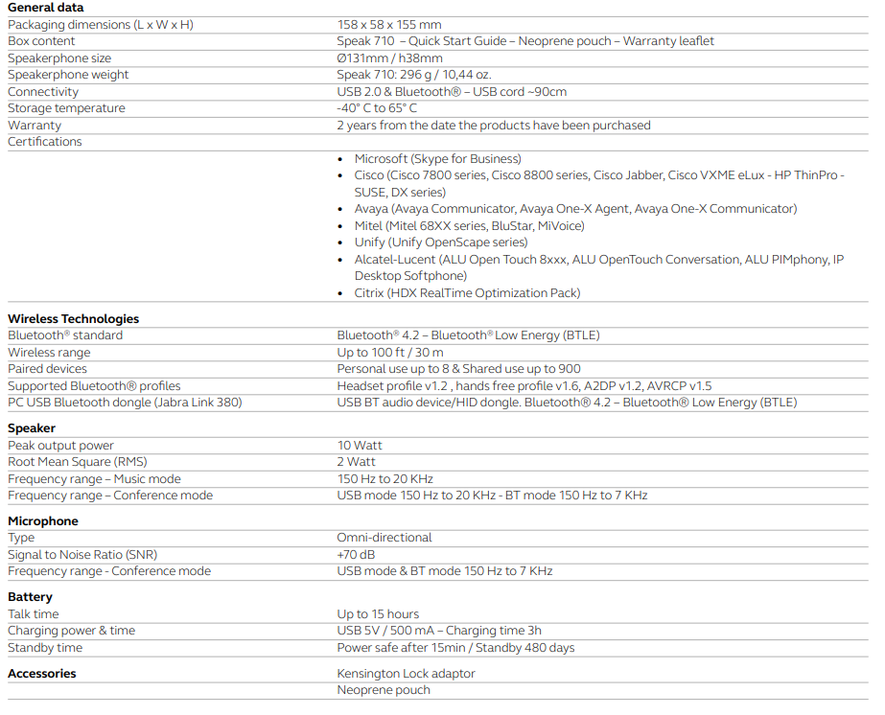 ***End***
Large (omni-directional microphone/speaker) | 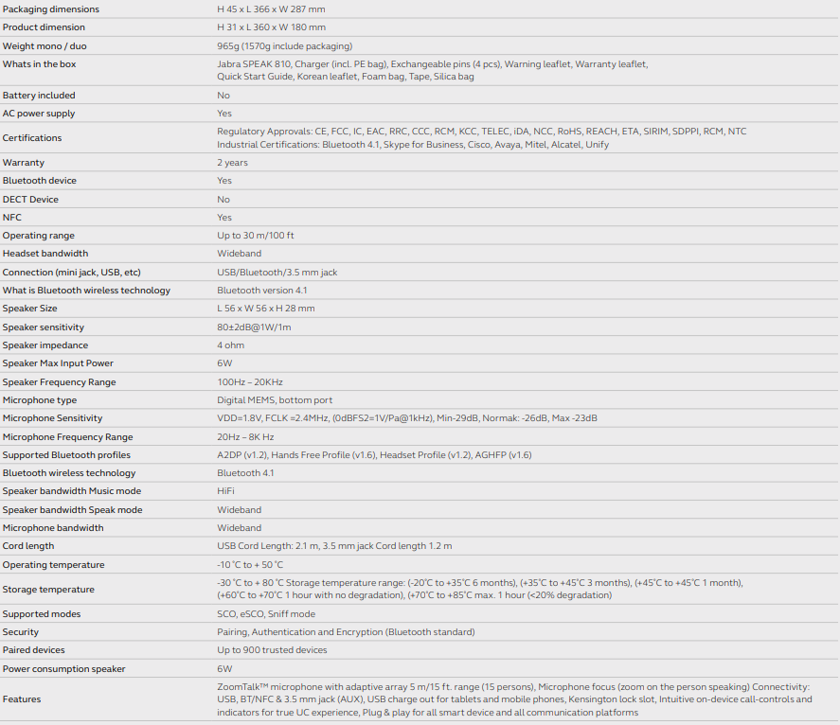 ***End***

LOT 4 - Security Devices and Licensing
*All prices must be comprehensive and include all other costs be expressed in Euro only and exclusive of VAT. The VAT rate(s) where applicable should be indicated separately.
Name | Details*
Mx 64W | Technical Specifications:  Network and Security Services  Stateful firewall, 1:1 NAT, DHCP, DMZ, static routing  Identity-based policies  Auto VPN™ self-configuring site-to-site VPN  Client VPN (IPsec)  User and device quarantine  VLAN support and DHCP services  Advanced Security Services  Content filtering (Webroot BrightCloud CIPA-compliant URL database)  Web search filtering (including Google and Bing SafeSearch)  YouTube for Schools  Intrusion prevention (SourceFire Snort based)  Cisco Advanced Malware Protection (AMP)  Requires Advanced Security License  WAN Performance Management  WAN link aggregation  Application level (Layer 7) traffic analysis and shaping  Automatic Layer 3 failover (including VPN connections)  WAN uplink selection based on traffic type  Monitoring and Management  Web based management and configuration  Throughput, connectivity monitoring and alerts  Network asset discovery and user identification  Built-in network-wide reporting, monitoring and alerts  Centralized policy management  Real-time diagnostic and troubleshooting over the web  Automatic firmware upgrades and security patches  Searchable network-wide event logs  Interfaces  WAN: 1 × 1 GbE  LAN: 4 × 1 GbE (1 optionally available for WAN connectivity)  Wireless: 802.11ac WiFi  USB: 1 × USB 2.0 for 3G/4G failover (supported devices)  Performance  Stateful firewall throughput: 250 Mbps  VPN throughput: 100 Mbps  Recommended for small branches (up to 50 users)  Power  Single 18W power supply  Environment  Operating temperature: 32°F to 104°F (0°C to 40°C)  Humidity: 5 to 95% non-condensing  Warranty  Lifetime hardware warranty with advanced replacement included  ***End***
Mx 64W license | 3 year license (advanced security)  ***End***
MX65W (small office, Up to 50 users with wireless included) | Technical Specifications:  Network and Security Services  Stateful firewall, 1:1 NAT, DHCP, DMZ, static routing  Identity-based policies  Auto VPN™ self-configuring site-to-site VPN  Client VPN (IPsec)  User and device quarantine  VLAN support and DHCP services  Advanced Security Services  Content filtering (Webroot BrightCloud CIPA-compliant URL database)  Web search filtering (including Google and Bing SafeSearch)  YouTube for Schools  Intrusion prevention (SourceFire Snort based)  Cisco Advanced Malware Protection (AMP)  Requires Advanced Security License  WAN Performance Management  WAN link aggregation  Application level (Layer 7) traffic analysis and shaping  Automatic Layer 3 failover (including VPN connections)  WAN uplink selection based on traffic type  Monitoring and Management  Web based management and configuration  Throughput, connectivity monitoring and alerts  Network asset discovery and user identification  Built-in network-wide reporting, monitoring and alerts  Centralized policy management  Real-time diagnostic and troubleshooting over the web  Automatic firmware upgrades and security patches  Searchable network-wide event logs  Interfaces  WAN: 2 × 1 GbE  LAN: 10 × 1 GbE (2 PoE+)  Wireless: 802.11ac WiFi  USB: 1 × USB 2.0 for 3G/4G failover (supported devices)  Performance  Stateful firewall throughput: 250 Mbps  VPN throughput: 100 Mbps  Recommended for small branches (up to 50 users)  Power  Single 90W power supply  Environment  Operating temperature: 32°F to 104°F (0°C to 40°C)  Humidity: 5 to 95% non-condensing  Warranty  Lifetime hardware warranty with advanced replacement included  ***End***
Mx 65W license | 3 year license (advanced security)  ***End***
Mx 85 Firewall (Medium office, Up to 250 users) | Meraki MX 85 Firewall  Technical Specifications:  Managed via Cisco Meraki Dashboard  Automatic Firmware upgrades  WAN Link Balancing  Automatic WAN Failover  SD-WAN over Meraki AutoVPN  L3/L7 Stateful Firewall  Geo based firewall rules  1:1 and 1:Many NAT  Configurable VLANs / DHCP support  Static Routing  Client VPN endpoint  Meraki AutoVPN and L2TP/IPSec VPN endpoint  Active Directory integration  Content Filtering  Malware Protection (AMP) w/ optional Threat Grid integration  IDS/IPS protection  Custom Traffic Shaping  Historical Client Usage statistics  Netflow support  Syslog integration  Remote Packet Capture tools  2 x 1 Gigabit Ethernet SFP ports dedicated for the WAN uplinks  1 x RJ45 / 1 Gigabit Ethernet port dedicated for the WAN uplinks  1 x RJ45 / 1 Gigabit Ethernet port with PoE+ capabilities dedicated for the WAN uplinks  8 x RJ45 / 1 Gigabit Ethernet LAN ports  2 x SFP / 1 Gigabit Ethernet LAN ports  1 x RJ45 dedicated management port for local status page access  1 x USB 3.0 port  ***End***
Mx 85 license | 3 year license (advanced security)  ***End***
UniFi Access Point U6 Lite (small office) | 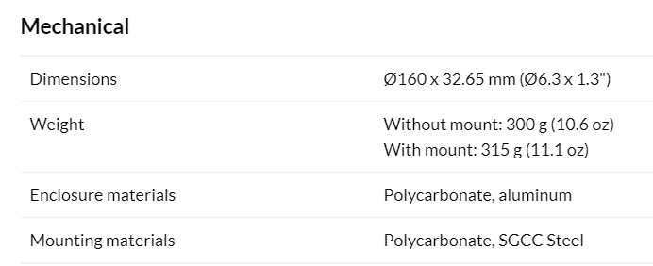  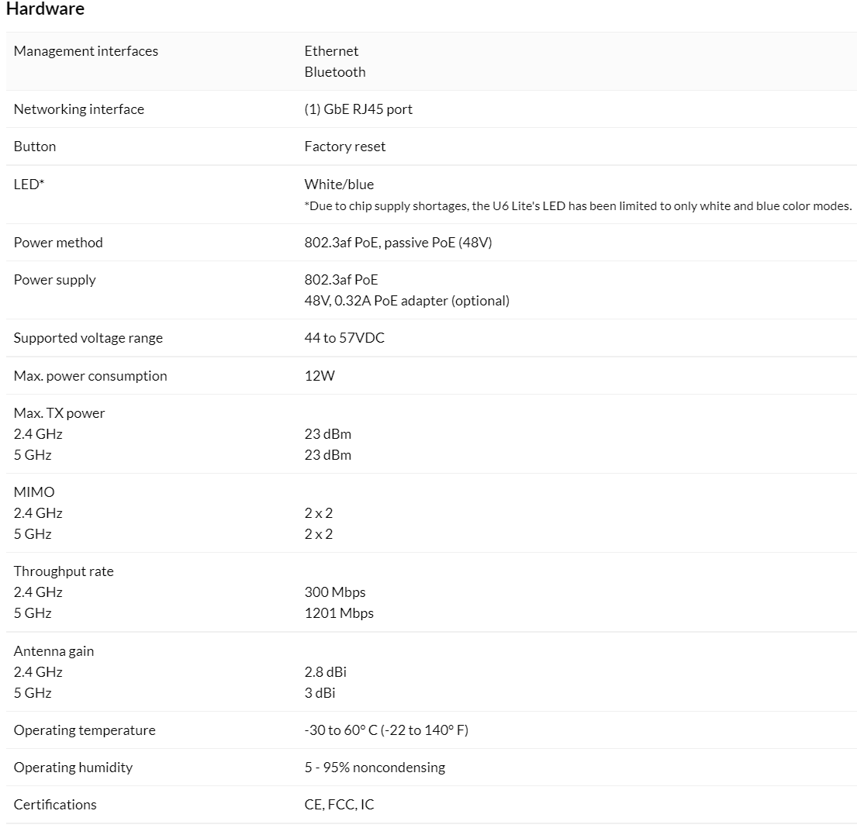  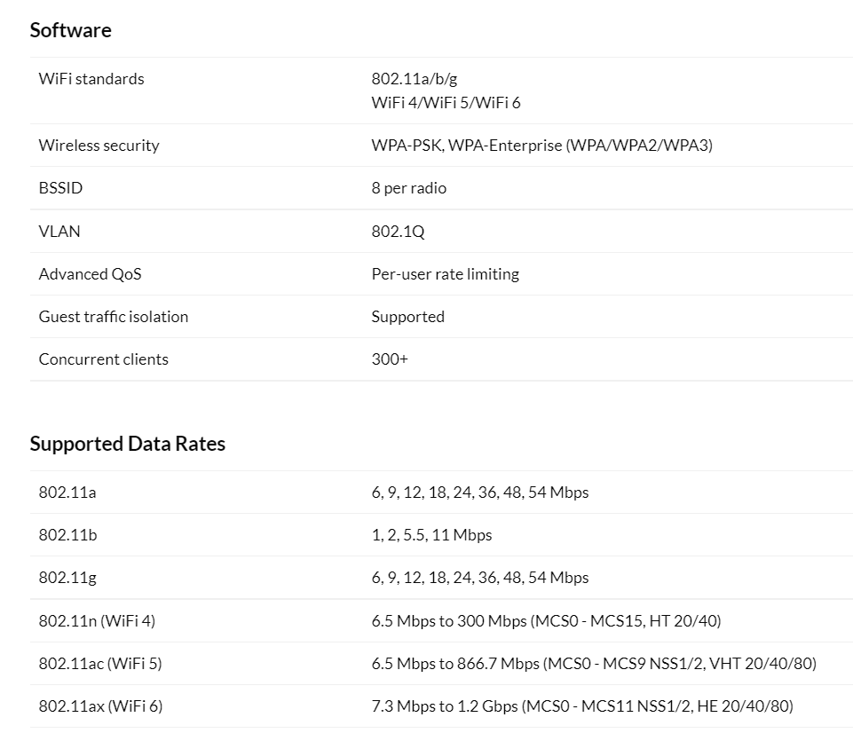
UniFi Access Point U6 Long range (medium office) | 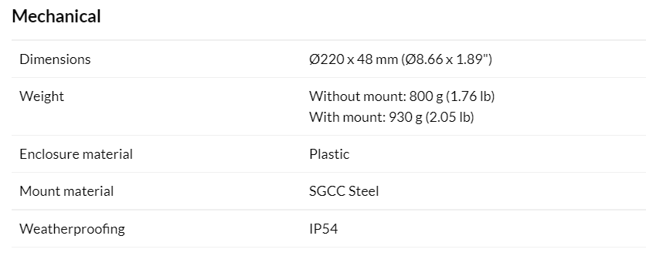  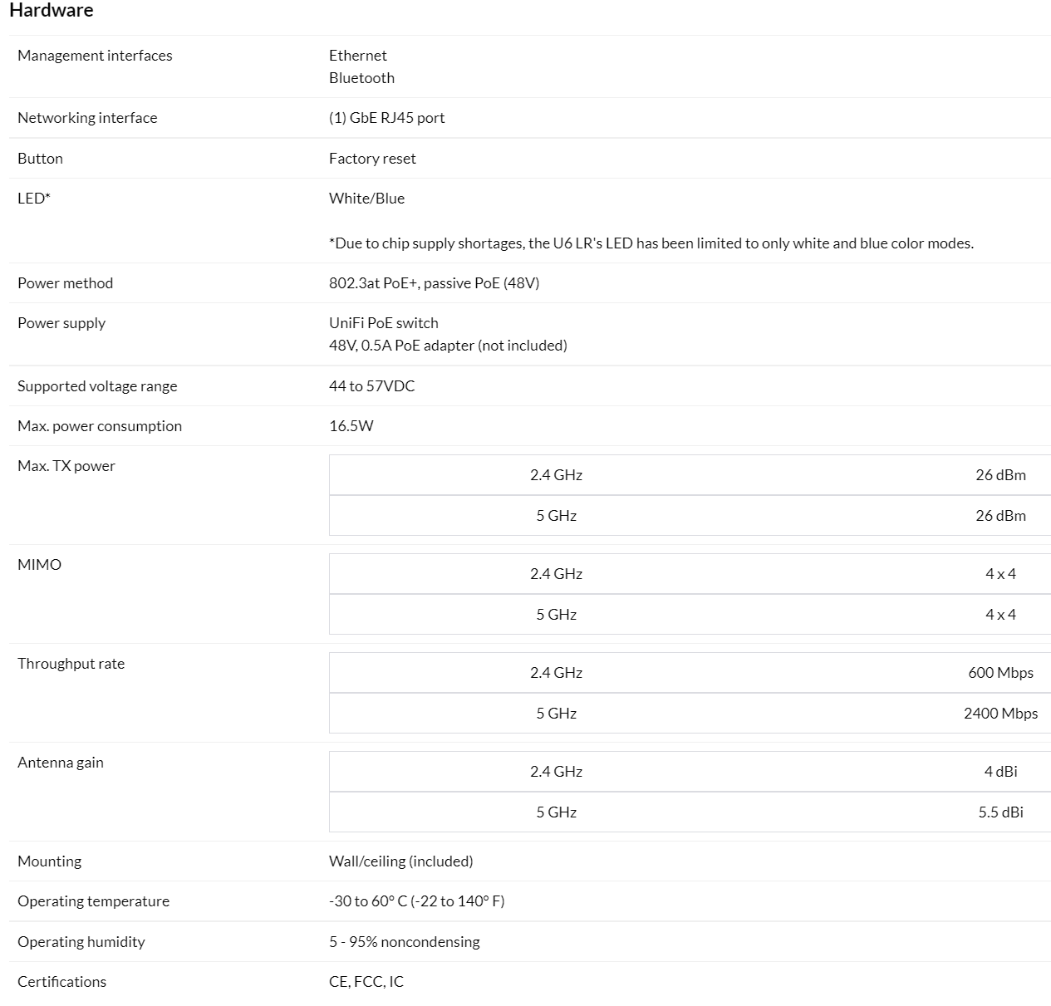  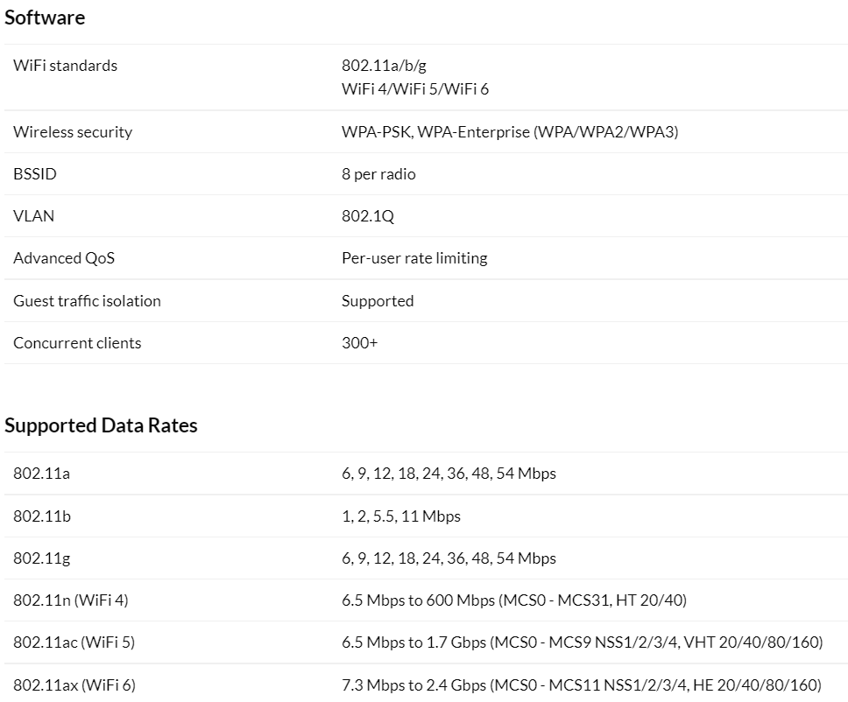

LOT 5 - IT infrastructure support services

Name | Details
Remote Senior Network Support Engineer - (Daily or hourly rate) | Remote Network support engineer with minimum 3 years of Network Infrastructure support in complex and challenging environment  Good Knowledge and troubleshooting skills of firewalling, switching and wifi on premise and in the cloud, including configuration of Azure services
Remote Senior Server Support Engineer - (Daily or hourly rate) | Remote Server support engineer with minimum 3 years of Server Infrastructure support in complex and challenging environment  Good knowledge and troubleshooting skills of latest windows servers on premise and in cloud, including configuration of Azure services
Remote Service Desk Support Engineer - (Daily or hourly rate) | Remote Service Desk Support with minimum 2 years experience of remote and desktop support of end users  Good knowledge and troubleshooting skills of Windows endpoints including commonly installed application like AV, office etc.

Signed: (Director) _________________________________________
Date: _________________________________________
Print Name: _________________________________________
Company Name: _________________________________________
Address: _________________________________________

