Appendix 1 - Company details

Contact Details
This section must include information regarding the individual or company and any partners or subcontractors:

Name of the Service Provider
Registered address of the Service Provider
Company Name
Address
Previous Name(s) if applicable
Registered Address if different from above
Company registration Number
Telephone
E-mail address
Website address
Year Established
Legal Form. Tick the relevant box | o Company  o Partnership |  | o Joint Venture  o Other (specify):
VAT/TVA/Tax Registration Number
Director's names and titles and any other key personnel
Please state name of any other persons/organisations (except Service Provider who will benefit from this contract (GOAL compliance matter)
Parent company
Ownership
Does Service Provider have associated companies? Tick relevant box. If YES – provide details for each company in the form of additional table as per Contact Details | oYes o No
 | Primary Contact | Secondary Contact
Name
Current Position in Service Providers organisation:
No. of years working with the Service Provider:
Email address
Telephone
Mobile
Other Relevant Skills:
Institution (Date from – to)
Degrees or Diplomas

Profile
Service Providers should note that the information requested below will be required under the Essential Criteria. In total the answers to these questions should take no more than two (2) pages.
No | Description | Response
1 | An outline of the scope of business activities, and in particular details of relevant experience regarding contracts of this nature.
2 | The number of years the Service Provider has been in business.
3 | Locations of the Laboratory Testing Facilities that will be used to deliver any resulting contract.
4 | Where the Service Provider proposes to use subcontractors or resellers/ distributors in the execution of the agreement, this section should include details of the quality assurance mechanisms used by the Service Provider to monitor the activities of its subcontractors or resellers/ distributors. Service Providers should note that commitment to quality, as evidenced by the existence of such quality control procedures, will be used as a Qualification Criteria.
5 | Any other relevant information.

References
At least two (2) relevant references who may be contacted on a confidential basis to verify satisfactory execution of contracts must be supplied. These references may not be GOAL personnel or related to a GOAL contract. Service Providers should supply this information for each of the references in the following format:
1 | Name
 | Organisation
 | Address
 | Phone
 | Fax
 | Email
 | Nature of Service / Supply
 | Approximate value of contract
2 | Name
 | Organisation
 | Address
 | Phone
 | Fax
 | Email
 | Nature of Service / Supply
 | Approximate value of contract
3 | Name
 | Organisation
 | Address
 | Phone
 | Fax
 | Email
 | Nature of Service / Supply
 | Approximate value of contract
4 | Name
 | Organisation
 | Address
 | Phone
 | Fax
 | Email
 | Nature of Service / Supply
 | Approximate value of contract

Appendix 2 - Declaration of Personal and Legal circumstances
THIS FORM MUST BE COMPLETED AND SIGNED BY A DULY AUTHORISED OFFICER OF THE SERVICE PROVIDER. Please tick Yes or No as appropriate to the following statements relating to the current status of your organisation |  |  | Yes | No
1 | The Service Provider is bankrupt or is being wound up or its affairs are being administered by the court or has entered into an arrangement with creditors or has suspended business activities or is in any analogous situation arising from a similar procedure under national laws and regulations.
2 | The Service Provider is the subject of proceedings for a declaration of bankruptcy, for an order for compulsory winding up or administration by the court or for an arrangement with creditors or of any other similar proceedings under national laws and regulations.
3 | The Service Provider, a director or partner, has been convicted of an offence concerning his professional conduct by a judgement which has the force of res judicata or been guilty of grave professional misconduct in the course of their business.
4 | The Service Provider has not fulfilled its obligations relating to the payment of taxes or social security contributions in Ireland or any other state in which the Service Provider is located.
5 | The Service Provider, a director or partner has been found guilty of fraud.
6 | The Service Provider, a director or partner has been found guilty of money laundering.
7 | The Service Provider, a director or partner has been found guilty of corruption.
8 | The Service Provider, a director or partner has been convicted of being a member of a criminal organisation.
9 | The Service Provider, a director or partner is under investigation, or has been sanctioned within the preceding three (3) years by any national authority of a United Nations Member State for engaging or having engaged in proscribed practices, including but not limited to: corruption, fraud, coercion, collusion, obstruction, or any other unethical practice.
10 | The Service Provider has been guilty of serious misrepresentation in providing information to a public buying agency.
11 | The Service Provider has contrived to misrepresent its Health & Safety information, Quality Assurance information, or any other information relevant to this application.
12 | The Service Provider has colluded between themselves and other bidders (a bidding ring), and/or the Service Provider has had improper contact or discussions with any member of GOAL staff and/or members of their family.
13 | The Service Provider is fully compliant with the minimum terms and conditions of the Employment Law and with all other relevant employment legislation, as well as all relevant Health & Safety Regulations in the countries of registration and operations.
14 | The Service Provider has procedures in place to ensure that subcontractors, if any are used for this contract, apply the same standards.
15 | The Service Provider will ensure during the term of any contract granted under the ITT that it will maintain appropriate policies in force with a reputable insurance company, and will, on GOAL’s request, produce a copy of the insurance certificate providing details of the cover and a copy of receipts for all premiums paid.
16 | Consistent with numerous United Nations Security Council resolutions including S/RES/1269 (1999), S/RES/1368 (2001) and S/RES/1373 (2001), GOAL is firmly committed to the international fight against terrorism, and in particular, against the financing of terrorism. It is the policy of GOAL to seek to ensure that none of its funds are used, directly or indirectly, to provide support to individuals or entities associated with terrorism. In accordance with this policy, the Service Provider undertakes to use all reasonable efforts to ensure that it does not provide support to individuals or entities associated with terrorism.
I certify that the information provided above is accurate and complete to the best of my knowledge and belief.
I understand that the provision of inaccurate or misleading information in this declaration may lead to my organisation being excluded from participation in future tenders.
Date
Name
Position
Telephone number
Signature and full name

Appendix 3 - Self declaration of finance and tax
Turnover History

Turnover figures entered in the table below must be the total sales value before any deductions.
‘Turnover of related products’ is for companies that provide items or services in multiple sectors. Please enter information on turnover of items or services that are similar in nature to the items or services requested under this ITT. Please indicate the currency.

Trading year | Total turnover
2021
2020
2019
Include a short narrative below to explain any trends year to year

GOAL operates within the law of the country of operation and within international legal requirements. GOAL expects all companies to fulfil their legal obligations, including meeting their tax liabilities and duties in accordance with the relevant tax legislation. Please comment below if you feel there are any matters you need to bring to GOAL’s attention.

Please continue on a separate sheet if necessary.

I certify that the information provided above is accurate and complete to the best of my knowledge and belief. I understand that the provision of inaccurate or misleading information in this declaration may lead to my organisation being excluded from participation in future tenders.
Signed (Director):

Print  name: |  | Date:
Company Name: |  | Company Stamp:

Appendix 4 – Certification / Accreditations / Licenses
Please supply copies of each certificate/license that you hold or provide.

Name of Certificate* | Purpose of Certificate |  | Date your Company received this Certificate | Date this Certificate expires | Comments from Company
ISO 9001 stated as ISO 9001:2015 online see https://www.iso.org/iso-9001-quality-management.html | Quality Management System Certificate | Submit a valid, up to date copy of this certificate
ISO 17025 stated as ISO/IEC 17025:2017 see https://www.iso.org/ISO-IEC-17025-testing-and-calibration-laboratories.html | ISO/IEC 17025 enables laboratories to demonstrate that they operate competently and generate valid results, thereby promoting confidence in their work both nationally and around the world. | Submit a valid, up to date copy of this certificate.
Certification from a TURKAK approved company (or equivalent if Service Providers Laboratory Testing facility is not based in Turkey) | Accreditation from any company that has itself been approved to perform inspections and certifications by the Turkish Accreditation Authority (TURKAK) | Submit a valid, up to date copy of this accreditation
Ministry of Agriculture Registration and Appropriate License (or equivalent if Service Providers Laboratory Testing facility is not based in Turkey) | - Establishment Permit  - Operation Permit  - Approved Operation List | Submit a valid, up to date copy of each registration and license.

APPENDIX 5 - Previous contracts

Quality and Delivery
The Testing Specification / Required Analysis & Methods included as Annex two (2) to this document are the World Food Programme (WFP) testing specifications. Please provide details below of contracts in chronological order starting with the most recent, for the provision of similar services.
Where possible GOAL would like to see evidence of previous contracts fulfilled for similar items in a humanitarian context. This can be redacted (edited) contracts or official documentation confirming fulfilment. GOAL also require a contact person from the organisation who can validate the delivery of the service.
Contract 1
Contract with (Organisation name)
Start and end date of contract
Food / Non-Food (Engine Oil) Items Tested
Value of contract
Lead Time from date of receipt of sample to provision of final report
Contact person to confirm contract details, include phone and email contact information.

Contract 2
Contract with (Organisation name)
Start and end date of contract
Food / Non-Food (Engine Oil) Items Tested
Value of contract
Lead Time from date of receipt of sample to provision of final report
Contact person to confirm contract details, include phone and email contact information

Contract 3
Contract with (Organisation name)
Start and end date of contract
Food / Non-Food (Engine Oil) Items Tested
Value of contract
Lead Time from Date of receipt of sample to provision of final report
Contact person to confirm contract details, include phone and email contact information.

APPENDIX 6 -Sample Reports
For GOAL to assess the quality of the Service Providers final reports, Service Providers are asked to submit a sample report demonstrating the Service Providers ability to meet the requirements listed in section 3.2 of this ITT. The sample report can be for any Food Item and must include a sample report for Engine Oil, as listed in Annex 1 of this ITT document but must be for an item that has not passed the testing protocols and a clear recommendation is shown. The sample report can be a redacted (edited) document, please attach as a separate PDF.

Appendix 7: Invitation to Tender (ITT) statement
Complete and return the following form ‘Invitation to Tender (ITT) Statement’ printed, signed and stamped

ITT STATEMENT
TO: [GOAL]
RE: ITT: ANT-X-30912 Invitation to Tender for Laboratory Testing Services for Food Items, including Fortified Wheat Flour and Dried Yeast & a Non-Food Item (Engine Oil)

Having examined all sections, appendices, and annexes to your Invitation to Tender (the “ITT”) we hereby agree and declare the following:
- We confirm we have fully reviewed and can fully meet the detailed Technical Testing Specifications included as Annexes 1 and 2 to this document.
- We accept all the Terms and Conditions of the ITT.
- We confirm our understanding that if successful, we will be commercially engaged under a GOAL Standard Form Contract and will be given time to review the Terms and Conditions contained within that contract.
- We confirm our understanding that we must meet a minimum Lead Time of fourteen (14) Calendar Days with Lead Time meaning Date from formal receipt of sample for testing to provision of final report to GOAL.
- We accept GOAL’s Supplier Code of Conduct.
- We accept all GOAL’s Policies.
- We confirm that we have the capability to satisfy the essential criteria listed for the ITT and ability to provide all required documentation.
- We confirm that GOAL can visit the Service Providers nominated testing facility and GOAL will notify the Service Provider one (1) week in advance of the site visit.
- We confirm the validity period of our ITT offer to be ninety (90) Days from date of submission.

Date:
Full Name:
Position:
Signature and company stamp:

APPENDIX 8 - Test Capability Statement
Food Items, including Fortified Wheat Flour and Dry Yeast & Non-food Item Engine Oil
No | Food Item | WFP required Number of Tests to be Performed as per Annex 1 to this ITT | Please enter a “Yes” below to confirm that you can complete all the tests required for food & non-food items as per Annex 2 (as per WFP Specifications), within a lead time of 14 Calendar Days. If the laboratory is unable to complete all tests required, please insert the number of tests that can be completed by the laboratory
1 | FORTIFIED WHEAT FLOUR | 12
2 | DRY YEAST | 12
3 | BULGUR | 19
4 | LENTIL (WHOLE & RED) | 16
5 | CHICKPEAS | 17
6 | TOMATO PASTE | 15
7 | OLIVE OIL | 18
8 | SUNFLOWER OIL | 15 (+ additional country specific test if required)
9 | CANNED TUNA | 20
10 | IODIZED SALT | 13
11 | VEGETABLE GHEE | 11
12 | CANNED CHICKEN | 10
13 | DRIED DATES | 16
14 | DRIED THYME | 19
15 | FRUIT JUICE | 17
16 | JAM | 7
17 | FAVA BEANS | 18
18 | CANNED VEGETABLES | 20
19 | ENGINE OIL | 12

Date:
Full Name:
Position:
Signature and company stamp:

Appendix 9: financial offer & Value-Added Questionnaire

No | Item to be tested | Number Of Tests to be Performed as per Annex 2 to the ITT. | Lead Time  (Number of calendar days from date of acceptance of sample to provision of final report to GOAL) Please insert number of days below | Price (USD)  (Total Price to complete all tests for - food items & Engine Oil) Please advise VAT if applicable to be included in final price | If it is not possible to complete all tests required as per Annex 2, please clarify the reason why the laboratory cannot complete all tests as per Annex 2.
1 | FORTIFIED WHEAT FLOUR | 12
2 | DRY YEAST | 12
3 | BULGUR | 19
4 | LENTIL (WHOLE & RED) | 16
5 | CHICKPEAS | 17
6 | TOMATO PASTE | 15
7 | OLIVE OIL | 18
8 | SUNFLOWER OIL | 15 (+ additional country specific test if required)
9 | CANNED TUNA | 20
10 | IODIZED SALT | 13
11 | VEGETABLE GHEE | 11
12 | CANNED CHICKEN | 10
13 | DRIED DATES | 16
14 | DRIED THYME | 19
15 | FRUIT JUICE | 17
16 | JAM | 7
17 | FAVA BEANS | 18
18 | CANNED VEGETABLES | 20
19 | ENGINE OIL | 12
Service Provider Name
Validity of Quote |  |  | 90 days
Name of Signatory
Company Stamp

Value Added Questionnaire
Question: | Answer:
1. Rush Test/Sample | Rush Test can be provided if required, please tick as appropriate. YES NO | Price in US Dollars $
Urgent courier service -fee indicated per rush test. Urgent courier service fee indicated per rush sample. Please indicate if this service cost differs from the quote provided above as per Annex 9.  2. Sample Reports can be provided in line with requirements listed in section 3.2 Scope of Work. Please tick YES or NO. YES Sample report attached | Sample Test can be provided if required, please tick as appropriate.  YES NO  NO Sample Report attached | Per Rush Test $ Per Sample Test $
3. Please list the qualifications, experience and proposed personnel who will be assigned to this contract and their positions in this contract using the template below, for example the Account Manager. Please replicate this table for each relevant key personnel. If additional information is being provided, please attach as 1 x A1 page as a separate PDF.
STANDARD PRESENTATION FORMAT

Proposed Position in the contract:
First Name(s):
Surname:
Third Level Education:

Institution (Date from – to) | Degrees or Diplomas
Other Relevant Skills:
Current Position in the Organisation:
No. of years working with the Organisation:
Proposed Position in the contract:
First Name(s):
Surname:
Third Level Education:

Institution (Date from – to) | Degrees or Diplomas
Other Relevant Skills:
Current Position in the Organisation:
No. of years working with the Organisation:

4. Additional services or functionality you can provide that may enhance your proposal – e.g., Seminar/Training Services/ Updates that will be offered to GOAL. Please outline or attach as 1 x A1 page in PDF format.

5. Any other information that may enhance your proposal - please outline below or attach as 1 x A1 page in PDF format.

Company Name
Name of Signatory
Company stamp

Annex 1- List of Commodities

1 | Fortified Wheat Flour Table 1
2 | Dry Yeast Table 2
3 | Bulgur Table 3
4 | Lentil (Whole & Red) Table 4
5 | Chickpeas Table 5
6 | Tomato Paste Table 6
7 | Olive Oil Table 7
8 | Sunflower Oil Table 8
9 | Canned Tuna Table 9
10 | Iodized Salt Table 10
11 | Vegetable Ghee Table 11
12 | Canned Chicken Table 12
13 | Dried Dates Table 13
14 | Dried Thyme Table 14
15 | Fruit Juice Table 15
16 | Jam Table 16
17 | Fava Beans Table 17
18 | Canned Vegetables Table 18
19 | Engine Oil Table 19

Annex 2 - Technical Specification Required for Analysis & Methods of Testing (WFP Specifications)
Please review the full WFP Technical Specifications included in this ITT as Annex 2:
Please note that to be considered for an individual Food Item or Non-food Item, the Service Provider must be able to perform all tests listed for that Food Items or Non-Food Item. For example, there are 12 tests listed for 1: Fortified Wheat Flour. The Service Provider must be able to perform all 12 Tests and must confirm this expressly as part of their tender submission. If the Service Provider is unable to complete all tests required, please insert the reason on Appendix 9- Financial Offer & Value-Added Questionnaire.
1: Fortified Wheat Flour
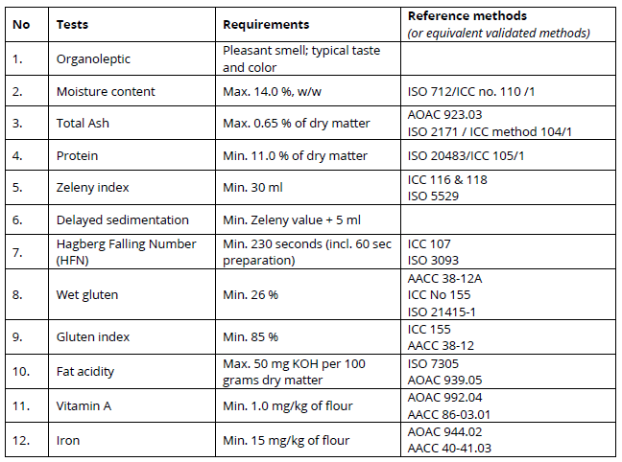

2: Dry Yeast
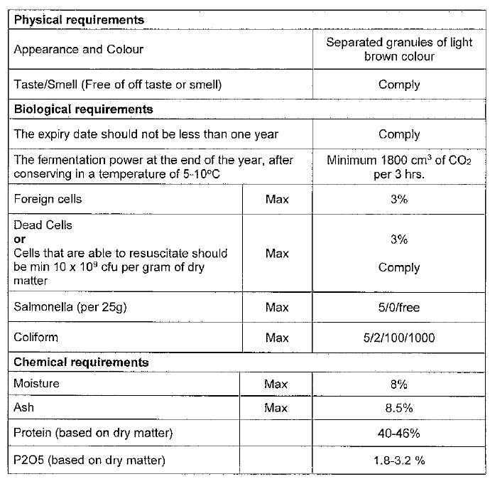

3: Bulgar
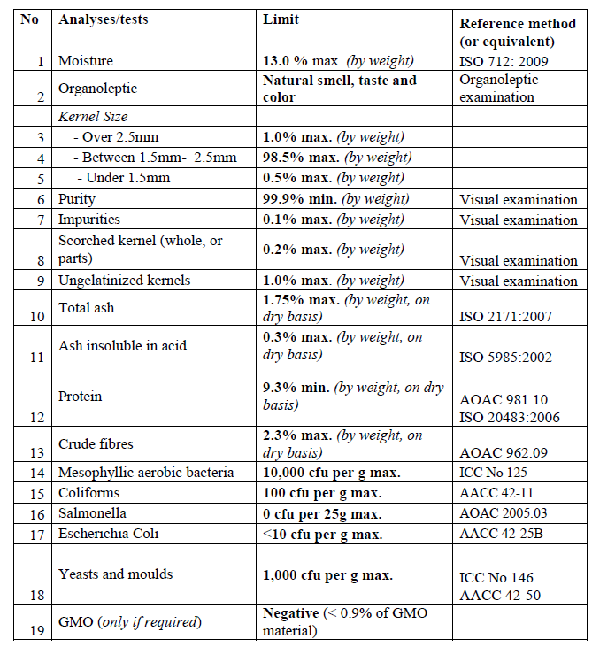

4: Lentil (Whole & Red)
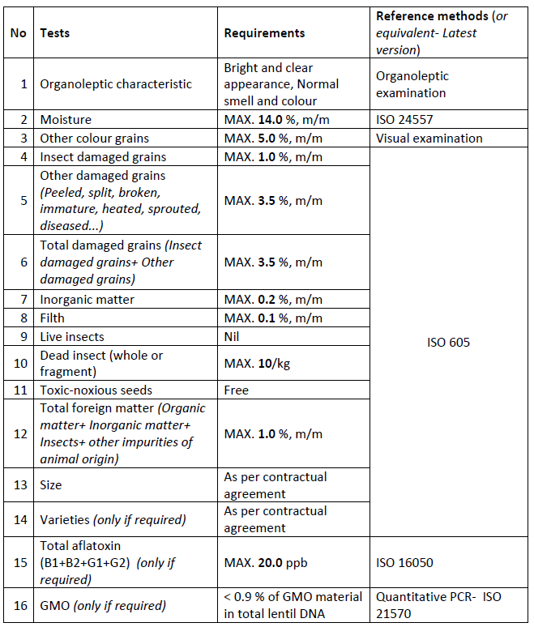

5: Chickpeas
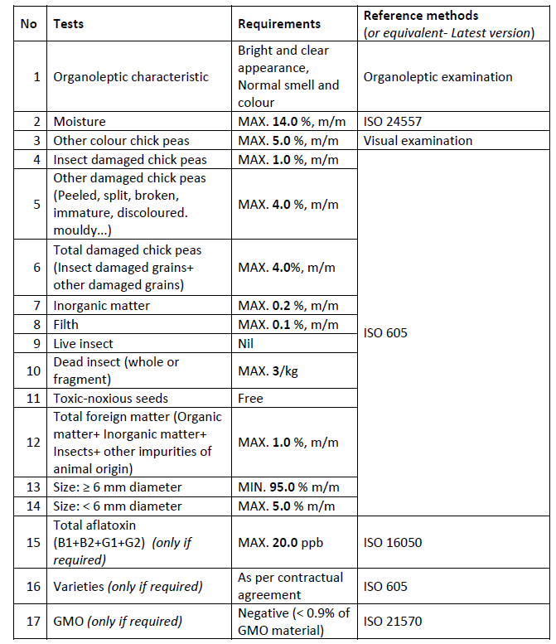

6: Tomato Paste
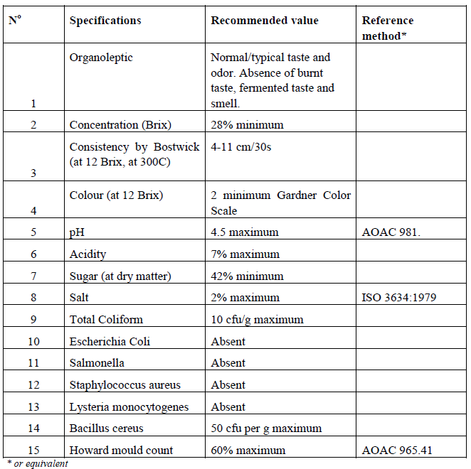

7: Olive Oil
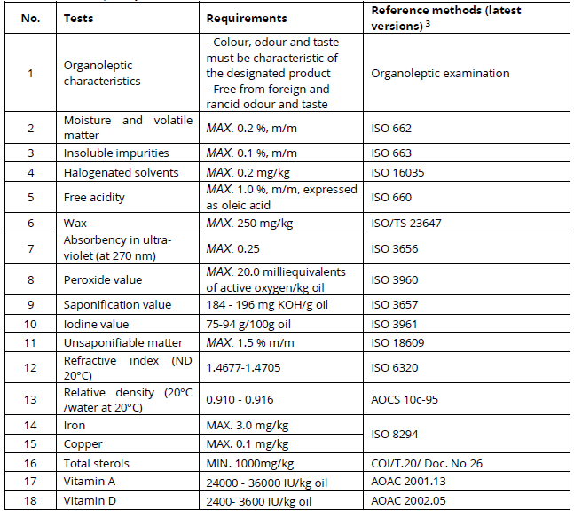

8: Sunflower Oil
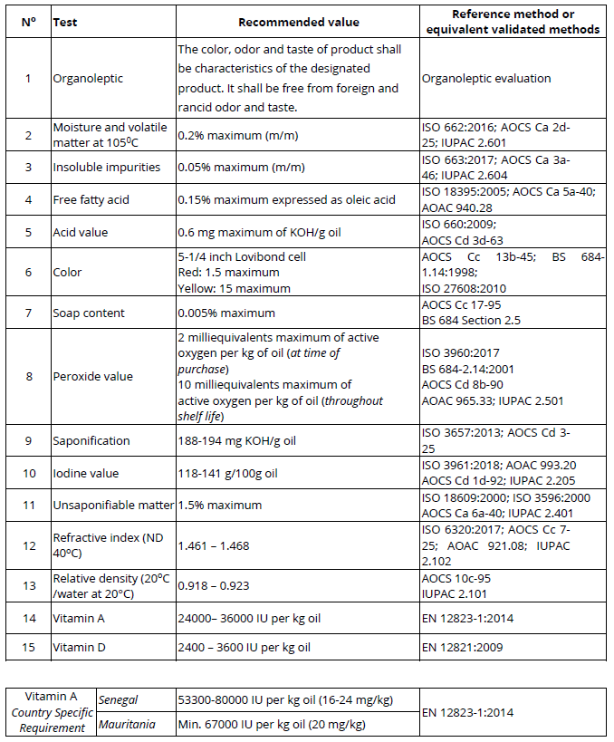

9: Canned Tuna
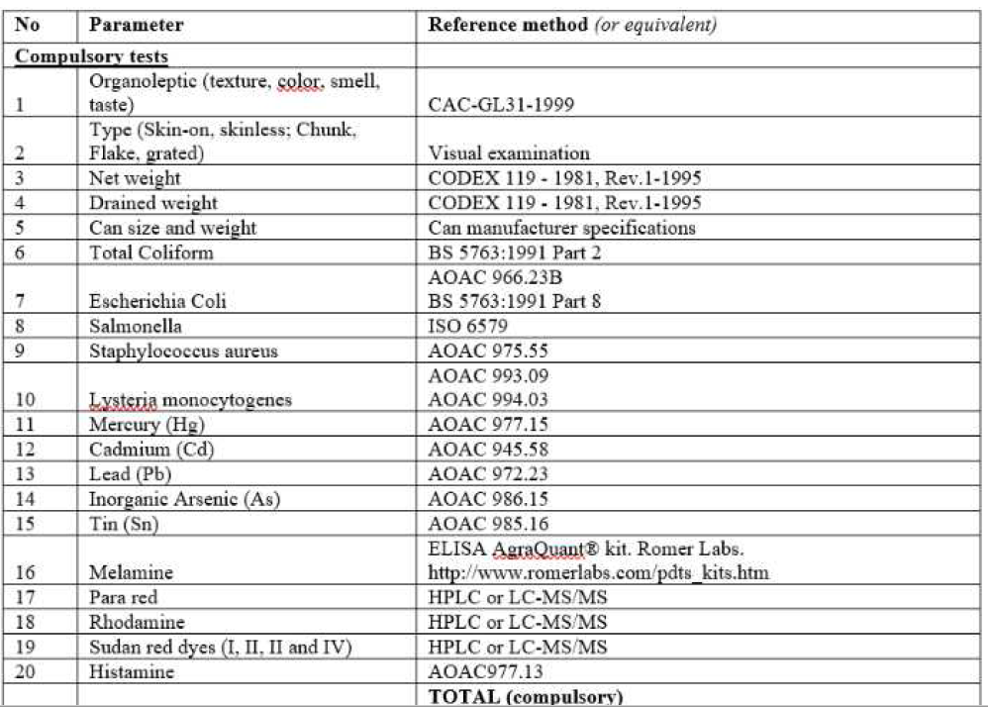

10: Iodized Salt
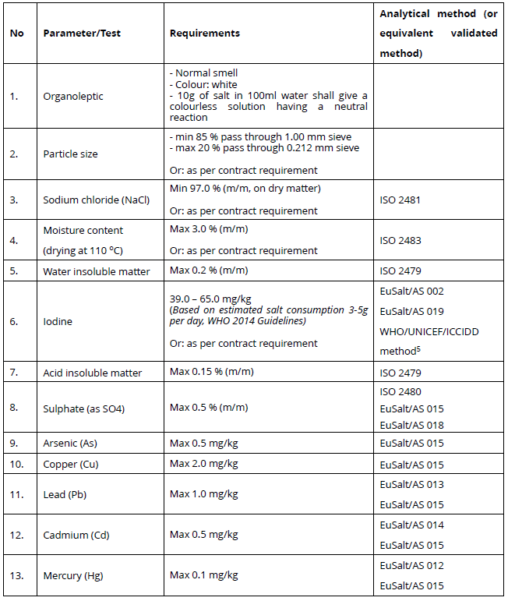

11: Vegetable Ghee
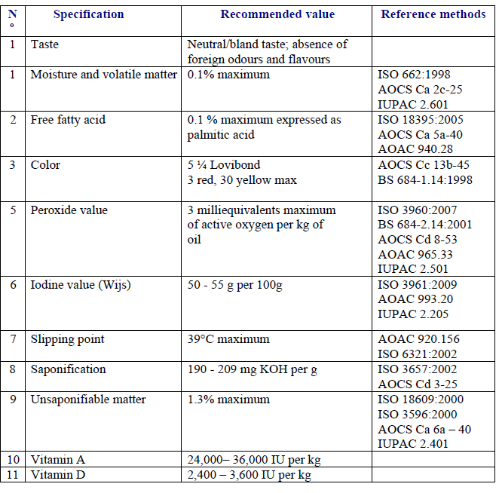

12: Canned Chicken
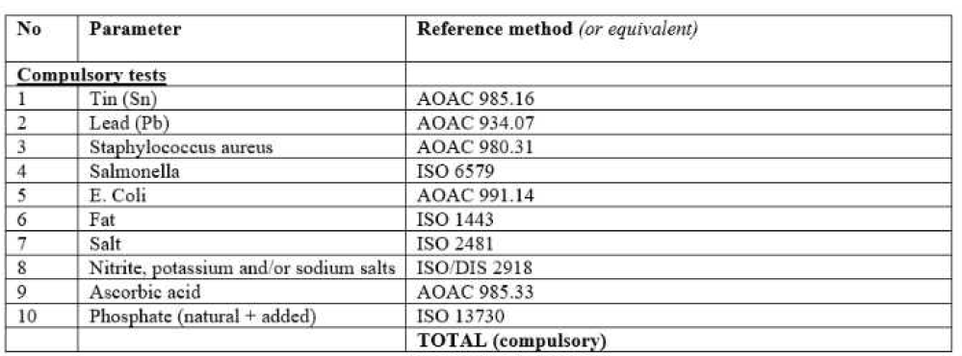

13: Dried Dates
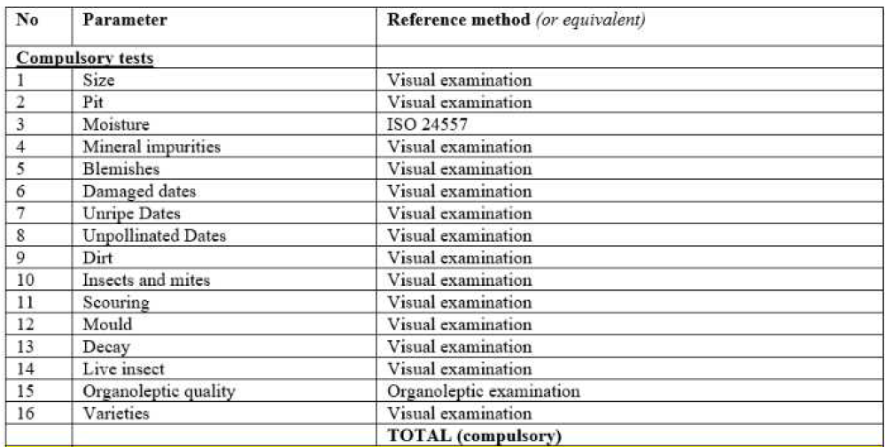

14: Dried Thyme
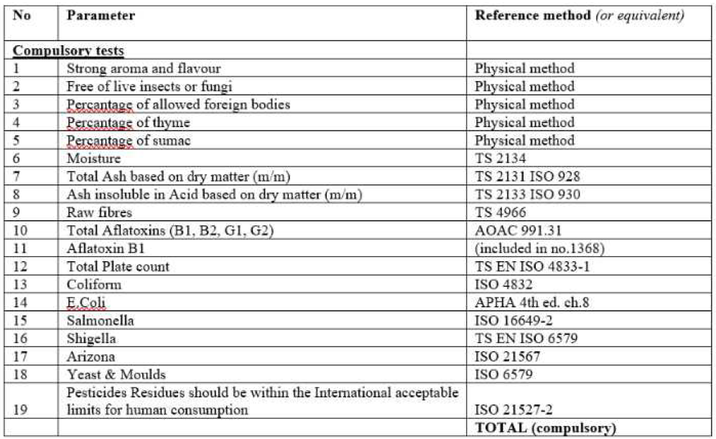

15: Fruit Juice
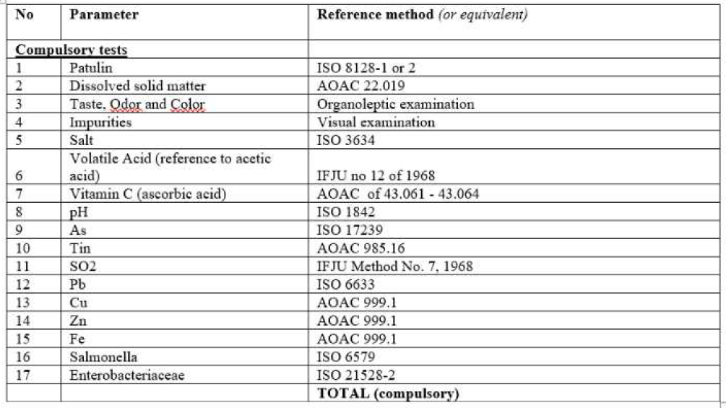

16: Jam
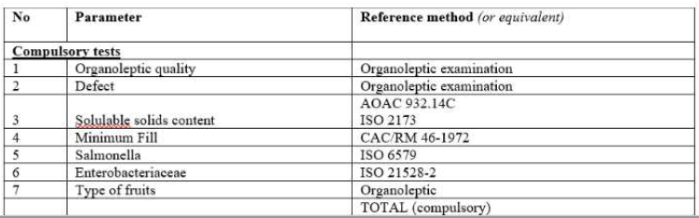

17: Canned Fava Beans
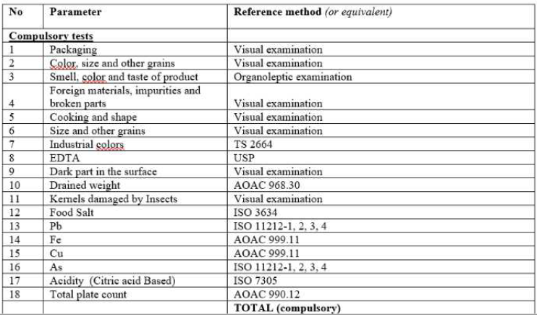

18: Canned Vegetables
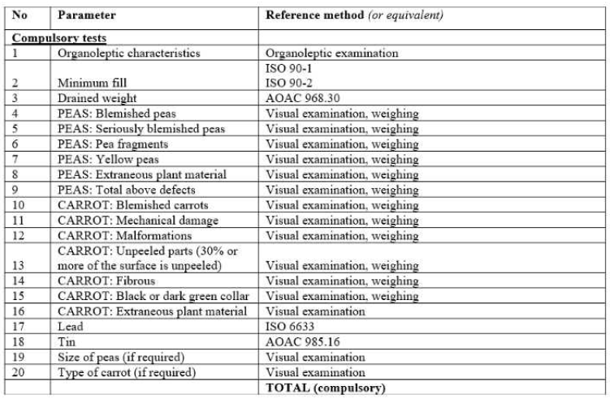

19: Engine Oil
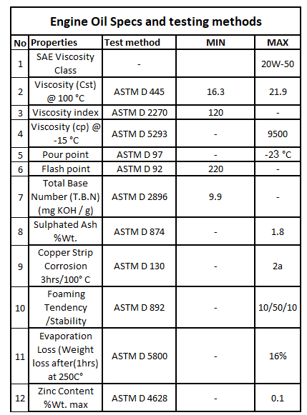

Annex 3 – Goal Standard Terms and Conditions
Attached as separate PDF

Annex 4 – GOAL Supplier Code of conduct
Attached as separate PDF

