

**Invitation to Tender (ITT) for the construction works of one Spring rehabilitation and pipeline expansion work, two boreholes rehabilitation and pipeline expansion works and four incinerators construction (Lot 1, Lot 2, Lot 3 and Lot 4****); in West Guji and Dollo Zones, Oromia, and Somali Regional States, respectively**

**REF: ORO-W-004201**

|  |
| --- |
| **GOAL is completely against fraud, bribery and corruption**  **GOAL does not ask for money for bids. If approached for money or other favours, of if you have any suspicions of attempted fraud, bribery or corruption please report immediately to email** [**speakup@goal.ie**](mailto:speakup@goal.ie)  **Please provide as much detail as possible with any reports** |

# About GOAL

Established in 1977, GOAL is an international humanitarian and development agency committed to working with communities to achieve sustainable and innovative early response in crises and to assist them to build lasting solutions to mitigate poverty and vulnerability. GOAL has worked in over 60 countries and responded to almost every major humanitarian disaster. We are currently operational in 13 countries globally. For more information on GOAL and its operations please visit <https://www.goalglobal.org/>tenders

GOAL has been working in Ethiopia since 1984, implementing a range of multi-sectoral development and humanitarian programmes responding to sudden-onset and protracted crises. Since 2017, GOAL has been one of the primary humanitarian agencies responding to the displacement crises in Ethiopia, operating a large-scale multi-sectoral response across more than 11 Zones in Oromiya, Somali, SNNP, Benishangul-Gumuz and Amhara. Interventions include: the treatment of acute malnutrition, mobile health activities, ensuring access to sanitation and water supply facilities, distribution of cash, shelter and non-food items, and psychosocial support.

GOAL Ethiopia supports several Water and Sanitation and Health (WASH) projects in various parts of the country providing clean water including small scale construction projects. One of our objectives is to enter into agreements with potential contractors to further strengthen the implementation of our WASH activities.

# Proposed Timelines

|  |  |  |
| --- | --- | --- |
| **Line** | **Item** | **Date** |
| 1 | ITT published | **11th October 2021** |
| 2 | Closing date for clarifications | **26th October 2021 at 04::00 PM East African Time (GMT+3)** |
| 3 | Closing date and time for receipt of Tenders | **1st November 2021 at 04:00 PM East African Time (GMT+3)** |
| 4 | Tender Opening Location | **Addis Ababa, GOAL Ethiopia Office** |
| 5 | Tender Opening Date and time | **02nd November 2021 at 09:00AM East African Time (GMT+3)** |

# 3. Overview of requirements

## Specification for Construction Works

GOAL Ethiopia, an International Humanitarian Organization, invites sealed bids from eligible bidders for the construction of one Spring Rehabilitation and Pipeline Expansion, two boreholes rehabilitation and pipeline expansion works and four incinerators construction (Lot 1, Lot 2, Lot 3 and Lot 4) all located in located in West Guji zone (Gelana and Abaya woredas) and Dollo zone (Warder, Bokh, Danot and Geladi woreda) in Oromia and Somali regions respectively.

These construction works are divided into four LOTS as follows:

|  |  |  |
| --- | --- | --- |
| **CODE** | **Summary of Main Activities** | **Location** |
| **LOT 1** | One borehole source rehabilitation and pipeline expansion work | **Gelana Woreda**   1. Tore kebele |
| **LOT 2** | One spring source rehabilitation and pipeline expansion work | **Abaya Woreda**   1. Bukissa Badiya kebele |
| **LOT 3** | One borehole source rehabilitation and pipeline expansion work | **Bokh Woreda**   1. Gobwayne kebele |
| **LOT 4** | Four incinerators construction | 1. Warder woreda 2. Bokh woreda 3. Danot woreda 4. Geladi woreda |

**Contractors must have Category GC/WWGC, six (6) & above** certifications to be eligible to bid on this tender. Prospective contractors must also be able to complete the construction works **within one hundred five (105) calendar days** and the winning bidder(s) will be required to enter to a contract agreement with GOAL Ethiopia. Contractors may bid for one, two, three, or all four LOTs but will be awarded a maximum of two LOTs. Contractor are expected to complete all construction works for the Lot/Lots awarded within 105 days of contract completion period.

## The service being offered must be in line with the following requirements

GOAL would like to see the following issues addressed in the response:

3.2.1 Technical proposal (completion of Appendix 2)

The bidder is required to show their methodology, equipment, personnel, work schedule, site visit certificate and attach related work experience in the technical offer document which will enable them to complete the works with efficiency. These include the following:

1. Schedule Form 1 (A for Lot 1 & 2 and B for Lot 3 & 4 depending on lots bid on) – Bidders Visit to Work Sites (SF1)
2. Schedule Form 2 - Summary of similar works carried out (SF2)
3. Schedule Form 3 (A for Lots 1 & 2 – B for Lots 3 & 4 – separate forms for each Lot) - Schedule of Intended Work Programme (SF3)
4. Schedule Form 4 (A for Lots 1 & 2 – B for Lots 3 & 4 – separate forms for each Lot) - Methodology of Work – one-page summary (SF4)
   * 1. Financial Proposal (completion of Appendix 3)

The bidder should fill in their price in the Bill of Quantities (BOQ) for each lot they are bidding for – as well as the summary costs using some of or all the following forms:

1. Summary of Bill of Quantities and Specifications for Lot 1 (Tore Kebele)
2. BOQ for Tore Kebele (Lot 1)
3. Summary of Bill of Quantities and Specifications for Lot 2 (Bukissa Badiya Kebele)
4. BOQ for Bukissa Badiya kebele (Lot 2)
5. Summary of BOQ for Lot 3 (Gobwayne kebele)
6. BOQ for Gobwayne kebele (Lot 3)
7. Summary of BOQ for Lot 4 (Warder, Bokh, Danot and Geladi woredas)
8. BOQ for Warder, Bokh, Danot and Geladi woredas (Lot 4)

3.2.3 All other documents submitted as per Section 6 of this document

# Terms of the Procurement

## Procurement Process

### This competition is being conducted under GOALs Invitation to Tender (ITT) Procedure.

### The Contracting Authority for this procurement is GOAL

### This procurement is funded by USAID/BHA and the tender and any contracts or agreements that may arise from it are bound by the regulations of that donor.

## Clarifications and Query Handling

### GOAL has taken care to be as clear as possible in the language and terms it has used in compiling this ITT. Where any ambiguity or confusion arises from the meaning or interpretation of any word or term used in this document or any other document relating to this tender, the meaning and interpretation attributed to that word or term by GOAL will be final. GOAL will not accept responsibility for any misunderstanding of this document or any others relating to this tender.

### Requests for additional information or clarifications can be made up to the deadline noted in section 2 above, and no later. Any queries about this ITT should be addressed in writing to GOAL via email on [clarifications@et.goal.ie](mailto:clarifications@et.goal.ie) until the **26th of October 2021 at 04::00 PM East African Time (GMT+3)**. Please include the reference number ORO-W-004201 and words “clarification required” in the subject liner.

## Conditions of Tender Submission

### Tenders must be completed in English.

### Tenders must respond to all requirements set out in this ITT and complete their offer in the Response Format.

### Failure to submit tenders in the required format will, in almost all circumstances, result in the rejection of the tender. Failure to resubmit a correctly formatted tender within 3 (three) working days of such a request will result in disqualification.

### Tenderers must disclose all relevant information to ensure that all tenders are fairly and legally evaluated. Additionally, tenderers must provide details of any implications they know or believe their response will have on the successful operation of the contract or on the normal day-to-day operations with GOAL. Any attempt to withhold any information that the tenderer knows to be relevant or to mislead GOAL and/or its evaluation team in any way will result in the disqualification of the tender.

### Tenders must detail all costs identified in this ITT in Ethiopian Birr (ETB). Additionally, tenders must detail any other costs whatsoever that could be incurred by GOAL in the usage of services and/or the availing of options that may not be explicitly identified/requested in this ITT. Tenderers’ attention is drawn to the fact that, in the event of a Contract/ Framework Agreement being awarded to them, the attempted imposition of undeclared costs will be considered a condition for default.

### Any conflicts of interest (including any family relations to GOAL staff) involving a tenderer must be fully disclosed to GOAL particularly where there is a conflict of interest in relation to any recommendations or proposals put forward by the tenderer.

### GOAL will not be liable in respect of any costs incurred by respondents in the preparation and submission of tenders or any associated work effort.

### GOAL will conduct this tender, including the evaluation of responses and final awards in accordance with the detail set out at in the Evaluation process. Tenders will be opened by at least three designated officers of GOAL.

### GOAL is not bound to accept the lowest, or any tender submitted.

### GOAL reserves the right to split the award of this contract between different bidders in any combination it deems appropriate, at its sole discretion.

### The Supplier shall seek written approval from GOAL before entering into any sub-contracts for the purpose of fulfilling this contract. Full details of the proposed subcontracting company and the nature of their services shall be included in the written request for approval. Written requests for approval must be submitted to GOAL.

### GOAL reserves the right to refuse any subcontractor that is proposed by the Supplier.

### GOAL reserves the right to negotiate with the Supplier who has submitted the lowest Bid that fully meets the technical requirements, for the purpose of seeking revisions of such Bid to enhance its technical aspects and/or to reduce the price.

### Information supplied by respondents will be treated as contractually binding. However, GOAL reserves the right to seek clarification or verification of any such information.

### GOAL reserves the right to terminate this competition at any stage.

### Unsuccessful tenderers will be notified.

### GOAL’s standard payment terms are by bank transfer within 30 days after satisfactory implementation and receipt of documents in order. Satisfactory implementation is decided solely by GOAL.

### This document is not construed in any way as an offer to contract.

### GOAL and all contracted suppliers must act in all its procurement and other activities in full compliance with donor requirements. Any contract(s) that arise from this ITT may be financed by multiple donors and those donors and/or their agents have rights of access to GOAL and/or any of its suppliers or contractors for audit purposes. These donors may also have additional regulations that it is not practical to list here. Submission of an offer under this ITT assumes Service Provider acceptance of these conditions.

### **Terrorism and Sanctions:** GOAL does not engage in transactions with any terrorist group or individual or entity involved with or associated with terrorism or individuals or entities that have active exclusion orders and/or sanctions against them. GOAL shall therefore not knowingly purchase supplies or services from companies that are associated in any way with terrorism and/or are the subject of any relevant international exclusion orders and/or sanctions. If you submit a bid based on this request, it shall constitute a guarantee that neither your company nor any affiliate or a subsidiary controlled by your company are associated with any known terrorist group or is/are the subject of any relevant international exclusion order and/or sanctions. A contract clause confirming this may be included in an eventual purchase order based on this request.

## Quality Control

3rd party companies may be contracted by GOAL to carry out random quality inspections of work carried out by the contracted party. The cost of the quality control inspections will be covered by GOAL.

In cases of supplier’s quality default, in addition to Liquidated Damages, section XVII of GOAL Standard Terms and Conditions, the costs of the quality inspections and loading surveyor will be charged to the Service Provider.

Sub-contracting: note section II in GOAL Standard Terms and Conditions. GOAL may choose to visit vendors, including sub-contractors (if any) as per of the evaluation process.

## Submission of Tenders

Tenders must be delivered in one of the following two ways:

1. Electronically with your financial and technical offers in separate emails to [tender@et.goal.ie](mailto:tender@goal.ie) and in the subject field state:
   1. ***ORO-W-004201 one Spring Rehabilitation and Pipeline Expansion, two boreholes rehabilitation and pipeline expansion work and four incinerators construction***
   2. ***Name of your firm with the title of the attachment***
   3. ***Number of emails that are sent e.g., 1 of 3, 2 of 3, 3 of 3.***

**All documents attached to emails must be in PDF or scan form. Any excel or word documents must be accompanied by a PDF or scan version of the document. Documents submitted solely in excel, word or other ‘soft copy’ format shall lead to the bid being rejected.**

1. If electronic bid submission is not possible, please submit in a sealed envelope marked:

***ORO-W-004201* one Spring Rehabilitation and Pipeline Expansion, two boreholes rehabilitation and pipeline expansion work and four incinerators construction – *not to be opened before*** *deadline* ***1st of November 2021 at 04:00 PM East African Time (GMT+3) by the tender committee’*** with all documents including your financial and technical offers to the Private Tender Box at:

**GOAL Ethiopia, Yeka Sub City, Woreda 9, H. No. 508 (Next compound to Kotebe Health Centre)  
P. O. Box 5504, TEL. 011-6-47-81-16/17, FAX 011-6-478118, Addis Ababa, Ethiopia.** The Bidder shall prepare two copies of the Bid, clearly marking each “Original Bid” and “Copy of Bid” as appropriate. In the event of any discrepancy between them, the original shall govern.

Envelopes may be sent through postal/courier services or delivered by hand; and will be accepted during normal working hours in GOAL Ethiopia (8:00AM – 4:30 PM). Please note that the GOAL office will not be open during weekends or public holidays.

* **All bids whether electronic or in hard copy should comprise all the documents requested in Section 6 of this ITT – a check list has been given to assist bidders in providing this complete application.**
* **Proof of sending is not proof of reception, either electronically or with post/courier/other physical service. Late delivery will result in your bid being rejected. Envelopes found open at the tender opening will be rejected. All information provided must be perfectly legible.**

## Tender Opening Meeting

Tenders will be opened as per Section 2 Proposed Timelines above at the following location:

**GOAL Ethiopia head office, Addis Ababa, Yeka Sub city, Woreda 9, H. No. 508, Next compound to Kotebe, Woreda 9 Health Centre.**

One **authorised representative** of each bidder may attend the opening of the bids. Companies wishing to attend are requested to notify their intention by sending an e-mail at least 48 hours in advance to the following e-mail address: [tender@et.goal.ie](mailto:tender@et.goal.ie). This notification must be signed by an authorised officer of the bidder and specify the name of the person who will attend the opening of the bids on the bidder's behalf.

Suppliers are invited to attend the Bid Opening Meeting at their own cost.

# Evaluation Process

## Evaluation stages

|  |  |  |
| --- | --- | --- |
| **Phase #** | **Evaluation Process Stage** | **The basic requirements with which proposals must comply with** |
| *The first phase of evaluation of the responses will determine whether the tender has been submitted in line with the administrative instructions and meets the essential criteria. Only those tenders meeting the essential criteria will go forward to the second phase of the evaluation.* | | |
| 1 | **Administrative instructions** | 1. **Closing Date:** Proposals must have met the deadline stated in section 2 of these Instructions to Tenderers, or such revised deadline as may be notified to Tenderers by GOAL. Tenderers must note that GOAL is prohibited from accepting any proposals after that deadline. 2. **Submission Method:** Proposals must be delivered in the method specified in section 4.5 of this document. GOAL will not accept responsibility for tenders delivered by any other method. Responses delivered in any other method may be rejected. 3. **Format and Structure of the Proposals:** Proposals must conform to the Response Format laid out in section 6 of these Instructions to Tenderers or such revised format and structure as may be notified to Tenderers by GOAL. **Failure to comply with the prescribed format and structure may result in your response being rejected at this stage.** 4. **Confirmation of validity of your proposal:** The Tenderers must confirm that the period of validity of their proposal is not less than 90 (ninety) days. |
| **2** | **Essential Criteria** | 1. **GC/WWGC, six (6) & above certificate,** for similar works type - certificate of competency should be attached. 2. Bid Security in the name of GOAL- Ethiopia from a recognized Bank, only in the form of CPO (certified payment order) amounting 1% of the bid offer for the works should be attached 3. Contractors shall attach at least one previous good work performance letter from GO/NGO in similar types of works in the past 3 years. 4. Adequacy and elaborated work plan (Implementation plan). Starting from agreement signed date. 5. Confirmation letter about the site visit by the bidder in the works area confirmed by GOAL Ethiopia, field office signature and stamp. |
| *The second stage of the evaluation will involve an assessment of the Tenderer’s personal and legal circumstances, economic and financial standing, to fulfil the obligations of the contract* | | |
| **3** | **Legal, Economic & Financial Criteria** | 1. Relevant and Valid licenses to operate in Ethiopia 2. VAT registration 3. Financial standing of company to complete contracts (financial stability) |
| *Each proposal that conforms to the Essential and Qualification Criteria will be evaluated according to the Award Criteria given below by GOAL.* | | |
| **4** | **Award Criteria** | Bids will be awarded marks under each of the award criteria listed in this section to determine the most economically advantageous bids.  Price (35%)  Technical/Quality (65%) determined by:   1. At least 1 previous work experience recommendation letter for completing 1 similar works in the last 3 years. for candidates that will submit more than 1 letter, depending on the number of letters, they will get extra points. 2. Adequacy of elaborated work plan (Implementation plan) 3. At least one page of Proposed Methodology for the works |
| **5** | **Post selection** | References and other checks are found to be clear and quality is assessed. |

Tenderers will be considered for participation in the Contract subject to the following qualification process:

## Tender Evaluation

GOAL will convene an evaluation team which may include members of the Finance, Logistics, Programmes, Donor Compliance and Internal Audit, as well as 3rd Party technical input.

During the evaluation period clarifications may be sought by e-mail from Tenderers. Clarifications may include testimonials from customers in support of aspects of a tender, whether such aspects are contained in the original submission or in subsequent responses to requests for clarification. Deadlines will be imposed for the receipt of such clarifications and failure to meet these deadlines may result in the disqualification of the Tender or loss of marks. Responses to requests for clarification shall not materially change any of the elements of the proposals submitted. Unsolicited communications from Tenderers will not be entertained during the evaluation period.

## Award Criteria

### Price

All prices must be in Ethiopian Birr (ETB) and a comprehensive and clear breakdown of prices must be shown as part of the financial offer – any transport fees, taxes, customs charges, component parts, packing fees etc. must be shown separately. In this ITT the prices offered in the BOQ forms provided constitute the financial offer.

Marks for cost will be awarded on the inverse proportion principle (shown below):

**Scorevendor =** **35 x (pricemin / pricevendor)**

Price accounts for 35% of the award criteria.

**All financial offers must be made on the basis of ‘best and final offer’.**

### Technical/Quality

The technical quality of received bids are determined through three main components as follows:

* 1. Contractors previous work experience from GO/NGO in similar types of works – primarily information from SF2 and any completion/competency certificates attached – and these may be verified by the evaluation team.
  2. Adequacy of elaborated work plan (Implementation plan) – completion of SF3 as well as verification of length of workplan and overall duration of project
  3. Proposed Methodology for the works – completion of SF4 – content analysis by the evaluation team of the one-page summary

Technical/quality assessments account for 65% of the award criteria.

### Summary of Award Criteria

|  |  |  |
| --- | --- | --- |
| **No** | **Qualitative award criteria** | **Weighting (maximum points)** |
| 1. | Price (from BOQ amounts) | 35 |
| 2. | Previous work Experience | 65 |
| 3. | Workplan (Timeline and order of works) |
| 4. | Methodology |
|  | **Total number of points** | **100** |

## Award of contract

As per section 4.3.10 above and following the analysis of bids against the award criteria laid out above in sections 5.1 and 5.3, contracts may be awarded to one supplier or divided between multiple suppliers at GOAL’s discretion. For such purposes, GOAL uses a Value for Money approach, which may include (but is not limited to) price, quality, lead time, context and risk analysis of the supply chain environment pertaining to the contract delivery.

# Response Format

## Introduction

All proposals must conform to the response format laid out below. Where a tender does not conform to the required format the Tenderer may be requested to resubmit it in the correct format, on the understanding that the resubmission cannot contain any material change from the original. Failure to resubmit in the correct format within 3 (three) working days may result in disqualification.

By responding to this ITT, each Tenderer is required to accept the terms and conditions of this ITT and to acknowledge and confirm their acceptance by returning a signed copy with its response. Should a Tenderer not comply with these requirements, GOAL may, at their sole discretion, reject the response.

If the Tenderer wishes to supplement their Response to any section of the ITT specifications with a reference to further supporting material, this reference must be clearly identified, including section and page number.

## Other Documents Required

### **Company Documents**

All submissions must be made with copies of the following documents included:

* Company Registration Certificate from trade & industry
* Trade Licence
* **only GC/WWGC, six (6) & above certificate** for similar works type - certificate.
* TIN Certificate
* VAT registration Certificate

This is so GOAL can ascertain that the company has legal and trading ability in Ethiopia.

### **Bid Security**

A bid bond in the form of CPO in the amount of 1% (one percent) of the total bid amount, valid for sixty (60) calendar days from the date of bid opening is required. The company must calculate the correct bid bond from its submission in the financial offer (BOQ completion). Any bid not accompanied by an acceptable bid security shall be rejected by GOAL as "non-responsive". If a bid security contains minor errors that require simple correction, GOAL may, at its sole discretion, allow the respective Bidder, via a written notice, a fixed time period within which the bid security may be corrected and re-submitted.

### **Audited Accounts**

Bidders need to submit an audited account regarding their past performance which details that the auditing is accomplished by certified accountants or mandated body to perform auditing. Audited accounts from 2018 and preferably 2017 in addition are required.

### **Appendices**

This is to remind all bidders that Appendix 1 needs to be completed IN FULL. Appendix 2 is your technical offer and relevant forms completed depending on the Lots the company has bid on – similarly with Appendix 3 as the Financial offer. Appendix 4 are the plans/drawings that must be followed. Appendix 5 Standard Terms and Conditions need to be initialled or signed and returned with your application.

## Submission Checklist

|  |  |  |  |  |
| --- | --- | --- | --- | --- |
| **Line** | **Item** | **How to submit** | | **Tick attached** |
| **Electronic submission** | **Physical submission** |  |
| 1 | This checklist | Ticked, scan and save as ‘Checklist’ | Tick and submit. |  |
| 2 | Company Details (appendix 1) – this includes Declaration of Finance and Tax | Complete, sign & stamp, scan and save as ‘Company Details’ | Complete, sign, stamp and submit. |  |
| 3 | Technical Offer (Appendix 2)  Comprising of: | Complete, sign & stamp, scan and save as ‘Technical Offer’ | Complete, sign, stamp and submit. |  |
| a) | SF1A Bidders site visit – Lots 1&2 | Complete, scan and save as individual forms (SF1A etc) OR scan all forms into one PDF and save as ‘Technical Offer Standard Forms’ | Complete and submit |  |
| b) | SF1B Bidders site visit – Lots 3&4 | Complete and submit |  |
| d) | SF2 Summary of executed Works | Complete and submit |  |
| e) | Comp Certificates/ Testimonies | Copy and submit |  |
| f) | SF3A Workplan – Lots 1&2 | Complete and submit |  |
| g) | SF3B Workplan – Lots 3&4 | Complete and submit |  |
| i) | SF4A Methodology – Lots 1&2 | Complete and submit |  |
| j) | SF4B Methodology – Lots 3&4 | Complete and submit |  |
| 4 | Financial Offer (Appendix 3) Comprising of: | Complete, sign & stamp, scan and save as ‘Financial Offer’ | Complete, sign, stamp and submit. |  |
| a) | Summary of Bill of Quantities and Specifications for Lot 1 (Tore kebele) | Complete, sign & stamp, scan and save as ‘BOQ Lot1’ | Complete, sign, stamp and submit. |  |
| b) | BOQ for Tore Kebele (Lot 1) |  |
| e) | Summary of Bill of Quantities and Specifications for Lot 2 (Bukissa Badiya kebele) |  |
| f) | BOQ for Bukissa Badiya kebele (Lot 2) |  |
| I) | Summary of BOQ for Lot 3 (Gobwayne kebele) | Complete, sign & stamp, scan and save as ‘BOQ Lot3’ | Complete, sign, stamp and submit. |  |
| j) | BOQ for Gobwayne kebele (Lot 3) |  |
| l) | Summary of BOQ for Lot 4 (warder, Bokh, Danot and Geladi woredas) | Complete, sign & stamp, scan and save as ‘BOQ Lot 4’ | Complete, sign, stamp and submit. |  |
| m) | BOQ for warder, Bokh, Danot and Geladi woredas (Lot 4) |  |
| 5 | GOAL Terms and Conditions (Appendix 5) signed | Sign, scan and save as ‘GOAL Terms and Conditions’ | Sign, stamp and submit. |  |
| 6 | 1% Bid Security in the name of GOAL- CPO only | Sign, scan and save as ‘Bid Security’ | Sign, stamp and submit. |  |
| 7 | Company Registration Certificate | Scan and save as ‘Com Reg Cert’ | Copy and submit |  |
| 8 | Trade Licence | Scan and save as ‘Trade Licence’ | Copy and submit |  |
| 9 | **only GC/WWGC, six (6) & above certificate** for similar works type – certificate. | Scan and save as ‘Works level Cert’ | Copy and submit |  |
| 10 | TIN Certificate | Scan and save as ‘TIN Cert’ | Copy and submit |  |
| 11 | VAT registration Certificate | Scan and save as ‘VAT Cert’ | Copy and submit |  |
| 12 | Copies of the last financial years’ AUDITED financial accounts (2020, 2019) | Attach copies of audited accounts and save as ‘Financial Accounts’ | Submit copies of audited accounts. |  |

# Appendix 1 – Company details

# Contact Details

This section must include the following information regarding the Individual or Company and any partners or sub-contractors:

|  |  |  |  |
| --- | --- | --- | --- |
| Name of the prime Tenderer |  | | |
| Registered address of the prime Tenderer |  | | |
| Company Name |  | | |
| Address |  | | |
| Previous Name(s) if applicable |  | | |
| Registered Address if different from above |  | | |
| Registration Number |  | | |
| Telephone |  | | |
| E-mail address |  | | |
| Website address |  | | |
| Year Established |  | | |
| Legal Form. Tick the relevant box | 🞏 Company  🞏 Partnership | | 🞏 Joint Venture  🞏 Other (specify): |
| VAT/TVA/Tax Registration Number |  | | |
| Directors names and titles and any other key personnel |  | | |
| Please state name of any other persons/organisations (except tenderer) who will benefit from this contract |  | | |
| Parent company |  | | |
| Ownership |  | | |
| Do you have associated companies? Tick relevant box. If YES – provide details for each company in the form of additional table as per **Contact Details** | 🞏Yes 🞏No | | |
|  | **Primary Contact** | **Secondary Contact** | |
| Name |  |  | |
| Current Position in the Organisation: |  |  | |
| No. of years working with the Organisation: |  |  | |
| Email address |  |  | |
| Telephone |  |  | |
| Mobile |  |  | |
| Other Relevant Skills: |  |  | |
| Institution (Date from – to) |  |  | |
| Degrees or Diplomas |  |  | |

## Professional or Corporate Memberships

These are with external professional bodies that your company is registered with (please note this is not the company/ business registration details). Please attach copies of any relevant certificates or memberships and use more lines if necessary:

|  |  |  |  |
| --- | --- | --- | --- |
| No | Name of the body | Year of registration | Membership Number |
| 1 |  |  |  |
| 2 |  |  |  |
| 3 |  |  |  |
| 4 |  |  |  |

## Profile

Tenderers should note that the information requested below will be required under the Essential Criteria. In total the answers to these questions should take no more than 2 pages

|  |  |  |  |
| --- | --- | --- | --- |
| **No** | **Description** | **Response** | |
| 1 | An outline of the scope of business activities, and in particular details of relevant experience regarding contracts of this nature |  | |
| 2 | Provide details of two contracts of a similar nature carried out in the last two years (please state customer name, delivery location, value of contract, and dates) |  | |
| 3 | The number of years the Tenderer has been in business in its present form |  | |
| 4 | A statement of overall turnover and turnover in respect to the goods and services offered under the proposed agreement for the last three years as per the following table: | | |
| **Year** | **Overall Turnover in Ethiopian Birr (ETB)** | **Offered of Similar Works Turnover in Ethiopian Birr (ETB)** |
| **2020** |  |  |
| **2019** |  |  |
| **2018** |  |  |
| 5 | Where the Supplier proposes to use subcontractors or resellers/ distributors in the execution of the agreement this section should include details of the quality assurance mechanisms used by the Supplier to monitor the activities of its subcontractors or resellers/ distributors. Suppliers should note that commitment to quality, as evidenced by the existence of such quality control procedures, will be used as a Qualification Criteria |  | |
| 6 | Any other relevant information |  | |
|  |  |  | |

## References

At least 2 (two) relevant references who may be contacted on a confidential basis to verify satisfactory execution of contracts must be supplied. These references may not be GOAL personnel or related to a GOAL contract. Respondents should supply this information for each of the references in the following format:

|  |  |  |
| --- | --- | --- |
| 1 | Name |  |
| Organisation |  |
| Address |  |
| Phone |  |
| Fax |  |
| Email |  |
| Nature of supply |  |
| Approximate value of contract |  |
| 2 | Name |  |
| Organisation |  |
| Address |  |
| Phone |  |
| Fax |  |
| Email |  |
| Nature of supply |  |
| Approximate value of contract |  |
| 3 | Name |  |
| Organisation |  |
| Address |  |
| Phone |  |
| Fax |  |
| Email |  |
| Nature of supply |  |
| Approximate value of contract |  |
| 4 | Name |  |
| Organisation |  |
| Address |  |
| Phone |  |
| Fax |  |
| Email |  |
| Nature of supply |  |
| Approximate value of contract |  |

By including the above information, tenderers confirm that they have consent from the data subject to share this information with GOAL for the purpose of providing a reference, to allow GOAL to analyse offers and award a contract under this tender; and that the data subject understands that the personal data may be shared internally within GOAL and externally if required by law and donor regulations; and may be stored for a period of up to 7 years from the award of contract.

# Declaration re Personal and Legal circumstances

|  |  |  |  |  |
| --- | --- | --- | --- | --- |
| THIS FORM MUST BE COMPLETED AND SIGNED BY A DULY AUTHORISED OFFICER OF THE TENDERERS’ ORGANISATION. Please tick Yes or No as appropriate to the following statements relating to the current status of your organisation | | | Yes | No |
| 1 | The Tenderer is bankrupt or is being wound up or its affairs are being administered by the court or has entered into an arrangement with creditors or has suspended business activities or is in any analogous situation arising from a similar procedure under national laws and regulations | |  |  |
| 2 | The Tenderer is the subject of proceedings for a declaration of bankruptcy, for an order for compulsory winding up or administration by the court or for an arrangement with creditors or of any other similar proceedings under national laws and regulations | |  |  |
| 3 | The Tenderer, a director or Partner, has been convicted of an offence concerning his professional conduct by a judgement which has the force of res judicata or been guilty of grave professional misconduct in the course of their business | |  |  |
| 4 | The Tenderer has not fulfilled its obligations relating to the payment of taxes or social security contributions in Ireland or any other State in which the tenderer is located | |  |  |
| 5 | The Tenderer, a director or Partner has been found guilty of fraud | |  |  |
| 6 | The Tenderer, a director or Partner has been found guilty of money laundering | |  |  |
| 7 | The Tenderer, a director or Partner has been found guilty of corruption | |  |  |
| 8 | The Tenderer, a director or Partner has been convicted of being a member of a criminal organisation | |  |  |
| 9 | The Tenderer, a director or Partner is under investigation, or has been sanctioned within the preceding three (3) years by any national authority of a United Nations Member State for engaging or having engaged in proscribed practices, including but not limited to: corruption, fraud, coercion, collusion, obstruction, or any other unethical practice. | |  |  |
| 10 | The Tenderer has been guilty of serious misrepresentation in providing information to a public buying agency | |  |  |
| 11 | The Tenderer has contrived to misrepresent its Health & Safety information, Quality Assurance information, or any other information relevant to this application | |  |  |
| 12 | The Tenderer has colluded between themselves and other bidders (a bidding ring), and/or the Tenderer has had improper contact or discussions with any member of GOAL staff and/or members of their family | |  |  |
| 13 | The Tenderer is fully compliant with the minimum terms and conditions of the Employment Law and with all other relevant employment legislation, as well as all relevant Health & Safety Regulations in the countries of registration and operations | |  |  |
| 14 | The Tenderer has procedures in place to ensure that subcontractors, if any are used for this contract, apply the same standards. | |  |  |
| 15 | Consistent with numerous United Nations Security Council resolutions including S/RES/1269 (1999), S/RES/1368 (2001) and S/RES/1373 (2001), GOAL is firmly committed to the international fight against terrorism, and in particular, against the financing of terrorism. It is the policy of GOAL to seek to ensure that none of its funds are used, directly or indirectly, to provide support to individuals or entities associated with terrorism. In accordance with this policy, **the Tenderer undertakes to use all reasonable efforts to ensure that it does not provide support to individuals or entities associated with terrorism.** | |  |  |
| I certify that the information provided above is accurate and complete to the best of my knowledge and belief.  I understand that the provision of inaccurate or misleading information in this declaration may lead to my organisation being excluded from participation in future tenders. | | | | |
| Date | |  | | |
| Name | |  | | |
| Position | |  | | |
| Telephone number | |  | | |
| Signature and full name | |  | | |

# self-declaration of finance and tax

|  |  |  |
| --- | --- | --- |
| **Turnover history** | | |
| **Turnover figures entered into the table must be the total sales value before any deductions**  ‘Turnover of related products’ is for companies that provide items or services in multiple sectors. Please enter information on turnover of items or services that are similar in nature to the items or services requested under this tender. | | |
| **Trading year** | **Total turnover** | **Turnover of related works** |
| **2020** |  |  |
| **2019** |  |  |
| **2018** |  |  |
| Include a short narrative below to explain any trends year to year | | |
|  | | |
| 1. **GOAL operates within the law of the country of operation and within international legal requirements. GOAL expects all companies to fulfil their legal obligations, including meeting their tax liabilities and duties in accordance with the relevant tax legislation. Please comment below if you feel there are any matters you need to bring to GOAL’s attention.** | | |
| *Please continue on a separate sheet if necessary.* | | |

I certify that the information provided above is accurate and complete to the best of my knowledge and belief. I understand that the provision of inaccurate or misleading information in this declaration may lead to my organisation being excluded from participation in future tenders.

Signed: (Director) _________________________________________

Date: _________________________________________

Print Name: _________________________________________

Company Name: _________________________________________

Address: _________________________________________

# Appendix 2 - Technical Offer

Name of Company: ______________________________________________

Indicate with YES/NO which LOTS the bid documentation is provided for:

|  |  |  |  |
| --- | --- | --- | --- |
| **CODE** | **Summary of Main Activities** | **Location** | **Yes/No** |
| **LOT 1** | One borehole source rehabilitation and pipeline expansion work | **Gelana Woreda**  Tore kebele |  |
| **LOT 2** | One spring source rehabilitation and pipeline expansion work | **Abaya Woreda**  Bukissa Badiya kebele |  |
| **LOT 3** | One borehole source rehabilitation and pipeline expansion work | **Bokh Woreda**   1. Gobwayne kebele |  |
| **LOT 4** | Four incinerators construction | 1. Warder woreda 2. Bokh woreda 3. Danot woreda 4. Geladi woreda |  |

“By submitted this offer, I confirm that all data subjects have specifically consented to the use and storage of their data by GOAL for the purpose of analysing the offers and awarding a contract under this bid; and further understood that the personal data may be shared internally within GOAL and externally if required by law and donor regulations; and may be stored for a period of up to 7 years from the award of contract.”

Signed: (Director) _________________________________________

Date: _________________________________________

Print Name: _________________________________________

Company Name: _________________________________________

Address: _________________________________________

**SCHEDULE OF FORMS (STANDARD FORMAT)**

**CERTIFICATE OF BIDDER’S VISIT TO THE WORK SITES**

**SCHEDULE FORM 1A [SF1A]**

**LOTs 1& 2**

One borehole source rehabilitation and pipeline expansion work and one spring source rehabilitation and pipeline expansion work in Gelana and Abaya woredas

| **No.** |  | Lot1 (Gelana Woreda) | Lot 2 (Abaya Woreda) |
| --- | --- | --- | --- |
| **1** | **Date/ Duration of Visit** |  |  |
| **2** | **Site (s) Visited** | 1. Tore kebele | 1. Bukissa Badiaya kebele |
| **3** | **Visitor’s Name (CONTRACTOR)**  **Name:**  **Signature:** |  |  |
| **4** | **Visitor’s Guide (Client/EMPLOYER)**  **Name:**  **Signature:**  **Stamp:** |  |  |
| **5.** | **Remarks** |  |  |

**Name of Bidder’s representative visiting site: ___________________________________**

**Signature: ___________________________________**

**Official Seal: _________________________________**

**DATE: ______________________________________**

**SCHEDULE OF FORMS (STANDARD FORMAT)**

**CERTIFICATE OF BIDDER’S VISIT TO THE WORK SITES**

**SCHEDULE FORM 1B [SF1B]**

**LOTs 3 & 4**

One borehole source rehabilitation and pipeline expansion work and four incinerators construction in Warder, Bokh, Danot and Geladi woredas

| **No.** |  | Lot3 (Bokh Woreda) | Lot 4 (Warder, Bokh, Danot and Geladi woredas) |
| --- | --- | --- | --- |
| **1** | **Date/ Duration of Visit** |  |  |
| **2** | **Site (s) Visited** | 1. Gobwayne kebele | 1. Warder woreda 2. Bokh woreda 3. Danot woreda 4. Geladi woreda |
| **3** | **Visitor’s Name (CONTRACTOR)**  **Name:**  **Signature:** |  |  |
| **4** | **Visitor’s Guide (Client/EMPLOYER)**  **Name:**  **Signature:**  **Stamp:** |  |  |
| **5.** | **Remarks** |  |  |

**Name of Bidder’s representative visiting site: ___________________________________**

**Signature: ___________________________________**

**Official Seal: _________________________________**

**DATE: ______________________________________**

**SUMMARY OF EXECUTED WORKS CARRIED OUT BY THE BIDDER**

**SCHEDULE FORM 2 [SF2]**

**For All Lots**

|  |  |  |  |  |  |  |  |
| --- | --- | --- | --- | --- | --- | --- | --- |
| NO. | Type of construction work | Employer/Client | Value of Contract  (in Birr) | Duration  (weeks) | Dates  (From-to) | Please put YES if the construction is done by your own company or NO if it is outsourced. | Reason for not the construction is done by your company/ Reason for outsourced. |
| 1 |  |  |  |  |  |  |  |
| 2 |  |  |  |  |  |  |  |
| 3 |  |  |  |  |  |  |  |
| 4 |  |  |  |  |  |  |  |
| 5 |  |  |  |  |  |  |  |

**Date:___________________________ Signature:_______________________**

**Company: _________________________Official Seal: _______________________**

Note: please attach your testimonies (Certificate of Work accomplishment)

SCHEDULE OF INTENDED WORK PROGRAM

**SCHEDULE FORM 3A [SF3A].**

**For Lots 1 and 2**

**Lot Number: 1 and 2 (use separate form if bidding on both lots)**

|  |  |  |  |  |  |  |  |  |  |  |  |  |  |  |  |  |  |
| --- | --- | --- | --- | --- | --- | --- | --- | --- | --- | --- | --- | --- | --- | --- | --- | --- | --- |
|  | **WORK ITEM** | **Duration in Days** | **Weeks** | | | | | | | | | | | | | | |
| **1** | **2** | **3** | **4** | **5** | **6** | **7** | **8** | **9** | **10** | **11** | **12** | **13** | **14** | **15** |
| **1** | **Advance processing, Site Handing over** |  |  |  |  |  |  |  |  |  |  |  |  |  |  |  |  |
| **2** | **Mobilization** |  |  |  |  |  |  |  |  |  |  |  |  |  |  |  |  |
| **3** | **Excavation and Earth work** |  |  |  |  |  |  |  |  |  |  |  |  |  |  |  |  |
| **4** | **Demolishing and disposal** |  |  |  |  |  |  |  |  |  |  |  |  |  |  |  |  |
| **5** | **Masonry work** |  |  |  |  |  |  |  |  |  |  |  |  |  |  |  |  |
| **6** | **Reinforcement and concrete work** |  |  |  |  |  |  |  |  |  |  |  |  |  |  |  |  |
| **7** | **Pipeline and plumbing works** |  |  |  |  |  |  |  |  |  |  |  |  |  |  |  |  |
| **8** | **Miscellaneous and finishing works** |  |  |  |  |  |  |  |  |  |  |  |  |  |  |  |  |
| **9** | **Handing Over** |  |  |  |  |  |  |  |  |  |  |  |  |  |  |  |  |

**Note: Use bars to fill chart**

**Based on the dates given in Section 2 of the ITT please estimate:**

|  |  |
| --- | --- |
| **how many days you need to sign a contract from the moment we announce that you are the winner** |  |
| **Earliest possible actual work commencement date** |  |
| **Time required for the execution of the WORKS** |  |

**Date of WORKS commencement is 2 days after ‘’order to commence’’ is received by the CONTRACTOR.**

**SIGNATURE: ____________________ OFFICIAL SEAL: _____________________**

**DATE: ____________________**

**SCHEDULE OF INTENDED WORK PROGRAM**

**SCHEDULE FORM 3B [SF3].**

**For Lots 3&4**

**Lot Number: 3 and 4 (use separate form if bidding on both lots)**

|  |  |  |  |  |  |  |  |  |  |  |  |  |  |  |  |  |  |
| --- | --- | --- | --- | --- | --- | --- | --- | --- | --- | --- | --- | --- | --- | --- | --- | --- | --- |
|  | **WORK ITEM** | **Duration in Days** | **Weeks** | | | | | | | | | | | | | | |
| **1** | **2** | **3** | **4** | **5** | **6** | **7** | **8** | **9** | **10** | **11** | **12** | **13** | **14** | **15** |
| **1** | **Advance processing, Site Handing over** |  |  |  |  |  |  |  |  |  |  |  |  |  |  |  |  |
| **2** | **Mobilization** |  |  |  |  |  |  |  |  |  |  |  |  |  |  |  |  |
| **3** | **Excavation and Earth work** |  |  |  |  |  |  |  |  |  |  |  |  |  |  |  |  |
| **4** | **Demolishing and disposal** |  |  |  |  |  |  |  |  |  |  |  |  |  |  |  |  |
| **5** | **Masonry work** |  |  |  |  |  |  |  |  |  |  |  |  |  |  |  |  |
| **6** | **Reinforcement and concrete work** |  |  |  |  |  |  |  |  |  |  |  |  |  |  |  |  |
| **7** | **Pipeline and plumbing works** |  |  |  |  |  |  |  |  |  |  |  |  |  |  |  |  |
| **8** | **Brick work** |  |  |  |  |  |  |  |  |  |  |  |  |  |  |  |  |
| **9** | **Miscellaneous and finishing works** |  |  |  |  |  |  |  |  |  |  |  |  |  |  |  |  |
| **10** | **Handing Over** |  |  |  |  |  |  |  |  |  |  |  |  |  |  |  |  |

**Note: Use bars to fill chart **

**Based on the dates given in Section 2 of the ITT please estimate:**

|  |  |
| --- | --- |
| **Earliest possible Contract signing date** |  |
| **Earliest possible actual work commencement date** |  |
| **Time required for the execution of the WORKS** |  |

**Date of WORKS commencement is 2 days after ‘’order to commence’’ is received by the CONTRACTOR.**

**SIGNATURE: ____________________ OFFICIAL SEAL: _____________________**

**DATE: ____________________**

**AT LEAST ONE PAGER METHODOLOGY OF WORK**

**SCHEDULE 4A[SF4A]**

**For Lots 1&2**

|  |
| --- |
|  |

**Date: ___________________________ Signature: ______________________**

**Official Seal: _______________________**

**AT LEAST ONE PAGER METHODOLOGY OF WORK**

**SCHEDULE 4B[SF4B]**

**For Lots 3&4**

|  |
| --- |
|  |

**Date: ___________________________ Signature: ______________________**

**Official Seal: _______________________**

# Appendix 3 - Financial Offer

**BILL OF QUANTITIES AND**

**SPECIFICATIONS**

**Summary of Bill of Quantities and Specifications for Lot 1, Tore kebele, Gelana woreda of West Guji zone for** **borehole source rehabilitation with pipeline expansion work project**

**Project Price Summary**

**Distribution and pressure pipeline work, ETB________________________**

**Elevated tanker seat construction, tanker supply and installation work, ETB_______________________________________________________________**

**Two Public Fountains construction work, ETB ________________________**

**Total for Gelana woreda borehole source rehabilitation and PEW (Lot 1), ETB _______________________________________________________________________**

**Rebate (____%), ETB ____________________________________________________**

**Total after Rebate, ETB _________________________________________________**

**15% VAT, ETB __________________________________________________________**

**Grand Total after Rebate and VAT for Gelana woreda (Lot 1), ETB ________________________________________________________________________**

|  |  |  |  |  |  |
| --- | --- | --- | --- | --- | --- |
| **A. Project Name: Tore borehole source rehabilitation and pipeline expansion work (Lot 1)**  **Title: Bill of Quantities and Specifications for borehole source rehabilitation and pipeline expansion**  **Location: Tore Kebele, Gelana woreda, West Guji zone**    **I. Distribution and pressure pipeline** | | | | | |
| **S/No** | **Description of Work** | **Unit** | **Qty** | **Unit rate** | **Total Amount** |
|  |
|  | **1. Excavation and Earth Work** |  |  |  |  |  |
| 1.1 | General clearance of site, along proposed transmission route to a width of max 2m of all bushes | M | 2300 |  |  |  |
| 1.2 | Trench excavation in normal soil formation to an average depth of 80cm and width of 60cm | M3 | 1104 |  |  |  |
| 1.3 | Backfill and compact all excavated materials | M3 | 1104 |  |  |  |
|  | **Sub Total (1)** | **Birr** |  |  |  |  |
|  | **2. Supply, join and laying of HDPE and class "B" GS pipe and fittings (For distribution and pressure lines)** |  |  |  |  |  |
| 2.1 | HDPE pipe, PN16 and OD 40mm | M | 300 |  |  |  |
| 2.2 | HDPE pipe, PN16 and OD 50mm | M | 2000 |  |  |  |
| 2.3 | HDPE male adapter with PN16 and OD 40mm | Pcs | 3 |  |  |  |
| 2.4 | HDPE male adapter with PN16 and OD 50mm | Pcs | 8 |  |  |  |
| 2.5 | HDPE female adapter with PN16 and OD 40mm | Pcs | 3 |  |  |  |
| 2.6 | HDPE female adapter with PN16 and OD 50mm | Pcs | 8 |  |  |  |
| 2.7 | Supply and install HDPE fitting-elbow, PN16, 40mm | Pcs | 4 |  |  |  |
| 2.8 | Supply and install HDPE fitting-elbow, PN16, 50mm | Pcs | 6 |  |  |  |
| 2.9 | Supply and install HDPE socket, PN16, 40mm | Pcs | 4 |  |  |  |
| 2.10 | Supply and install HDPE socket, PN16, 50mm | Pcs | 6 |  |  |  |
| 2.11 | Supply and install HDPE tee, PN16, 40mm | Pcs | 3 |  |  |  |
| 2.12 | Supply and install HDPE tee, PN16, 50mm | Pcs | 6 |  |  |  |
| 2.13 | Supply and install HDPE reducer, PN16, 63mm - 50mm | Pcs | 3 |  |  |  |
| 2.14 | Supply and install HDPE reducer, PN16, 50mm-40mm | Pcs | 4 |  |  |  |
| 2.15 | Supply and install 1 1/2 " class "B" GS pipes | M | 300 |  |  |  |
| 2.16 | Supply and install 3/4 " class "B" GS pipes | M | 6 |  |  |  |
|  | **2.17 Class "B" GS fittings** |  |  |  |  |  |
| 2.17.1 | Union 1 1/ 2 ’’ | Pcs | 6 |  |  |  |
| 2.17.2 | Gate Valve 1 1/2 ’’ | Pcs | 3 |  |  |  |
| 2.17.3 | Elbow 90 1 1/2" | Pcs | 2 |  |  |  |
| 2.17.4 | Tee 1 1/2" | Pcs | 4 |  |  |  |
| 2.17.5 | Nipples 1 1/2 ’’ | Pcs | 12 |  |  |  |
| 2.17.6 | Reducer 2"-1 1/2" | Pcs | 4 |  |  |  |
| **S/ No** | **Description of Work** | **Unit** | **Qty** | **Unit Rate** | **Total Amount** |  |
| 2.17.7 | Reducer 1 1/2"-3/4" | Pcs | 4 |  |  |  |
| 2.17.8 | 3/4" faucet for the tap at health facility | Pcs | 1 |  |  |  |
|  | **Sub Total (2)** | **Birr** |  |  |  |  |
|  | **Total for distribution and pressure pipeline without VAT** | **Birr** |  |  |  |  |
|  | | | | | |  |
|  | | | | | |  |
| **II. Elevated tanker seat construction, tanker supply and installation** | | | | | |  |
|  | | | | | |  |
| **S/ No** | **Description of Work** | **Unit** | **Qty** | **Unit Rate** | **Total Amount** |  |
|  | **1. Excavation and Earth Work** |  |  |  |  |  |
| 1.1 | Site clearing up to a depth of 20 cm to remove the top vegetative soil | M2 | 7 |  |  |  |
| 1.2 | Pit excavation for footing up to 1.5m from the reduced level. | M3 | 17.4 |  |  |  |
| 1.3 | Back fill with granular material from quarry | M3 | 1.7 |  |  |  |
| 1.4 | Cart away surplus excavated materials | M3 | 17.1 |  |  |  |
|  | **Sub Total (1)** | **Birr** |  |  |  |  |
|  | **2. Masonry Work** |  |  |  |  |  |
| 2.1 | 25cm thick hard-core filling, well rolled and consolidated with crushed stone | M3 | 1.6 |  |  |  |
| 2.2 | 40 cm thick basaltic or trachytic stone masonry bedded with (1:3) mortar above ground level | M3 | 2.4 |  |  |  |
|  | **Sub Total (2)** | **Birr** |  |  |  |  |
|  | **3. Concrete Work** |  |  |  |  |  |
| 3.1 | 5cm thick lean concrete (1:3:6) for footing |  |  |  |  |  |
|  | A) Under footing | M2 | 1.96 |  |  |  |
|  | B) Under masonry wall | M2 | 3.2 |  |  |  |
| 3.2 | 30 cm thick RCC (1:2:4) footing | M3 | 2.52 |  |  |  |
| 3.3 | 20cm X 20cm reinforced concrete for four horizontal beam constructions for tying the six columns with a concrete quality of C-20, 1:2:4 | M3 | 3.2 |  |  |  |
| 3.4 | Six (30cm X 30cm) reinforced concrete for columns construction with a concrete quality of C-20, 1:2:4 | M3 | 3.24 |  |  |  |
| 3.5 | 20cm thick reinforced concrete for suspended slab construction with a concrete quality of C-20, 1:2:4 | M3 | 4.08 |  |  |  |
| 3.6 | Provide steel reinforcement according to drawing (C/C 15cm) cut, bend & placed in position, unit price shall include cutting, bending, and placing in position & tying wires |  |  |  |  |  |
|  | a) Ø 14 mm deformed bar | Kg | 308.63 |  |  |  |
|  | b) Ø 12 mm deformed bar | Kg | 186.93 |  |  |  |
|  | c) Ø 10 mm deformed bar | Kg | 347.99 |  |  |  |
|  | d) Ø 6 mm plain bar | Kg | 80 |  |  |  |
| **S/ No** | **Description of Work** | **Unit** | **Qty** | **Unit Rate** | **Total Amount** |  |
| 3.7 | Provide, Cut and fix in position sawn zigba formwork or equivalent |  |  |  |  |  |
|  | a) For footing pads | M2 | 2.44 |  |  |  |
|  | b) For footing columns | M2 | 43.2 |  |  |  |
|  | c) For grade beams | M2 | 48 |  |  |  |
|  | d) For Suspended slab | M2 | 22 |  |  |  |
|  | **Sub Total (3)** | **Birr** |  |  |  |  |
|  | **4. Finishing Work** |  |  |  |  |  |
| 4.1 | 3 cm thick cement screed over the RCC slab | M2 | 22 |  |  |  |
| 4.2 | Ditto, but plastering for the columns | M2 | 43.2 |  |  |  |
| 4.3 | Ditto, but plastering for the beams | M2 | 56 |  |  |  |
|  | **Sub Total (4)** | **Birr** |  |  |  |  |
|  | **5. Supply and installation of fibre glass tanker** |  |  |  |  |  |
| 5.1 | Provide and fix 25,000 lit capacity horizontal fibre glass water tank of good quality as approved by the site engineer. Price includes all the required accessories and all plumbing works. Use a crane or appropriate lifting mechanism to install the tanker | Pcs | 1 |  |  |  |
| 5.2 | Install & fix all necessary 1" class "B" GS pipes & fittings with all necessary accessories, gate valves, float Valves asper the drawings and site engineer. Price includes fixing In-let, out-let, Vent pipe, drainpipes, & over-flow system of the tanker | Ls | 1 |  |  |  |
| 5.3 | Construct a hollow concrete block manhole, supply & install lockable steel manhole cover with all fixing hinges & accessories with lock gate | No | 1 |  |  |  |
| 5.4 | Supply and install an external ladder made of class "B" G S Pipe of DN 25 mm length 6 m having extra 1.0 m high handle at the top for external Ladder | No | 1 |  |  |  |
| 5.5 | Install and fix quality water meter DN 80 mm at the outlet of the tanker with appropriate fittings and gate Valve | No | 1 |  |  |  |
|  | **Sub Total (5)** | **Birr** |  |  |  |  |
|  | **Total for elevated tanker seat, tanker supply and installation without VAT** | **Birr** |  |  |  |  |
|  |  |  |  |  |  |  |
| 1. **Public Fountain** | | | | | |  |
| **S/ No** | **Description of Work** | **Unit** | **Qty** | **Unit Rate** | **Total Amount** |  |
| 1 | **Excavation and Earth Work** |  |  |  |  |  |
| 1.1 | Site clearing to an average depth of 20cm to remove the top vegetated soil | m2 | 25 |  |  |  |
| 1.2 | Excavation for foundation to a depth of 40 cm | m3 | 6 |  |  |  |
| 1.3 | Cart away the excavated surplus material to a distance not less than 100m | m3 | 14 |  |  |  |
| 1.4 | Placing 25cm thick hardcore of basaltic or equivalent material well rolled, compacted, and blinded with crushed stone | m3 | 4 |  |  |  |
|  | **Sub Total (1)** | **Birr** |  |  |  |  |
| 2 | **Masonry work** |  |  |  |  |  |
| 2.1 | Construction of masonry wall for six faucet water point embedded in 1:3 cement sand mortar mix | m3 | 1.35 |  |  |  |
| 2.2 | Mass concrete pavement around the water point with drainage ditch as per the drawing (200 mm thick with 1:3 mortar) | m3 | 4.6 |  |  |  |
|  | **Sub Total (2)** | **Birr** |  |  |  |  |
| **3** | **Concrete work** |  |  |  |  |  |
| 3.1 | Casting 50mm thick lean concrete of 1:3:6 mix ratio (minimum cement content of 150kg/m3) | m3 | 20.06 |  |  |  |
| 3.2 | Mass concrete (1:3:6) mix below foundation wall | m3 | 3 |  |  |  |
| 3.3 | Construction of water point cap with concrete of 1:2:3 mix ratio as per the design drawing | m3 | 0.9 |  |  |  |
| 3.4 | Smooth and well strutted zigba form work | m2 | 19.43 |  |  |  |
| 3.5 | Construction of drainage ditch all-round the water points to the soak away pit. Price includes soak away pit construction filled with gravel and 15cm thick, 60cm wide and 1.5m length reinforced concrete cover slab with 10mm reinforcement bars with the necessary inclination for people with disabilities | Ls | 1 |  |  |  |
|  | **Sub Total (3)** | **Birr** |  |  |  |  |
| 4 | **Plumbing Works** |  |  |  |  |  |
| 4.1 | **Pipe supply and connecting work** |  |  |  |  |  |
| 4.1.1 | GS pipe Ø= 11/2" | M | 6 |  |  |  |
| 4.1.2 | GS pipe Ø= 1" | M | 6 |  |  |  |
| 4.1.3 | GS pipe Ø= 3/4" | M | 3 |  |  |  |
| 4.2 | **Fitting supply and connecting work** |  |  |  |  |  |
| 4.2.1 | 90-degree elbow Ø=11/2" | Pcs | 6 |  |  |  |
| 4.2.2 | Gate valve Ø=11/2" | Pcs | 1 |  |  |  |
| 4.2.3 | Water meter Ø=11/2" | Pcs | 1 |  |  |  |
| 4.2.4 | Union Ø=11/2" | Pcs | 1 |  |  |  |
| 4.2.5 | Union Ø=1" | Pcs | 2 |  |  |  |
| 4.2.6 | Nipples Ø=11/2" | Pcs | 6 |  |  |  |
| 4.2.7 | Nipples Ø=1" | Pcs | 4 |  |  |  |
| 4.2.8 | Tee Ø=11/2" | Pcs | 1 |  |  |  |
| **S/ No** | **Description of Work** | **Unit** | **Qty** | **Unit Rate** | **Total Amount** |  |
| 4.2.9 | Cross tee Ø=1" | Pcs | 2 |  |  |  |
| 4.2.10 | Reducer Ø= 11/2" - Ø=1" | Pcs | 2 |  |  |  |
| 4.2.11 | Reducer Ø= 1" - Ø=3/4" | Pcs | 6 |  |  |  |
| 4.2.12 | Coupling Ø= 3/4" | Pcs | 6 |  |  |  |
| 4.2.13 | Faucet Ø=3/4" | Pcs | 6 |  |  |  |
|  | **Sub Total (4)** | **Birr** |  |  |  |  |
| **5** | **Miscellaneous and Finishing works** |  |  |  |  |  |
| 5.1 | Construction of HCB common walled valve chamber for gate valve and water meter. Price includes supply and fixing anti rust painted and lockable metal valve chamber cover size 1m*1m with angle iron frame and proper installation of fittings and pointing of HCB | No | 1 |  |  |  |
| 5.2 | 12mm thick plastering of all exposed surface of concrete and masonry wall with cement mortar mix of 1:3 | m2 | 20 |  |  |  |
| 5.3 | 5mm pouring of cement screed placing for floor finish of water points | m2 | 11.28 |  |  |  |
|  | **Sub Total (5)** | **Birr** |  |  |  |  |
| 6 | **Fencing Work** |  |  |  |  |  |
| 6.1 | Fencing around the compound (6*6m) with 10cm well-seasoned Tid post stand to the height of 2m above ground level with 0.5m deep concrete foundation and bracing diagonals at the corner. The fence shall be constructed from mesh wire of thickness 3.1mm and mesh size – 50X50mm each, firmly fixed to the wooden poles with nails and black wires | m2 | 36.00 |  |  |  |
| 6.2 | Supply and fix G-32 corrugated iron sheet door of size 2m*1m with tabular post including pad lock | Ls | 1.00 |  |  |  |
|  | **Sub Total (6)** | **Birr** |  |  |  |  |
|  | **Total for One Public Fountain** | **Birr** |  |  |  |  |
|  | **Grand Total for two public fountains without VAT** | **Birr** |  |  |  |  |

**Summary of Bill of Quantities and Specifications for Lot 2, Bukissa Badiya kebele, Abaya woreda of West Guji zone for spring source rehabilitation with pipeline expansion work project**

**Project Price Summary**

1. **25m3 holding capacity collection chamber/Night Storage Construction work, ETB_________________________________________________________**
2. **Distribution Pipeline work, ETB_____________________________________**
3. **Two Public Fountains construction work, ETB ________________________**

**Total for Abaya woreda spring source rehabilitation and PEW (Lot 2), ETB ________________________________________________________________________**

**Rebate ( ____%), ETB ____________________________________________________**

**Total after Rebate, ETB _________________________________________________**

**15% VAT, ETB __________________________________________________________**

**Grand Total after Rebate and VAT for Abaya woreda (Lot 2), ETB ________________________________________________________________________**

1. **Project Name: Pipeline expansion work from spring source (Lot 2)**

**Title: Bill of Quantities and Specifications for Pipeline expansion work from spring source**

**Location: West Guji zone, Abaya woreda, Bukissa Badiya kebele**

1. **25m3 holding capacity collection chamber/Night Storage Construction**

|  |  |  |  |  |  |
| --- | --- | --- | --- | --- | --- |
| **S/No** | **Description of Works** | **Unit** | **Qty** | **Unit Rate** | **Total Amount** |
|  | **1. Excavation and Earth Work** |  |  |  |  |
| 1.1 | Foundation excavation to a depth of 75 cm below ground level | m3 | 22.6 |  |  |
| 1.2 | Filling and compacting foundation base with selected materials for 20 cm’s | m3 | 4.3 |  |  |
| 1.3 | Placing 25 cm thick basaltic stone or equivalent hard core well-rolled consolidated and blinded with gravel | m3 | 8.6 |  |  |
| 1.4 | Back filling around a foundation with approved selected materials from site well rammed in layer of 20 cm | m3 | 1.8 |  |  |
| 1.5 | Cart away surplus excavated materials from the site to 100 m | m3 | 25 |  |  |
|  | **Sub Total (1)** | **Birr** |  |  |  |
|  | **2. Concrete work** |  |  |  |  |
| 2.1 | Casting 50 mm thick Lean concrete over hard-core with Grade C-15 concrete with minimum cement 150kg/m3 | m2 | 21.2 |  |  |
| 2.2 | Casting 25 cm thick Base slab in Grade C-25 reinforced concrete with minimum cement 360kg/m3 mix 1:2:4 | m3 | 5.3 |  |  |
| 2.3 | Casting 20 cm thick Roof cover slab with Grade C-25 reinforced concrete of minimum cement 360kg/m3 | m3 | 4.2 |  |  |
| 2.4 | Construction of friction key with Grade C-25 reinforced concrete simultaneously with base slab | m3 | 0.7 |  |  |
| 2.5 | Construction of 10 cm thick reinforced concrete Grade C-25 filled between masonry wall reinforced with Hexagonal Mesh-Wire of size ¾ | m3 | 3.1 |  |  |
| 2.6 | Casting 20cm thick concrete Ring beam of Grade C-25 with minimum cement 360kg/m3 | m3 | 1.3 |  |  |
| 2.7 | Supply, cut, bend and fix in position reinforcement bars |  |  |  |  |
|  | a/ ø 6mm | Kg | 53 |  |  |
|  | b/ ø 8mm | Kg | 42 |  |  |
|  | c/ ø10mm | Kg | 716 |  |  |
|  | d/ ø 12mm | Kg | 108 |  |  |
| **S/ No** | **Description of Work** | **Unit** | **Qty** | **Unit Rate** | **Total Amount** |
| 2.8 | Supply and fix3/4 Hexagonal Mesh Wire for hoop stress | m2 | 35.5 |  |  |
| 2.9 | Fixing of good quality wooden or metal form work firmly with strong strutting & tight to avoid Bleeding & Bulging out | m2 | 35 |  |  |
|  | **Sub Total (2)** | **Birr** |  |  |  |
|  | **3. Masonry Work** |  |  |  |  |
| 3.1 | Construction of 2 x 20 cm thick masonry Wall on both side of the Concrete - Core embedded with cement Sand mortar of mix 1 : 3 | m3 | 13.1 |  |  |
| 3.2 | Floor finish 30 mm thick trawl and smooth finish with 1:3 cement Sand mortar screed | m2 | 11 |  |  |
| 3.3 | Semi Dressed Stone Pavement around the Reservoir 1.0 m wide cemented with in 1:3 mix cement mortar | m2 | 32 |  |  |
| 3.4 | Construction of Semi-Circular 30 cm diameter Drainage Ditch as per drawing | m | 35 |  |  |
| 3.5 | Construction of 100 x 100 x 100 cm Valve chamber with Hollow Concrete Block. Lockable Steel Man-Hole cover with all fixing hinges & Accessories with lock gate | No | 2 |  |  |
|  | **Sub Total (3)** | **Birr** |  |  |  |
|  | **4. Miscellaneous & Finishing Works** |  |  |  |  |
| 4.1 | Install & Fix all necessary pipes & fittings with all necessary accessories, gate valves, Float Valves asper the Design Drawings for In-let, Out-let, Vent pipe Drain, & Over-flow system of the reservoir | LS | 1 |  |  |
| 4.2 | Supply & Install lockable Steel Man-Hole cover with all fixing hinges & Accessories with lock gate (Design) | No | 1 |  |  |
| 4.3 | Supply and install both External & Internal Ladder made of Class B, G S Pipe of DN 25 mm Length 3.0 m having extra 1.0 m high handle at the top for External Ladder | No | 2 |  |  |
| 4.4 | Install and fix quality water meter DN 80 mm at the outlet of the reservoir with appropriate fittings and Gate Valve | No | 1 |  |  |
| 4.5 | Supply and fix 25 mm thick quality expansion Joint made of Bitumen asphalt applied when necessary | m2 | 3 |  |  |
| 4.6 | Plastering the whole inner wall face and exposed faces of concrete works with three coats of cement sand mortar of mix 1 : 2 | m2 | 68 |  |  |
| 4.7 | Pointing the whole External face of the masonry wall with cement mortar mix 1 : 2 | m2 | 38.5 |  |  |
|  | **Sub Total (4)** | **Birr** |  |  |  |
|  | **Total for one 25m3 collection chamber without VAT** | **Birr** |  |  |  |
|  |  |  |  |  |  |
| 1. **Distribution Pipeline** | | | | | |
| **S/No** | **Description of Works** | **Unit** | **Qty** | **Unit Rate** | **Total Amount** |
|  | **1. Excavation and Earth work** |  |  |  |  |
| 1.1 | General clearance of site, along proposed transmission route to a width of max 2m of all bushes | M | 1500 |  |  |
| 1.2 | Trench excavation in hard soil and rock formation to an average depth of 80cm and width of 60cm | M3 | 720 |  |  |
| 1.3 | Backfill and compact all excavated materials | M3 | 720 |  |  |
|  | **Sub Total (1)** | **Birr** |  |  |  |
| **2** | **Supply, join and laying of HDPE and class "B" GS pipe and fittings** |  |  |  |  |
| 2.1 | HDPE pipe, PN16 and OD 40mm | M | 1500.00 |  |  |
| 2.2 | HDPE male adapter with PN16 and OD 40mm | Pcs | 6.00 |  |  |
| 2.3 | HDPE female adapter with PN16 and OD 40mm | Pcs | 6.00 |  |  |
| 2.4 | Supply and install HDPE fitting-elbow, PN16, 40mm | Pcs | 4.00 |  |  |
| 2.5 | Supply and install HDPE socket, PN16, 40mm | Pcs | 4.00 |  |  |
| 2.6 | Supply and install HDPE tee, PN16, 40mm | Pcs | 2.00 |  |  |
| 2.7 | Supply and install HDPE reducer, PN16, 50mm-40mm | Pcs | 3.00 |  |  |
| 2.8 | Supply and install 1 1/2 " class "B" GS pipes | M | 72.00 |  |  |
|  | **2.9 Class "B" GS fittings** |  |  |  |  |
| 2.9.1 | Union 1 1/ 2 ’’ | Pcs | 6.00 |  |  |
| 2.9.2 | Gate Valve 1 1/2 ’’ | Pcs | 3.00 |  |  |
| 2.9.3 | Elbow 90 1 1/2" | Pcs | 2.00 |  |  |
| 2.9.4 | Tee 1 1/2" | Pcs | 2.00 |  |  |
| 2.9.5 | Nipples 1 1/2 ’’ | Pcs | 8.00 |  |  |
| 2.9.6 | Reducer 1 1/2"-3/4" | Pcs | 4.00 |  |  |
|  | **Sub Total (2)** | **Birr** |  |  |  |
|  | **Total for pipeline distribution without VAT** | **Birr** |  |  |  |
|  |  |  |  |  |  |
| 1. **Public Fountain** | | | | | |
| **S/ No** | **Description of Work** | **Unit** | **Qty** | **Unit Rate** | **Total Amount** |
| 1 | **Excavation and Earth Work** |  |  |  |  |
| 1.1 | Site clearing to an average depth of 20cm to remove the top vegetated soil | m2 | 25 |  |  |
| 1.2 | Excavation for foundation to a depth of 40 cm | m3 | 6 |  |  |
| 1.3 | Cart away the excavated surplus material to a distance not less than 100m | m3 | 14 |  |  |
| 1.4 | Placing 25cm thick hardcore of basaltic or equivalent material well rolled, compacted, and blinded with crushed stone | m3 | 4 |  |  |
|  | **Sub Total (1)** | **Birr** |  |  |  |
| 2 | **Masonry work** |  |  |  |  |
| 2.1 | Construction of masonry wall for six faucet water point embedded in 1:3 cement sand mortar mix | m3 | 1.35 |  |  |
| **S/ No** | **Description of Work** | **Unit** | **Qty** | **Unit Rate** | **Total Amount** |
| 2.2 | Mass concrete pavement around the water point with drainage ditch as per the drawing (200 mm thick with 1:3 mortar) | m3 | 4.6 |  |  |
|  | **Sub Total (2)** | **Birr** |  |  |  |
| **3** | **Concrete work** |  |  |  |  |
| 3.1 | Casting 50mm thick lean concrete of 1:3:6 mix ratio (minimum cement content of 150kg/m3) | m3 | 20.06 |  |  |
| 3.2 | Mass concrete (1:3:6) mix below foundation wall | m3 | 3 |  |  |
| 3.3 | Construction of water point cap with concrete of 1:2:3 mix ratio as per the design drawing | m3 | 0.9 |  |  |
| 3.4 | Smooth and well strutted zigba form work | m2 | 19.43 |  |  |
| 3.5 | Construction of drainage ditch all-round the water points to the soak away pit. Price includes soak away pit construction filled with gravel and 15cm thick, 60cm wide and 1.5m length reinforced concrete cover slab with 10mm reinforcement bars with the necessary inclination for people with disabilities | Ls | 1 |  |  |
|  | **Sub Total (3)** | **Birr** |  |  |  |
| 4 | **Plumbing Works** |  |  |  |  |
| 4.1 | **Pipe supply and connecting work** |  |  |  |  |
| 4.1.1 | GS pipe Ø= 11/2" | M | 6 |  |  |
| 4.1.2 | GS pipe Ø= 1" | M | 6 |  |  |
| 4.1.3 | GS pipe Ø= 3/4" | M | 3 |  |  |
| 4.2 | **Fitting supply and connecting work** |  |  |  |  |
| 4.2.1 | 90-degree elbow Ø=11/2" | Pcs | 6 |  |  |
| 4.2.2 | Gate valve Ø=11/2" | Pcs | 1 |  |  |
| 4.2.3 | Water meter Ø=11/2" | Pcs | 1 |  |  |
| 4.2.4 | Union Ø=11/2" | Pcs | 1 |  |  |
| 4.2.5 | Union Ø=1" | Pcs | 2 |  |  |
| 4.2.6 | Nipples Ø=11/2" | Pcs | 6 |  |  |
| 4.2.7 | Nipples Ø=1" | Pcs | 4 |  |  |
| 4.2.8 | Tee Ø=11/2" | Pcs | 1 |  |  |
| 4.2.9 | Cross tee Ø=1" | Pcs | 2 |  |  |
| 4.2.10 | Reducer Ø= 11/2" - Ø=1" | Pcs | 2 |  |  |
| 4.2.11 | Reducer Ø= 1" - Ø=3/4" | Pcs | 6 |  |  |
| 4.2.12 | Coupling Ø= 3/4" | Pcs | 6 |  |  |
| 4.2.13 | Faucet Ø=3/4" | Pcs | 6 |  |  |
|  | **Sub Total (4)** | **Birr** |  |  |  |
| **5** | **Miscellaneous and Finishing works** |  |  |  |  |
| 5.1 | Construction of HCB common walled valve chamber for gate valve and water meter. Price includes supply and fixing anti rust painted and lockable metal valve chamber cover size 1m*1m with angle iron frame and proper installation of fittings and pointing of HCB | No | 1 |  |  |
|  |  |  |  |  |  |
| **S/ No** | **Description of Work** | **Unit** | **Qty** | **Unit Rate** | **Total Amount** |
| 5.2 | 12mm thick plastering of all exposed surface of concrete and masonry wall with cement mortar mix of 1:3 | m2 | 20 |  |  |
| 5.3 | 5mm pouring of cement screed placing for floor finish of water points | m2 | 11.28 |  |  |
|  | **Sub Total (5)** | **Birr** |  |  |  |
| 6 | **Fencing Work** |  |  |  |  |
| 6.1 | Fencing around the compound (6*6m) with 10cm well-seasoned Tid post stand to the height of 2m above ground level with 0.5m deep concrete foundation and bracing diagonals at the corner. The fence shall be constructed from mesh wire of thickness 3.1mm and mesh size – 50X50mm each, firmly fixed to the wooden poles with nails and black wires | m2 | 36.00 |  |  |
| 6.2 | Supply and fix G-32 corrugated iron sheet door of size 2m*1m with tabular post including pad lock | Ls | 1.00 |  |  |
|  | **Sub Total (6)** | **Birr** |  |  |  |
|  | **Total for One Public Fountain** | **Birr** |  |  |  |
|  | **Grand Total for two public fountains without VAT** | **Birr** |  |  |  |

|  |  |  |  |  |  |
| --- | --- | --- | --- | --- | --- |
| **Summary of Bill of Quantities and Specifications for Lot 3, Gobwayne kebele, Bokh woreda of Dollo zone for borehole source rehabilitation with pipeline expansion work project**  **Project Price Summary**   1. **50m3 RCC Elevated reservoir construction work, ETB_________________** 2. **Three Public Fountains construction work, ETB _______________________** 3. **Pipeline network Installation Work, ETB _____________________________**   **Total for Bokh woreda borehole source rehabilitation and PEW (Lot 3), ETB ________________________________________________________________________**  **Rebate (____%), ETB _____________________________________________________**  **Total after Rebate, ETB __________________________________________________**  **15% VAT, ETB __________________________________________________________**  **Grand Total after Rebate and VAT for Bokh woreda (Lot 3), ETB _________________________________________________________________________**   1. **Project Name: Pipeline expansion work from borehole source (Lot 3)**   **Title: Bill of Quantities and Specifications for Pipeline expansion work from borehole source**  **Location: Dollo zone, Bokh woreda, Gobwayne kebele**   1. **50m3 RCC Elevated reservoir construction** | | | | | |
| **S/ No** | **Description of Work** | **Unit** | **Qty** | **Unit Rate** | **Total Amount** |
|  |
| 1 | **Excavation and Earth Work** |  |  |  |  |  |
| 1.1 | Site clearing & grubbing up to an average depth of 20 cm to remove top vegetated soil | m2 | 49.00 |  |  |  |
| 1.2 | Bulk excavation in ordinary soil to depth not greater than 1.5m for the isolated footings. | m3 | 30.00 |  |  |  |
| 1.3 | Ditto but to depth greater than 1.5m | m3 | 25.00 |  |  |  |
| 1.4 | Extra for excavation in soft rock | m3 | 1.00 |  |  |  |
| 1.5 | Extra for excavation in hard rock | m3 | 1.00 |  |  |  |
| 1.6 | Cart away excavated material, deposit and spread to appropriate distance not exceeding 1 km | m3 | 65.00 |  |  |  |
| 1.7 | Fill 150 mm thick hard trachyte stone hard core to reservoir and valve room, including for sloping section | m2 | 32.15 |  |  |  |
| 1.8 | Selected material fills and compaction for foundation | m3 | 50.00 |  |  |  |
|  | **Sub Total (1)** | **Birr** |  |  |  |  |
| **2** | **Concrete Work** |  |  |  |  |  |
| 2.1 | **The price for concrete shall include the cost of labour, equipment, supply of materials as well as mixing, placing, and curing** |  |  |  |  |  |
| 2.2 | Class C-15 concrete blinding layers 5cm. thick to reservoir and valve room, including for sloping section | m2 | 32.15 |  |  |  |
| 2.3 | Class C-25 in isolated foundation pads | m3 | 3.60 |  |  |  |
| 2.4 | Ditto but in Columns. | m3 | 6.90 |  |  |  |
| 2.5 | Ditto but in Bracing | m3 | 3.48 |  |  |  |
| 2.6 | Class C-30 bottom ring beam | m3 | 1.20 |  |  |  |
| 2.7 | Ditto but in Intermediate beam C 30 | m3 | 0.41 |  |  |  |
| 2.8 | Ditto but in Slab of reservoir C 30 | m3 | 5.50 |  |  |  |
| 2.9 | Ditto but in Wall of reservoir C 30 | m3 | 10.56 |  |  |  |
| 2.10 | Ditto but in Dome of reservoir C 30 | m3 | 3.77 |  |  |  |
| 2.11 | Reinforcement bar work |  |  |  |  |  |
| **S/ No** | **Description of Work** | **Unit** | **Qty** | **Unit Rate** | **Total Amount** |  |
| 2.12 | Class I Reinforcement Steel (T = 1400 Kg/Cm2) |  |  |  |  |  |
| 2.13 | Supply cut, bend and fix in position high yield steel reinforcement bars of diameter |  |  |  |  |  |
|  | a) 6 mm diameter plain bars | kg | - |  |  |  |
|  | b) 8 mm diameter deformed bars | kg | 480.00 |  |  |  |
|  | c) 10 mm diameter deformed bars | kg | 687.00 |  |  |  |
|  | d) 12 mm diameter deformed bars | kg | 378.00 |  |  |  |
|  | e) 14 mm diameter deformed bars | kg | 1,674.00 |  |  |  |
|  | f) 16 mm diameter deformed bars | kg | 2,100.00 |  |  |  |
|  | g) 20 mm diameter deformed bars | kg | 10.00 |  |  |  |
|  | **Sub Total (2)** | **Birr** |  |  |  |  |
| **3** | **Form work** |  |  |  |  |  |
| 3.1 | Supply, fix and remove form work for footing pads, Columns, Slab, Wall, Dome, and all beams |  |  |  |  |  |
| 3.1.1 | Footing pads | m2 | 10.00 |  |  |  |
| 3.1.2 | Columns | m2 | 75.00 |  |  |  |
| 3.1.3 | Bracing beams | m2 | 38.40 |  |  |  |
| 3.1.4 | Ring beam | m2 | 18.80 |  |  |  |
| 3.1.5 | Intermediate beam | m2 | 9.45 |  |  |  |
| 3.1.6 | Slab (bottom) | m2 | 28.00 |  |  |  |
| 3.1.7 | Concrete wall | m2 | 104.00 |  |  |  |
| 3.1.8 | Dome (top slab) | m2 | 16.00 |  |  |  |
|  | **Sub Total (3)** | **Birr** |  |  |  |  |
| **4** | **Pipe Work** |  |  |  |  |  |
| 4.1 | Supply and installation of inlet pipe in G.I.S pipe, Class-B, & DN 3" (80mm) , as shown in the drawing. | M | 18.00 |  |  |  |
| 4.2 | Supply and installation of outlet pipe in G.I.S pipe, Class-B, & DN 3" (80mm) , as shown in the drawing. | M | 18.00 |  |  |  |
| 4.3 | Supply and installation of drainage and overflow pipes in G.I.S pipe, Class-B, & DN 3" (80mm) , as shown in the drawing. | M | 18.00 |  |  |  |
| **S/ No** | **Description of Work** | **Unit** | **Qty** | **Unit Rate** | **Total Amount** |  |
| 4.4 | Construct outlet Valve chamber in 10cm thick RC wall, inside dimension 80cmx80cmx100cm and 7cm thick cover and as shown in the drawing, | LS | 1.00 |  |  |  |
| 4.5 | Ditto but drainage and overflow Valve chamber in 10cm thick RC wall, inside dimension 80cmx80cmx100cm and 7cm thick cover and as shown in the drawing, | LS | 1.00 |  |  |  |
|  | **Sub Total (4)** | **Birr** |  |  |  |  |
| **5** | **Miscellaneous works** |  |  |  |  |  |
| 5.1 | Supply and build-in Complete DN-4" (100mm) G.I.S ventilation pipe in class-B as detailed | m | 2.00 |  |  |  |
| 5.2 | Provide and install 300mm wide water stop made of natural or synthetic rubber or elastomeric plastic compound with basic risen poly-vinyl chloride (PVC) | m | 45.77 |  |  |  |
| 5.3 | Supply and fix steel ladder with 1" (25mm) G.I.S pipe in class-B with extended stringers 40cm C/C and width of 60cm for reservoir and valve room as shown in the drawing | m | 15.00 |  |  |  |
|  | **Sub Total (5)** | **Birr** |  |  |  |  |
| 6 | **Accessories and finishing works** |  |  |  |  |  |
| 6.1 | Provide and apply 50mm cement screed to the reservoir bottom and dome slab and to valve chamber | m2 | 50.00 |  |  |  |
| 6.2 | Provide and apply 3 coats of plaster to internal walls and to embedded part of external wall surface | m2 | 53.85 |  |  |  |
| 6.3 | Rendering external wall | m2 | 53.85 |  |  |  |
| 6.4 | Supply and install level gauges | No | 1.00 |  |  |  |
| 6.5 | Paint reservoir internal surfaces | m2 | 93.42 |  |  |  |
| 6.6 | Leakage test for reservoir & pipe work | LS | 1.00 |  |  |  |
| 6.7 | Fencing around the compound with 100mm treated/impregnated wooden post spaced at 130cm c/c, height 200cm above ground level with 80cm deep concrete foundation and bracing diagonals at the corners. The fence shall be constructed with 3mm barbed wire horizontally | m | 80.00 |  |  |  |
| 6.8 | Wooden framed & braced gate covered with corrugated iron sheet, 1 x 1,8m2, framed in 7cm X 5cm purlins, and as shown in the drawing | No. | 1.00 |  |  |  |
| 6.9 | Ditto, but 3 x 1.8m2 (in two leaves) each 1.5 x 1.8 | No. | 1.00 |  |  |  |
| 6.10 | Provide 200 kg calcium hypo chloride with PVC container for dripping system at the reservoir. Price includes sheet metal shed with RHS structures and all accessories as per the approval of the Engineer | L.S | 1.00 |  |  |  |
|  | **Sub Total (6)** | **Birr** |  |  |  |  |
|  | **Total for one 50 m3 RCC reservoir without VAT** | **Birr** |  |  |  |  |
| 1. **Public Fountain** | |  |  |  |  |  |
| **S/ No** | **Description of Work** | **Unit** | **Qty** | **Unit Rate** | **Total Amount** |  |
| 1 | **Excavation and Earth Work** |  |  |  |  |  |
| 1.1 | Site clearing to an average depth of 20cm to remove the top vegetated soil | m2 | 25 |  |  |  |
| 1.2 | Excavation for foundation to a depth of 40 cm | m3 | 6 |  |  |  |
| 1.3 | Cart away the excavated surplus material to a distance not less than 100m | m3 | 14 |  |  |  |
| 1.4 | Placing 25cm thick hardcore of basaltic or equivalent material well rolled, compacted, and blinded with crushed stone | m3 | 4 |  |  |  |
|  | **Sub Total (1)** | **Birr** |  |  |  |  |
| 2 | **Masonry work** |  |  |  |  |  |
| 2.1 | Construction of masonry wall for six faucet water point embedded in 1:3 cement sand mortar mix | m3 | 1.35 |  |  |  |
| 2.2 | Mass concrete pavement around the water point with drainage ditch as per the drawing (200 mm thick with 1:3 mortar) | m3 | 4.6 |  |  |  |
|  | **Sub Total (2)** | **Birr** |  |  |  |  |
| **3** | **Concrete work** |  |  |  |  |  |
| 3.1 | Casting 50mm thick lean concrete of 1:3:6 mix ratio (minimum cement content of 150kg/m3) | m3 | 20.06 |  |  |  |
| 3.2 | Mass concrete (1:3:6) mix below foundation wall | m3 | 3 |  |  |  |
| 3.3 | Construction of water point cap with concrete of 1:2:3 mix ratio as per the design drawing | m3 | 0.9 |  |  |  |
| 3.4 | Smooth and well strutted zigba form work | m2 | 19.43 |  |  |  |
| 3.5 | Construction of drainage ditch all-round the water points to the soak away pit. Price includes soak away pit construction filled with gravel and 15cm thick, 60cm wide and 1.5m length reinforced concrete cover slab with 10mm reinforcement bars with the necessary inclination for people with disabilities | Ls | 1 |  |  |  |
|  | **Sub Total (3)** | **Birr** |  |  |  |  |
| 4 | **Plumbing Works** |  |  |  |  |  |
| 4.1 | **Pipe supply and connecting work** |  |  |  |  |  |
| 4.1.1 | GS pipe Ø= 11/2" | M | 6 |  |  |  |
| 4.1.2 | GS pipe Ø= 1" | M | 6 |  |  |  |
| 4.1.3 | GS pipe Ø= 3/4" | M | 3 |  |  |  |

|  |  |  |  |  |  |
| --- | --- | --- | --- | --- | --- |
| **S/ No** | **Description of Work** | **Unit** | **Qty** | **Unit Rate** | **Total Amount** |
| **4.2** | **Fitting supply and connecting work** |  |  |  |  |
| 4.2.1 | 90-degree elbow Ø=11/2" | Pcs | 6 |  |  |
| 4.2.2 | Gate valve Ø=11/2" | Pcs | 1 |  |  |
| 4.2.3 | Water meter Ø=11/2" | Pcs | 1 |  |  |
| 4.2.4 | Union Ø=11/2" | Pcs | 1 |  |  |
| 4.2.5 | Union Ø=1" | Pcs | 2 |  |  |
| 4.2.6 | Nipples Ø=11/2" | Pcs | 6 |  |  |
| 4.2.7 | Nipples Ø=1" | Pcs | 4 |  |  |
| 4.2.8 | Tee Ø=11/2" | Pcs | 1 |  |  |
| 4.2.9 | Cross tee Ø=1" | Pcs | 2 |  |  |
| 4.2.10 | Reducer Ø= 11/2" - Ø=1" | Pcs | 2 |  |  |
| 4.2.11 | Reducer Ø= 1" - Ø=3/4" | Pcs | 6 |  |  |
| 4.2.12 | Coupling Ø= 3/4" | Pcs | 6 |  |  |
| 4.2.13 | Faucet Ø=3/4" | Pcs | 6 |  |  |
|  | **Sub Total (4)** | **Birr** |  |  |  |
| **5** | **Miscellaneous and Finishing works** |  |  |  |  |
| 5.1 | Construction of HCB common walled valve chamber for gate valve and water meter. Price includes supply and fixing anti rust painted and lockable metal valve chamber cover size 1m*1m with angle iron frame and proper installation of fittings and pointing of HCB | No | 1 |  |  |
| 5.2 | 12mm thick plastering of all exposed surface of concrete and masonry wall with cement mortar mix of 1:3 | m2 | 20 |  |  |
| 5.3 | 5mm pouring of cement screed placing for floor finish of water points | m2 | 11.28 |  |  |
|  | **Sub Total (5)** | **Birr** |  |  |  |
| 6 | **Fencing Work** |  |  |  |  |
| 6.1 | Fencing around the compound (6*6m) with 10cm well-seasoned Tid post stand to the height of 2m above ground level with 0.5m deep concrete foundation and bracing diagonals at the corner. The fence shall be constructed from mesh wire of thickness 3.1mm and mesh size – 50X50mm each, firmly fixed to the wooden poles with nails and black wires | m2 | 36.00 |  |  |
| 6.2 | Supply and fix G-32 corrugated iron sheet door of size 2m*1m with tabular post including pad lock | Ls | 1.00 |  |  |
|  | **Sub Total (6)** | **Birr** |  |  |  |
|  | **Total for One Public Fountain** | **Birr** |  |  |  |
|  | **Total for three public fountains without VAT** | **Birr** |  |  |  |

|  |  |  |  |  |  |
| --- | --- | --- | --- | --- | --- |
| 1. **Pipeline network Installation** | |  |  |  |  |
| **S/ No** | **Description of Work** | **Unit** | **Qty** | **Unit Rate** | **Total Amount** |
|  | **1. Excavation and Earth work** |  |  |  |  |
| 1.1 | Trench excavation in hard soil and rock formation to an average depth of 60cm and width of 60cm | m | 800.00 |  |  |
| 1.2 | Backfill and compact all excavated materials | m | 800.00 |  |  |
|  | **Sub Total (1)** | **Birr** |  |  |  |
|  | **2. Pipeline network installation** |  |  |  |  |
| 2.1 | Supply, join and laying of pipe and fittings |  |  |  |  |
| 2.2 | G.I.S pipe, class-B and 2" in diameter | m | 500.00 |  |  |
| 2.3 | G.I.S coupling 2" | Pc | 20.00 |  |  |
| 2.4 | G.I.S Union, 2" | Pc | 10.00 |  |  |
| 2.5 | G.I.S elbow 90 degree | Pc | 10.00 |  |  |
| 2.6 | G.I.S reducer 3" to 2" | Pc | 1.00 |  |  |
| 2.7 | Supply and install HDPE socket, PN16, OD 75mm | Pc | 5.00 |  |  |
| 2.8 | Supply and install HDPE reducer, PN16, 75mm- 50mm | Pc | 6.00 |  |  |
| 2.9 | HDPE pipe, PN16 and OD 50mm | m | 300.00 |  |  |
| 2.10 | HDPE male adapter with PN16 and OD 50mm | Pc | 8.00 |  |  |
| 2.11 | HDPE female adapter with PN16 and OD 50mm | Pc | 6.00 |  |  |
| 2.12 | Supply and install HDPE fitting-elbow, PN16, OD 50mm | Pc | 8.00 |  |  |
| 2.13 | Supply and install HDPE socket, PN16, OD 50mm | Pc | 10.00 |  |  |
|  | **Sub Total (2)** | **Birr** |  |  |  |
|  | **Total for pipeline network installation without VAT** | **Birr** |  |  |  |

**Summary of Bill of Quantities and Specifications for Lot 4, Warder, Bokh, Danot and Geladi woredas of Dollo zone for incinerators construction work project**

**Project Price Summary**

1. **Four incinerators construction work, ETB__________________________**

**Total for** **Warder, Bokh, Danot and Geladi woredas Incinerator Construction work (Lot 4), ETB _______________________________________________________**

**Rebate (____%), ETB ____________________________________________________**

**Total after Rebate, ETB _________________________________________________**

**15% VAT, ETB __________________________________________________________**

**Grand Total after Rebate and VAT for Warder, Bokh, Danot and Geladi woredas (Lot 4), ETB ____________________________________________________**

1. **Project Name: Four Incinerators construction (Lot 4)**

**Title: Bill of Quantities and Specifications for incinerators construction**

**Location: Dollo zone, Warder, Bokh, Danot and Geladi woredas**

1. **Incinerator’s construction**

|  |  |  |  |  |  |
| --- | --- | --- | --- | --- | --- |
| **S/ No** | **Description of Work** | **Unit** | **Qty** | **Unit Rate** | **Total Amount** |
|  | **A- SUB – STRUCTURE** |  |  |  |  |
| **1** | **Excavation & earth work** |  |  |  |  |
| 1.1 | Site Clearance | m2 | 12.25 |  |  |
| 1.2 | Excavation for foundation | m3 | 1.06 |  |  |
| 1.3 | Back fill with selected material | m3 | 0.14 |  |  |
| 1.4 | Cart away | m3 | 1.38 |  |  |
| 1.5 | Pit Excavation | m3 | 12.00 |  |  |
|  | **Sub Total (1)** | **Birr** |  |  |  |
| **2** | **Masonry work** |  |  |  |  |
| 2.1 | Hard core filling | m2 | 4.00 |  |  |
| 2.2 | Rise 35cm thick 0.5m high stone masonry wall | m3 | 0.81 |  |  |
| 2.3 | Stone pavement around incinerator | m2 | 4.00 |  |  |
|  | **Sub Total (2)** | **Birr** |  |  |  |
| **3** | **Concrete work** |  |  |  |  |
| 3.1 | 5cm thick lean concrete under masonry foundation | m2 | 1.31 |  |  |
| 3.2 | 10cm thick RCC footing pad | m3 | 1.23 |  |  |
| 3.3 | RC for grade beam | m3 | 1.21 |  |  |
| 3.4 | Steel reinforcement |  |  |  |  |
|  | a) 6mm diameter plain bar | kg | 25.00 |  |  |
|  | b) 12mm diameter deformed bar | kg | 70.00 |  |  |
| 3.5 | Form work |  |  |  |  |
|  | a) for footing pad | m2 | 0.60 |  |  |
|  | b) for grade beams | m2 | 2.40 |  |  |
|  | **Sub Total (3)** | **Birr** |  |  |  |
|  | **B. SUPER _ STRUCTURE** |  |  |  |  |
| 4. | **Brick work** |  |  |  |  |
| 4.1 | 20cm thick fire brick wall construction | * | 4.00 |  |  |
| 4.2 | Ditto, but over the oven | m2 | 3.60 |  |  |
|  | **Sub Total (4)** | **Birr** |  |  |  |
| 5. | **Miscellaneous works** |  |  |  |  |
| 5.1 | Construction of combustion chamber | ls | 1.00 |  |  |
| 5.2 | Metal sheet 2mm thick welded in to angle iron | ls | 1.00 |  |  |
| 5.3 | Damp proof application | m2 | 2.25 |  |  |
| 5.4 | Diameter 16mm deformed Steel reinforcement bar | kg | 60.62 |  |  |
| **S/ No** | **Description of Work** | **Unit** | **Qty** | **Unit Rate** | **Total Amount** |
| 5.5 | Covering slab & grade beam | m2 | 6.00 |  |  |
|  | **Sub Total (5)** | **Birr** |  |  |  |
|  | **Total Cost for One Incinerator construction** | **Birr** |  |  |  |
|  | **Total Cost for Four Incinerators construction without VAT** | **Birr** |  |  |  |

|  |  |  |  |
| --- | --- | --- | --- |
| **Signed:** |  | | |
| **Print name:** |  | **Position:** |  |
| **Company Name:** |  | **Date:** |  |
| **Address:** |  | | |

**Appendix 4:**

**DRAWINGS**

* 1. **Elevated tanker seat**





* 1. 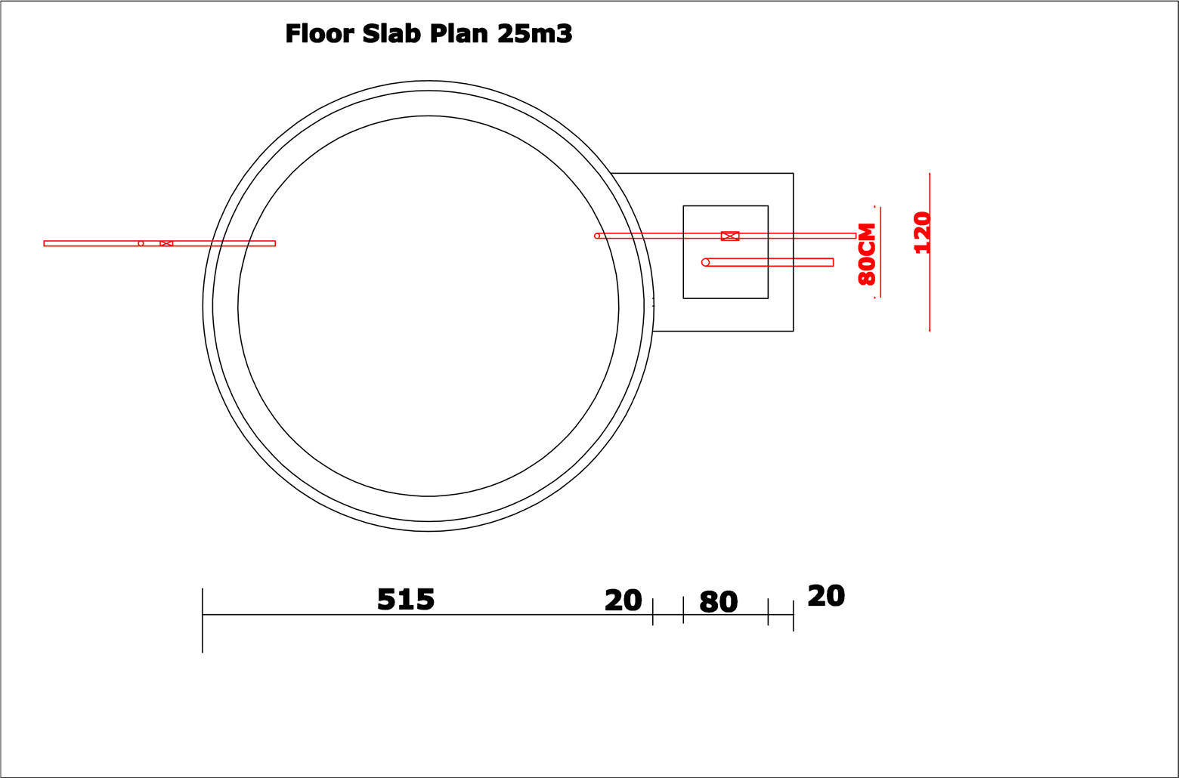 **25m3 Reservoir**

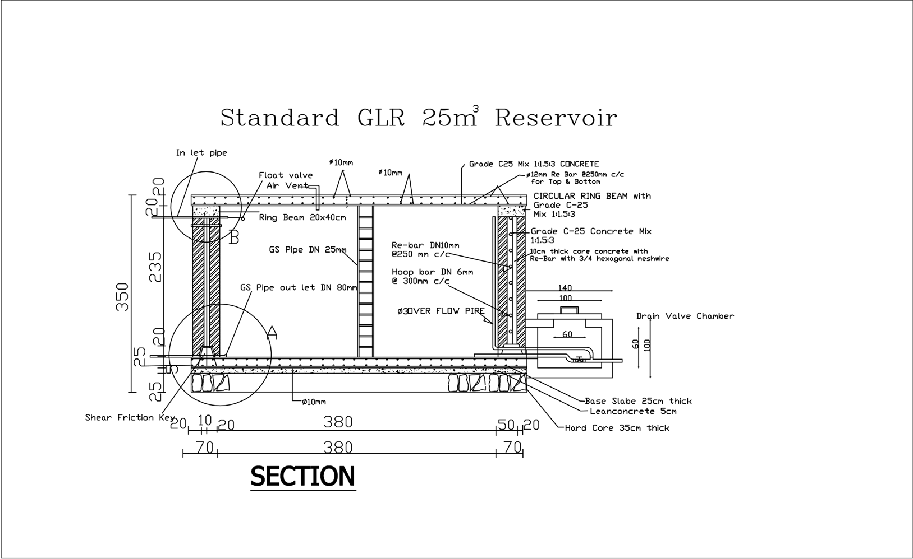

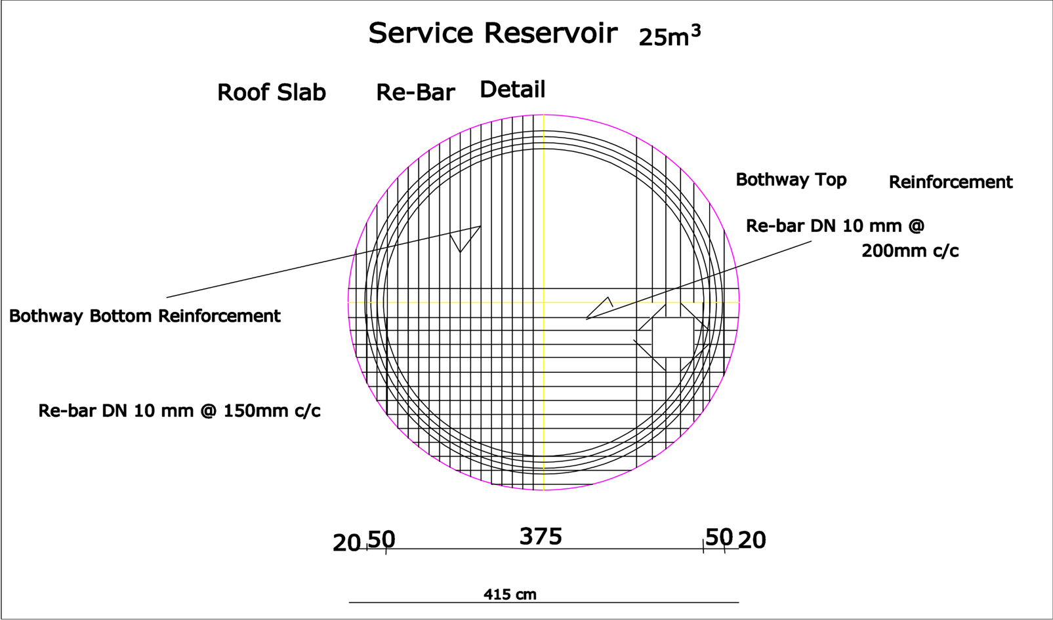

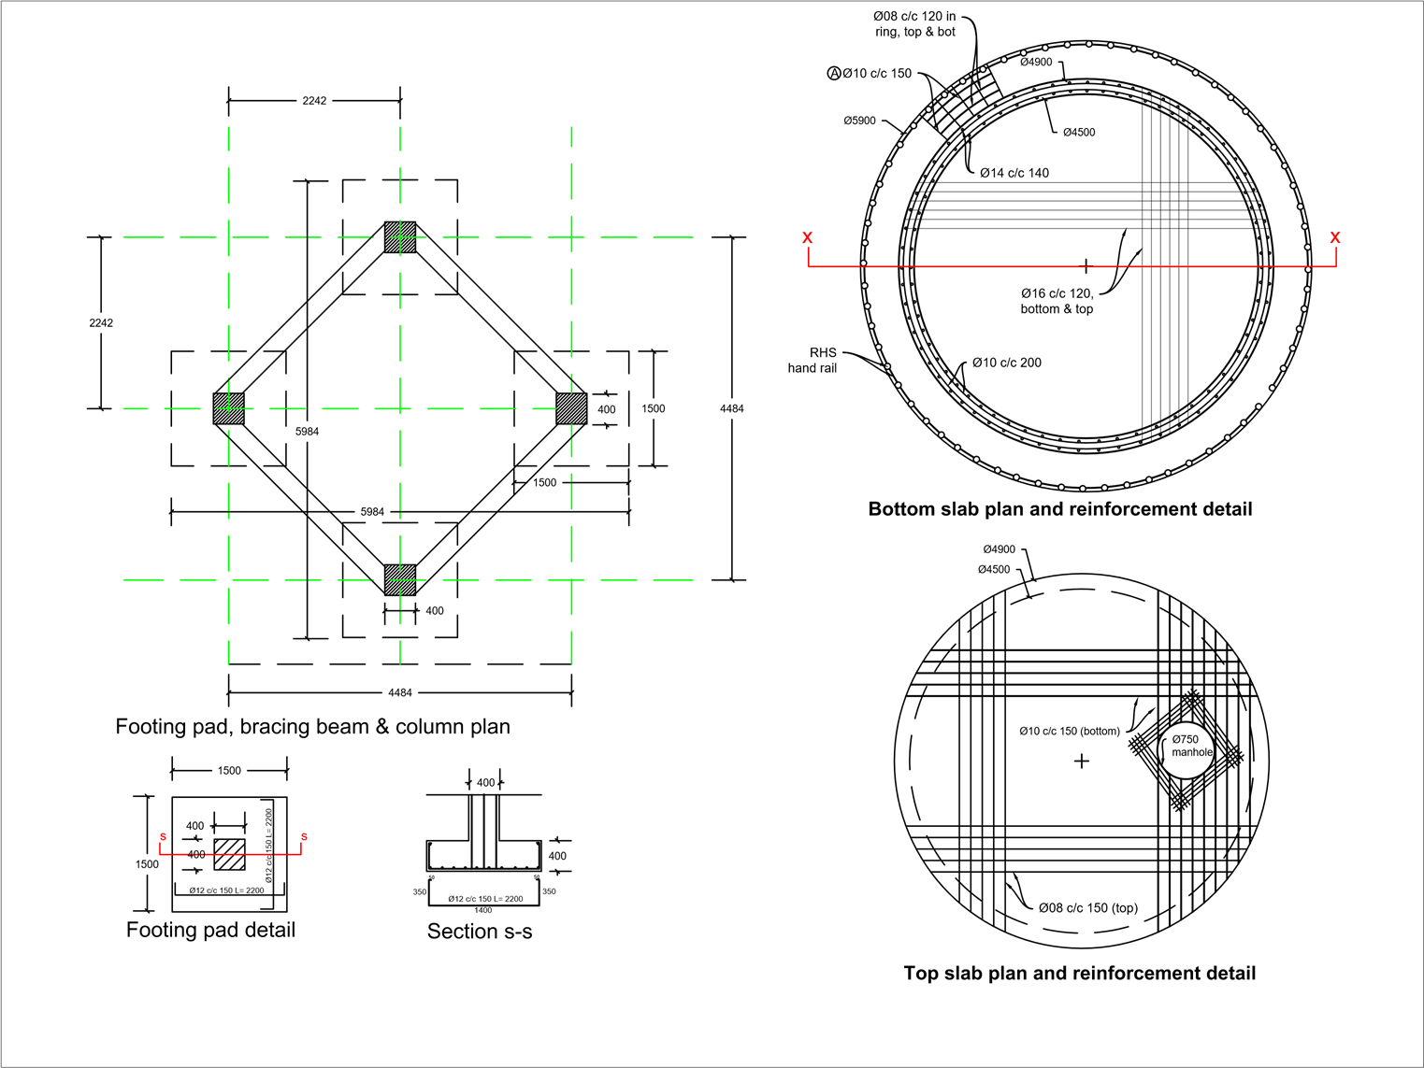

**4.3 50m3 ELEVATED RCC RESERVIOR**

# 

* 1. 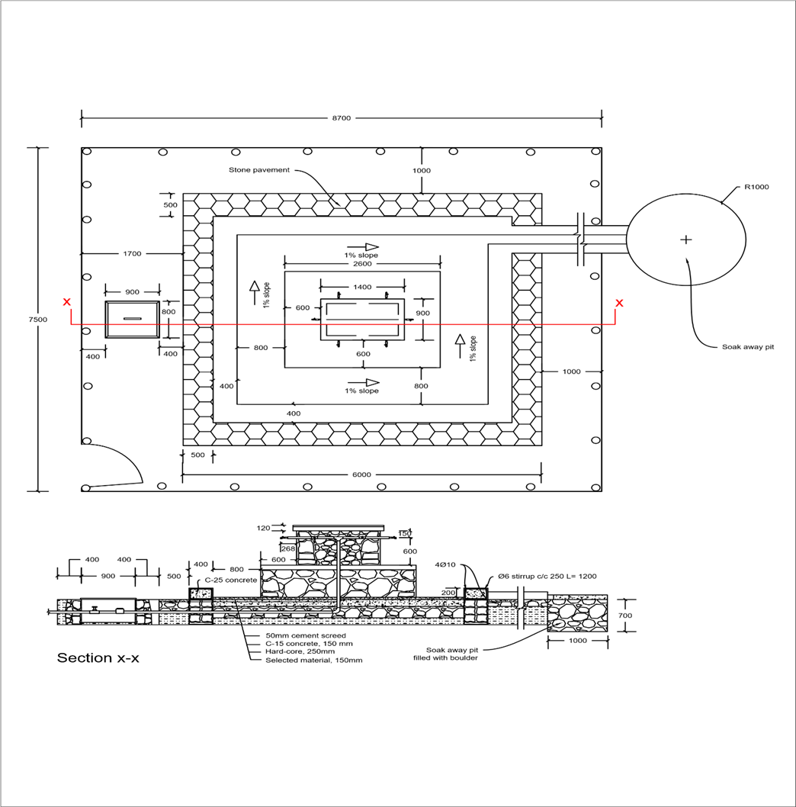 **Public Fountain**

# 4.5 incinerator

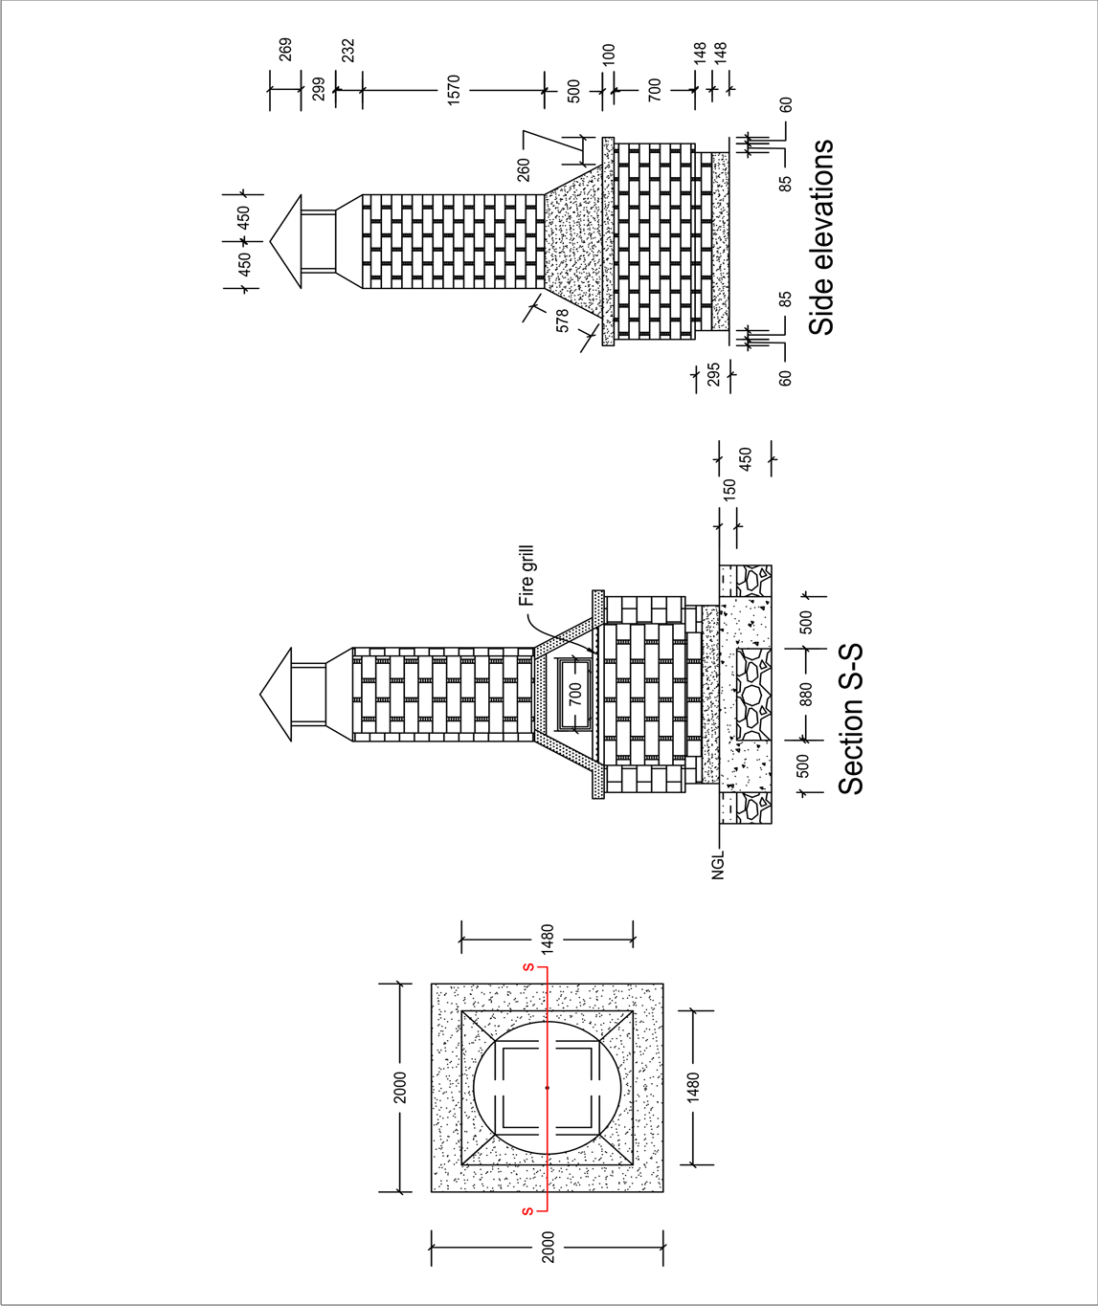

# 

# APPENDIX 5 - GOAL TERMS AND CONDITIONS

1. LEGAL STATUS

The Vendor shall be considered as having the legal status of an independent contractor vis-à-vis GOAL. The Vendor, its personnel and sub-contractors shall not be considered in any respect as being the employees of GOAL. The Vendor shall be fully responsible for all work and services performed by its employees, and for all acts and omissions of such employees.

II. SUB-CONTRACTING

In the event the Vendor requires the services of a sub-contractor, the Vendor shall obtain the prior written approval of GOAL for all sub-contractors. The Vendor shall be fully responsible for all work and services performed by its sub-contractors and vendors, and for all acts and omissions of such sub-contractors and vendors. The approval 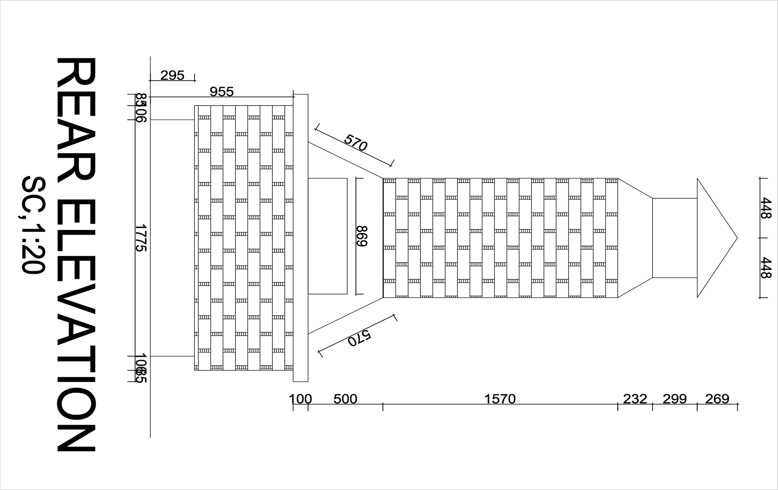of GOAL of a sub-contractor shall not relieve the Vendor of any of its obligations under this Contract. The terms of any sub-contract shall be subject to and conform with the provisions of this Contract.

III. OBLIGATIONS

The Vendor shall neither seek nor accept instructions from any authority external to GOAL. Vendors may not communicate at any time to any other person, government or authority external to GOAL any information known to them by reason of their association with GOAL which has not been made public, except in the course of their duties or by authorization of the GOAL: nor shall Vendors at any time use such information to private advantage. These obligations do not lapse upon termination/expiration of their agreement with GOAL.

IV. ACCEPTANCE AND ACKNOWLEDGEMENT

Initiation of performance under this contract by the vendor shall constitute acceptance of the contract, including all terms and conditions herein contained or otherwise incorporated by reference.

V. WARRANTY

The Vendor warrants the goods furnished under this Contract to conform to the specifications and to be free from damage and defects in workmanship or materials. This warranty is without prejudice to any further guarantees that the Vendor provides to purchasers. Such guarantees shall apply to the goods subject to this Contract.

VI. INSPECTION

The duly accredited representatives of GOAL or the donor shall have the right to inspect the goods called for under this Contract at Vendor’s stores, during manufacture, in the ports or places of shipment, and the Vendor shall provide all facilitates for such inspection. GOAL may issue a written waiver of inspection at its discretion. Any inspection carried out by representatives of GOAL or the donor or any waiver thereof shall not prejudice the implementation of the other relevant provisions of this Contract concerning obligations subscribed by the Vendor, such as warranty or specifications.

VII. EXPORT LICENCE

The Contract is subject to the obtaining of any export licence or other governmental authorisation that may be required. It shall be the responsibility of the Vendor to obtain such licence or authorisation. GOAL may, at its discretion, use its best endeavours to assist.

VIII. OFFICIALS NOT TO BENEFIT

The Vendor represents and warrants that no official of GOAL has been, or shall be, offered by the Vendor any direct or indirect benefit arising from this Contract or the award thereof. The Vendor agrees that breach of this provision is breach of an essential term of this Contract.

IX FORCE MAJEURE

For the purposes of this Contract, force majeure means any act of God, act of war, civil disturbance, explosion, fire, any law or action taken by a government or public authority or other exceptional event which is unforeseeable in the circumstances, which cannot be overcome and which prevents, hinders or delays either party from performing any of its obligations under this Contract. As soon as possible and in any event within five (5) working days after the occurrence of a force majeure event, the affected party shall give notice and full particulars to the other party in writing. The affected party shall not be in breach of this Contract nor liable for delay in performing its obligations under this does Contract if and to the extent that such delay is directly caused by the force majeure event provided that such party uses best endeavour to limit the effect of the force majeure event on the performance of its obligations. If such a period of delay or non-performance by the Vendor continues for ten (10) working days, GOAL may terminate this agreement by giving five (5) days' written notice to the Vendor.

X. DEFAULT

In case of default by the Vendor, including, but not limited to, failure or refusal to make deliveries within the limit specified, GOAL may procure the goods or services from other sources, and hold the Vendor responsible for any excess cost occasioned thereby. Furthermore, GOAL may, by written notice, terminate the right of the Vendor to proceed with deliveries or such part or parts thereof as to which there has been default.

XI. REJECTION

In the case of goods or services purchased based on specifications or scope of works, GOAL shall have the right to reject the goods or services or any part thereof if they do not conform to specifications or the scope of works.

XII. AMENDMENTS

No change in or modification of this Contract shall be made except by prior agreement between the Responsible Buyer in GOAL and the Vendor.

XIII. ASSIGNMENTS

The Vendor shall not assign, transfer, pledge or make other disposition of this Contract or any part thereof or of any of the Vendor’s rights, claims or obligations under this Contract except with the prior written consent of GOAL.

XIV.INDEMNIFICATION

The Vendor agrees to indemnify, hold and save GOAL harmless and defend at its own expense GOAL, its officers, agents and employees from and against all suits, claims, demands and liability of whatever nature or kind, including costs and expenses thereof and liability arising there from, with respect to, arising from or attributable to acts or omissions of the Vendor or its employees or sub-contractors in or relating to the performance of this Contract. This provision shall extend to, but shall not be limited to, claims and liability in the nature of product liability claims.

GOAL will promptly notify the Vendor of any such suit, claim, proceeding, demand or liability within a reasonable period of time after having received written notice thereof, and will reasonably co‑operate with the Vendor, at the Vendor’s expense, in the investigation, defence or settlement thereof, subject to the privileges and immunities of GOAL.

The Vendor shall not permit any lien, attachment or other encumbrance by any person or entity to remain on file in any public or official office or on file with GOAL against any monies due or to become due for any work done or materials furnished under this Contract, or by reason of any other claim or demand against the Vendor.

XV. DISPUTES - ARBITRATION

Any claim or controversy arising out of or relating to this or any contract resulting here from, or to the breach, termination or invalidity thereof, shall be, unless settled amicably through negotiation, submitted to arbitration in accordance with Ethiopian law.

XVI. USE OF NAME, EMBLEM OR OFFICIAL SEAL

Unless authorised in writing by GOAL, the Vendor shall not advertise or otherwise make public the fact that he is a Vendor to GOAL or use the name, emblem or official seal of GOAL or any abbreviation of the name of GOAL for advertising purposes or for any other purposes.

XVII. LIQUIDATED DAMAGES

Late delivery, or dispatch outside the agreed shipping schedule, shall be subject, without notice, to an assessment of liquidated damages equivalent to 1 percent of the Contract value per day or part thereof. GOAL has the right to deduct this amount from the Vendor’s outstanding invoices, if any. This remedy is without prejudice to any others that may be available to GOAL, including cancellation, for the Vendor’s non-performance, breach or violation of any term or condition of the Contract.

Acceptance of goods delivered late shall not be deemed a waiver of GOAL’s rights to hold the Vendor liable for any loss and/or damage resulted therefrom, nor shall it act as a modification of the vendor’s obligation to make future deliveries in accordance with the delivery schedule.

XVIII. ANTI-BRIBERY/CORRUPTION

The Vendor shall comply with all applicable laws, statutes and regulations relating to anti-bribery and anti-corruption including but not limited to the UK Bribery Act 2010 and the the United States Foreign Corrupt Practices Act 1977 (“Relevant Requirements”).

The Vendor shall have and maintain in place throughout the term of any contract with GOAL its own policies and procedures to ensure compliance with the Relevant Requirements.

No monies are payable to GOAL by the Vendor in association with the execution of this contract. If the Vendor is approached by a GOAL member of staff for a payment, commission, ‘kickback’ or associated payment or any other advantage of any kind, they are obliged to report the request or payment directly to GOAL’s Country Director within thirty-six hours. Failure to report any request for payment by a GOAL member of staff or actual payment by the Vendor to a GOAL member of staff to the GOAL Country Director shall result in the immediate termination of any contract and may result in disqualification of the Vendor from participation in future contracts with GOAL.

XIX. ANTI-PERSONNEL MINES

The Vendor guarantees that it is not engaged in the sale or manufacture, either directly or indirectly, of anti-personnel mines or any components produced primarily for the operation thereof. Any breach of this representation and warranty shall entitle GOAL to terminate this Contract immediately upon notice to the Vendor, at no cost to GOAL.

XX. ETHICAL PROCUREMENT

The Vendor represents and warrants that neither it, nor any of its vendors is engaged in any practice inconsistent with the following code of conduct for vendors: Employment is freely chosen, freedom of association and the right to collective bargaining are respected, working conditions are safe and hygienic, no child labour/protection of children is ensured, living wages are paid, working hours are not excessive, no discrimination is practiced, regular employment is provided, no harsh or inhumane treatment is allowed, any harm to the environment shall be avoided or limited. Any breach of this representation and warranty shall entitle GOAL to terminate this Contract immediately upon notice to the Vendor, at no cost to GOAL.

XXI. VENDOR INELIGIBILITY

Candidates that fall into any of the following categories are ineligible to participate in GOAL procurement processes: (a) They are bankrupt or being wound up, are having their affairs administered by the courts, have entered into an arrangement with creditors, have suspended business activities, are the subject of proceedings concerning those matters, or are in any analogous situation arising from a similar procedure provided for in national legislation or regulations; (b) They have been convicted of an offence concerning their professional conduct by a judgement that has the force of res judicata; (c) They have been guilty of grave professional misconduct proven by any means that the contracting authority can justify; (d) They have not fulfilled obligations relating to the payment of social security contributions or the payment of taxes in accordance with the legal provisions of the country in which they are established or with those of the country of the contracting authority or those of the country where the contract is to be performed; (e) They have been the subject of a judgement that has the force of res judicata for fraud, corruption, involvement in a criminal organisation or any other illegal activity; (f) Following another procurement procedure or grant award procedure, they have been declared to be in serious breach of contract for failure to comply with their contractual obligations;

XXII. VENDOR EXCLUSION

Negotiation with vendors or potential vendors may be severed at any stage during a procurement process if it is found that they meet either of the following exclusion criteria: (a) Are subject to a conflict of interest; (b) Are guilty of misrepresentation in supplying the information required by GOAL as a condition of participation in the contract procedure, or fail to supply all of the information requested.

XXIII. PRIOR NEGOTIATIONS SUPERSEDED BY CONTRACT

This Contract supersedes all communications, representations, arrangements, negotiations, requests for proposals and proposals related to the subject matter of this Contract.

XXIV. INTELLECTUAL PROPERTY INFRINGEMENT

The Vendor warrants that the use or supply by GOAL of the goods sold under this Contract does not infringe on any patent, design, tradename or trademark. In addition, the Vendor shall, pursuant to this warranty, indemnify, defend and hold GOAL harmless from any actions or claims brought against GOAL pertaining to the alleged infringement of a patent, design, trade-name or trade-mark arising in connection with the goods sold under this Contract.

XXV. TITLE RIGHTS

GOAL shall be entitled to all property rights including but not limited to patents, copyrights and trademarks, with regard to material which bears a direct relation to, or is made in consequence of, the services provided to the organisation by the Vendor. At the request of GOAL, the Vendor shall take all necessary steps, execute all necessary documents and generally assist in securing such property rights transferring them to the organisation in compliance with the requirements of the applicable law.

Title to any equipment and supplies which may be furnished by GOAL and any such equipment shall be returned to GOAL at the conclusion of this Contract or when no longer needed by the Vendor. Such equipment, when returned to GOAL, shall be in the same condition as when delivered to the Vendor, subject to normal wear and tear.

XXVI. PACKING

The Vendor shall pack the goods with new, sound materials and with every care, in accordance with the normal commercial standards of export packing for the type of goods specified herein. Such packing materials used must be adequate to safeguard the goods while in transit. The Vendor shall be responsible for any damage or loss that can be shown to have resulted from faulty or inadequate packing.

XXVII. INSURANCE

The vendor shall provide and thereafter maintain for the duration of this contract and any extension thereof all appropriate workmen’s compensation insurance or its equivalent with respect to its employees to cover claims for personal injury and death in connection with this contract. The vendor shall, upon request, furnish proof to the satisfaction of the GOAL, of such liability insurance. The vendor shall further provide such health and medical insurance for its agents and employees, as the vendor may consider advisable.

The Vendor shall have in force and maintain in force during the term of this Contract adequate public liability insurance, product liability insurance and other insurance policies required in connection with its business and in respect of the products and/or services supplied by the Vendor.

XXVIII. TERMINATION OF CONTRACT

Termination without default: Either party may terminate this Contract by giving notice in writing to the other party in accordance with this clause XXVIII. The required period of notice shall be five (5) working days in the case of contracts for a total period of less than two months or fifteen (15) working days in the case of contracts for a longer period. In addition, GOAL may terminate this Contract with immediate effect by giving notice in writing to the Vendor if there is a discontinuation or termination (in whole or in part) of donor funding related to this Contract. In the event of the Contract being terminated in accordance with this sub-clause, the Vendor shall be compensated on a pro rata basis for no more than the actual amount of work performed to the satisfaction of GOAL. Additional costs incurred by GOAL resulting from the termination of the Contract by the Vendor may be withheld from any amount otherwise due to the Vendor from GOAL.

Termination with default: Without prejudice to GOAL’s right to terminate this Contract with immediate effect provided for elsewhere in this Contract, GOAL may terminate this Contract with immediate effect without compensation by giving notice in writing to the Vendor where the Vendor: (i) commits a material breach of this Contract which cannot be remedied or has not been remedied within a period of seven (7) days after being notified in writing by GOAL; (ii) ceases to carry on the whole or a substantial part of its business, becomes unable to pay its debts as they fall due, becomes insolvent, enters into any compromise or arrangement with its creditors (other than in the context of solvent reconstruction or amalgamation), is the subject of a resolution to wind up or winding up proceedings, has an administrator, examiner or receiver appointed in respect of some or all of its assets, or being an individual, is the subject of a bankruptcy petition, or any event occurs, or proceeding are taken, with respect to the Vendor in any jurisdiction to which it is subject that has an effect equivalent or similar to any of the foregoing; (iii) commits an offence under anti-terrorism, anti-bribery/corruption or anti-money laundering legislation in any jurisdiction or is involved in organised crime or illegal activity; or (v) undergoes a change of control. GOAL’s termination of this Contract for default whether under this or another provision of this Contract shall be without prejudice to GOAL’s other rights, including but not limited to the right to claim for costs and losses incurred.

XXIX. ASSIGNMENT OF PERSONNEL

The Contractor shall not assign any persons other than those accepted by GOAL for work performed under this Contract.

XXX. OVERRIDING CLAUSE

In the event of any conflict or inconsistencies between these Terms and Conditions or any other document which forms part of the Contract, the contract shall prevail except where they have been amended (by specific reference to the relevant clause and paragraph of these Terms and Conditions) as provided for herein.

XXXI. WITHHOLDING TAX

GOAL reserves the right to deduct withholding tax from the vendor's invoice if so required by law. This will apply unless the vendor has supplied in advance the required documentation proving its exemption from withholding tax (e.g. withholding tax exemption certificate).

1. ACCESS TO DOCUMENTATION

GOAL, its donors or any of their duly authorized representatives, shall have access to any books, documents, papers, and records of the vendor which are directly pertinent to the specific program for the purpose of making audits, examinations, excerpts and transcriptions

|  |  |  |  |
| --- | --- | --- | --- |
| Signed: |  | | |
| Print name: |  | Position: |  |
| Company Name: |  | Date: |  |
| Address: |  | | |