DUB-ITD-356 clarification published 01/03/2021.
# | Clarifications
1 | GOAL’s M365 user count: below the break down in to quantities for all different levels of M365, e.g. E1, E3, F3, etc.  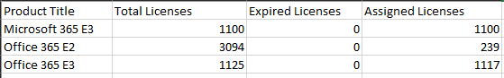
2 | The location of GOAL’s Microsoft tenant is in Ireland using subdomains per country:  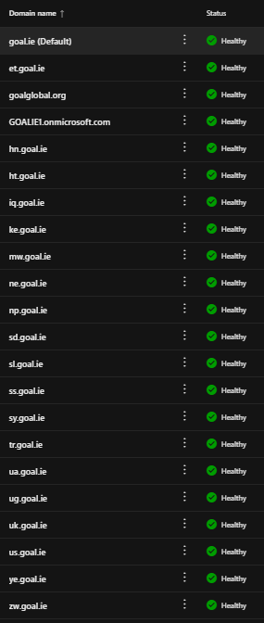
3 | Regarding our users in Syria currently impacted by Microsoft licensing restrictions for use in that country: No restrictions on Software currently.
4 | Are changes permitted to the terms and conditions and GDPR agreement (Appendices 4 and 5)?  Terms and Conditions can be discussed with the winning bidder. However, all Data of GOAL should be secured according to the new terms of EU Privacy Shield.
5 | Can additional terms be discussed and signed in addition to the proposed terms, for example a Statement of Work and associated service terms, as part of the final contract?  Terms for the final contract can be discussed if the provider has his own ones.

