Invitation to Tender (ITT) for the construction works for
Four ventilated improved pit latrines (VIPL) constructions, seven Incinerators construction , three Spring Rehabilitation and Pipeline Expansion and one borehole rehabilitation and pipe line expansion works (Lot 1, Lot 2, Lot 3, Lot 4 and Lot 5); in Guji, West Guji, Gedeo and Dollo Zones, Oromia , SNNP and Somali Regional States
PR. ORO-W-003504
GOAL is completely against fraud, bribery and corruption

GOAL does not ask for money for tenders. If approached for money or other favours, of if you have any suspicions of attempted fraud, bribery or corruption please report immediately to email speakup@goal.ie

Please provide as much detail as possible with any reports

About GOAL
Established in 1977, GOAL is an international humanitarian and development agency committed to working with communities to achieve sustainable and innovative early response in crises and to assist them to build lasting solutions to mitigate poverty and vulnerability. GOAL has worked in over 60 countries and responded to almost every major humanitarian disaster. We are currently operational in 13 countries globally. For more information on GOAL and its operations please visit https://www.goalglobal.org/tenders
GOAL has been working in Ethiopia since 1984, implementing a range of multi-sectoral development and humanitarian programmes responding to sudden-onset and protracted crises. Since 2017, GOAL has been one of the primary humanitarian agencies responding to the displacement crises in Ethiopia, operating a large-scale multi-sectoral response across more than 11 Zones in Oromiya, Somali, SNNP, Benishangul-Gumuz and Amhara. Interventions include: the treatment of acute malnutrition, mobile health activities, ensuring access to sanitation and water supply facilities, distribution of cash, shelter and non-food items, and psychosocial support.
GOAL Ethiopia supports several Water and Sanitation and Health (WASH) projects in various parts of the country providing clean water including small scale construction projects. One of our objectives is to enter into agreements with potential contractors to further strengthen the implementation of our WASH activities.

Proposed Timelines
Line | Item | Date
1 | ITT published | October 12, 2020
2 | Closing date for clarifications | 29th October 2020 04:00 PMGMT +3 East African Time
3 | Closing date and time for receipt of Tenders | 02nd November 2020 02:00 PMGMT +3 East African Time
4 | Tender Opening Location | Addis Ababa, GOAL Ethiopia Office
5 | Tender Opening Date and time | 03rd November 2020 09:00 AM-GMT +3 East African Time

Overview of requirements

Specification for Construction Works
GOAL Ethiopia, an International Humanitarian Organization, invites sealed tenders from eligible tenderers for the construction of four ventilated improved pit latrines (VIPL) constructions, seven Incinerators construction, three Spring Rehabilitation and Pipeline Expansion and one borehole rehabilitation and pipe line expansion sites (Lot 1, Lot 2, Lot 3, Lot 4 & Lot 5) all located in Guji zone (Oddo Shakisso and Uraga woredas) , West Guji zone (Abaya woreda), Gedeo zone (Yirgachefe woreda), Dollo zone (Warder woreda) in Oromia, SNNP and Somali regions respectively.
These construction works are divided into five LOTS as follows:
CODE | Summary of Main Activities | Location
LOT 1 | One VIPL construction, One incinerator construction and One spring source rehabilitation and pipeline expansion work | Oddo Shakisso Woreda  - Walabu kebele HP  - Korcha kebele HC  - Walena Reji kebele
LOT 2 | One VIPL construction, One incinerator construction and One spring source rehabilitation and pipeline expansion work | Uraga Woreda  - Haro Wacho kebele HC  - Raro Nasbo kebele HC  - Tabe Haro Wato kebele
LOT 3 | One VIPL construction and One incinerator construction | Abaya Woreda  - Debeka kebele HC  - Guangua kebele HC
LOT 4 | One VIPL construction, One incinerator construction and One spring source rehabilitation and pipeline expansion work | Yirgachefe Woreda  - Chito kebele HC  - Chito kebele HC  - Ela Tincha kebele
LOT 5 | Three incinerators construction and One borehole source rehabilitation and pipeline expansion work | Warder, Bokh and Danot Woredas  1.Elanle kebele HC  2. Dumo kebele HC  3. Qorile kebele HC  4. Elanle kebele  3.

Contractors must have Category GC/WWGC, five (5) & above certifications to be eligible to tender on this tender. Prospective contractors must also be able to complete the construction works within seventy (70) calendar days and the winning tenderer(s) will be required to enter a contract agreement with GOAL Ethiopia. Contractors may tender for one, two, three, four or all five LOTs. Final decision on the allocation of Lots will be based on the award criteria which includes price, location of sites, lead-times and capacity and factoring in any security issues. Contractor are expected to complete all construction works for the Lot/Lots awarded within 70 days of contract completion period.

The service being offered must be in line with the following requirements
GOAL would like to see the following issues addressed in the response:

3.2.1 Technical proposal (completion of Appendix 2)
The tenderer is required to show their methodology, equipment, personnel, work schedule, site visit certificate and attach related work experience in the technical offer document which will enable them to complete the works with efficiency. These include the following:
- Schedule Form 1 (A and/or B depending on lots tender on) – Tenderers Visit to Work Sites

- Schedule Form 2 - Summary of similar works carried out
- Schedule Form 3 (A for Lots 1 & 2 – B for Lots 3 & 4, C for Lot-5 – separate forms for each Lot) - Schedule of Intended Work Programme
- Schedule Form 4 (A for Lots 1 & 2 – B for Lots 3 & 4, C for Lot-5 – separate forms for each Lot) - Methodology of Work – one-page summary
    - Financial Proposal (completion of Appendix 3)
The tenderer should fill in their price in the Bill of Quantities (BOQ) for each lot they are tendering for – as well as the summary costs using some of or all the following forms:
- Summary of Bill of Quantities and Specifications for Lot 1 (three sites Walabu , Korcha and Walena Reji Kebeles)
- BOQ for Walabu Kebele (Lot 1)
- BOQ for Korcha kebele (Lot 1)
- BOQ for Walena Reji kebele (Lot 1)
- Summary of Bill of Quantities and Specifications for Lot 2 (three sites Haro Wacho , Raro Nasbo and Tabe Haro Wato Kebeles)
- BOQ for Haro Wacho kebele (Lot 2)
- BOQ for Raro Nasbo kebele (Lot 2)
- BOQ for Tabe Haro Wato kebele (Lot 2)
- Summary of BOQ for Lot 3 (two sites Debeka and Guangua kebeles)
- BOQ for Debeka kebele (Lot 3)
- BOQ for Guangua kebele (Lot 3)
- Summary of BOQ for Lot 4 (three sites Chito and Ela Tincha kebeles)
- BOQ for Chito kebele (Lot 4)
- BOQ for Chito kebele (Lot 4)
- BOQ for Ela Tincha kebele (Lot 4)
- Summary of BOQ for Lot 5 (four sites, Elanle , Dumo & Qorile HC’s and Elanle kebele)
- BOQ for three incinerators Construction (Lot-5)
- BOQ for Elanle PEW (Lot-5)

3.2.3 All other documents submitted as per Section 6 of this document

Terms of the Procurement

Procurement Process

This competition is being conducted under GOALs Invitation to Tender (ITT) Procedure.

The Contracting Authority for this procurement is GOAL

This procurement is funded by OFDA and the tender and any contracts or agreements that may arise from it are bound by the regulations of that donor.

Clarifications and Query Handling

GOAL has taken care to be as clear as possible in the language and terms it has used in compiling this ITT. Where any ambiguity or confusion arises from the meaning or interpretation of any word or term used in this document or any other document relating to this tender, the meaning and interpretation attributed to that word or term by GOAL will be final. GOAL will not accept responsibility for any misunderstanding of this document or any others relating to this tender.

Requests for additional information or clarifications can be made up to the deadline noted in section 2 above, and no later. Any queries about this ITT should be addressed in writing ONLY by letter or fax GOAL Ethiopia or preferably via email at clarifications@et.goal.ie> with the reference ORO-W-003504 Clarifications in the email subject line and answers shall be collated and published online at https://www.goalglobal.org/tenders in a timely manner.

Conditions of Tender Submission

Tender must be completed in English.

Tenderers must respond to all requirements set out in this ITT and complete their offer in the Response Format.

Failure to submit tender in the required format will, in almost all circumstances, result in the rejection of the tender. Failure to resubmit a correctly formatted tender within 3 (three) working days of such a request will result in disqualification.

Tenderers must disclose all relevant information to ensure that all tenders are fairly and legally evaluated. Additionally, tenderers must provide details of any implications they know or believe their response will have on the successful operation of the contract or on the normal day-to-day operations with GOAL. Any attempt to withhold any information that the tenderer knows to be relevant or to mislead GOAL and/or its evaluation team in any way will result in the disqualification of the tender.

Tenders must detail all costs identified in this ITT in Ethiopian Birr (ETB). Additionally, tenders must detail any other costs whatsoever that could be incurred by GOAL in the usage of services and/or the availing of options that may not be explicitly identified/requested in this ITT. Tenderers’ attention is drawn to the fact that, in the event of a Contract/ Framework Agreement being awarded to them, the attempted imposition of undeclared costs will be considered a condition for default.

Any conflicts of interest (including any family relations to GOAL staff) involving a tenderer must be fully disclosed to GOAL particularly where there is a conflict of interest in relation to any recommendations or proposals put forward by the tenderer.

GOAL will not be liable in respect of any costs incurred by respondents in the preparation and submission of tenders or any associated work effort.

GOAL will conduct this tender, including the evaluation of responses and final awards in accordance with the detail set out at in the Evaluation process. Tenders will be opened by at least three designated officers of GOAL.

GOAL is not bound to accept the lowest, or any tender submitted.

GOAL reserves the right to split the award of this contract between different tenderers in any combination it deems appropriate, at its sole discretion.

The Supplier shall seek written approval from GOAL before entering into any sub-contracts for the purpose of fulfilling this contract. Full details of the proposed subcontracting company and the nature of their services shall be included in the written request for approval. Written requests for approval must be submitted to GOAL.

GOAL reserves the right to refuse any subcontractor that is proposed by the Supplier.

GOAL reserves the right to negotiate with the Supplier who has submitted the lowest Tender that fully meets the technical requirements, for the purpose of seeking revisions of such Tender to enhance its technical aspects and/or to reduce the price.

Information supplied by respondents will be treated as contractually binding. However, GOAL reserves the right to seek clarification or verification of any such information.

GOAL reserves the right to terminate this competition at any stage.

Unsuccessful tenderers will be notified.

GOAL’s standard payment terms are by bank transfer within 30 days after satisfactory implementation and receipt of documents in order. Satisfactory implementation is decided solely by GOAL.

This document is not construed in any way as an offer to contract.

GOAL and all contracted suppliers must act in all its procurement and other activities in full compliance with donor requirements. Any contract(s) that arise from this ITT may be financed by multiple donors and those donors and/or their agents have rights of access to GOAL and/or any of its suppliers or contractors for audit purposes. These donors may also have additional regulations that it is not practical to list here. Submission of an offer under this ITT assumes Service Provider acceptance of these conditions.

Terrorism and Sanctions: GOAL does not engage in transactions with any terrorist group or individual or entity involved with or associated with terrorism or individuals or entities that have active exclusion orders and/or sanctions against them. GOAL shall therefore not knowingly purchase supplies or services from companies that are associated in any way with terrorism and/or are the subject of any relevant international exclusion orders and/or sanctions. If you submit a tender based on this request, it shall constitute a guarantee that neither your company nor any affiliate or a subsidiary controlled by your company are associated with any known terrorist group or is/are the subject of any relevant international exclusion order and/or sanctions. A contract clause confirming this may be included in an eventual purchase order based on this request.

Quality Control
3rd party companies may be contracted by GOAL to carry out random quality inspections of work carried out by the contracted party. The cost of the quality control inspections will be covered by GOAL.
In cases of supplier’s quality default, in addition to Liquidated Damages, section XVII of GOAL Standard Terms and Conditions, the costs of the quality inspections and loading surveyor will be charged to the Service Provider.
Sub-contracting: note section II in GOAL Standard Terms and Conditions. GOAL may choose to visit vendors, including sub-contractors (if any) as per of the evaluation process.

Submission of Tenders
Tenders must be delivered in one of the following two ways:
- Electronically with your financial and technical offers in separate emails to tender@goal.ie and in the subject field state:
  - ORO-W-003504-VIPL, Incinerators, Spring and Borehole R&PE construction
  - Name of your firm with the title of the attachment
  - Number of emails that are sent e.g. 1 of 3, 2 of 3, 3 of 3.
All documents attached to emails must be in PDF or scan form. Any excel or word documents must be accompanied by a PDF or scan version of the document. Documents submitted solely in excel, word or other ‘soft copy’ format shall lead to the tender being rejected.
- If electronic tender submission is not possible please submit in a sealed envelope marked:ORO-W-003504 VIPL, Incinerators, Spring and Borehole R&PE construction– not to be opened before the deadline 02nd November 2020 at 02:00 PM GMT +3 East African Time by the tender committee’ with all documents including your financial and technical offers to the Private Tender Box at: GOAL Ethiopia, Yeka Sub City, Woreda 9, H. No. 508 (Next compound to Kotebe Health Centre) P. O. Box 5504, TEL. 011-6-47-81-16/17, FAX 011-6-478118, Addis Ababa, Ethiopia. The Bidder shall prepare two copies of the Bid, clearly marking each “Original Bid” and “Copy of Bid” as appropriate. In the event of any discrepancy between them, the original shall govern. Envelopes may be sent through postal/courier services or delivered by hand; and will be accepted during normal working hours in GOAL Ethiopia (between 8:00AM – 4:30 PM office hours from Monday to Friday. Please note that the GOAL office will not be open during weekends or public holidays.

- All tenders whether electronic or in hard copy should comprise all the documents requested in Section 6 of this ITT – a check list has been given to assist tenders in providing this complete application.
- Proof of sending is not proof of reception, either electronically or with post/courier/other physical service. Late delivery will result in your tender being rejected. Envelopes found open at the tender opening will be rejected. All information provided must be perfectly legible.

Tender Opening Meeting
Tenders will be opened as per Section 2 Proposed Timelines above at the following location:
GOAL Ethiopia head office, Addis Ababa, Yeka Sub city, Woreda 9, H. No. 508, Next compound to Kotebe, Woreda 9 Health Centre.
One authorised representative of each tenderer may attend the opening of the tenders. Companies wishing to attend are requested to notify their intention by sending an e-mail at least 48 hours in advance to the following e-mail address: tender@et.goal.ie This notification must be signed by an authorised officer of the tenderer and specify the name of the person who will attend the opening of the tenders on the tenderer's behalf.
Suppliers are invited to attend the Tender Opening Meeting at their own cost.

Evaluation Process

Evaluation stages
Tenderers will be considered for participation in the Contract subject to the following qualification process:
Phase # | Evaluation Process Stage | The basic requirements with which proposals must comply with
The first phase of evaluation of the responses will determine whether the tender has been submitted in line with the administrative instructions and meets the essential criteria. Only those tenders meeting the essential criteria will go forward to the second phase of the evaluation.
1 | Administrative instructions | - Closing Date: Proposals must have met the deadline stated in section 2 of these Instructions to Tenderers, or such revised deadline as may be notified to Tenderers by GOAL. Tenderers must note that GOAL is prohibited from accepting any proposals after that deadline.  - Submission Method: Proposals must be delivered in the method specified in section 4.5 of this document. GOAL will not accept responsibility for tenders delivered by any other method. Responses delivered in any other method may be rejected.  - Format and Structure of the Proposals: Proposals must conform to the Response Format laid out in section 6 of these Instructions to Tenderers or such revised format and structure as may be notified to Tenderers by GOAL. Failure to comply with the prescribed format and structure may result in your response being rejected at this stage.  - Confirmation of validity of your proposal: The Tenderers must confirm that the period of validity of their proposal is not less than 90 (ninety) days.
2 | Essential Criteria | - Attach Certificate of competency: WWGC/GC five (5) and above for similar works type - certificate of competency should be attached.  - CPO Tender Security in the name of GOAL- Ethiopia from a recognized Bank, only in the form of CPO (certified payment order) amounting 1% of the tender offer for the works should be attached  - Tenderer needs to attach their previous work performance letters from GO/NGO in similar types of works  - Schedule of Intended Work Program (SF3). Starting from agreement signed date.  - Proposed Methodology of work (SF4)  - GOAL ET field office signed & stamped site visit document confirming site visit by the tenderer in the works area (SF1).
The second stage of the evaluation will involve an assessment of the Tenderer’s personal and legal circumstances, economic and financial standing, to fulfil the obligations of the contract
3 | Legal, Economic & Financial Criteria | - Relevant and Valid licenses to operate in Ethiopia  - VAT registration  - Financial standing of company to complete contracts (financial stability)
Each proposal that conforms to the Essential and Qualification Criteria will be evaluated according to the Award Criteria given below by GOAL.
4 | Award Criteria | Tenders will be awarded marks under each of the award criteria listed in this section to determine the most economically advantageous tenders.  - Price (35%)  - Technical/Quality (65%) determined by:  - Quality of reference from GO/NGO in similar types of works  - Adequacy of Intended Work Program (SF3)  - Quality of Proposed Methodology of work (SF4)
5 | Post selection | References and other checks are found to be clear and quality is assessed.

Tender Evaluation
GOAL will convene an evaluation team which may include members of the Finance, Logistics, Programmes, Donor Compliance and Internal Audit, as well as 3rd Party technical input.
During the evaluation period clarifications may be sought by e-mail from Tenderers. Clarifications may include testimonials from customers in support of aspects of a tender, whether such aspects are contained in the original submission or in subsequent responses to requests for clarification. Deadlines will be imposed for the receipt of such clarifications and failure to meet these deadlines may result in the disqualification of the Tender or loss of marks. Responses to requests for clarification shall not materially change any of the elements of the proposals submitted. Unsolicited communications from Tenderers will not be entertained during the evaluation period.

Award Criteria

Price
All prices must be in Ethiopian Birr (ETB) and a comprehensive and clear breakdown of prices must be shown as part of the financial offer – any transport fees, taxes, customs charges, component parts, packing fees etc. must be shown separately. In this ITT the prices offered in the BOQ forms provided constitute the financial offer.
Marks for cost will be awarded on the inverse proportion principle (shown below):
Score^{vendor} = 35 x (price^{min} / price^{vendor})
Price accounts for 35% of the award criteria.
All financial offers must be made on the basis of ‘best and final offer’.

Technical/Quality
The technical quality of received tenders are determined through three main components as follows:
  - Contractors previous work experience from GO/NGO in similar types of works – primarily information from SF2 and any completion/competency certificates attached – and these may be verified by the evaluation team.
  - Adequacy of elaborated work plan (Implementation plan) – completion of SF3 as well as verification of length of workplan and overall duration of project
  - Proposed Methodology for the works – completion of SF4 – content analysis by the evaluation team of the one-page summary
Technical/quality assessments account for 65% of the award criteria.

Summary of Award Criteria
No | Qualitative award criteria | Weighting (maximum points)
1. | Price (from BOQ amounts) | 35
2. | Quality of reference from GO/NGO in similar types of works | 65
3. | Adequacy of Intended Work Program (SF3)
4. | Quality of Proposed Methodology of work (SF4)
 | Total number of points | 100

Award of contract
As per section 4.3.10 above and following the analysis of tenders against the award criteria laid out above in sections 5.1 and 5.3, contracts may be awarded to one supplier or divided between multiple suppliers at GOAL’s discretion. For such purposes, GOAL uses a Value for Money approach, which may include (but is not limited to) price, quality, lead time, context and risk analysis of the supply chain environment pertaining to the contract delivery.

Response Format

Introduction
All proposals must conform to the response format laid out below. Where a tender does not conform to the required format the Tenderer may be requested to resubmit it in the correct format, on the understanding that the resubmission cannot contain any material change from the original. Failure to resubmit in the correct format within 3 (three) working days may result in disqualification.
By responding to this ITT, each Tenderer is required to accept the terms and conditions of this ITT and to acknowledge and confirm their acceptance by returning a signed copy with its response. Should a Tenderer not comply with these requirements, GOAL may, at their sole discretion, reject the response.
If the Tenderer wishes to supplement their Response to any section of the ITT specifications with a reference to further supporting material, this reference must be clearly identified, including section and page number.

Other Documents Required

Company Documents
All submissions must be made with copies of the following documents included:
- Company Registration Certificate
- Trade Licence
- WWGC/GC five (5) and above for similar works type - certificate.
- TIN Certificate
- VAT registration Certificate
This is so GOAL can ascertain that the company has legal and trading ability in Ethiopia.

Tender Security
A tender bond in the form of CPO in the amount of 1% (one percent) of the total tender amount, valid for seventy (70) calendar days from the date of tender opening is required. The company must calculate the correct tender bond from its submission in the financial offer (BOQ completion). Any tender not accompanied by an acceptable tender security shall be rejected by GOAL as "non-responsive". If a tender security contains minor errors that require simple correction, GOAL may, at its sole discretion, allow the respective Tenderer, via a written notice, a fixed time period within which the tender security may be corrected and re-submitted.
The contractor who submits their bids through online, the original CPO should be submitted during bid opening date. If the contractor fails to do so, GOAL will take appropriate measure to disqualify the bid.

Audited Accounts
Tenderers need to submit an audited account regarding their past performance which details that the auditing is accomplished by certified accountants or mandated body to perform auditing. Audited accounts from 2018 and preferably 2019 in addition are required.

Appendices
This is to remind all tenderers that Appendix 1 needs to be completed IN FULL. Appendix 2 is your technical offer and relevant forms completed depending on the Lots the company has tender on – similarly with Appendix 3 as the Financial offer. Appendix 4 are the plans/drawings that must be followed. Appendix 5 Standard Terms and Conditions need to be initialled or signed and returned with your application.

Submission Checklist
Line | Item | How to submit |  | Tick attached
 |  | Electronic submission | Physical submission
1 | This checklist | Ticked, scan and save as ‘Checklist’ | Tick and submit.
2 | Company Details (appendix 1) – this includes Declaration of Finance and Tax | Complete, sign & stamp, scan and save as ‘Company Details’ | Complete, sign, stamp and submit.
3 | Technical Offer (Appendix 2)  Comprising of: | Complete, sign & stamp, scan and save as ‘Technical Offer’ | Complete, sign, stamp and submit.
a) | SF1A Tenderers site visit - Lots 1&2 | Complete, scan and save as individual forms (SF1A etc) OR scan all forms into one PDF and save as ‘Technical Offer Standard Forms’ | Complete and submit
b) | SF1B Tenderers site visit – Lots 3&4 |  | Complete and submit
c) | SF1C Tenderers site visit – Lot 5
d) | SF2 Summary of executed Works |  | Complete and submit
e) | Comp Certificates/ Testimonies |  | Copy and submit
f) | SF3A Schedule of Intended work Program – Lots 1&2 |  | Complete and submit
g) | SF3B Schedule of Intended work Program – Lots 3&4 |  | Complete and submit
h) | SF3C Schedule of Intended work Program – Lot 5
i) | SF4A Work Methodology – Lots 1&2 |  | Complete and submit
j) | SF4B Work Methodology – Lots 3&4 |  | Complete and submit
k) | SF4C Work Methodology – Lot 5
4 | Financial Offer (Appendix 3) Comprising of: | Complete, sign & stamp, scan and save as ‘Financial Offer’ | Complete, sign, stamp and submit.
a) | Summary of Bill of Quantities and Specifications for Lot 1 (three sites Walabu , Korcha and Walena Reji Kebeles) | Complete, sign & stamp, scan and save as ‘BOQ Lot1’ | Complete, sign, stamp and submit.
b) | BOQ for Walabu Kebele (Lot 1)
c) | BOQ for Korcha kebele (Lot 1)
d) | BOQ for Walena Reji kebele (Lot 1) | Complete, sign & stamp, scan and save as ‘BOQ Lot2’ | Complete, sign, stamp and submit.
e) | Summary of Bill of Quantities and Specifications for Lot 2 (three sites Haro Wacho , Raro Nasbo and Tabe Haro Wato Kebeles)
f) | BOQ for Haro Wacho kebele (Lot 2)
g) | BOQ for Raro Nasbo kebele (Lot 2)
h) | BOQ for Tabe Haro Wato kebele (Lot 2)
I) | Summary of BOQ for Lot 3 (two sites Debeka and Guangua kebeles) | Complete, sign & stamp, scan and save as ‘BOQ Lot3’ | Complete, sign, stamp and submit.
j) | BOQ for Debeka kebele (Lot 3)
k) | BOQ for Guangua kebele (Lot 3)
l) | Summary of BOQ for Lot 4 (three sites Chito and Ela Tincha kebeles) | Complete, sign & stamp, scan and save as ‘BOQ Lot 4’ | Complete, sign, stamp and submit.
m) | BOQ for Chito kebele (Lot 4)
n) | BOQ for Chito kebele (Lot 4)
o) | BOQ for Ela Tincha kebele (Lot 4)
p) | Summary of BOQ for Lot 5 (four sites, Elanle , Dumo & Qorile HC’s and Elanle kebele) | Complete, sign & stamp, scan and save as ‘BOQ Lot 5’ | Complete, sign, stamp and submit.
q) | BOQ for three incinerators constructions, Elanle , Dumo & Qorile HC’s (Lot-5)
r) | BOQ for Elanle PEW (Lot-5)
5 | GOAL Terms and Conditions (Appendix 5) signed | Sign, scan and save as ‘GOAL Terms and Conditions’ | Sign, stamp and submit.
6 | 1% Tender Security in the name of GOAL- CPO only | Sign, scan and save as ‘Tender Security’ | Sign, stamp and submit.
7 | Company Registration Certificate | Scan and save as ‘Com Reg Cert’ | Copy and submit
8 | Trade Licence | Scan and save as ‘Trade Licence’ | Copy and submit
9 | WWGC/GC five (5) and above for similar works type - certificate. | Scan and save as ‘Works level Cert’ | Copy and submit
10 | TIN Certificate | Scan and save as ‘TIN Cert’ | Copy and submit
11 | VAT registration Certificate | Scan and save as ‘VAT Cert’ | Copy and submit
12 | Copies of the last financial years’ AUDITED financial accounts (2019, 2018) | Attach copies of audited accounts and save as ‘Financial Accounts’ | Submit copies of audited accounts.
13 | Company Assessment | Complete, sign & stamp, scan and save | Complete, sign & stamp, scan and save

Appendix 1 - Company details

Contact Details
This section must include the following information regarding the Individual or Company and any partners or sub-contractors:

Name of the prime Tenderer
Registered address of the prime Tenderer
Company Name
Owner Nationality
Address
Previous Name(s) if applicable
Registered Address if different from above
Registration Number
Telephone
E-mail address
Website address
Year Established
Legal Form. Tick the relevant box | Company  Partnership |  | Joint Venture  Other (specify):
VAT/TVA/Tax Registration Number
Directors names and titles and any other key personnel
Please state name of any other persons/organisations (except tenderer) who will benefit from this contract
Parent company
Ownership
Do you have associated companies? Tick relevant box. If YES – provide details for each company in the form of additional table as per Contact Details | Yes No
 | Primary Contact | Secondary Contact
Name
Current Position in the Organisation:
No. of years working with the Organisation:
Email address
Telephone
Mobile
Other Relevant Skills:
Institution (Date from – to)
Degrees or Diplomas

Professional or Corporate Memberships
These are with external professional bodies that your company is registered with (please note this is not the company/ business registration details). Please attach copies of any relevant certificates or memberships and use more lines if necessary:
No | Name of the body | Year of registration | Membership Number
1
2
3
4

Profile
Tenderers should note that the information requested below will be required under the Essential Criteria. In total the answers to these questions should take no more than 2 pages
No | Description | Response
1 | An outline of the scope of business activities, and in particular details of relevant experience regarding contracts of this nature
2 | Provide details of two contracts of a similar nature carried out in the last two years (please state customer name, delivery location, value of contract, and dates)
3 | The number of years the Tenderer has been in business in its present form
4 | A statement of overall turnover and turnover in respect to the goods and services offered under the proposed agreement for the last three years as per the following table:
 | Year | Overall Turnover in Ethiopian Birr (ETB) | Offered Works Turnover in Ethiopian Birr (ETB)
 | 2019
 | 2018
 | 2017
5 | Where the Supplier proposes to use subcontractors or resellers/ distributors in the execution of the agreement this section should include details of the quality assurance mechanisms used by the Supplier to monitor the activities of its subcontractors or resellers/ distributors. Suppliers should note that commitment to quality, as evidenced by the existence of such quality control procedures, will be used as a Qualification Criteria
6 | Any other relevant information

References
At least 2 (two) relevant references who may be contacted on a confidential basis to verify satisfactory execution of contracts must be supplied. These references may not be GOAL personnel or related to a GOAL contract. Respondents should supply this information for each of the references in the following format:
1 | Name
 | Organisation
 | Address
 | Phone
 | Fax
 | Email
 | Nature of supply
 | Approximate value of contract
2 | Name
 | Organisation
 | Address
 | Phone
 | Fax
 | Email
 | Nature of supply
 | Approximate value of contract
3 | Name
 | Organisation
 | Address
 | Phone
 | Fax
 | Email
 | Nature of supply
 | Approximate value of contract
4 | Name
 | Organisation
 | Address
 | Phone
 | Fax
 | Email
 | Nature of supply
 | Approximate value of contract

By including the above information, tenderers confirm that they have consent from the data subject to share this information with GOAL for the purpose of providing a reference, to allow GOAL to analyse offers and award a contract under this tender; and that the data subject understands that the personal data may be shared internally within GOAL and externally if required by law and donor regulations; and may be stored for a period of up to 7 years from the award of contract.

Declaration re Personal and Legal circumstances

THIS FORM MUST BE COMPLETED AND SIGNED BY A DULY AUTHORISED OFFICER OF THE TENDERERS’ ORGANISATION. Please tick Yes or No as appropriate to the following statements relating to the current status of your organisation |  |  | Yes | No
1 | The Tenderer is bankrupt or is being wound up or its affairs are being administered by the court or has entered into an arrangement with creditors or has suspended business activities or is in any analogous situation arising from a similar procedure under national laws and regulations
2 | The Tenderer is the subject of proceedings for a declaration of bankruptcy, for an order for compulsory winding up or administration by the court or for an arrangement with creditors or of any other similar proceedings under national laws and regulations
3 | The Tenderer, a Director or Partner, has been convicted of an offence concerning his professional conduct by a judgement which has the force of res judicata or been guilty of grave professional misconduct in the course of their business
4 | The Tenderer has not fulfilled its obligations relating to the payment of taxes or social security contributions in Ireland or any other State in which the tenderer is located
5 | The Tenderer, a Director or Partner has been found guilty of fraud
6 | The Tenderer, a Director or Partner has been found guilty of money laundering
7 | The Tenderer, a Director or Partner has been found guilty of corruption
8 | The Tenderer, a Director or Partner has been convicted of being a member of a criminal organisation
9 | The Tenderer, a Director or Partner is under investigation, or has been sanctioned within the preceding three (3) years by any national authority of a United Nations Member State for engaging or having engaged in proscribed practices, including but not limited to: corruption, fraud, coercion, collusion, obstruction, or any other unethical practice.
10 | The Tenderer has been guilty of serious misrepresentation in providing information to a public buying agency
11 | The Tenderer has contrived to misrepresent its Health & Safety information, Quality Assurance information, or any other information relevant to this application
12 | The Tenderer has colluded between themselves and other tenderers (a tendering ring), and/or the Tenderer has had improper contact or discussions with any member of GOAL staff and/or members of their family
13 | The Tenderer is fully compliant with the minimum terms and conditions of the Employment Law and with all other relevant employment legislation, as well as all relevant Health & Safety Regulations in the countries of registration and operations
14 | The Tenderer has procedures in place to ensure that subcontractors, if any are used for this contract, apply the same standards.
15 | Consistent with numerous United Nations Security Council resolutions including S/RES/1269 (1999), S/RES/1368 (2001) and S/RES/1373 (2001), GOAL is firmly committed to the international fight against terrorism, and in particular, against the financing of terrorism. It is the policy of GOAL to seek to ensure that none of its funds are used, directly or indirectly, to provide support to individuals or entities associated with terrorism. In accordance with this policy, the Tenderer undertakes to use all reasonable efforts to ensure that it does not provide support to individuals or entities associated with terrorism.
I certify that the information provided above is accurate and complete to the best of my knowledge and belief.
I understand that the provision of inaccurate or misleading information in this declaration may lead to my organisation being excluded from participation in future tenders.
Date
Name
Position
Telephone number
Signature and full name

self-declaration of finance and tax
            - Turnover history

Turnover figures entered into the table must be the total sales value before any deductions
‘Turnover of related products’ is for companies that provide items or services in multiple sectors. Please enter information on turnover of items or services that are similar in nature to the items or services requested under this tender.

Trading year | Total turnover | Turnover of related products
2019
2018
2017
Include a short narrative below to explain any trends year to year

- GOAL operates within the law of the country of operation and within international legal requirements. GOAL expects all companies to fulfil their legal obligations, including meeting their tax liabilities and duties in accordance with the relevant tax legislation. Please comment below if you feel there are any matters you need to bring to GOAL’s attention.

Please continue on a separate sheet if necessary.

I certify that the information provided above is accurate and complete to the best of my knowledge and belief. I understand that the provision of inaccurate or misleading information in this declaration may lead to my organisation being excluded from participation in future tenders.

Signed: (Director) _________________________________________
Date: _________________________________________
Print Name: _________________________________________
Company Name: _________________________________________
Address: _________________________________________

Appendix 2 - Technical Offer

Name of Company: ______________________________________________

Indicate with YES/NO which LOTS the tender documentation is provided for:

CODE | Summary of Main Activities | Location | Yes/No
LOT 1 | One VIPL construction, One incinerator construction and One spring source rehabilitation and pipeline expansion work | Oddo Shakisso Woreda  - Walabu kebele HP  - Korcha kebele HC  - Walena Reji kebele
LOT 2 | One VIPL construction, One incinerator construction and One spring source rehabilitation and pipeline expansion work | Uraga Woreda  - Haro Wacho kebele HC  - Raro Nasbo kebele HC  - Tabe Haro Wato kebele
LOT 3 | One VIPL construction and One incinerator construction | Abaya Woreda  - Debeka kebele HC  - Guangua kebele HC
LOT 4 | One VIPL construction, One incinerator construction and One spring source rehabilitation and pipeline expansion work | Yirgachefe Woreda  - Chito kebele HC  - Chito kebele HC  - Ela Tincha kebele
LOT 5 | Three incinerators construction and One borehole source rehabilitation and pipeline expansion work | Warder, Bokh and Danot Woredas  1.Elanle kebele HC  2. Dumo kebele HC  3. Qorile kebele HC  4. Elanle kebele

“By submitting this offer, I confirm that all data subjects have specifically consented to the use and storage of their data by GOAL for the purpose of analysing the offers and awarding a contract under this tender; and further understood that the personal data may be shared internally within GOAL and externally if required by law and donor regulations; and may be stored for a period of up to 7 years from the award of contract.”

Signed: (Director) _________________________________________
Date: _________________________________________
Print Name: _________________________________________
Company Name: _________________________________________
Address: _________________________________________

SCHEDULE OF FORMS (STANDARD FORMAT)
CERTIFICATE OF TENDERDER’S VISIT TO THE WORK SITES
SCHEDULE FORM 1A [SF1A]
LOTs 1& 2
Two VIPL, two incinerators and two rehabilitation and pipeline expansion work in Oddo Shakisso and Uraga woredas
No. |  | Lot1 (Oddo Shakisso Woreda) | Lot 2 (Uraga Woreda)
1 | Date/ Duration of Visit
2 | Site (s) Visited | - Walabu kebele HP  - Korcha kebele HC  - Walena Reji kebele | - Haro Wacho kebele HC  - Raro Nasbo kebele HC  - Tabe Haro Wato kebele
3 | Visitor’s Name (CONTRACTOR)  Name:  Signature:
4 | Visitor’s Guide (Client/EMPLOYER)  Name:  Signature:  Stamp:
5. | Remarks

Name of Tenderer representative visiting site: ___________________________________
Signature: ___________________________________
Official Seal: _________________________________
DATE: ______________________________________

SCHEDULE OF FORMS (STANDARD FORMAT)
CERTIFICATE OF TENDERDER’S VISIT TO THE WORK SITES
SCHEDULE FORM 1B [SF1B]
LOTs 3 & 4
Two ventilated improved pit latrine construction, two incinerators and one rehabilitation and pipeline expansion work in Abaya and Yirgachefe woredas
No. |  | Lot3 (Abaya Woreda) | Lot 4 (Yirgachefe Woreda)
1 | Date/ Duration of Visit
2 | Site (s) Visited | - Debeka kebele HC  - Guangua kebele HC | - Chito kebele HC  - Chito kebele HC  - Ela Tincha kebele
3 | Visitor’s Name (CONTRACTOR)  Name:  Signature:
4 | Visitor’s Guide (Client/EMPLOYER)  Name:  Signature:  Stamp:
5. | Remarks

Name of Tenderer representative visiting site: ___________________________________
Signature: ___________________________________
Official Seal: _________________________________
DATE: ______________________________________

SCHEDULE OF FORMS (STANDARD FORMAT)
CERTIFICATE OF TENDERDER’S VISIT TO THE WORK SITES
SCHEDULE FORM 1C [SF1C]
LOT 5
Three incinerators and one rehabilitation and one pipeline expansion work in Warder woreda
No. |  | Lot 5 (Warder, Bokh and Danot Woredas)
1 | Date/ Duration of Visit
2 | Site (s) Visited | 1. Elanle kebele HC  2. Dumo kebele HC  3. Qorile kebele HC  4. Elanle kebele
3 | Visitor’s Name (CONTRACTOR)  Name:  Signature:
4 | Visitor’s Guide (Client/EMPLOYER)  Name:  Signature:  Stamp:
5. | Remarks

Name of Tenderer representative visiting site: ___________________________________
Signature: ___________________________________
Official Seal: _________________________________
DATE: ______________________________________

SUMMARY OF EXECUTED WORKS CARRIED OUT BY THE TENDERDER
SCHEDULE FORM 2 [SF2]
For All Lots

NO. | Type of construction work | Employer/Client | Value of Contract  (in Birr) | Duration  (weeks) | Dates  (From-to) | Commissioned (Yes/No) | Reason for not commissioning (if applicable)
1
2
3
4
5

Date:___________________________ Signature:_______________________

Company: _________________________Official Seal: _______________________

Note: please attach your testimonies (Certificate of Work accomplishment)

SCHEDULE OF INTENDED WORK PROGRAM
SCHEDULE FORM 3A [SF3A].
For Lots 1 and 2
Lot Number: _____ (use separate form if tendering on both lots)
 | WORK ITEM | Duration in Days | Weeks
 |  |  | 1 | 2 | 3 | 4 | 5 | 6 | 7 | 8 | 9 | 10
1 | Advance processing, Site Handing over
2 | Mobilization
3 | Excavation and Earth work
4 | Demolishing and disposal
5 | Masonry work
6 | Reinforcement and concrete work
7 | Pipeline and plumbing works
8 | Miscellaneous and finishing works
9 | Handing Over

Note: Use bars to fill chart
Based on the dates given in Section 2 of the ITT please estimate:
Earliest possible Contract signing date
Earliest possible actual work commencement date
Time required for the execution of the WORKS

Date of WORKS commencement is 2 days after ‘’order to commence’’ is received by the CONTRACTOR.

SIGNATURE: ____________________ OFFICIAL SEAL: _____________________

DATE: ____________________

SCHEDULE OF INTENDED WORK PROGRAM
SCHEDULE FORM 3B [SF3].
For Lots 3&4

Lot Number: _____ (use separate form if tendering on both lots)
 | WORK ITEM | Duration in Days | Weeks
 |  |  | 1 | 2 | 3 | 4 | 5 | 6 | 7 | 8 | 9 | 10
1 | Advance processing, Site Handing over
2 | Mobilization
3 | Excavation and Earth work
4 | Masonry work
5 | Reinforcement and concrete work
6 | Wall and metal works
7 | Roofing and carpentry work
8 | Miscellaneous and finishing works
9 | Handing Over

Note: Use bars to fill chart
Based on the dates given in Section 2 of the ITT please estimate:
Earliest possible Contract signing date
Earliest possible actual work commencement date
Time required for the execution of the WORKS

Date of WORKS commencement is 2 days after ‘’order to commence’’ is received by the CONTRACTOR.

SIGNATURE: ____________________ OFFICIAL SEAL: _____________________

DATE: ____________________

SCHEDULE OF INTENDED WORK PROGRAM
SCHEDULE FORM 3C [SF3].
For Lot 5

Lot Number: _____ (use separate form if tendering on both lots)
 | WORK ITEM | Duration in Days | Weeks
 |  |  | 1 | 2 | 3 | 4 | 5 | 6 | 7 | 8 | 9 | 10
1 | Advance processing, Site Handing over
2 | Mobilization
3 | Excavation and Earth work
4 | Masonry work
5 | Reinforcement and concrete work
6 | Wall and metal works
7 | Roofing and carpentry work
8 | Miscellaneous and finishing works
9 | Handing Over

Note: Use bars to fill chart
Based on the dates given in Section 2 of the ITT please estimate:
Earliest possible Contract signing date
Earliest possible actual work commencement date
Time required for the execution of the WORKS

Date of WORKS commencement is 2 days after ‘’order to commence’’ is received by the CONTRACTOR.

SIGNATURE: ____________________ OFFICIAL SEAL: _____________________

DATE: ____________________

METHODOLOGY OF WORK
SCHEDULE 4A[SF4A]
For Lots 1&2

Date: ___________________________ Signature: ______________________

Official Seal: _______________________

METHODOLOGY OF WORK
SCHEDULE 4B[SF4B]
For Lots 3&4

Date: ___________________________ Signature: ______________________

Official Seal: _______________________

METHODOLOGY OF WORK
SCHEDULE 4C [SF4C]
For Lot 5

Date: ___________________________ Signature: ______________________

Official Seal: _______________________

Appendix 3 - Financial Offer

BILL OF QUANTITIES AND
SPECIFICATIONS

Name of Company: ______________________________________________
Indicate with YES/NO which LOTS the BOQ prices are provided for:

CODE | Summary of Main Activities | Location | Yes/No
LOT 1 | One VIPL construction, One incinerator construction and One spring source rehabilitation and pipeline expansion work | Oddo Shakisso Woreda  - Walabu kebele HP  - Korcha kebele HC  - Walena Reji kebele
LOT 2 | One VIPL construction, One incinerator construction and One spring source rehabilitation and pipeline expansion work | Uraga Woreda  - Haro Wacho kebele HC  - Raro Nasbo kebele HC  - Tabe Haro Wato kebele
LOT 3 | One VIPL construction and One incinerator construction | Abaya Woreda  - Debeka kebele HC  - Guangua kebele HC
LOT 4 | One VIPL construction, One incinerator construction and One spring source rehabilitation and pipeline expansion work | Yirgachefe Woreda  - Chito kebele HC  - Chito kebele HC  - Ela Tincha kebele
LOT 5 | Three incinerators construction and One borehole source rehabilitation and pipeline expansion work | Warder, Bokh and Danot Woredas  1.Elanle kebele HC  2. Dumo kebele HC  3. Qorile kebele HC  4. Elanle kebele

“By submitting this offer, I confirm that all data subjects have specifically consented to the use and storage of their data by GOAL for the purpose of analysing the offers and awarding a contract under this tender; and further understood that the personal data may be shared internally within GOAL and externally if required by law and donor regulations; and may be stored for a period of up to 7 years from the award of contract.”

Signed: (Director) _________________________________________
Date: _________________________________________
Print Name: _________________________________________
Company Name: _________________________________________
Address: _________________________________________

Summary of Bill of Quantities and Specifications for Lot-1, Oddo Shakisso woreda of Guji zone for Ventilated improved pit latrine (VIPL), Incinerator and spring source rehabilitation with pipeline expansion work project

Project Price Summary

- VIPL construction work, ETB__________________________________________

- Incinerator construction work, ETB____________________________________

- Spring source rehabilitation with pipeline expansion work , ETB ______________________________________________________________________

Total for Oddo Shakisso woreda (Lot-1), ETB _____________________________

Rebate, ETB ____________________________________________________________

Total after Rebate, ETB _________________________________________________

15% VAT, ETB __________________________________________________________

Grand Total after Rebate and VAT for Oddo Shakisso woreda (Lot-1), ETB __________________________________________________________________________

- Ventilated improved pit latrine, Incinerator and Spring source rehabilitation and PEW (Lot-1)

1. Project name: One, Six Stance Ventilated Improved Pit Latrine (VIPL) Constructions with Hollow Concrete Blocks (Lot-1)
Title: Bill of Quantities and Specifications for one VIPL in health post
Location: Guji zone, Oddo Shakisso woreda, Walabu kebele
S/No | Description of Works | Unit | Qty | Unit Price | Total Amount
 | A. SUB STRACTURE
 | 1. EXCAVATION & EARTH WORK
1.1 | Clear off the site to remove topsoil to an average depth of 20 cm | M² | 45.18
1.2 | Bulk excavation in ordinary soil to an average depth not exceeding 1.5 m from reduced level. | M³ | 26.52
1.3 | Ditto item 1.2 but below 1.5m but not exceeding 3.5m | M³ | 35.36
1.4 | Ditto, but for strip foundation | M³ | 4.47
1.5 | Back fill under hard core & around masonry with selected granular borrowed material from outside & well ram in layers not exceeding 20cm thick. | M³ | 14.63
1.6 | Cart away surplus excavated material & deposit at a distance not exceeding 1 km from the site. | M³ | 60.75
1.7 | 25cm thick basaltic or equivalent stone hardcore, well rolled, consolidated, and blinded with crushed stone | M² | 8.93
 | Sub Total (1) | Birr
 | 2.CONCRETE WORK
2.1 | 5cm thick lean concrete class C-5 , 150 kg cement / m3 concrete,
 | a) under masonry foundation wall | M² | 15.67
2.2 | Reinforced concrete, C-25, 360 kg cement/m3 of concrete filled in to form work and vibrated around reinforcement measured separately.
 | a) In grade beam | M³ | 1.76
 | b) In 15cm thick RC floor slab | M³ | 2.58
2.3 | Cut and fix in position sawn zigba wood or steel formwork to:
 | a) Grade beam | M² | 13.65
 | b) Ground floor slab | M² | 22.61
S/No | Description of Works | Unit | Qty | Unit Price | Total Amount
2.4 | Steel reinforcement according to drawing cut, bend & placed in position c/c 15 cm, unit price shall include cutting, bedding & placing in position & tying wires.
 | a) Ф 6 mm | kg | 32.00
 | b) Ф 12 mm | kg | 55.44
 | c) Ф 10 mm | kg | 203.80
 | Sub Total (2) | Birr
 | 3. MASONRY WORK
3.1 | 40cm top and 60cm bottom thick trachytic or equivalent stone masonry below ground level bedded in cement mortar (1:3) in full joints. | M³ | 25.90
3.2 | 40cm thick trachytic or equivalent stone masonry above ground level bedded in cement mortar (1:3) in full joints. | M³ | 3.12
3.3 | Ditto 3.2 but for steps | M³ | 1.80
3.4 | 80cm wide pavement all-round the latrine, made of 10cm thick mass concrete laid over 25cm thick hardcore. Price includes laying of mass concrete and hardcore as well as formwork for casting concrete | M² | 16.92
 | Sub Total (3) | Birr
 | B. SUPPER STRUCTURE
 | 4. CONCRETE WORK
4.1 | Reinforced concrete, C-25, 360 kg cement/m3 of concrete filled in to form work and vibrated around reinforcement, steel and formwork measured separately.
 | a) In elevation column | M³ | 0.37
 | b) In top tie beam | M³ | 0.60
4.2 | Cut and fix in position sawn zigba wood or steel formwork to:
 | a) Elevation column | M² | 9.40
 | b) Top tie beam | M² | 7.45
4.3 | Steel reinforcement according to drawing cut, bend & placed in position, unit price shall include cutting, bedding & placing in position & tying wires.
 | a) Ф 6mm | kg | 28.00
 | b) Ф 12mm | kg | 109.05
 | Sub Total (4) | Birr
 | 5. BLOCK WORK
5.1 | 15X15X40cm HCB Wall "class C" bedded in cement sand mortar 1:3 both sides left for plastering | M² | 70.38
 | Sub Total (5) | Birr
 | 6. ROOFING WORK
S/No | Description of Works | Unit | Qty | Unit Price | Total Amount
6.1 | Fix Roof cover in G=32 CIS Nailed to 5x7cm battens as proposed by the engineer. | M² | 21.20
6.2 | Fix diam 110mm uPVC vent pipes at three places including vent cup and fly screen as shown in the drawing | M | 12.00
 | Sub Total (6) | Birr
 | 7. CARPENTRY WORK
7.1 | All structure truss members shall be in seasoned eucalyptus wood and painted two coats of anti-termite solution and shall be tight fixed with top tie beam with 6mm diameter plain bar.
 | a) Fix Diameter 10cm eucalyptus upper and lower chord | M | 30.00
 | b) Fix Diameter10cm eucalyptus vertical and diagonal members | M | 20.00
 | c) Fix 50 x 70mm zigba roof purlin | M | 38.00
 | d) Fix galvanized 2mm thick steel mesh wire welded into an angle iron all round between lintel and top tie beam | M2 | 4.80
 | Sub Total (7) | Birr
 | 8. METAL WORK
 | All metal doors and windows are manufactured from locally produced LTZ steel profile frames. All works should be cut and assembled to sizes and shapes of the door schedule upon submitting workshop drawing by the Engineer. Price includes supplying and fixing of doors, supply and fixing of internal and external door locks and a padlock for external side
8.1 | Door
 | a) Fix Type D1, size: - 70x210cm | Pcs | 5.00
 | b) Fix Type D2, size: - 85x210cm | Pcs | 1.00
 | Sub Total (8) | Birr
 | 9. PLASTERING AND POINTING
9.1 | Apply three coats of plastering to all the internal HCB wall surface in cement sand mortar of 1:3 | M² | 70.38
9.2 | Pointing to all external HCB wall surfaces with cement sand mortar 1:2 | M² | 70.38
9.3 | Apply three coats of plastering to beam & columns surface in cement sand mortar of 1:3 | M² | 6.66
9.4 | Apply an average thickness of 3cm cement/sand screed with 0.1 aggregate mix for the floor and internal walls up to 1m height, with cement, sand and aggregate mix ratio of 1:2:3. Price Includes chiseling of floor | M² | 26.93
 | Sub Total (9) | Birr
 | 10. PAINTING WORK
10.1 | Apply three coats of approved type of plastic paint to all internal & external columns and beams | M² | 6.66
 | Sub Total (10) | Birr
 | C. MISCELLANEOUS WORKS
S/No | Description of Works | Unit | Qty | Unit Price | Total Amount
 | 11. HAND WASHING
11.1 | 10 cm thick concrete strip footing for masonry structure | M² | 0.70
11.2 | Construct trachytic or equivalent stone masonry structure for hand washing above ground level bedded in cement mortar (1:3) in full joint | M³ | 0.50
11.3 | Apply three coats of plastering to the exposed surface of the structure | M² | 2.00
11.4 | Install 1’‘class "B" GS pipes and faucets connected to the pipe line from elevated reservoir and align pipe with tap to one of the rooms for menstrual hygiene purpose and one for hand washing externally. Price includes supply and laying of 1" GS pipes (The length is as identified during site visit by the contractor) , two faucets and all fitting and plumbing works as required | Ls | 1.00
11.5 | Install 50 mm uPVC drainpipe and connect to the sewer pipe of the compound. Price includes all accessories | M | 2.00
11.6 | Supply and fix a good quality facia board all-round the roofing. The facia board shall have a dimension of 20cm width and 2cm thickness. Price includes fixing and all other carpentry works | M | 16.60
 | Sub Total (11) | Birr
 | 12. RAMP ENTRANCE
12.1 | Place 25 cm hardcore on compacted soil at the ramp entrance of the latrine providing a maximum of 6% slope. | M² | 2.00
12.2 | Place 5 cm thick lean concrete class C-5, 150 kg cement/m3 of concrete | M² | 2.00
12.3 | Place class C-20 concrete 10cm thick rump floor with minimum cement content of 320 kg/m3 of cement | M² | 2.00
12.4 | Fix 1'' galvanized steel pipe or equivalent material handrail spaced at 30 cm c/c, price shall include welding and other work required to fix the handrail internally for the room wall and for the ramp externally | M | 7.50
12.5 | Produce and fix precast concrete manhole cover | Pcs | 2.00
 | Sub Total (12) | Birr
 | Total for One VIPL Construction | Birr

2.Project Name: One Incinerator Construction (Lot-1)
Title: Bill of Quantities and Specifications for one Incinerator constructions at health center
Location: Guji zone, Oddo Shakisso woreda, Korcha kebele
S/No | Description of Works | Unit | Qty | Unit Price | Total Amount
 | A. SUB STRUCTURE
 | 1. Excavation and Earth Work
1.1 | Site clearing up to a depth of 20 cm to remove the top vegetative soil | M2 | 20.00
1.2 | Excavation for foundation wall | M3 | 4.06
1.3 | Back fill with selected granular material from site | M3 | 1.04
1.4 | Cart away excavated materials at least 1km away | M3 | 5.47
 | Sub Total (1) | Birr
 | 2. MASONRY WORK
2.1 | 25cm thick hard-core filling for footing | M2 | 9.00
2.2 | Raise 35cm thick 0.5m high hard trachyte or equivalent stone masonry wall bedded in cement mortar mix 1:3 | M3 | 1.20
2.3 | Laying of stone pavement around the incinerator having a width of 100cm | M2 | 12.00
 | Sub Total (2) | Birr
 | 3. CONCRETE WORK
3.1 | 5cm thick lean concrete (1:3:6) above hard core for footing | M2 | 9.00
3.2 | 10 cm thick RCC (1:2:4) footing pad | M3 | 0.23
3.3 | Reinforced concrete for grade beam construction with a concrete quality of C-25 | M3 | 0.21
3.4 | Steel reinforcement according to drawing cut, bend & placed in position, unit price shall include cutting, bending and placing in position & tying wires
 | a) Ø 6 mm plain bar | Kg | 22.00
 | b) Ø 12 mm deformed bar | Kg | 61.00
3.5 | Cut and fix in position sawn zigba formwork or equivalent.
 | a) For footing pads | M2 | 0.60
 | c) For grade beams | M2 | 2.40
 | Sub Total (3) | Birr
 | 4. BRICK WORK
4.1 | 20cm thick fire brick wall bedded in cement mortar mix 1:3 | M2 | 4.00
4.2 | Ditto, but over the oven | M2 | 4.32
 | Sub Total (4) | Birr
 | 5. MISCELLANEOUS WORKS
5.1 | Construction of combustion chamber with installation of Ø 10 mm reinforcement bars welded both directions for carrying and burning of wastes and with cap for ventilation as shown in the drawing. | Ls | 1.00
S/No | Description of Works | Unit | Qty | Unit Price | Total Amount
5.2 | Installation of metal sheets having a thickness of 2mm welded in to angle iron for the inlet of waste and ash removal having a dimension of 90cm X 60cm. Leave space for entrance of waste and ash removal. The metal sheets have to be produced and installed in a way to be easily opened and closed | No | 2.00
5.3 | Damp Proof coat (DPC) Asphalt paint (2 coats) b/n the masonry foundation & the grade beam | M2 | 2.25
5.4 | Cut & fix in position mild steel reinforcement bars
 | a) Ø 16 mm deformed bar | Kg | 60.62
5.5 | Covering of the slab with concrete in C-25 in trapezoidal shape between top of combustion chamber and the chimney | M2 | 6.00
5.6 | Pointing of all the external faces of the brick work with 1:3 cement mortar mix ratio | M2 | 8.32
 | Sub Total (5) | Birr
 | Total for One Incinerator construction | Birr

3. Project Name: Sakaro spring rehabilitation and pipeline expansion work (Lot-1)
Title: Bill of Quantities and Specifications for Spring rehabilitation and pipeline expansion work
Location: Guji zone, Oddo Shakisso woreda, Walena Reji kebele
I. Collection Chamber Rehabilitation
S/No | Description of Works | Unit | Qty | Unit Price | Total Amount
 | 1. Chiseling and cement screed work
1.1 | Chisel and remove the floor screed of the collection chamber | M2 | 24.62
1.2 | 5cm thick screed the floor of the collection chamber with 1:2 cement mortar mix | M2 | 24.62
 | Sub Total (1) | Birr
 | Total for collection chamber rehabilitation | Birr
II. Distribution Pipeline
S/No | Description of Works | Unit | Qty | Unit Price | Total Amount
 | 1. Excavation and Earth work
1.1 | General clearance of site, along proposed transmission route to a width of max 2m of all bushes | M | 2020
1.2 | Trench excavation in hard soil and rock formation to an average depth of 80cm and width of 60cm | M3 | 969.6
1.3 | Backfill and compact all excavated materials | M3 | 969.6
 | Sub Total (1) | Birr
2 | Supply, join and laying of HDPE and class "B" GS pipe and fittings
2.1 | HDPE pipe, PN16 and OD 63mm | M | 920.00
2.2 | HDPE pipe, PN16 and OD 50mm | M | 700.00
2.3 | HDPE male adapter with PN16 and OD 63mm | Pcs | 4.00
2.4 | HDPE male adapter with PN16 and OD 50mm | Pcs | 3.00
2.5 | HDPE female adapter with PN16 and OD 63mm | Pcs | 4.00
2.6 | HDPE female adapter with PN16 and OD 50mm | Pcs | 3.00
2.7 | Supply and install HDPE fitting-elbow,PN16, 63mm | Pcs | 4.00
2.8 | Supply and install HDPE fitting-elbow,PN16, 50mm | Pcs | 3.00
2.9 | Supply and install HDPE socket ,PN16, 63mm | Pcs | 4.00
2.10 | Supply and install HDPE socket ,PN16, 50mm | Pcs | 3.00
2.11 | Supply and install HDPE tee ,PN16, 63mm | Pcs | 2.00
2.12 | Supply and install HDPE tee ,PN16, 50mm | Pcs | 2.00
2.13 | Supply and install HDPE reducer ,PN16, 63mm - 50mm | Pcs | 4.00
2.14 | Supply and install HDPE reducer ,PN16, 50mm-40mm | Pcs | 3.00
S/No | Description of Works | Unit | Qty | Unit Price | Total Amount
2.15 | Supply and install 1 1/2 " class "B" GS pipes | M | 400.00
 | 2.16 Class "B" GS fittings
2.16.1 | Union 1 1/ 2 ’’ | Pcs | 7.00
2.16.2 | Gate Valve 1 1/2 ’’ | Pcs | 3.00
2.16.3 | Elbow 90 1 1/2" | Pcs | 2.00
2.16.4 | Tee 1 1/2" | Pcs | 2.00
2.16.5 | Nipples 1 1/2 ’’ | Pcs | 8.00
2.16.6 | Reducer 1 1/2"-3/4" | Pcs | 4.00
 | Sub Total (2) | Birr
 | Total for pipeline distribution | Birr
III. Public Fountain
S/No | Description of Works | Unit | Qty | Unit Price | Total Amount
1 | Excavation and Earth Work
1.1 | Site clearing to an average depth of 20cm to remove the top vegetated soil | m2 | 25.00
1.2 | Excavation for foundation to a depth of 40 cm | m3 | 6.00
1.3 | Cart away the excavated surplus material to a distance not less than 100m | m3 | 14.00
1.4 | Placing 25cm thick hardcore of basaltic or equivalent material well rolled, compacted and blinded with crushed stone | m3 | 4.00
 | Sub Total (1) | Birr
2 | Masonry work
2.1 | Construction of masonry wall for six faucet water point embedded in 1:3 cement sand mortar mix | m3 | 1.35
 | Sub Total (2) | Birr
3 | Concrete work
3.1 | Casting 50mm thick lean concrete of 1:3:6 mix ratio (minimum cement content of 150kg/m3) | m3 | 20.06
3.2 | Mass concrete (1:3:6) mix below foundation wall | m3 | 3.00
3.3 | Construction of water point cap with concrete of 1:2:3 mix ratio as per the design drawing | m3 | 0.90
3.4 | Smooth and well strutted zigba form work | m2 | 19.43
3.5 | Construction of drainage ditch all-round the water points to the soak away pit. Price includes soak away pit construction filled with gravel and 15cm thick, 60cm wide and 1.5m length reinforced concrete cover slab with 10mm reinforcement bars with the necessary inclination for people with disabilities | Ls | 1.00
 | Sub Total (3) | Birr
4 | Plumbing Works
4.1 | Pipe supply and connecting work
4.1.1 | GS pipe Ø= 11/2" | M | 6.00
S/No | Description of Works | Unit | Qty | Unit Price | Total Amount
4.1.2 | GS pipe Ø= 1" | M | 6.00
4.1.3 | GS pipe Ø= 3/4" | M | 3.00
4.2 | Fitting supply and connecting work
4.2.1 | 90-degree elbow Ø=11/2" | Pcs | 6.00
4.2.2 | Gate valve Ø=11/2" | Pcs | 1.00
4.2.3 | Water meter Ø=11/2" | Pcs | 1.00
4.2.4 | Union Ø=11/2" | Pcs | 1.00
4.2.5 | Union Ø=1" | Pcs | 2.00
4.2.6 | Nipples Ø=11/2" | Pcs | 6.00
4.2.7 | Nipples Ø=1" | Pcs | 4.00
4.2.8 | Tee Ø=11/2" | Pcs | 1.00
4.2.9 | Cross tee Ø=1" | Pcs | 2.00
4.2.10 | Reducer Ø= 11/2" - Ø=1" | Pcs | 2.00
4.2.11 | Reducer Ø= 1" - Ø=3/4" | Pcs | 6.00
4.2.12 | Coupling Ø= 3/4" | Pcs | 6.00
4.2.13 | Faucet Ø=3/4" | Pcs | 6.00
 | Sub Total (4) | Birr
5 | Miscellaneous and Finishing works
5.1 | Construction of HCB common walled valve chamber for gate valve and water meter. Price includes supply and fixing anit rust painted and lockable metal valve chamber size 1m*1m with angle iron frame and proper installation of fittings and pointing of HCB | No | 1.00
5.2 | 12mm thick plastering of all exposed surface of concrete and masonry wall with cement mortar mix of 1:3 | m2 | 20.00
5.3 | 5mm pouring of cement screed placing for floor finish of water points | m2 | 11.28
 | Sub Total (5) | Birr
6 | Fencing work
6.1 | Fencing around the compound (6*6m) with 10cm well-seasoned Tid post stand to the height of 2m above ground level with 0.5m deep concrete foundation and bracing diagonals at the corner. The fence shall be constructed from mesh wire of thickness 3.1mm and mesh size – 50X50mm each, firmly fixed to the wooden poles with nails and black wires | m2 | 36.00
6.2 | Supply and fix G-32 corrugated iron sheet door of size 2m*1m with tabular post including pad lock | Ls | 1.00
 | Sub Total (6) | Birr
 | Total for One Public Fountain | Birr
 | Total for two public fountains | Birr
 | Total Project Cost for Sakaro Spring rehabilitation and PEW (I+II+III) | Birr

Summary of Bill of Quantities and Specifications for Lot-2, Uraga woreda of Guji zone for Ventilated improved pit latrine (VIPL), Incinerator and spring source rehabilitation with pipeline expansion work project

Project Price Summary

- VIPL construction work, ETB__________________________________________

- Incinerator construction work, ETB____________________________________

- Spring source rehabilitation with pipeline expansion work , ETB ______________________________________________________________________

Total for Uraga woreda (Lot-2), ETB _______________________________

Rebate, ETB ____________________________________________________________

Total after Rebate, ETB _________________________________________________

15% VAT, ETB __________________________________________________________

Grand Total after Rebate and VAT for Uraga woreda (Lot-2), ETB ________________________________________________________________________

- Ventilated improved pit latrine, Incinerator and Spring source rehabilitation and PEW (Lot-2)

1. Project name: One, Six Stance Ventilated Improved Pit Latrine (VIPL) Constructions with Hollow Concrete Blocks (Lot-2)
Title: Bill of Quantities and Specifications for one VIPL in health center
Location: Guji zone, Uraga woreda, Haro Wacho kebele
S/No | Description of Works | Unit | Qty | Unit Price | Total Amount
 | A. SUB STRACTURE
 | 1. EXCAVATION & EARTH WORK
1.1 | Clear off the site to remove topsoil to an average depth of 20 cm | M² | 45.18
1.2 | Bulk excavation in ordinary soil to an average depth not exceeding 1.5 m from reduced level. | M³ | 26.52
1.3 | Ditto item 1.2 but below 1.5m but not exceeding 3.5m | M³ | 35.36
1.4 | Ditto, but for strip foundation | M³ | 4.47
1.5 | Back fill under hard core & around masonry with selected granular borrowed material from outside & well ram in layers not exceeding 20cm thick. | M³ | 14.63
1.6 | Cart away surplus excavated material & deposit at a distance not exceeding 1 km from the site. | M³ | 60.75
1.7 | 25cm thick basaltic or equivalent stone hardcore, well rolled, consolidated, and blinded with crushed stone | M² | 8.93
 | Sub Total (1) | Birr
 | 2.CONCRETE WORK
2.1 | 5cm thick lean concrete class C-5 , 150 kg cement / m3 concrete,
 | a) under masonry foundation wall | M² | 15.67
2.2 | Reinforced concrete, C-25, 360 kg cement/m3 of concrete filled in to form work and vibrated around reinforcement measured separately.
 | a) In grade beam | M³ | 1.76
 | b) In 15cm thick RC floor slab | M³ | 2.58
2.3 | Cut and fix in position sawn zigba wood or steel formwork to:
 | a) Grade beam | M² | 13.65
 | b) Ground floor slab | M² | 22.61
S/No | Description of Works | Unit | Qty | Unit Price | Total Amount
2.4 | Steel reinforcement according to drawing cut, bend & placed in position c/c 15 cm, unit price shall include cutting, bedding & placing in position & tying wires.
 | a) Ф 6 mm | kg | 32.00
 | b) Ф 12 mm | kg | 55.44
 | c) Ф 10 mm | kg | 203.80
 | Sub Total (2) | Birr
 | 3. MASONRY WORK
3.1 | 40cm top and 60cm bottom thick trachytic or equivalent stone masonry below ground level bedded in cement mortar (1:3) in full joints. | M³ | 25.90
3.2 | 40cm thick trachytic or equivalent stone masonry above ground level bedded in cement mortar (1:3) in full joints. | M³ | 3.12
3.3 | Ditto 3.2 but for steps | M³ | 1.80
3.4 | 80cm wide pavement all-round the latrine, made of 10cm thick mass concrete laid over 25cm thick hardcore. Price includes laying of mass concrete and hardcore as well as formwork for casting concrete | M² | 16.92
 | Sub Total (3) | Birr
 | B. SUPPER STRUCTURE
 | 4. CONCRETE WORK
4.1 | Reinforced concrete, C-25, 360 kg cement/m3 of concrete filled in to form work and vibrated around reinforcement, steel and formwork measured separately.
 | a) In elevation column | M³ | 0.37
 | b) In top tie beam | M³ | 0.60
4.2 | Cut and fix in position sawn zigba wood or steel formwork to:
 | a) Elevation column | M² | 9.40
 | b) Top tie beam | M² | 7.45
4.3 | Steel reinforcement according to drawing cut, bend & placed in position, unit price shall include cutting, bedding & placing in position & tying wires.
 | a) Ф 6mm | kg | 28.00
 | b) Ф 12mm | kg | 109.05
 | Sub Total (4) | Birr
 | 5. BLOCK WORK
5.1 | 15X15X40cm HCB Wall "class C" bedded in cement sand mortar 1:3 both sides left for plastering | M² | 70.38
 | Sub Total (5) | Birr
 | 6. ROOFING WORK
6.1 | Fix Roof cover in G=32 CIS Nailed to 5x7cm battens as proposed by the engineer. | M² | 21.20
S/No | Description of Works | Unit | Qty | Unit Price | Total Amount
6.2 | Fix diam 110mm uPVC vent pipes at three places including vent cup and fly screen as shown in the drawing | M | 12.00
 | Sub Total (6) | Birr
 | 7. CARPENTRY WORK
7.1 | All structure truss members shall be in seasoned eucalyptus wood and painted two coats of anti-termite solution and shall be tight fixed with top tie beam with 6mm diameter plain bar.
 | a) Fix Diameter 10cm eucalyptus upper and lower chord | M | 30.00
 | b) Fix Diameter10cm eucalyptus vertical and diagonal members | M | 20.00
 | c) Fix 50 x 70mm zigba roof purlin | M | 38.00
 | d) Fix galvanized 2mm thick steel mesh wire welded into an angle iron all round between lintel and top tie beam | M2 | 4.80
 | Sub Total (7) | Birr
 | 8. METAL WORK
 | All metal doors and windows are manufactured from locally produced LTZ steel profile frames. All works should be cut and assembled to sizes and shapes of the door schedule upon submitting workshop drawing by the Engineer. Price includes supplying and fixing of doors, supply and fixing of internal and external door locks and a padlock for external side
8.1 | Door
 | a) Fix Type D1, size: - 70x210cm | Pcs | 5.00
 | b) Fix Type D2, size: - 85x210cm | Pcs | 1.00
 | Sub Total (8) | Birr
 | 9. PLASTERING AND POINTING
9.1 | Apply three coats of plastering to all the internal HCB wall surface in cement sand mortar of 1:3 | M² | 70.38
9.2 | Pointing to all external HCB wall surfaces with cement sand mortar 1:2 | M² | 70.38
9.3 | Apply three coats of plastering to beam & columns surface in cement sand mortar of 1:3 | M² | 6.66
9.4 | Apply an average thickness of 3cm cement/sand screed with 0.1 aggregate mix for the floor and internal walls up to 1m height, with cement, sand and aggregate mix ratio of 1:2:3. Price Includes chiseling of floor | M² | 26.93
 | Sub Total (9) | Birr
 | 10. PAINTING WORK
10.1 | Apply three coats of approved type of plastic paint to all internal & external columns and beams | M² | 6.66
 | Sub Total (10) | Birr
 | C. MISCELLANEOUS WORKS
 | 11. HAND WASHING
11.1 | 10 cm thick concrete strip footing for masonry structure | M² | 0.70
S/No | Description of Works | Unit | Qty | Unit Price | Total Amount
11.2 | Construct trachytic or equivalent stone masonry structure for hand washing above ground level bedded in cement mortar (1:3) in full joint | M³ | 0.50
11.3 | Apply three coats of plastering to the exposed surface of the structure | M² | 2.00
11.4 | Install 1’‘class "B" GS pipes and faucets connected to the pipe line from elevated reservoir and align pipe with tap to one of the rooms for menstrual hygiene purpose and one for hand washing externally. Price includes supply and laying of 1" GS pipes (The length is as identified during site visit by the contractor) , two faucets and all fitting and plumbing works as required | Ls | 1.00
11.5 | Install 50 mm uPVC drainpipe and connect to the sewer pipe of the compound. Price includes all accessories | M | 2.00
11.6 | Supply and fix a good quality facia board all-round the roofing. The facia board shall have a dimension of 20cm width and 2cm thickness. Price includes fixing and all other carpentry works | M | 16.60
 | Sub Total (11) | Birr
 | 12. RAMP ENTRANCE
12.1 | Place 25 cm hardcore on compacted soil at the ramp entrance of the latrine providing a maximum of 6% slope. | M² | 2.00
12.2 | Place 5 cm thick lean concrete class C-5, 150 kg cement/m3 of concrete | M² | 2.00
12.3 | Place class C-20 concrete 10cm thick rump floor with minimum cement content of 320 kg/m3 of cement | M² | 2.00
12.4 | Fix 1'' galvanized steel pipe or equivalent material handrail spaced at 30 cm c/c, price shall include welding and other work required to fix the handrail internally for the room wall and for the ramp externally | M | 7.50
12.5 | Produce and fix precast concrete manhole cover | Pcs | 2.00
 | Sub Total (12) | Birr
 | Total for One VIPL Construction | Birr

2.Project Name: One Incinerator Constructions (Lot-2)
Title: Bill of Quantities and Specifications for one Incinerator construction at health center
Location: Guji zone, Uraga woreda, Raro Nasbo kebele
S/No | Description of Works | Unit | Qty | Unit Price | Total Amount
 | A. SUB STRUCTURE
 | 1. Excavation and Earth Work
1.1 | Site clearing up to a depth of 20 cm to remove the top vegetative soil | M2 | 20.00
1.2 | Excavation for foundation wall | M3 | 4.06
1.3 | Back fill with selected granular material from site | M3 | 1.04
1.4 | Cart away excavated materials at least 1km away | M3 | 5.47
 | Sub Total (1) | Birr
 | 2. MASONRY WORK
2.1 | 25cm thick hard-core filling for footing | M2 | 9.00
2.2 | Raise 35cm thick 0.5m high hard trachyte or equivalent stone masonry wall bedded in cement mortar mix 1:3 | M3 | 1.20
2.3 | Laying of stone pavement around the incinerator having a width of 100cm | M2 | 12.00
 | Sub Total (2) | Birr
 | 3. CONCRETE WORK
3.1 | 5cm thick lean concrete (1:3:6) above hard core for footing | M2 | 9.00
3.2 | 10 cm thick RCC (1:2:4) footing pad | M3 | 0.23
3.3 | Reinforced concrete for grade beam construction with a concrete quality of C-25 | M3 | 0.21
3.4 | Steel reinforcement according to drawing cut, bend & placed in position, unit price shall include cutting, bending and placing in position & tying wires
 | a) Ø 6 mm plain bar | Kg | 22.00
 | b) Ø 12 mm deformed bar | Kg | 61.00
3.5 | Cut and fix in position sawn zigba formwork or equivalent.
 | a) For footing pads | M2 | 0.60
 | c) For grade beams | M2 | 2.40
 | Sub Total (3) | Birr
 | 4. BRICK WORK
4.1 | 20cm thick fire brick wall bedded in cement mortar mix 1:3 | M2 | 4.00
4.2 | Ditto, but over the oven | M2 | 4.32
 | Sub Total (4) | Birr
 | 5. MISCELLANEOUS WORKS
5.1 | Construction of combustion chamber with installation of Ø 10 mm reinforcement bars welded both directions for carrying and burning of wastes and with cap for ventilation as shown in the drawing. | Ls | 1.00
S/No | Description of Works | Unit | Qty | Unit Price | Total Amount
5.2 | Installation of metal sheets having a thickness of 2mm welded in to angle iron for the inlet of waste and ash removal having a dimension of 90cm X 60cm. Leave space for entrance of waste and ash removal. The metal sheets have to be produced and installed in a way to be easily opened and closed | No | 2.00
5.3 | Damp Proof coat (DPC) Asphalt paint (2 coats) b/n the masonry foundation & the grade beam | M2 | 2.25
5.4 | Cut & fix in position mild steel reinforcement bars
 | a) Ø 16 mm deformed bar | Kg | 60.62
5.5 | Covering of the slab with concrete in C-25 in trapezoidal shape between top of combustion chamber and the chimney | M2 | 6.00
5.6 | Pointing of all the external faces of the brick work with 1:3 cement mortar mix ratio | M2 | 8.32
 | Sub Total (5) | Birr
 | Total for One Incinerator construction | Birr

- Project Name: Haro Wato spring rehabilitation and pipeline expansion work (Lot-2)
Title : Bill of Quantities and Specifications for Spring rehabilitation and pipe line expansion work
Location : Guji zone, Uraga woreda, Tabe Haro Wato kebele
I. Existing system Rehabilitation
S/No | Description of Works | Unit | Qty | Unit Price | Total Amount
 | A. Spring Rehabilitation
 | 1. Masonry Works
1.1 | Remove the manhole cover and clean the internal part of the spring box and seal with new manhole after completing the plastering. Price includes external mud removal | Ls | 1.00
1.2 | Chisel the internal and external part of the spring plastering and screed, remove the chiseled materials | M2 | 32.00
1.3 | 3cm thick 3 coat internal and external plastering with 1:2 cement mortar mix for the spring box and remove the leakage | M2 | 26.00
1.4 | 5cm thick cement screed for the floor of the spring box with 1:2 cement mortar mix | M2 | 6.00
 | Sub Total (1) | Birr
 | B. Collection Chamber Rehabilitation
 | 2. Chiseling and cement screed work
2.1 | Remove the manhole cover and clean the internal part of the collection chamber and seal the manhole after completing the plastering | Ls | 1.00
2.2 | Chisel the internal and external part of the collection chamber plastering and screed, remove the chiseled materials | M2 | 79.00
2.3 | 3cm thick 3 coat internal and external plastering with 1:2 cement mortar mix for the collection chamber and remove the leakage | M2 | 68.00
2.4 | 5cm thick cement screed for the floor of the collection chamber with 1:2 cement mortar mix | M2 | 11.00
2.5 | Construction of masonry pillar for the pipe running from spring to collection chamber | M3 | 0.82
 | Sub Total (2) | Birr
 | C. Water points Rehabilitation
 | 3. Plastering of Water points and replacement of faucets
3.1 | Chisel the external part of four water points plastering and screed, remove the chiseled materials | M2 | 30.56
3.2 | 3cm thick 3 coat the external plastering with 1:2 cement mortar mix for the water point | M2 | 30.56
3.3 | Replace 3/4" faucets for four water points | No | 8.00
3.4 | Replacement of class "B" 2" check valve at source | No | 1.00
3.5 | Replacement of class "B" 2" water meter at source | No | 1.00
 | Sub Total (3) | Birr
 | Total for existing system rehabilitation | Birr
II. Distribution Pipeline
S/No | Description of Works | Unit | Qty | Unit Price | Total Amount
 | 1. Excavation and Earth work
1.1 | General clearance of site, along proposed transmission route to a width of max 2m of all bushes | M | 800
1.2 | Trench excavation in hard soil and normal soil formation to an average depth of 80cm and width of 60cm | M3 | 384
1.3 | Backfill and compact all excavated materials | M3 | 384
 | Sub Total (1) | Birr
2 | Supply, join and laying of class "B" GS pipe and fittings
2.1 | Supply and install 1 1/2 " class "B" GS pipes | M | 800.00
 | 2.2 Class "B" GS fittings
2.2.1 | Union 1 1/ 2 ’’ | Pcs | 16.00
2.2.2 | Gate Valve 1 1/2 ’’ | Pcs | 4.00
2.2.3 | Elbow 90 1 1/2" | Pcs | 4.00
2.2.4 | Tee 1 1/2" | Pcs | 4.00
2.2.5 | Nipples 1 1/2 ’’ | Pcs | 16.00
2.2.6 | Reducer 1 1/2"-3/4" | Pcs | 4.00
2.2.7 | Reducer 2"- 1 1/2" | Pcs | 4.00
 | Sub Total (2) | Birr
 | Total for pipeline distribution | Birr
III. Public Fountain
S/No | Description of Works | Unit | Qty | Unit Price | Total Amount
1 | Excavation and Earth Work
1.1 | Site clearing to an average depth of 20cm to remove the top vegetated soil | m2 | 25.00
1.2 | Excavation for foundation to a depth of 40 cm | m3 | 6.00
1.3 | Cart away the excavated surplus material to a distance not less than 100m | m3 | 14.00
1.4 | Placing 25cm thick hardcore of basaltic or equivalent material well rolled, compacted, and blinded with crushed stone | m3 | 4.00
 | Sub Total (1) | Birr
2 | Masonry work
2.1 | Construction of masonry wall for six faucet water point embedded in 1:3 cement sand mortar mix | m3 | 1.35
 | Sub Total (2) | Birr
3 | Concrete work
3.1 | Casting 50mm thick lean concrete of 1:3:6 mix ratio (minimum cement content of 150kg/m3) | m3 | 20.06
3.2 | Mass concrete (1:3:6) mix below foundation wall | m3 | 3.00
S/No | Description of Works | Unit | Qty | Unit Price | Total Amount
3.3 | Construction of water point cap with concrete of 1:2:3 mix ratio as per the design drawing | m3 | 0.90
3.4 | Smooth and well strutted zigba form work | m2 | 19.43
3.5 | Construction of drainage ditch all-round the water points to the soak away pit. Price includes soak away pit construction filled with gravel and 15cm thick, 60cm wide and 1.5m length reinforced concrete cover slab with 10mm reinforcement bars with the necessary inclination for people with disabilities | Ls | 1.00
 | Sub Total (3) | Birr
4 | Plumbing Works
4.1 | Pipe supply and connecting work
4.1.1 | GS pipe Ø= 11/2" | M | 6.00
4.1.2 | GS pipe Ø= 1" | M | 6.00
4.1.3 | GS pipe Ø= 3/4" | M | 3.00
4.2 | Fitting supply and connecting work
4.2.1 | 90-degree elbow Ø=11/2" | Pcs | 6.00
4.2.2 | Gate valve Ø=11/2" | Pcs | 1.00
4.2.3 | Water meter Ø=11/2" | Pcs | 1.00
4.2.4 | Union Ø=11/2" | Pcs | 1.00
4.2.5 | Union Ø=1" | Pcs | 2.00
4.2.6 | Nipples Ø=11/2" | Pcs | 6.00
4.2.7 | Nipples Ø=1" | Pcs | 4.00
4.2.8 | Tee Ø=11/2" | Pcs | 1.00
4.2.9 | Cross tee Ø=1" | Pcs | 2.00
4.2.10 | Reducer Ø= 11/2" - Ø=1" | Pcs | 2.00
4.2.11 | Reducer Ø= 1" - Ø=3/4" | Pcs | 6.00
4.2.12 | Coupling Ø= 3/4" | Pcs | 6.00
4.2.13 | Faucet Ø=3/4" | Pcs | 6.00
 | Sub Total (4) | Birr
5 | Miscellaneous and Finishing works
5.1 | Construction of HCB common walled valve chamber for gate valve and water meter. Price includes supply and fixing anti rust painted and lockable metal valve chamber size 1m*1m with angle iron frame and proper installation of fittings and pointing of HCB | No | 1.00
5.2 | 12mm thick plastering of all exposed surface of concrete and masonry wall with cement mortar mix of 1:3 | m2 | 20.00
5.3 | 5mm pouring of cement screed placing for floor finish of water points | m2 | 11.28
 | Sub Total (5) | Birr
6 | Fencing work
S/No | Description of Works | Unit | Qty | Unit Price | Total Amount
6.1 | Fencing around the compound (6*6m) with 10cm well-seasoned Tid post stand to the height of 2m above ground level with 0.5m deep concrete foundation and bracing diagonals at the corner. The fence shall be constructed from mesh wire of thickness 3.1mm and mesh size – 50X50mm each, firmly fixed to the wooden poles with nails and black wires | m2 | 36.00
6.2 | Supply and fix G-32 corrugated iron sheet door of size 2m*1m with tabular post including pad lock | Ls | 1.00
 | Sub Total (6) | Birr
 | Total for One Public Fountain | Birr
 | Total for three public fountains | Birr
 | Total Project Cost for Haro Wato Spring rehabilitation and PEW (I+II+III) | Birr

Summary of Bill of Quantities and Specifications for Lot-3, Abaya woreda of West Guji zone for Ventilated improved pit latrine (VIPL) and Incinerator construction project

Project Price Summary

- VIPL construction work, ETB__________________________________________

- Incinerator construction work, ETB____________________________________

Total for Abaya woreda (Lot-3), ETB _____________________________________

Rebate, ETB ____________________________________________________________

Total after Rebate, ETB __________________________________________________

15% VAT, ETB ___________________________________________________________

Grand Total after Rebate and VAT for Abaya woreda (Lot-3), ETB __________________________________________________________________________

- Ventilated improved pit latrine and Incinerator construction (Lot-3)

1. Project name: One, Six Stance Ventilated Improved Pit Latrine (VIPL) Constructions with Hollow Concrete Blocks (Lot-3)
Title: Bill of Quantities and Specifications for one VIPL in health center
Location: West Guji zone, Abaya woreda, Debeka kebele
S/No | Description of Works | Unit | Qty | Unit Price | Total Amount
 | A. SUB STRACTURE
 | 1. EXCAVATION & EARTH WORK
1.1 | Clear off the site to remove topsoil to an average depth of 20 cm | M² | 45.18
1.2 | Bulk excavation in ordinary soil to an average depth not exceeding 1.5 m from reduced level. | M³ | 26.52
1.3 | Ditto item 1.2 but below 1.5m but not exceeding 3.5m | M³ | 35.36
1.4 | Ditto, but for strip foundation | M³ | 4.47
1.5 | Back fill under hard core & around masonry with selected granular borrowed material from outside & well ram in layers not exceeding 20cm thick. | M³ | 14.63
1.6 | Cart away surplus excavated material & deposit at a distance not exceeding 1 km from the site. | M³ | 60.75
1.7 | 25cm thick basaltic or equivalent stone hardcore, well rolled, consolidated, and blinded with crushed stone | M² | 8.93
 | Sub Total (1) | Birr
 | 2.CONCRETE WORK
2.1 | 5cm thick lean concrete class C-5 , 150 kg cement / m3 concrete,
 | a) under masonry foundation wall | M² | 15.67
2.2 | Reinforced concrete, C-25, 360 kg cement/m3 of concrete filled in to form work and vibrated around reinforcement measured separately.
 | a) In grade beam | M³ | 1.76
 | b) In 15cm thick RC floor slab | M³ | 2.58
2.3 | Cut and fix in position sawn zigba wood or steel formwork to:
 | a) Grade beam | M² | 13.65
 | b) Ground floor slab | M² | 22.61
2.4 | Steel reinforcement according to drawing cut, bend & placed in position c/c 15 cm, unit price shall include cutting, bedding & placing in position & tying wires.
 | a) Ф 6 mm | kg | 32.00
 | b) Ф 12 mm | kg | 55.44
 | c) Ф 10 mm | kg | 203.80
 | Sub Total (2) | Birr
S/No | Description of Works | Unit | Qty | Unit Price | Total Amount
 | 3. MASONRY WORK
3.1 | 40cm top and 60cm bottom thick trachytic or equivalent stone masonry below ground level bedded in cement mortar (1:3) in full joints. | M³ | 25.90
3.2 | 40cm thick trachytic or equivalent stone masonry above ground level bedded in cement mortar (1:3) in full joints. | M³ | 3.12
3.3 | Ditto 3.2 but for steps | M³ | 1.80
3.4 | 80cm wide pavement all-round the latrine, made of 10cm thick mass concrete laid over 25cm thick hardcore. Price includes laying of mass concrete and hardcore as well as formwork for casting concrete | M² | 16.92
 | Sub Total (3) | Birr
 | B. SUPPER STRUCTURE
 | 4. CONCRETE WORK
4.1 | Reinforced concrete, C-25, 360 kg cement/m3 of concrete filled in to form work and vibrated around reinforcement, steel and formwork measured separately.
 | a) In elevation column | M³ | 0.37
 | b) In top tie beam | M³ | 0.60
4.2 | Cut and fix in position sawn zigba wood or steel formwork to:
 | a) Elevation column | M² | 9.40
 | b) Top tie beam | M² | 7.45
4.3 | Steel reinforcement according to drawing cut, bend & placed in position, unit price shall include cutting, bedding & placing in position & tying wires.
 | a) Ф 6mm | kg | 28.00
 | b) Ф 12mm | kg | 109.05
 | Sub Total (4) | Birr
 | 5. BLOCK WORK
5.1 | 15X15X40cm HCB Wall "class C" bedded in cement sand mortar 1:3 both sides left for plastering | M² | 70.38
 | Sub Total (5) | Birr
 | 6. ROOFING WORK
6.1 | Fix Roof cover in G=32 CIS Nailed to 5x7cm battens as proposed by the engineer. | M² | 21.20
6.2 | Fix diam 110mm uPVC vent pipes at three places including vent cup and fly screen as shown in the drawing | M | 12.00
 | Sub Total (6) | Birr
 | 7. CARPENTRY WORK
7.1 | All structure truss members shall be in seasoned eucalyptus wood and painted two coats of anti-termite solution and shall be tight fixed with top tie beam with 6mm diameter plain bar.
 | a) Fix Diameter 10cm eucalyptus upper and lower chord | M | 30.00
S/No | Description of Works | Unit | Qty | Unit Price | Total Amount
 | b) Fix Diameter10cm eucalyptus vertical and diagonal members | M | 20.00
 | c) Fix 50 x 70mm zigba roof purlin | M | 38.00
 | d) Fix galvanized 2mm thick steel mesh wire welded into an angle iron all round between lintel and top tie beam | M2 | 4.80
 | Sub Total (7) | Birr
 | 8. METAL WORK
 | All metal doors and windows are manufactured from locally produced LTZ steel profile frames. All works should be cut and assembled to sizes and shapes of the door schedule upon submitting workshop drawing by the Engineer. Price includes supplying and fixing of doors, supply and fixing of internal and external door locks and a padlock for external side
8.1 | Door
 | a) Fix Type D1, size: - 70x210cm | Pcs | 5.00
 | b) Fix Type D2, size: - 85x210cm | Pcs | 1.00
 | Sub Total (8) | Birr
 | 9. PLASTERING AND POINTING
9.1 | Apply three coats of plastering to all the internal HCB wall surface in cement sand mortar of 1:3 | M² | 70.38
9.2 | Pointing to all external HCB wall surfaces with cement sand mortar 1:2 | M² | 70.38
9.3 | Apply three coats of plastering to beam & columns surface in cement sand mortar of 1:3 | M² | 6.66
9.4 | Apply an average thickness of 3cm cement/sand screed with 0.1 aggregate mix for the floor and internal walls up to 1m height, with cement, sand and aggregate mix ratio of 1:2:3. Price Includes chiseling of floor | M² | 26.93
 | Sub Total (9) | Birr
 | 10. PAINTING WORK
10.1 | Apply three coats of approved type of plastic paint to all internal & external columns and beams | M² | 6.66
 | Sub Total (10) | Birr
 | C. MISCELLANEOUS WORKS
 | 11. HAND WASHING
11.1 | 10 cm thick concrete strip footing for masonry structure | M² | 0.70
11.2 | Construct trachytic or equivalent stone masonry structure for hand washing above ground level bedded in cement mortar (1:3) in full joint | M³ | 0.50
11.3 | Apply three coats of plastering to the exposed surface of the structure | M² | 2.00
S/No | Description of Works | Unit | Qty | Unit Price | Total Amount
11.4 | Install 1’‘class "B" GS pipes and faucets connected to the pipe line from elevated reservoir and align pipe with tap to one of the rooms for menstrual hygiene purpose and one for hand washing externally. Price includes supply and laying of 1" GS pipes (The length is as identified during site visit by the contractor) , two faucets and all fitting and plumbing works as required | Ls | 1.00
11.5 | Install 50 mm uPVC drainpipe and connect to the sewer pipe of the compound. Price includes all accessories | M | 2.00
11.6 | Supply and fix a good quality facia board all-round the roofing. The facia board shall have a dimension of 20cm width and 2cm thickness. Price includes fixing and all other carpentry works | M | 16.60
 | Sub Total (11) | Birr
 | 12. RAMP ENTRANCE
12.1 | Place 25 cm hardcore on compacted soil at the ramp entrance of the latrine providing a maximum of 6% slope. | M² | 2.00
12.2 | Place 5 cm thick lean concrete class C-5, 150 kg cement/m3 of concrete | M² | 2.00
12.3 | Place class C-20 concrete 10cm thick rump floor with minimum cement content of 320 kg/m3 of cement | M² | 2.00
12.4 | Fix 1'' galvanized steel pipe or equivalent material handrail spaced at 30 cm c/c, price shall include welding and other work required to fix the handrail internally for the room wall and for the ramp externally | M | 7.50
12.5 | Produce and fix precast concrete manhole cover | Pcs | 2.00
 | Sub Total (12) | Birr
 | Total for One VIPL Construction | Birr

2.Project Name: One Incinerator Construction (Lot-3)
Title: Bill of Quantities and Specifications for one Incinerator construction at health center
Location: West Guji zone, Abaya woreda, Guangua kebele
S/No | Description of Works | Unit | Qty | Unit Price | Total Amount
 | A. SUB STRUCTURE
 | 1. Excavation and Earth Work
1.1 | Site clearing up to a depth of 20 cm to remove the top vegetative soil | M2 | 20.00
1.2 | Excavation for foundation wall | M3 | 4.06
1.3 | Back fill with selected granular material from site | M3 | 1.04
1.4 | Cart away excavated materials at least 1km away | M3 | 5.47
 | Sub Total (1) | Birr
 | 2. MASONRY WORK
2.1 | 25cm thick hard-core filling for footing | M2 | 9.00
2.2 | Raise 35cm thick 0.5m high hard trachyte or equivalent stone masonry wall bedded in cement mortar mix 1:3 | M3 | 1.20
2.3 | Laying of stone pavement around the incinerator having a width of 100cm | M2 | 12.00
 | Sub Total (2) | Birr
 | 3. CONCRETE WORK
3.1 | 5cm thick lean concrete (1:3:6) above hard core for footing | M2 | 9.00
3.2 | 10 cm thick RCC (1:2:4) footing pad | M3 | 0.23
3.3 | Reinforced concrete for grade beam construction with a concrete quality of C-25 | M3 | 0.21
3.4 | Steel reinforcement according to drawing cut, bend & placed in position, unit price shall include cutting, bending and placing in position & tying wires
 | a) Ø 6 mm plain bar | Kg | 22.00
 | b) Ø 12 mm deformed bar | Kg | 61.00
3.5 | Cut and fix in position sawn zigba formwork or equivalent.
 | a) For footing pads | M2 | 0.60
 | c) For grade beams | M2 | 2.40
 | Sub Total (3) | Birr
 | 4. BRICK WORK
4.1 | 20cm thick fire brick wall bedded in cement mortar mix 1:3 | M2 | 4.00
4.2 | Ditto, but over the oven | M2 | 4.32
 | Sub Total (4) | Birr
 | 5. MISCELLANEOUS WORKS
5.1 | Construction of combustion chamber with installation of Ø 10 mm reinforcement bars welded both directions for carrying and burning of wastes and with cap for ventilation as shown in the drawing. | Ls | 1.00
S/No | Description of Works | Unit | Qty | Unit Price | Total Amount
5.2 | Installation of metal sheets having a thickness of 2mm welded in to angle iron for the inlet of waste and ash removal having a dimension of 90cm X 60cm. Leave space for entrance of waste and ash removal. The metal sheets have to be produced and installed in a way to be easily opened and closed | No | 2.00
5.3 | Damp Proof coat (DPC) Asphalt paint (2 coats) b/n the masonry foundation & the grade beam | M2 | 2.25
5.4 | Cut & fix in position mild steel reinforcement bars
 | a) Ø 16 mm deformed bar | Kg | 60.62
5.5 | Covering of the slab with concrete in C-25 in trapezoidal shape between top of combustion chamber and the chimney | M2 | 6.00
5.6 | Pointing of all the external faces of the brick work with 1:3 cement mortar mix ratio | M2 | 8.32
 | Sub Total (5) | Birr
 | Total for One Incinerator construction | Birr

Summary of Bill of Quantities and Specifications for Lot-4, Yirgachefe woreda of Gedeo zone for Ventilated improved pit latrine (VIPL), Incinerator and spring source rehabilitation with pipeline expansion work project

Project Price Summary

- VIPL construction work, ETB__________________________________________

- Incinerator construction work, ETB____________________________________

- Spring source rehabilitation with pipeline expansion work , ETB ______________________________________________________________________

Total for Yirgachefe woreda (Lot-4), ETB _______________________________

Rebate, ETB _____________________________________________________________

Total after Rebate, ETB ___________________________________________________

15% VAT, ETB ___________________________________________________________

Grand Total after Rebate and VAT for Yirgachefe woreda (Lot-4), ETB __________________________________________________________________________

- Ventilated improved pit latrine, Incinerator and Spring source rehabilitation and PEW (Lot-4)

1. Project name: One, Six Stance Ventilated Improved Pit Latrine (VIPL) Constructions with Hollow Concrete Blocks (Lot-4)
Title: Bill of Quantities and Specifications for one VIPL in health center
Location: Gedeo zone, Yirgachefe woreda, Chito kebele
S/No | Description of Works | Unit | Qty | Unit Price | Total Amount
 | A. SUB STRACTURE
 | 1. EXCAVATION & EARTH WORK
1.1 | Clear off the site to remove topsoil to an average depth of 20 cm | M² | 45.18
1.2 | Bulk excavation in ordinary soil to an average depth not exceeding 1.5 m from reduced level. | M³ | 26.52
1.3 | Ditto item 1.2 but below 1.5m but not exceeding 3.5m | M³ | 35.36
1.4 | Ditto, but for strip foundation | M³ | 4.47
1.5 | Back fill under hard core & around masonry with selected granular borrowed material from outside & well ram in layers not exceeding 20cm thick. | M³ | 14.63
1.6 | Cart away surplus excavated material & deposit at a distance not exceeding 1 km from the site. | M³ | 60.75
1.7 | 25cm thick basaltic or equivalent stone hardcore, well rolled, consolidated, and blinded with crushed stone | M² | 8.93
 | Sub Total (1) | Birr
 | 2.CONCRETE WORK
2.1 | 5cm thick lean concrete class C-5 , 150 kg cement / m3 concrete,
 | a) under masonry foundation wall | M² | 15.67
2.2 | Reinforced concrete, C-25, 360 kg cement/m3 of concrete filled in to form work and vibrated around reinforcement measured separately.
 | a) In grade beam | M³ | 1.76
 | b) In 15cm thick RC floor slab | M³ | 2.58
2.3 | Cut and fix in position sawn zigba wood or steel formwork to:
 | a) Grade beam | M² | 13.65
 | b) Ground floor slab | M² | 22.61
2.4 | Steel reinforcement according to drawing cut, bend & placed in position c/c 15 cm, unit price shall include cutting, bedding & placing in position & tying wires.
 | a) Ф 6 mm | kg | 32.00
 | b) Ф 12 mm | kg | 55.44
 | c) Ф 10 mm | kg | 203.80
 | Sub Total (2) | Birr
 | 3. MASONRY WORK
S/No | Description of Works | Unit | Qty | Unit Price | Total Amount
3.1 | 40cm top and 60cm bottom thick trachytic or equivalent stone masonry below ground level bedded in cement mortar (1:3) in full joints. | M³ | 25.90
3.2 | 40cm thick trachytic or equivalent stone masonry above ground level bedded in cement mortar (1:3) in full joints. | M³ | 3.12
3.3 | Ditto 3.2 but for steps | M³ | 1.80
3.4 | 80cm wide pavement all-round the latrine, made of 10cm thick mass concrete laid over 25cm thick hardcore. Price includes laying of mass concrete and hardcore as well as formwork for casting concrete | M² | 16.92
 | Sub Total (3) | Birr
 | B. SUPPER STRUCTURE
 | 4. CONCRETE WORK
4.1 | Reinforced concrete, C-25, 360 kg cement/m3 of concrete filled in to form work and vibrated around reinforcement, steel and formwork measured separately.
 | a) In elevation column | M³ | 0.37
 | b) In top tie beam | M³ | 0.60
4.2 | Cut and fix in position sawn zigba wood or steel formwork to:
 | a) Elevation column | M² | 9.40
 | b) Top tie beam | M² | 7.45
4.3 | Steel reinforcement according to drawing cut, bend & placed in position, unit price shall include cutting, bedding & placing in position & tying wires.
 | a) Ф 6mm | kg | 28.00
 | b) Ф 12mm | kg | 109.05
 | Sub Total (4) | Birr
 | 5. BLOCK WORK
5.1 | 15X15X40cm HCB Wall "class C" bedded in cement sand mortar 1:3 both sides left for plastering | M² | 70.38
 | Sub Total (5) | Birr
 | 6. ROOFING WORK
6.1 | Fix Roof cover in G=32 CIS Nailed to 5x7cm battens as proposed by the engineer. | M² | 21.20
6.2 | Fix diam 110mm uPVC vent pipes at three places including vent cup and fly screen as shown in the drawing | M | 12.00
 | Sub Total (6) | Birr
 | 7. CARPENTRY WORK
7.1 | All structure truss members shall be in seasoned eucalyptus wood and painted two coats of anti-termite solution and shall be tight fixed with top tie beam with 6mm diameter plain bar.
 | a) Fix Diameter 10cm eucalyptus upper and lower chord | M | 30.00
S/No | Description of Works | Unit | Qty | Unit Price | Total Amount
 | b) Fix Diameter10cm eucalyptus vertical and diagonal members | M | 20.00
 | c) Fix 50 x 70mm zigba roof purlin | M | 38.00
 | d) Fix galvanized 2mm thick steel mesh wire welded into an angle iron all round between lintel and top tie beam | M2 | 4.80
 | Sub Total (7) | Birr
 | 8. METAL WORK
 | All metal doors and windows are manufactured from locally produced LTZ steel profile frames. All works should be cut and assembled to sizes and shapes of the door schedule upon submitting workshop drawing by the Engineer. Price includes supplying and fixing of doors, supply and fixing of internal and external door locks and a padlock for external side
8.1 | Door
 | a) Fix Type D1, size: - 70x210cm | Pcs | 5.00
 | b) Fix Type D2, size: - 85x210cm | Pcs | 1.00
 | Sub Total (8) | Birr
 | 9. PLASTERING AND POINTING
9.1 | Apply three coats of plastering to all the internal HCB wall surface in cement sand mortar of 1:3 | M² | 70.38
9.2 | Pointing to all external HCB wall surfaces with cement sand mortar 1:2 | M² | 70.38
9.3 | Apply three coats of plastering to beam & columns surface in cement sand mortar of 1:3 | M² | 6.66
9.4 | Apply an average thickness of 3cm cement/sand screed with 0.1 aggregate mix for the floor and internal walls up to 1m height, with cement, sand and aggregate mix ratio of 1:2:3. Price Includes chiseling of floor | M² | 26.93
 | Sub Total (9) | Birr
 | 10. PAINTING WORK
10.1 | Apply three coats of approved type of plastic paint to all internal & external columns and beams | M² | 6.66
 | Sub Total (10) | Birr
 | C. MISCELLANEOUS WORKS
 | 11. HAND WASHING
11.1 | 10 cm thick concrete strip footing for masonry structure | M² | 0.70
11.2 | Construct trachytic or equivalent stone masonry structure for hand washing above ground level bedded in cement mortar (1:3) in full joint | M³ | 0.50
11.3 | Apply three coats of plastering to the exposed surface of the structure | M² | 2.00
S/No | Description of Works | Unit | Qty | Unit Price | Total Amount
11.4 | Install 1’‘class "B" GS pipes and faucets connected to the pipe line from elevated reservoir and align pipe with tap to one of the rooms for menstrual hygiene purpose and one for hand washing externally. Price includes supply and laying of 1" GS pipes (The length is as identified during site visit by the contractor) , two faucets and all fitting and plumbing works as required | Ls | 1.00
11.5 | Install 50 mm uPVC drainpipe and connect to the sewer pipe of the compound. Price includes all accessories | M | 2.00
11.6 | Supply and fix a good quality facia board all-round the roofing. The facia board shall have a dimension of 20cm width and 2cm thickness. Price includes fixing and all other carpentry works | M | 16.60
 | Sub Total (11) | Birr
 | 12. RAMP ENTRANCE
12.1 | Place 25 cm hardcore on compacted soil at the ramp entrance of the latrine providing a maximum of 6% slope. | M² | 2.00
12.2 | Place 5 cm thick lean concrete class C-5, 150 kg cement/m3 of concrete | M² | 2.00
12.3 | Place class C-20 concrete 10cm thick rump floor with minimum cement content of 320 kg/m3 of cement | M² | 2.00
12.4 | Fix 1'' galvanized steel pipe or equivalent material handrail spaced at 30 cm c/c, price shall include welding and other work required to fix the handrail internally for the room wall and for the ramp externally | M | 7.50
12.5 | Produce and fix precast concrete manhole cover | Pcs | 2.00
 | Sub Total (12) | Birr
 | 13. Replacement of five doors for existing latrine at Chito health center
13.1 | Removing of existing damaged doors and replacement of new steel doors having a dimension of 80cm X 190cm with internal and external locks | No | 5.00
 | Sub Total (13) | Birr
 | Total for One VIPL Construction | Birr

2. Project Name: One Incinerator Construction (Lot-4)
Title: Bill of Quantities and Specifications for one Incinerator constructions at health center
Location: Gedeo zone, Yirgachefe woreda, Chito kebele
S/No | Description of Works | Unit | Qty | Unit Price | Total Amount
 | A. SUB STRUCTURE
 | 1. Excavation and Earth Work
1.1 | Site clearing up to a depth of 20 cm to remove the top vegetative soil | M2 | 20.00
1.2 | Excavation for foundation wall | M3 | 4.06
1.3 | Back fill with selected granular material from site | M3 | 1.04
1.4 | Cart away excavated materials at least 1km away | M3 | 5.47
 | Sub Total (1) | Birr
 | 2. MASONRY WORK
2.1 | 25cm thick hard-core filling for footing | M2 | 9.00
2.2 | Raise 35cm thick 0.5m high hard trachyte or equivalent stone masonry wall bedded in cement mortar mix 1:3 | M3 | 1.20
2.3 | Laying of stone pavement around the incinerator having a width of 100cm | M2 | 12.00
 | Sub Total (2) | Birr
 | 3. CONCRETE WORK
3.1 | 5cm thick lean concrete (1:3:6) above hard core for footing | M2 | 9.00
3.2 | 10 cm thick RCC (1:2:4) footing pad | M3 | 0.23
3.3 | Reinforced concrete for grade beam construction with a concrete quality of C-25 | M3 | 0.21
3.4 | Steel reinforcement according to drawing cut, bend & placed in position, unit price shall include cutting, bending and placing in position & tying wires
 | a) Ø 6 mm plain bar | Kg | 22.00
 | b) Ø 12 mm deformed bar | Kg | 61.00
3.5 | Cut and fix in position sawn zigba formwork or equivalent.
 | a) For footing pads | M2 | 0.60
 | c) For grade beams | M2 | 2.40
 | Sub Total (3) | Birr
 | 4. BRICK WORK
4.1 | 20cm thick fire brick wall bedded in cement mortar mix 1:3 | M2 | 4.00
4.2 | Ditto, but over the oven | M2 | 4.32
 | Sub Total (4) | Birr
 | 5. MISCELLANEOUS WORKS
5.1 | Construction of combustion chamber with installation of Ø 10 mm reinforcement bars welded both directions for carrying and burning of wastes and with cap for ventilation as shown in the drawing. | Ls | 1.00
S/No | Description of Works | Unit | Qty | Unit Price | Total Amount
5.2 | Installation of metal sheets having a thickness of 2mm welded in to angle iron for the inlet of waste and ash removal having a dimension of 90cm X 60cm. Leave space for entrance of waste and ash removal. The metal sheets have to be produced and installed in a way to be easily opened and closed | No | 2.00
5.3 | Damp Proof coat (DPC) Asphalt paint (2 coats) b/n the masonry foundation & the grade beam | M2 | 2.25
5.4 | Cut & fix in position mild steel reinforcement bars
 | a) Ø 16 mm deformed bar | Kg | 60.62
5.5 | Covering of the slab with concrete in C-25 in trapezoidal shape between top of combustion chamber and the chimney | M2 | 6.00
5.6 | Pointing of all the external faces of the brick work with 1:3 cement mortar mix ratio | M2 | 8.32
 | Sub Total (5) | Birr
 | 6. Demolishing and cart away of damaged incinerator at Chito health center
6.1 | Demolishing of an existing damaged incinerator and cart away of the demolished materials out of the HC compound at Chito kebele | No | 1
 | Sub Total (6) | Birr
 | Total for One Incinerator construction including demolishing of one | Birr

3. Project Name: Dyamo Goti spring rehabilitation and pipeline expansion work (Lot-4)
Title: Bill of Quantities and Specifications for Spring rehabilitation and pipeline expansion work
Location: Gedeo zone, Yirgachefe woreda, Ela Tincha kebele
I. 50m3 Reservoir Rehabilitation
S/No | Description of Works | Unit | Qty | Unit Price | Total Amount
 | 1. Chiseling and cement screed work
1.1 | Remove the manhole cover and clean the internal part of the reservoir and seal the manhole after completing the plastering | Ls | 1.00
1.2 | Chisel the internal and external part of the reservoir plastering and screed, remove the chiseled materials | M2 | 126.60
1.3 | 3cm thick 3 coat internal and external plastering with 1:2 cement mortar mix for the reservoir and remove the leakage | M2 | 102.00
1.4 | 5cm thick cement screed for the floor of the reservoir with 1:2 cement mortar mix | M2 | 24.60
 | Sub Total (1) | Birr
 | Total for reservoir rehabilitation | Birr
II. Distribution Pipeline
S/No | Description of Works | Unit | Qty | Unit Price | Total Amount
 | 1. Excavation and Earth work
1.1 | General clearance of site, along proposed transmission route to a width of max 2m of all bushes | M | 4000
1.2 | Trench excavation in hard soil and rock formation to an average depth of 80cm and width of 60cm | M3 | 1920
1.3 | Backfill and compact all excavated materials | M3 | 1920
 | Sub Total (1) | Birr
2 | Supply, join and laying of HDPE and class "B" GS pipe and fittings
2.1 | HDPE pipe , PN16 and OD 40mm | M | 2000.00
2.2 | HDPE pipe , PN16 and OD 50mm | M | 2000.00
2.3 | HDPE male adapter with PN16 and OD 40mm | Pcs | 6.00
2.4 | HDPE male adapter with PN16 and OD 50mm | Pcs | 5.00
2.5 | HDPE female adapter with PN16 and OD 40mm | Pcs | 5.00
2.6 | HDPE female adapter with PN16 and OD 50mm | Pcs | 6.00
2.7 | Supply and install HDPE fitting-elbow,PN16, 40mm | Pcs | 5.00
2.8 | Supply and install HDPE fitting-elbow,PN16, 50mm | Pcs | 6.00
2.9 | Supply and install HDPE socket ,PN16, 40mm | Pcs | 5.00
2.10 | Supply and install HDPE socket ,PN16, 50mm | Pcs | 6.00
2.11 | Supply and install HDPE tee ,PN16, 40mm | Pcs | 3.00
2.12 | Supply and install HDPE tee ,PN16, 50mm | Pcs | 3.00
2.13 | Supply and install HDPE reducer ,PN16, 63mm - 50mm | Pcs | 4.00
2.14 | Supply and install HDPE reducer ,PN16, 50mm-40mm | Pcs | 4.00
S/No | Description of Works | Unit | Qty | Unit Price | Total Amount
2.15 | Supply and install 1 1/2 " class "B" GS pipes | M | 48.00
 | 2.16 Class "B" GS fittings
2.16.1 | Union 1 1/ 2 ’’ | Pcs | 3.00
2.16.2 | Gate Valve 1 1/2 ’’ | Pcs | 2.00
2.16.3 | Elbow 90 1 1/2" | Pcs | 2.00
2.16.4 | Tee 1 1/2" | Pcs | 2.00
2.16.5 | Nipples 1 1/2 ’’ | Pcs | 8.00
2.16.6 | Reducer 2"-1 1/2" | Pcs | 4.00
2.16.7 | Reducer 1 1/2"-3/4" | Pcs | 4.00
 | Sub Total (2) | Birr
 | Total for pipeline distribution | Birr
III. Public Fountain
S/No | Description of Works | Unit | Qty | Unit Price | Total Amount
1 | Excavation and Earth Work
1.1 | Site clearing to an average depth of 20cm to remove the top vegetated soil | m2 | 25.00
1.2 | Excavation for foundation to a depth of 40 cm | m3 | 6.00
1.3 | Cart away the excavated surplus material to a distance not less than 100m | m3 | 14.00
1.4 | Placing 25cm thick hardcore of basaltic or equivalent material well rolled, compacted and blinded with crushed stone | m3 | 4.00
 | Sub Total (1) | Birr
2 | Masonry work
2.1 | Construction of masonry wall for six faucet water point embedded in 1:3 cement sand mortar mix | m3 | 1.35
 | Sub Total (2) | Birr
3 | Concrete work
3.1 | Casting 50mm thick lean concrete of 1:3:6 mix ratio (minimum cement content of 150kg/m3) | m3 | 20.06
3.2 | Mass concrete (1:3:6) mix below foundation wall | m3 | 3.00
3.3 | Construction of water point cap with concrete of 1:2:3 mix ratio as per the design drawing | m3 | 0.90
3.4 | Smooth and well strutted zigba form work | m2 | 19.43
3.5 | Construction of drainage ditch all-round the water points to the soak away pit. Price includes soak away pit construction filled with gravel and 15cm thick, 60cm wide and 1.5m length reinforced concrete cover slab with 10mm reinforcement bars with the necessary inclination for people with disabilities | Ls | 1.00
 | Sub Total (3) | Birr
4 | Plumbing Works
4.1 | Pipe supply and connecting work
4.1.1 | GS pipe Ø= 11/2" | M | 6.00
S/No | Description of Works | Unit | Qty | Unit Price | Total Amount
4.1.2 | GS pipe Ø= 1" | M | 6.00
4.1.3 | GS pipe Ø= 3/4" | M | 3.00
4.2 | Fitting supply and connecting work
4.2.1 | 90-degree elbow Ø=11/2" | Pcs | 6.00
4.2.2 | Gate valve Ø=11/2" | Pcs | 1.00
4.2.3 | Water meter Ø=11/2" | Pcs | 1.00
4.2.4 | Union Ø=11/2" | Pcs | 1.00
4.2.5 | Union Ø=1" | Pcs | 2.00
4.2.6 | Nipples Ø=11/2" | Pcs | 6.00
4.2.7 | Nipples Ø=1" | Pcs | 4.00
4.2.8 | Tee Ø=11/2" | Pcs | 1.00
4.2.9 | Cross tee Ø=1" | Pcs | 2.00
4.2.10 | Reducer Ø= 11/2" - Ø=1" | Pcs | 2.00
4.2.11 | Reducer Ø= 1" - Ø=3/4" | Pcs | 6.00
4.2.12 | Coupling Ø= 3/4" | Pcs | 6.00
4.2.13 | Faucet Ø=3/4" | Pcs | 6.00
 | Sub Total (4) | Birr
5 | Miscellaneous and Finishing works
5.1 | Construction of HCB common walled valve chamber for gate valve and water meter. Price includes supply and fixing anit rust painted and lockable metal valve chamber size 1m*1m with angle iron frame and proper installation of fittings and pointing of HCB | No | 1.00
5.2 | 12mm thick plastering of all exposed surface of concrete and masonry wall with cement mortar mix of 1:3 | m2 | 20.00
5.3 | 5mm pouring of cement screed placing for floor finish of water points | m2 | 11.28
 | Sub Total (5) | Birr
6 | Fencing work
6.1 | Fencing around the compound (6*6m) with 10cm well-seasoned Tid post stand to the height of 2m above ground level with 0.5m deep concrete foundation and bracing diagonals at the corner. The fence shall be constructed from mesh wire of thickness 3.1mm and mesh size – 50X50mm each, firmly fixed to the wooden poles with nails and black wires. | m2 | 36.00
6.2 | Supply and fix G-32 corrugated iron sheet door of size 2m*1m with tabular post including pad lock | Ls | 1.00
 | Sub Total (6) | Birr
 | Total for One Public Fountain | Birr
 | Total for four public fountains | Birr
 | Total Project Cost for Dyamo Goti Spring rehabilitation and PEW (I+II+III) | Birr

Summary of Bill of Quantities and Specifications for Lot-5, Warder, Bokh and Danot woredas of Dollo zone for Incinerators and borehole source rehabilitation with pipeline expansion work project

Project Price Summary

- Three Incinerators construction work, ETB_____________________________

- Borehole source rehabilitation with pipeline expansion work , ETB ______________________________________________________________________

Total for Warder, Bokh and Danot woredas (Lot-5), ETB ______________

Rebate, ETB ____________________________________________________________

Total after Rebate, ETB _________________________________________________

15% VAT, ETB __________________________________________________________

Grand Total after Rebate and VAT for Warder, Bokh and Danot woredas (Lot-5), ETB __________________________________________________

E. Incinerators and Borehole source rehabilitation and PEW (Lot-5)
1. Project name: Three Incinerators Construction (Lot-5)
Title: Bill of Quantities and Specifications for three Incinerators construction in health centres
Location: Dollo zone, Warder, Bokh and Danot woredas (Elanle, Dumo and Qrile kebeles)

S/No | Description of Works | Unit | Qty | Unit Price | Total Amount
 | 1. EXCAVATION & EARTH WORK
1.1 | Clear and remove topsoil to an average depth of 200mm. | m² | 20.25
1.2 | Bulk excavation to reduce level to a depth not exceeding 1500mm. | m³ | 2.20
1.3 | Trench excavation for strip foundation in ordinary soil to a depth of 550mm starting from reduced ground level. | m³ | 2.15
1.4 | Fill around foundation and under pavement with selected excavated material from site and compact in layers not exceeding 200 mm | m³ | 14.19
1.5 | Load and cart away excavated material to an appropriate tip. | m³ | 8.40
1.6 | 250mm thick basaltic or equivalent stone hardcore, well rolled, consolidated and blinded with crushed stone. | m² | 9.64
 | Sub Total (1) | Birr |  |  | -
 | 2. MASONRY WORK
2.1 | 250mm thick burnt double brick wall bedded in cement mortar (1:3) and external side left for pointing. Price shall include mortar bed. | m² | 7.06
2.2 | Ditto but 120mm thick single brick wall | m² | 4.45
 | Sub Total (2) | Birr
 | 3. CONCRETE WORK
3.1 | 50mm lean concrete quality C-5, 150 kg of cement/m3, under
 | a) Under Strip foundation | m² | 1.03
3.2 | Reinforced concrete quality C-20,320 kg of cement/m3 filled in to form work and vibrated around rod reinforcement (formwork and reinforcement measured separately)
 | a) In Strip foundation | m³ | 1.03
 | b) In 150mm thick ground slab | m² | 0.64
 | c) In 120mm thick Suspended slab | m² | 4.02
3.3 | Provide, cut and fix in position sawn structural wood or steel formwork: -
S/No | Description of Works | Unit | Qty | Unit Price | Total Amount
 | a) To Strip foundation | m² | 5.86
 | b) To 120mm thick Suspended slab | m² | 4.02
3.4 | Mild steel reinforcement according to structural drawings. Price includes cutting, bending, placing in position and tying wire.
 | a) Dia 6 mm plain bar | kg | 2.10
 | b) Dia 8 mm deformed bar | kg | 40.09
 | c) Dia 10 mm deformed bar | kg | 4.15
3.5 | Apply two coats of Bituminous damp proofing course underground slab. | m² | 0.64
 | Sub Total (3) | Birr
 | 4. METAL WORK
4.1 | Supply and fix 1.5mm thick sheet metal opening with handle and angle iron frame anchored to concrete slab. Price shall include one coat of anti-rust, two coats of synthetic paint and all the necessary accessories to complete the work
 | a) Size 600x400mm. | Pcs | 1.00
4.2 | Supply and install 1.5mm thick sheet metal Ash box according to detail drawing. Price shall include one coat of anti-rust, two coats of synthetic paint and all the necessary accessories to complete the work | Pcs | 1.00
4.3 | Supply and install metal fire grill made of Ǿ20mm reinforcement bar c/c 50mm both ways. Price shall include one coat of anti-rust, two coats of synthetic paint and all the necessary accessories to complete the work | Pcs | 1.00
 | Sub Total (4) | Birr
 | 5. FINISHING WORK
5.1 | Apply three coats of plastering in cement mortar (1:3). Price shall include pre-cleaning and preparation of the surface.
 | - To concrete slab. | m² | 4.02
5.2 | Apply pointing to Brick wall surface in cement mortar (1:2). Price shall include pre-cleaning and preparation of the surface. | m² | 11.51
 | Sub Total (5) | Birr
 | Total for One Incinerator | Birr
 | Total for Three Incinerators constructions | Birr

2. Project name: Elanle Borehole source rehabilitation and pipeline expansion work (Lot-5)

Title: Bill of Quantities and Specifications for one borehole source rehabilitation and pipeline expansion work
Location: Dollo zone, Warder woreda, Elanle kebele

- 50m³ RCC Elevated reservoir

S/No | Description of works | Unit | Qty | Unit Price | Total Amount
 | 1. Excavation and Earth Work
1.1 | Site clearing & grubbing up to a average depth of 20 cm to remove top vegetated soil | m² | 55.39
1.2 | Bulk excavation in ordinary soil to depth not greater than 1.5m | m³ | 48.23
1.3 | Bulk excavation in ordinary soil to depth greater than 1.5m | m³ | 48.23
1.4 | Extra for excavation in soft rock | m³ | 10.20
1.5 | Extra for excavation in hard rock | m³ | 4.56
1.6 | Cart away excavated material, deposit and spread to appropriate distance not exceeding 1 km | m³ | 107.54
1.7 | Fill 150 mm thick hard trachyte stone hard core | m² | 32.15
1.8 | Selected material fill and compaction for foundation | m³ | 78.38
 | Sub-Total (1) | Birr
 | 2. Concrete Work
2.1 | The price for concrete shall include the cost of labor, equipment, supply of materials as well as mixing, placing and curing
2.2 | Class C-15 concrete blinding layers 5cm. thick to reservoir and valve room, including for sloping section | m³ | 32.15
2.3 | Class C-25 in Foundation for ring | m³ | 3.2
2.4 | Class C-25 Bottom ring beam | m³ | 0.98
2.5 | Ditto but in Column. | m³ | 1.02
2.6 | Ditto but in Bracing | m³ | 4.2
2.7 | Ditto but in Intermediate beam | m³ | 2
2.8 | Ditto but in Slab of reservoir C 30 | m³ | 3.8
2.9 | Ditto but in Wall of reservoir C 30 | m³ | 10.33
2.10 | Ditto but in Beam of reservoir C 30 | m³ | 0.49
2.11 | Ditto but in Dome of reservoir C 30 | m³ | 3.77
2.12 | Reinforcement bar work
2.13 | Class I Reinforcement Steel (T = 1400 Kg/Cm2)
2.14 | Supply cut, bend and fix in position high yield steel reinforcement bars of dia 8mm
S/No | Description of works | Unit | Qty | Unit Price | Total Amount
 | a) 6 mm. dia | kg | 47.787
 | b) 8 mm. dia | kg | 567.18
 | c) 10 mm. dia | kg | 422.31
 | d) 12 mm. dia | kg | 465.47
 | e) 14 mm. dia | kg | 1427.2
 | f) 16 mm. dia | kg | 923.19
 | g) 20 mm. dia | kg | 627.3
2.15 | Form work
 | a) Form work for Rings, Columns, Slab, Wall, Dome and Bracings | m² | 297
 | Sub-Total (2) | Birr |  |  | -
 | 3. Pipe and fitting Works
3.1 | Supply and installation of inlet pipe in GS pipe DN 3" (80mm) , as shown in the drawing. | Pcs | 3
3.2 | Supply and installation of outlet pipe in GS pipe DN 3" (80mm) , as shown in the drawing. | Pcs | 3
3.3 | Supply and installation of drainage and overflow pipes in GS pipe DN 3" (80mm) , as shown in the drawing. | LS | 1
3.4 | Construct outlet Valve chamber in 10cm thick RC wall ,inside dimension 80cmx80cmx100cm and 7cm thick cover and as shown in the drawing, | LS | 1
3.5 | Ditto but drainage and overflow Valve chamber in 10cm thick RC wall ,inside dimension 80cmx80cmx100cm and 7cm thick cover and as shown in the drawing, | LS | 1
 | Sub-Total (3) | Birr
 | 4.Miscellaneous
4.1 | Supply and build-in Complete DN 100mm GS ventilation pipe as detailed | m | 3
4.2 | Provide and install 300mm wide water stop made of natural or synthetic rubber or elastomeric plastic compound with basic risen polyenyl chloride (PVC) | m | 45.77
4.3 | Supply and fix steel ladder with 1" GI pipe with extended stringers 40cm. C/C for reservoir and valve room as shown in the drawing | No. | 1
 | Sub-Total (4) | Birr
 | 5. Accessories and finishing
5.1 | Provide and apply 50 mm cement screed to the reservoir floor and roof slab to valve chamber | m² | 22.05
5.2 | Provide and apply 3 coats of plaster to internal walls and to embedded part of external wall surface | m² | 53.85
5.3 | Rendering external wall | m² | 53.85
5.4 | Supply and install level gauges | No | 1
S/No | Description of works | Unit | Qty | Unit Price | Total Amount
5.5 | Paint reservoir internal surfaces | m² | 93.42
5.6 | Leakage test for reservoir & pipe work | LS | 1
5.7 | Fencing around the compound with 100mm treated/impregnated wooden post spaced at 130cm c/c, height 200cm above ground level with 80cm deep concrete foundation and bracing diagonals at the corners. The fence shall be constructed with 3mm barbed wire hori | m | 80
5.8 | Wooden framed & braced gate covered with corrugated iron sheet, 1 x 1,8m2, framed in 7cm X 5cm purlins, and as shown in the dwg. | No. | 1
5.9 | Ditto, but 3 x 1.8m2 (in two leaves) each 1.5 x 1.8 | No. | 1
5.10 | Provide 200 kg calcium hypo chloride with PVC container for dripping system at the reservoir. Price includes sheet metal shed with RHS structures and all accessories as per the approval of the Engineer | Ls | 1
 | Sub-Total (5) | Birr
 | Total for 50 m³ RCC reservoir | Birr

- Distribution Pipeline

S/No | Description of works | Unit | Qty | Unit Price | Total Amount
 | 1. Excavation and Earth Work
1.2 | Trench excavation in hard soil and rock formation to an average depth of 80cm and width of 60cm | M³ | 384.00
1.3 | Backfill and compact all excavated materials | M³ | 249.60
 | Sub-Total (1) | Birr
 | 2. Supply, join and laying of HDPE pipe and fittings from the 50m3 elevated reservoir
2.1 | HDPE pipe, PN16 and OD 75mm | M | 800.00
2.2 | HDPE male adapter with PN16 and OD 75mm | Pcs | 10.00
2.3 | HDPE female adapter with PN16 and OD 75mm | Pcs | 10.00
2.4 | Supply and install HDPE fitting-elbow, PN16, OD 75mm | Pcs | 3.00
2.5 | Supply and install HDPE socket, PN16, OD 75mm | Pcs | 6.00
2.7 | Supply and install HDPE reducer, PN16, 75mm- 50mm | Pcs | 3.00
2.8 | Supply and install HDPE reducer, PN16, 75mm- 50mm | Pcs | 3.00
 | Sub-Total (2) | Birr
 | Total for Distribution pipeline | Birr
- Water network to health center hand washing sinks in four blocks & latrines

S/No | Description of works | Unit | Qty | Unit Price | Total Amount
 | - Supply, join and laying of HDPE and class "B" GS pipe and fittings for Health center four blocks
1.1 | Supply and install HDPE reducer, PN16, 50mm-20mm | pcs | 3.00
1.2 | Class "B" GS gate valve 3/4" | pcs | 1.00
1.3 | Class "B" GS Union 3/4" | pcs | 2.00
1.4 | Class "B" GS Elbow 3/4" | pcs | 2.00
1.5 | Class "B" GS Nipples 3/4" | pcs | 2.00
1.6 | Class "B" GS Tee 3/4" | pcs | 2.00
1.7 | Class "B" GS Faucet 3/4" | pcs | 2.00
1.8 | Supply and install 3/4 " class "B" GS pipes with socket for health center's four blocks | M | 15.00
 | Sub-Total (1) | Birr
 | Total for One ward of health center | Birr
 | Total for One block three wards of the health center | Birr
 | Total for Four blocks of the health center | Birr

- Public Fountain

S/No | Description of Works | Unit | Qty | Unit Price | Total Amount
1 | Excavation and Earth Work
1.1 | Site clearing to an average depth of 20cm to remove the top vegetated soil | m2 | 25.00
1.2 | Excavation for foundation to a depth of 40 cm | m3 | 6.00
1.3 | Cart away the excavated surplus material to a distance not less than 100m | m3 | 14.00
1.4 | Placing 25cm thick hardcore of basaltic or equivalent material well rolled, compacted and blinded with crushed stone | m3 | 4.00
 | Sub Total (1) | Birr
2 | Masonry work
2.1 | Construction of masonry wall for six faucet water point embedded in 1:3 cement sand mortar mix | m3 | 1.35
 | Sub Total (2) | Birr
3 | Concrete work
3.1 | Casting 50mm thick lean concrete of 1:3:6 mix ratio (minimum cement content of 150kg/m3) | m3 | 20.06
3.2 | Mass concrete (1:3:6) mix below foundation wall | m3 | 3.00
3.3 | Construction of water point cap with concrete of 1:2:3 mix ratio as per the design drawing | m3 | 0.90
3.4 | Smooth and well strutted zigba form work | m2 | 19.43
3.5 | Construction of drainage ditch all-round the water points to the soak away pit. Price includes soak away pit construction filled with gravel and 15cm thick, 60cm wide and 1.5m length reinforced concrete cover slab with 10mm reinforcement bars with the necessary inclination for people with disabilities | Ls | 1.00
 | Sub Total (3) | Birr
4 | Plumbing Works
4.1 | Pipe supply and connecting work
4.1.1 | GS pipe Ø= 11/2" | M | 6.00
4.1.2 | GS pipe Ø= 1" | M | 6.00
4.1.3 | GS pipe Ø= 3/4" | M | 3.00
4.2 | Fitting supply and connecting work
4.2.1 | 90-degree elbow Ø=11/2" | Pcs | 6.00
4.2.2 | Gate valve Ø=11/2" | Pcs | 1.00
4.2.3 | Water meter Ø=11/2" | Pcs | 1.00
4.2.4 | Union Ø=11/2" | Pcs | 1.00
4.2.5 | Union Ø=1" | Pcs | 2.00
4.2.6 | Nipples Ø=11/2" | Pcs | 6.00
4.2.7 | Nipples Ø=1" | Pcs | 4.00
4.2.8 | Tee Ø=11/2" | Pcs | 1.00
4.2.9 | Cross tee Ø=1" | Pcs | 2.00
4.2.10 | Reducer Ø= 11/2" - Ø=1" | Pcs | 2.00
4.2.11 | Reducer Ø= 1" - Ø=3/4" | Pcs | 6.00
S/No | Description of Works | Unit | Qty | Unit Price | Total Amount
4.2.12 | Coupling Ø= 3/4" | Pcs | 6.00
4.2.13 | Faucet Ø=3/4" | Pcs | 6.00
 | Sub Total (4) | Birr
5 | Miscellaneous and Finishing works
5.1 | Construction of HCB common walled valve chamber for gate valve and water meter. Price includes supply and fixing anit rust painted and lockable metal valve chamber size 1m*1m with angle iron frame and proper installation of fittings and pointing of HCB | No | 1.00
5.2 | 12mm thick plastering of all exposed surface of concrete and masonry wall with cement mortar mix of 1:3 | m2 | 20.00
5.3 | 5mm pouring of cement screed placing for floor finish of water points | m2 | 11.28
 | Sub Total (5) | Birr
6 | Fencing work
6.1 | Fencing around the compound (6*6m) with 10cm well-seasoned Tid post stand to the height of 2m above ground level with 0.5m deep concrete foundation and bracing diagonals at the corner. The fence shall be constructed from mesh wire of thickness 3.1mm and mesh size – 50X50mm each, firmly fixed to the wooden poles with nails and black wires | m2 | 36.00
6.2 | Supply and fix G-32 corrugated iron sheet door of size 2m*1m with tabular post including pad lock | Ls | 1.00
 | Sub Total (6) | Birr
 | Total for One Public Fountain | Birr
 | Total Project Cost for Elanle borehole source rehabilitation and PEW (I+II+III+IV) | Birr

Appendix 4:

DRAWINGS

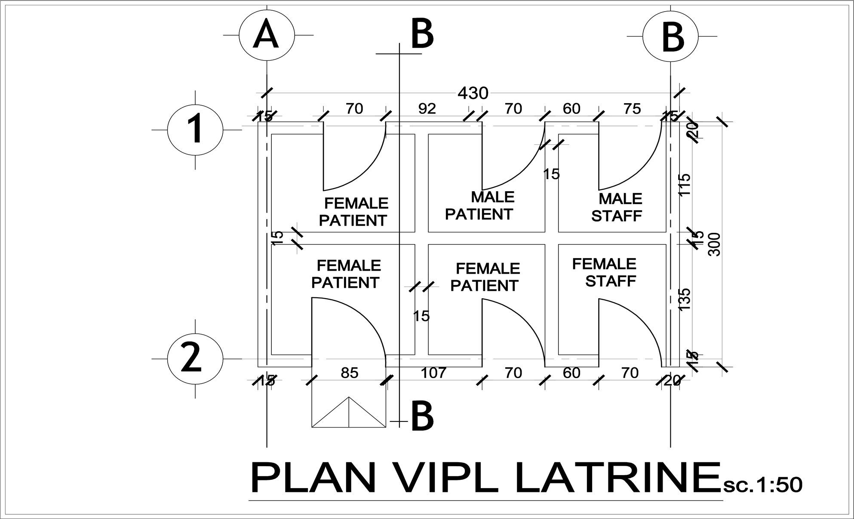
  - VIPL
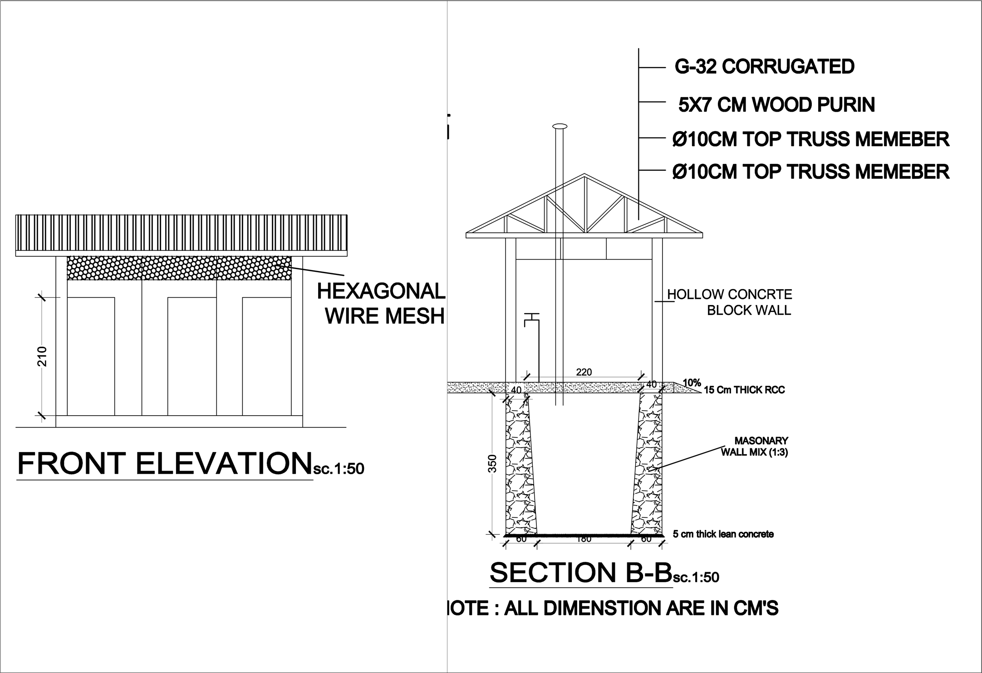

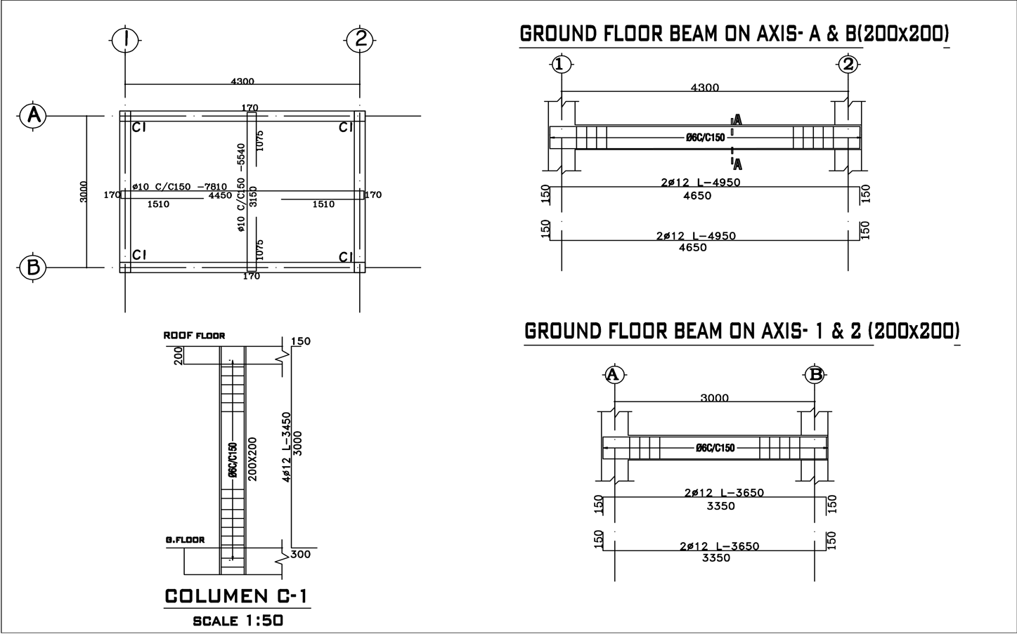

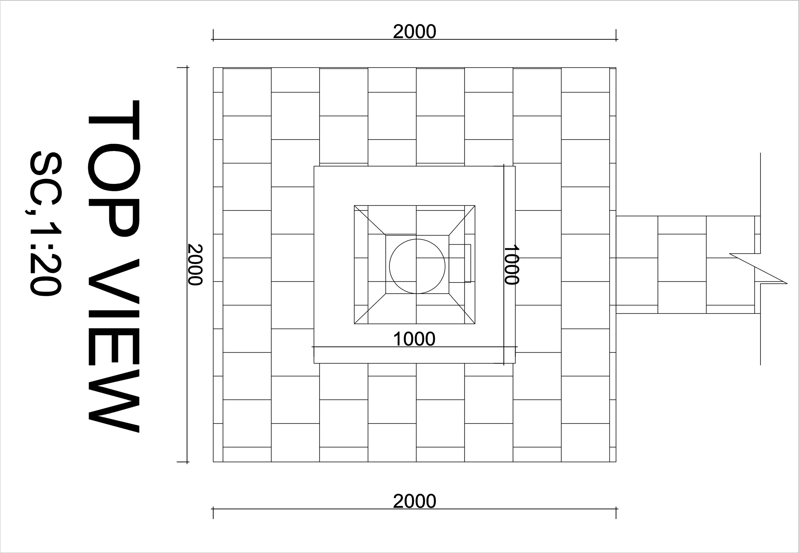
  - INCINERATOR
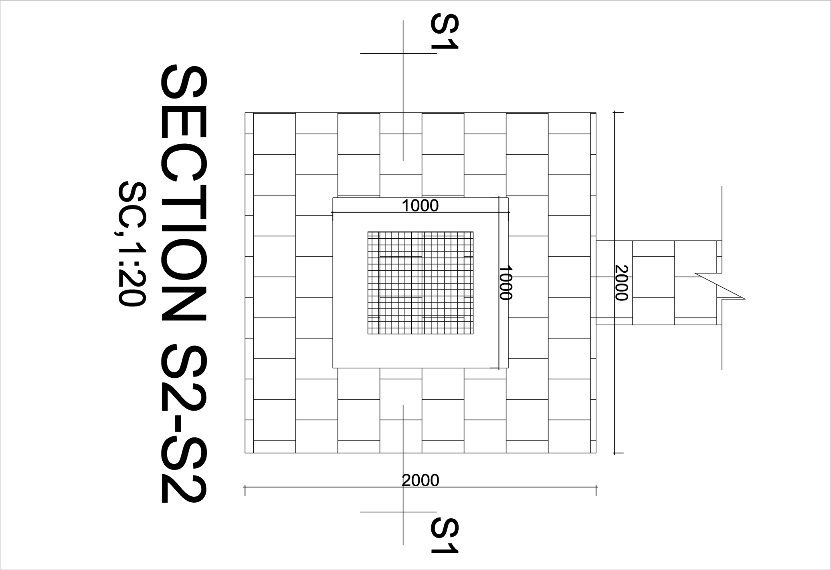

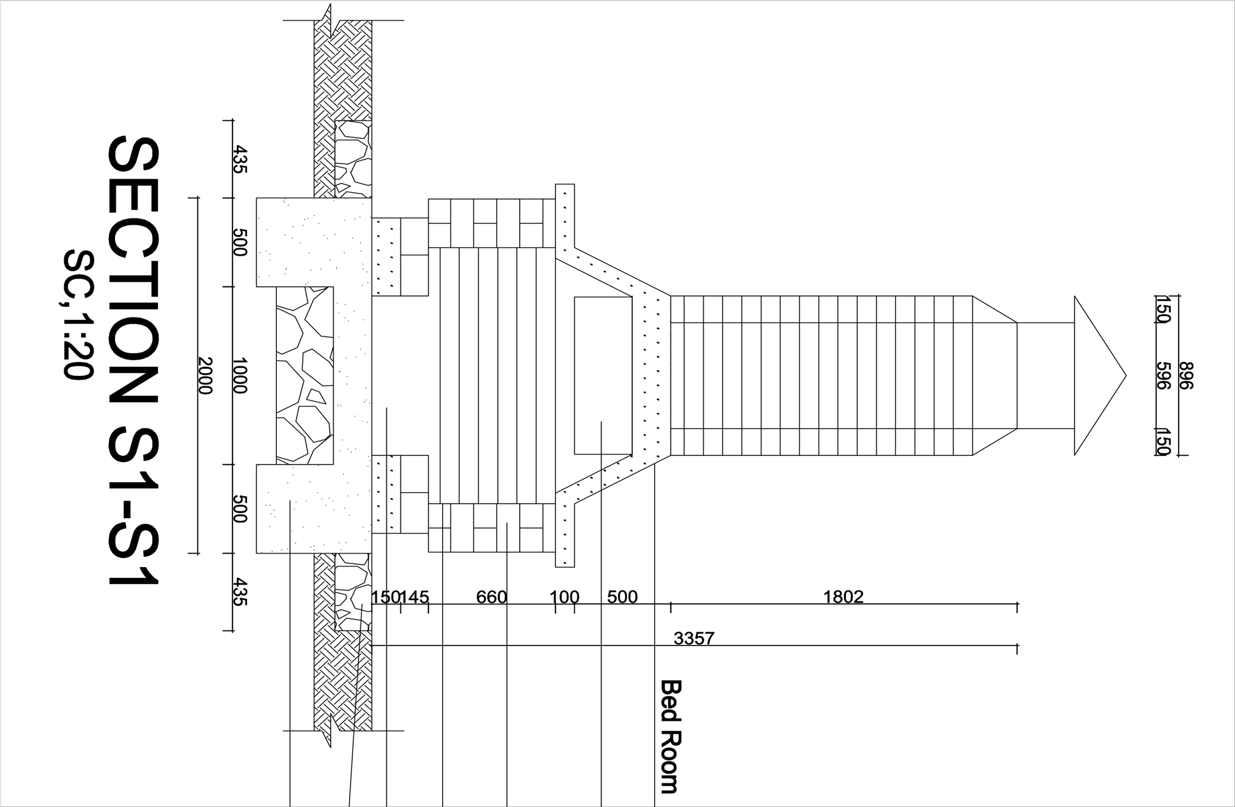
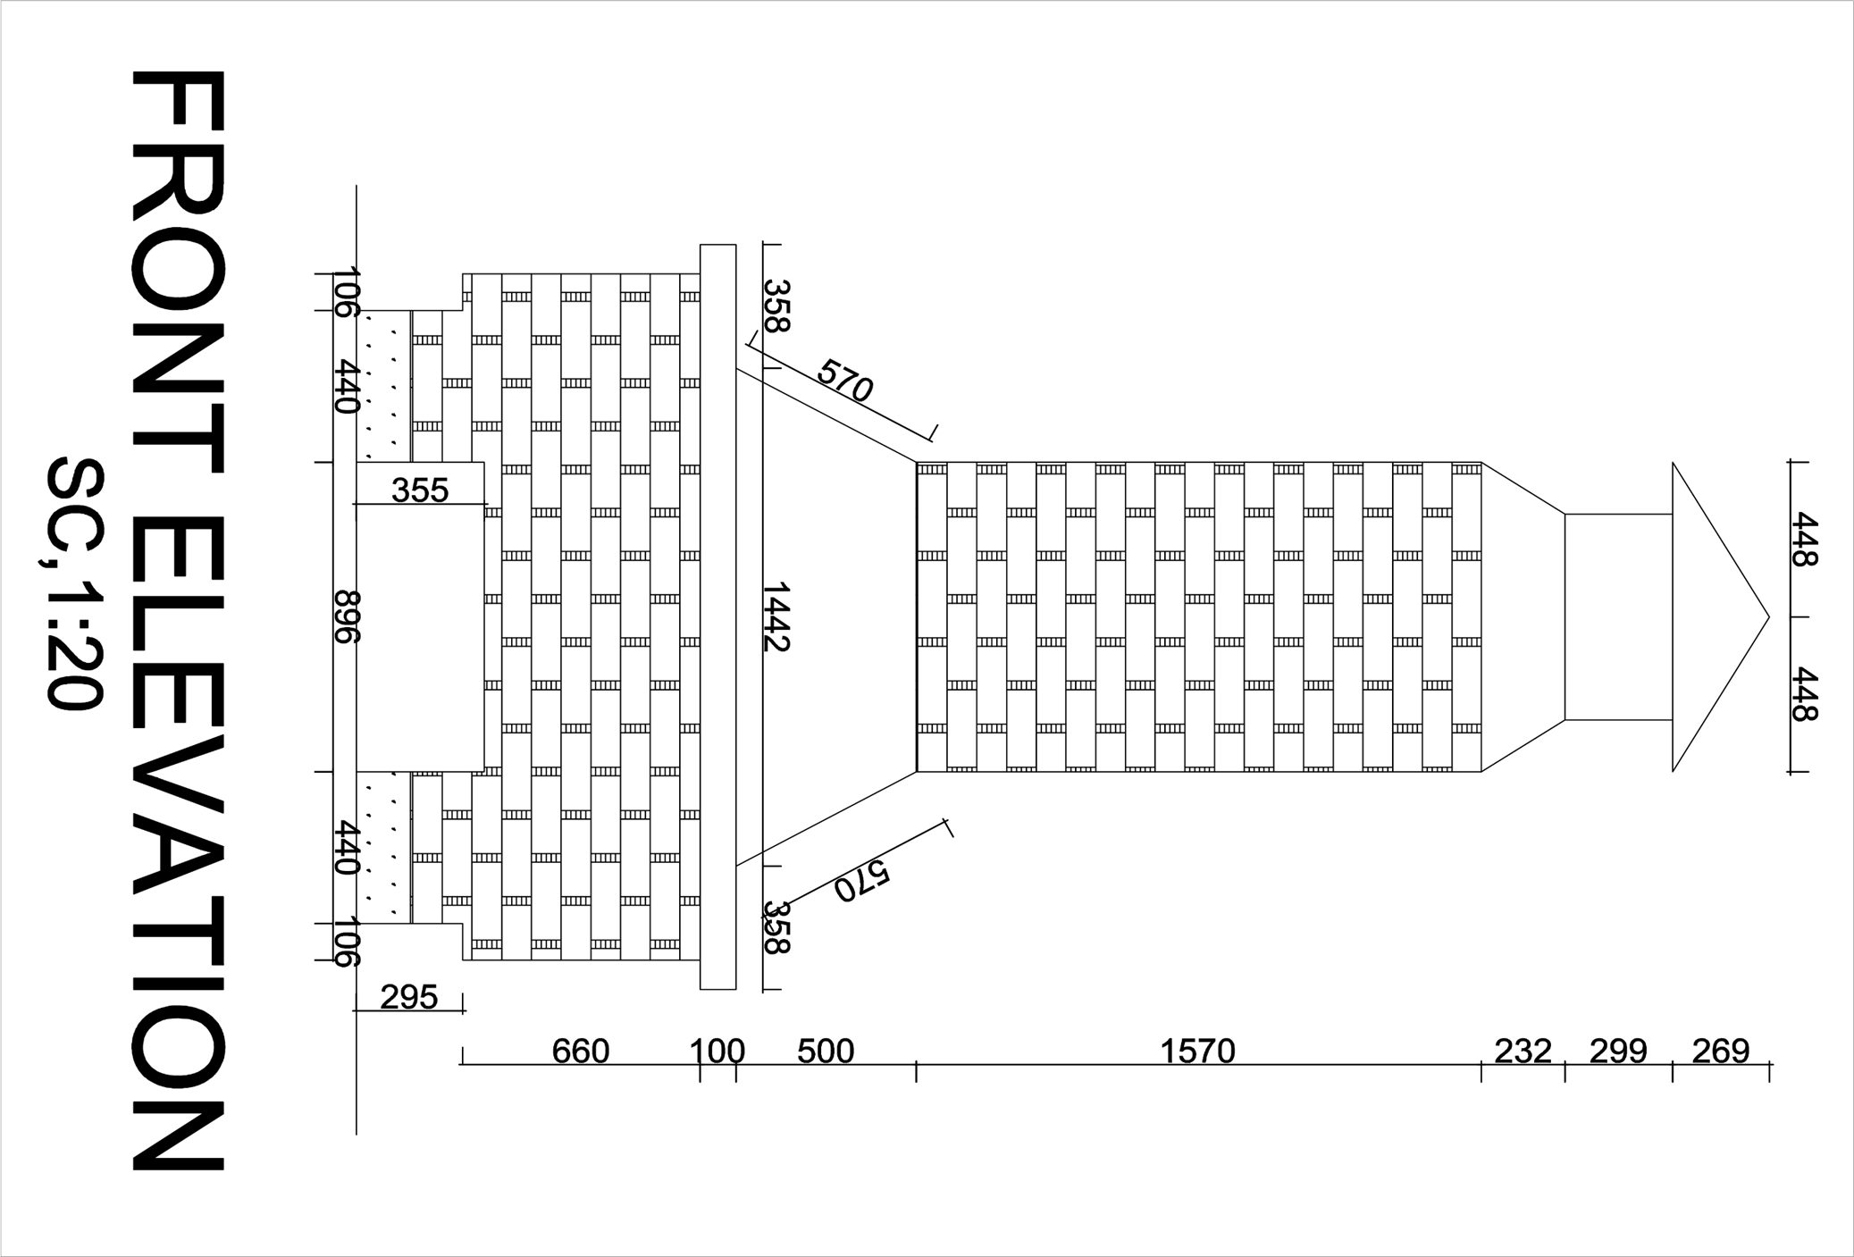

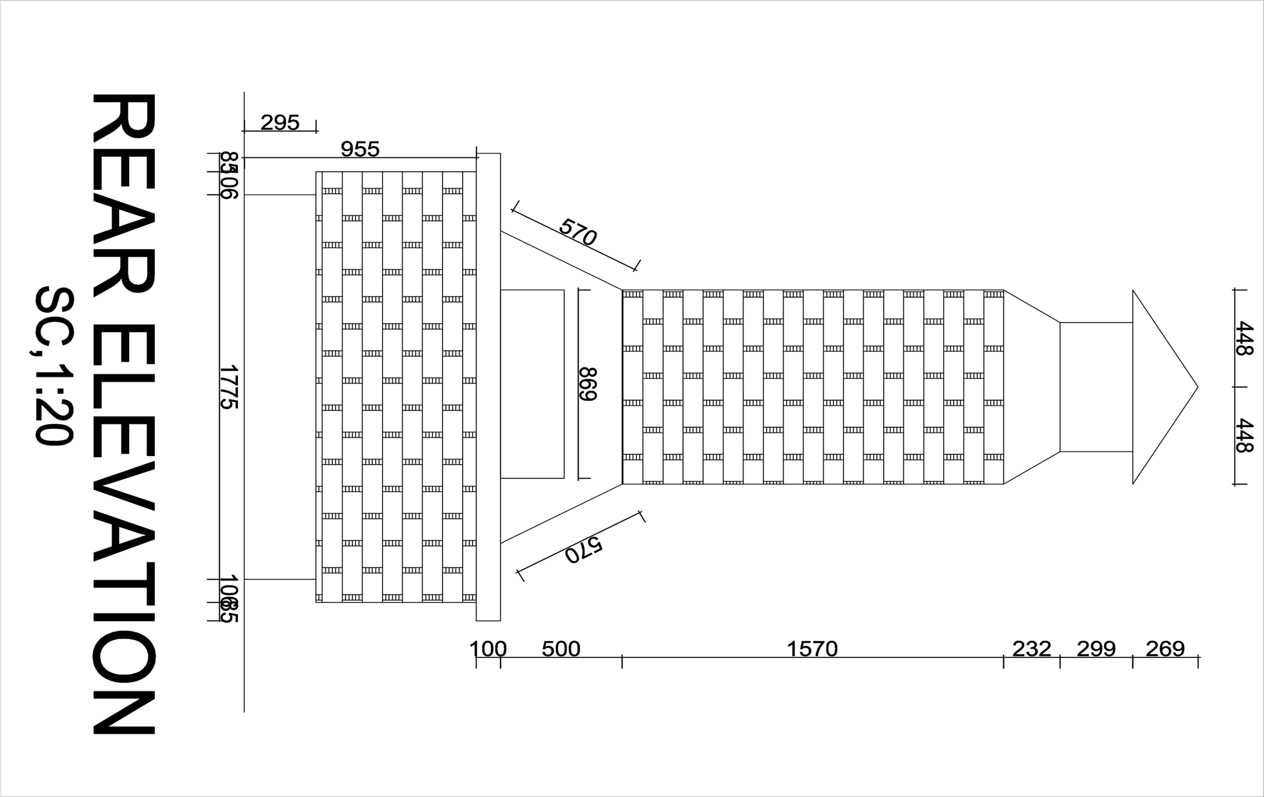

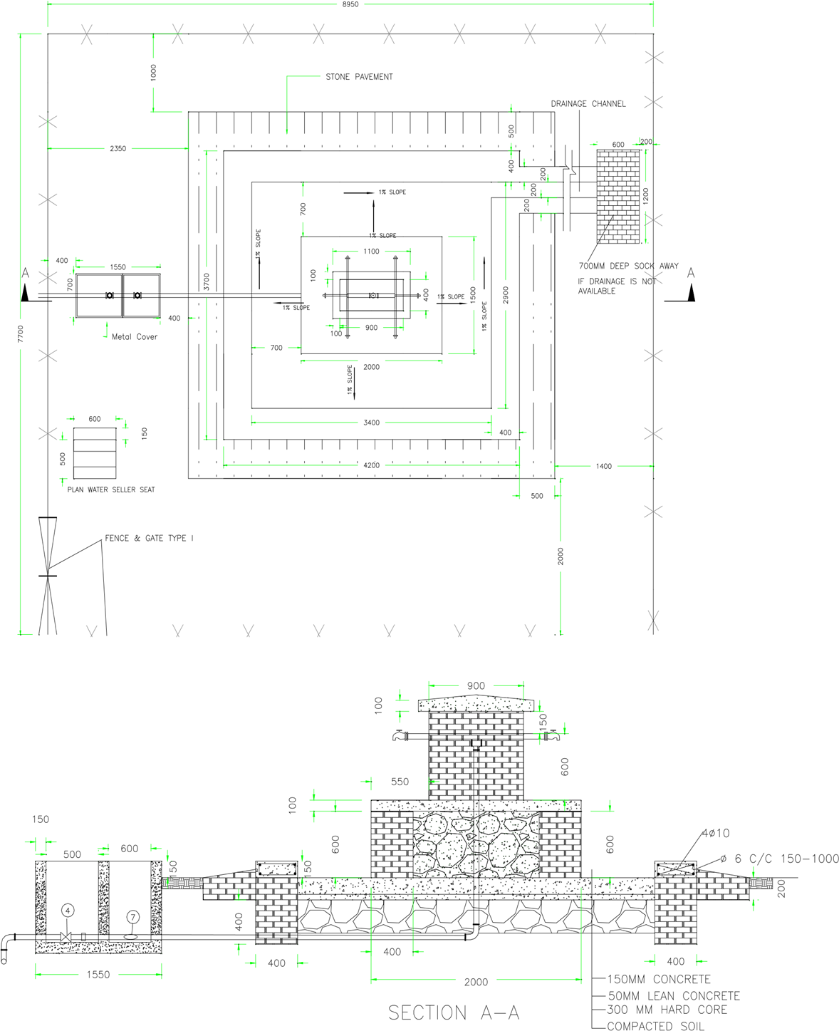
4.3 PUBLIC FOUNTAIN

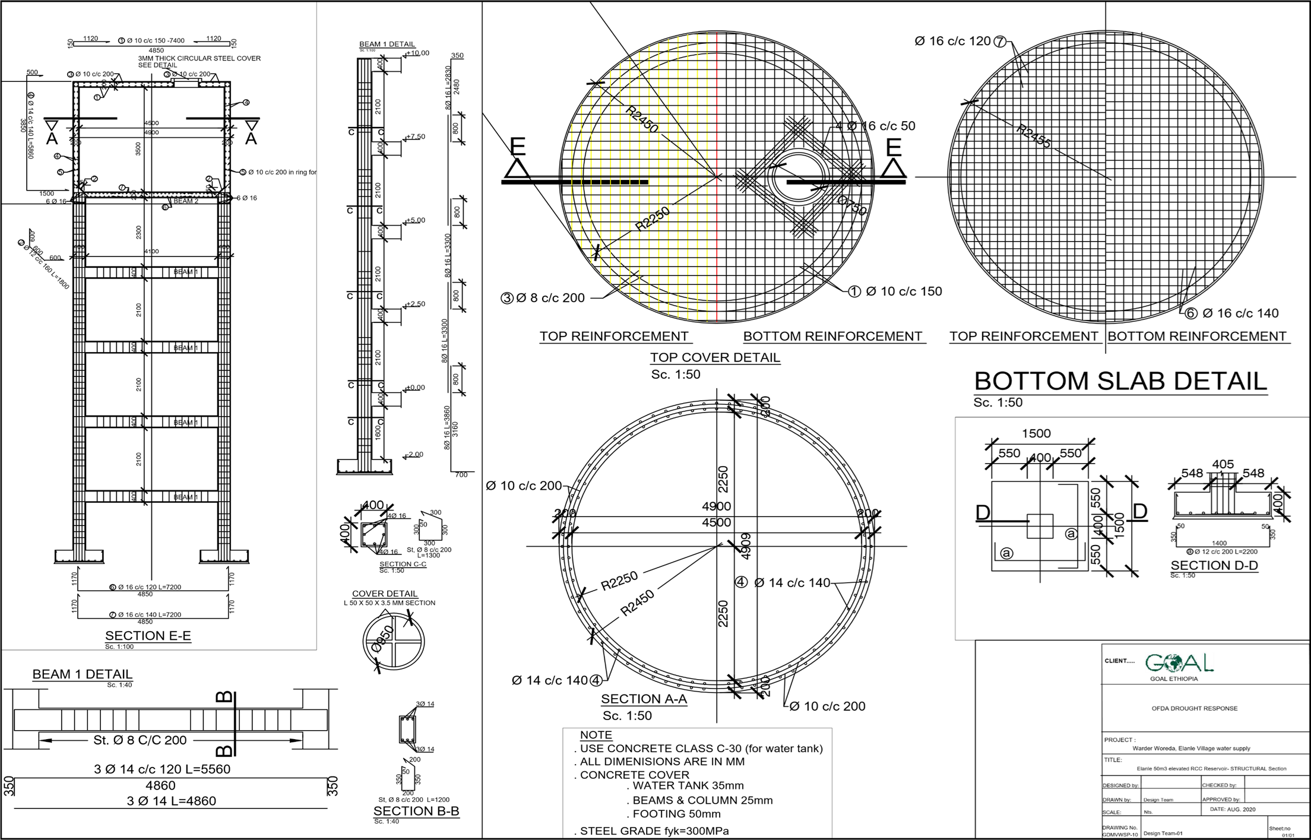
4.4 50m3 ELEVATED RCC RESERVIOR

APPENDIX 5 - GOAL TERMS AND CONDITIONS
- LEGAL STATUS
The Vendor shall be considered as having the legal status of an independent contractor vis-à-vis GOAL. The Vendor, its personnel and sub-contractors shall not be considered in any respect as being the employees of GOAL. The Vendor shall be fully responsible for all work and services performed by its employees, and for all acts and omissions of such employees.
II. SUB-CONTRACTING
In the event the Vendor requires the services of a sub-contractor, the Vendor shall obtain the prior written approval of GOAL for all sub-contractors. The Vendor shall be fully responsible for all work and services performed by its sub-contractors and vendors, and for all acts and omissions of such sub-contractors and vendors. The approval of GOAL of a sub-contractor shall not relieve the Vendor of any of its obligations under this Contract. The terms of any sub-contract shall be subject to and conform with the provisions of this Contract.
III. OBLIGATIONS
The Vendor shall neither seek nor accept instructions from any authority external to GOAL. Vendors may not communicate at any time to any other person, government or authority external to GOAL any information known to them by reason of their association with GOAL which has not been made public, except in the course of their duties or by authorization of the GOAL: nor shall Vendors at any time use such information to private advantage. These obligations do not lapse upon termination/expiration of their agreement with GOAL.
IV. ACCEPTANCE AND ACKNOWLEDGEMENT
Initiation of performance under this contract by the vendor shall constitute acceptance of the contract, including all terms and conditions herein contained or otherwise incorporated by reference.
V. WARRANTY
The Vendor warrants the goods furnished under this Contract to conform to the specifications and to be free from damage and defects in workmanship or materials. This warranty is without prejudice to any further guarantees that the Vendor provides to purchasers. Such guarantees shall apply to the goods subject to this Contract.
VI. INSPECTION
The duly accredited representatives of GOAL or the donor shall have the right to inspect the goods called for under this Contract at Vendor’s stores, during manufacture, in the ports or places of shipment, and the Vendor shall provide all facilitates for such inspection. GOAL may issue a written waiver of inspection at its discretion. Any inspection carried out by representatives of GOAL or the donor or any waiver thereof shall not prejudice the implementation of the other relevant provisions of this Contract concerning obligations subscribed by the Vendor, such as warranty or specifications.
VII. EXPORT LICENCE
The Contract is subject to the obtaining of any export licence or other governmental authorisation that may be required. It shall be the responsibility of the Vendor to obtain such licence or authorisation. GOAL may, at its discretion, use its best endeavours to assist.
VIII. OFFICIALS NOT TO BENEFIT
The Vendor represents and warrants that no official of GOAL has been, or shall be, offered by the Vendor any direct or indirect benefit arising from this Contract or the award thereof. The Vendor agrees that breach of this provision is breach of an essential term of this Contract.

IX FORCE MAJEURE
For the purposes of this Contract, force majeure means any act of God, act of war, civil disturbance, explosion, fire, any law or action taken by a government or public authority or other exceptional event which is unforeseeable in the circumstances, which cannot be overcome and which prevents, hinders or delays either party from performing any of its obligations under this Contract. As soon as possible and in any event within five (5) working days after the occurrence of a force majeure event, the affected party shall give notice and full particulars to the other party in writing. The affected party shall not be in breach of this Contract nor liable for delay in performing its obligations under this does Contract if and to the extent that such delay is directly caused by the force majeure event provided that such party uses best endeavour to limit the effect of the force majeure event on the performance of its obligations. If such a period of delay or non-performance by the Vendor continues for ten (10) working days, GOAL may terminate this agreement by giving five (5) days' written notice to the Vendor.
X. DEFAULT
In case of default by the Vendor, including, but not limited to, failure or refusal to make deliveries within the limit specified, GOAL may procure the goods or services from other sources, and hold the Vendor responsible for any excess cost occasioned thereby. Furthermore, GOAL may, by written notice, terminate the right of the Vendor to proceed with deliveries or such part or parts thereof as to which there has been default.
XI. REJECTION
In the case of goods or services purchased based on specifications or scope of works, GOAL shall have the right to reject the goods or services or any part thereof if they do not conform to specifications or the scope of works.
XII. AMENDMENTS
No change in or modification of this Contract shall be made except by prior agreement between the Responsible Buyer in GOAL and the Vendor.
XIII. ASSIGNMENTS
The Vendor shall not assign, transfer, pledge or make other disposition of this Contract or any part thereof or of any of the Vendor’s rights, claims or obligations under this Contract except with the prior written consent of GOAL.
XIV. INDEMNIFICATION
The Vendor agrees to indemnify, hold and save GOAL harmless and defend at its own expense GOAL, its officers, agents and employees from and against all suits, claims, demands and liability of whatever nature or kind, including costs and expenses thereof and liability arising there from, with respect to, arising from or attributable to acts or omissions of the Vendor or its employees or sub-contractors in or relating to the performance of this Contract. This provision shall extend to, but shall not be limited to, claims and liability in the nature of product liability claims.
GOAL will promptly notify the Vendor of any such suit, claim, proceeding, demand or liability within a reasonable period of time after having received written notice thereof, and will reasonably co-operate with the Vendor, at the Vendor’s expense, in the investigation, defence or settlement thereof, subject to the privileges and immunities of GOAL.
The Vendor shall not permit any lien, attachment or other encumbrance by any person or entity to remain on file in any public or official office or on file with GOAL against any monies due or to become due for any work done or materials furnished under this Contract, or by reason of any other claim or demand against the Vendor.

XV. DISPUTES - ARBITRATION
Any claim or controversy arising out of or relating to this or any contract resulting here from, or to the breach, termination or invalidity thereof, shall be, unless settled amicably through negotiation, submitted to arbitration in accordance with Ethiopian law.
XVI. USE OF NAME, EMBLEM OR OFFICIAL SEAL
Unless authorised in writing by GOAL, the Vendor shall not advertise or otherwise make public the fact that he is a Vendor to GOAL or use the name, emblem or official seal of GOAL or any abbreviation of the name of GOAL for advertising purposes or for any other purposes.
XVII. LIQUIDATED DAMAGES
Late delivery, or dispatch outside the agreed shipping schedule, shall be subject, without notice, to an assessment of liquidated damages equivalent to 1 percent of the Contract value per day or part thereof. GOAL has the right to deduct this amount from the Vendor’s outstanding invoices, if any. This remedy is without prejudice to any others that may be available to GOAL, including cancellation, for the Vendor’s non-performance, breach or violation of any term or condition of the Contract.
Acceptance of goods delivered late shall not be deemed a waiver of GOAL’s rights to hold the Vendor liable for any loss and/or damage resulted therefrom, nor shall it act as a modification of the vendor’s obligation to make future deliveries in accordance with the delivery schedule.
XVIII. ANTI-BRIBERY/CORRUPTION
The Vendor shall comply with all applicable laws, statutes and regulations relating to anti-bribery and anti-corruption including but not limited to the UK Bribery Act 2010 and the the United States Foreign Corrupt Practices Act 1977 (“Relevant Requirements”).
The Vendor shall have and maintain in place throughout the term of any contract with GOAL its own policies and procedures to ensure compliance with the Relevant Requirements.
No monies are payable to GOAL by the Vendor in association with the execution of this contract. If the Vendor is approached by a GOAL member of staff for a payment, commission, ‘kickback’ or associated payment or any other advantage of any kind, they are obliged to report the request or payment directly to GOAL’s Country Director within thirty-six hours. Failure to report any request for payment by a GOAL member of staff or actual payment by the Vendor to a GOAL member of staff to the GOAL Country Director shall result in the immediate termination of any contract and may result in disqualification of the Vendor from participation in future contracts with GOAL.
XIX. ANTI-PERSONNEL MINES
The Vendor guarantees that it is not engaged in the sale or manufacture, either directly or indirectly, of anti-personnel mines or any components produced primarily for the operation thereof. Any breach of this representation and warranty shall entitle GOAL to terminate this Contract immediately upon notice to the Vendor, at no cost to GOAL.
XX. ETHICAL PROCUREMENT
The Vendor represents and warrants that neither it, nor any of its vendors is engaged in any practice inconsistent with the following code of conduct for vendors: Employment is freely chosen, freedom of association and the right to collective bargaining are respected, working conditions are safe and hygienic, no child labour/protection of children is ensured, living wages are paid, working hours are not excessive, no discrimination is practiced, regular employment is provided, no harsh or inhumane treatment is allowed, any harm to the environment shall be avoided or limited. Any breach of this representation and warranty shall entitle GOAL to terminate this Contract immediately upon notice to the Vendor, at no cost to GOAL.
XXI. VENDOR INELIGIBILITY
Candidates that fall into any of the following categories are ineligible to participate in GOAL procurement processes: (a) They are bankrupt or being wound up, are having their affairs administered by the courts, have entered into an arrangement with creditors, have suspended business activities, are the subject of proceedings concerning those matters, or are in any analogous situation arising from a similar procedure provided for in national legislation or regulations; (b) They have been convicted of an offence concerning their professional conduct by a judgement that has the force of res judicata; (c) They have been guilty of grave professional misconduct proven by any means that the contracting authority can justify; (d) They have not fulfilled obligations relating to the payment of social security contributions or the payment of taxes in accordance with the legal provisions of the country in which they are established or with those of the country of the contracting authority or those of the country where the contract is to be performed; (e) They have been the subject of a judgement that has the force of res judicata for fraud, corruption, involvement in a criminal organisation or any other illegal activity; (f) Following another procurement procedure or grant award procedure, they have been declared to be in serious breach of contract for failure to comply with their contractual obligations;
XXII. VENDOR EXCLUSION
Negotiation with vendors or potential vendors may be severed at any stage during a procurement process if it is found that they meet either of the following exclusion criteria: (a) Are subject to a conflict of interest; (b) Are guilty of misrepresentation in supplying the information required by GOAL as a condition of participation in the contract procedure, or fail to supply all of the information requested.
XXIII. PRIOR NEGOTIATIONS SUPERSEDED BY CONTRACT
This Contract supersedes all communications, representations, arrangements, negotiations, requests for proposals and proposals related to the subject matter of this Contract.
XXIV. INTELLECTUAL PROPERTY INFRINGEMENT
The Vendor warrants that the use or supply by GOAL of the goods sold under this Contract does not infringe on any patent, design, tradename or trademark. In addition, the Vendor shall, pursuant to this warranty, indemnify, defend and hold GOAL harmless from any actions or claims brought against GOAL pertaining to the alleged infringement of a patent, design, trade-name or trade-mark arising in connection with the goods sold under this Contract.
XXV. TITLE RIGHTS
GOAL shall be entitled to all property rights including but not limited to patents, copyrights and trademarks, with regard to material which bears a direct relation to, or is made in consequence of, the services provided to the organisation by the Vendor. At the request of GOAL, the Vendor shall take all necessary steps, execute all necessary documents and generally assist in securing such property rights transferring them to the organisation in compliance with the requirements of the applicable law.
Title to any equipment and supplies which may be furnished by GOAL and any such equipment shall be returned to GOAL at the conclusion of this Contract or when no longer needed by the Vendor. Such equipment, when returned to GOAL, shall be in the same condition as when delivered to the Vendor, subject to normal wear and tear.
XXVI. PACKING
The Vendor shall pack the goods with new, sound materials and with every care, in accordance with the normal commercial standards of export packing for the type of goods specified herein. Such packing materials used must be adequate to safeguard the goods while in transit. The Vendor shall be responsible for any damage or loss that can be shown to have resulted from faulty or inadequate packing.
XXVII. INSURANCE
The vendor shall provide and thereafter maintain for the duration of this contract and any extension thereof all appropriate workmen’s compensation insurance or its equivalent with respect to its employees to cover claims for personal injury and death in connection with this contract. The vendor shall, upon request, furnish proof to the satisfaction of the GOAL, of such liability insurance. The vendor shall further provide such health and medical insurance for its agents and employees, as the vendor may consider advisable.
The Vendor shall have in force and maintain in force during the term of this Contract adequate public liability insurance, product liability insurance and other insurance policies required in connection with its business and in respect of the products and/or services supplied by the Vendor.
XXVIII. TERMINATION OF CONTRACT
Termination without default: Either party may terminate this Contract by giving notice in writing to the other party in accordance with this clause XXVIII. The required period of notice shall be five (5) working days in the case of contracts for a total period of less than two months or fifteen (15) working days in the case of contracts for a longer period. In addition, GOAL may terminate this Contract with immediate effect by giving notice in writing to the Vendor if there is a discontinuation or termination (in whole or in part) of donor funding related to this Contract. In the event of the Contract being terminated in accordance with this sub-clause, the Vendor shall be compensated on a pro rata basis for no more than the actual amount of work performed to the satisfaction of GOAL. Additional costs incurred by GOAL resulting from the termination of the Contract by the Vendor may be withheld from any amount otherwise due to the Vendor from GOAL.
Termination with default: Without prejudice to GOAL’s right to terminate this Contract with immediate effect provided for elsewhere in this Contract, GOAL may terminate this Contract with immediate effect without compensation by giving notice in writing to the Vendor where the Vendor: (i) commits a material breach of this Contract which cannot be remedied or has not been remedied within a period of seven (7) days after being notified in writing by GOAL; (ii) ceases to carry on the whole or a substantial part of its business, becomes unable to pay its debts as they fall due, becomes insolvent, enters into any compromise or arrangement with its creditors (other than in the context of solvent reconstruction or amalgamation), is the subject of a resolution to wind up or winding up proceedings, has an administrator, examiner or receiver appointed in respect of some or all of its assets, or being an individual, is the subject of a bankruptcy petition, or any event occurs, or proceeding are taken, with respect to the Vendor in any jurisdiction to which it is subject that has an effect equivalent or similar to any of the foregoing; (iii) commits an offence under anti-terrorism, anti-bribery/corruption or anti-money laundering legislation in any jurisdiction or is involved in organised crime or illegal activity; or (v) undergoes a change of control. GOAL’s termination of this Contract for default whether under this or another provision of this Contract shall be without prejudice to GOAL’s other rights, including but not limited to the right to claim for costs and losses incurred.
XXIX. ASSIGNMENT OF PERSONNEL
The Contractor shall not assign any persons other than those accepted by GOAL for work performed under this Contract.
XXX. OVERRIDING CLAUSE
In the event of any conflict or inconsistencies between these Terms and Conditions or any other document which forms part of the Contract, the contract shall prevail except where they have been amended (by specific reference to the relevant clause and paragraph of these Terms and Conditions) as provided for herein.

XXXI. WITHHOLDING TAX
GOAL reserves the right to deduct withholding tax from the vendor's invoice if so required by law. This will apply unless the vendor has supplied in advance the required documentation proving its exemption from withholding tax (e.g. withholding tax exemption certificate).
- ACCESS TO DOCUMENTATION
GOAL, its donors or any of their duly authorized representatives, shall have access to any books, documents, papers, and records of the vendor which are directly pertinent to the specific program for the purpose of making audits, examinations, excerpts and transcriptions

Signed:
Print name: |  | Position:
Company Name: |  | Date:
Address:

Appendix 6- Assessment check list

6.1 Specify the number of staff and labour force:
That you had employed when you started your business |  |  |  |  | That you have employed currently
Engineers / Technicians | Site Supervisor | Operators + Drivers | Skilled Labourers | Unskilled Labourers | Engineers / Technicians | Site Supervisor | Equipment Operators | Skilled Labourers | Unskilled Labourers

6.2 Specify the types and numbers of your equipment:
That you were owning when you started your business: | That you are owning now:
- …………………………………………………………...  - …………………………………………………………...  - …………………………………………………………...  - …………………………………………………………...  - …………………………………………………………...  - …………………………………………………………...  - …………………………………………………………...  - …………………………………………………………...  - …………………………………………………………...  - …………………………………………………………... | - …………………………………………………………...  - …………………………………………………………...  - …………………………………………………………...  - …………………………………………………………...  - …………………………………………………………...  - …………………………………………………………...  - …………………………………………………………...  - …………………………………………………………...  - …………………………………………………………...  - …………………………………………………………...
6.3 In case you (also) hire equipment, please specify the typical equipment sets that you hire for road works:
- ………………………………………………………….............................................................................................
- ………………………………………………………….............................................................................................
- ………………………………………………………….............................................................................................
- ………………………………………………………….............................................................................................
- ………………………………………………………….............................................................................................
- ………………………………………………………….............................................................................................

  - Do you have your own company infrastructure, e.g. workshop, office, stores, etc.?
yes no
If yes, please specify:
Infrastructure when you started your business: | Infrastructure you are using now:
- …………………………………………………………...  - …………………………………………………………...  - …………………………………………………………...  - …………………………………………………………...  - …………………………………………………………...  - …………………………………………………………...  - …………………………………………………………...  - …………………………………………………………... | - …………………………………………………………...  - …………………………………………………………...  - …………………………………………………………...  - …………………………………………………………...  - …………………………………………………………...  - …………………………………………………………...  - …………………………………………………………..  - …………………………………………………………...
Note: behind each item indicate in brackets (o) for owning and (h) for hiring

  - Please specify a breakdown of the most important hand tools you own (type and number):
Hand tools you owned when you started your business: | Hand tools you are owning now:
- …………………………………………………………...  - …………………………………………………………...  - …………………………………………………………...  - …………………………………………………………...  - …………………………………………………………...  - …………………………………………………………...  - …………………………………………………………...  - …………………………………………………………...  - …………………………………………………………...  - …………………………………………………………...  - …………………………………………………………...  - …………………………………………………………...  - …………………………………………………………...  - …………………………………………………………...  - …………………………………………………………... | - …………………………………………………………...  - …………………………………………………………...  - …………………………………………………………...  - …………………………………………………………...  - …………………………………………………………...  - …………………………………………………………...  - …………………………………………………………..  - …………………………………………………………...  - …………………………………………………………...  - …………………………………………………………...  - …………………………………………………………...  - …………………………………………………………...  - …………………………………………………………...  - …………………………………………………………...  - …………………………………………………………..

