Invitation to Tender ITT (ITT) for the supply of an E-Transfer Platform for GOAL’s Syria Programme

REF: G-SY-ANT-V-21120

GOAL is completely against fraud, bribery and corruption

GOAL does not ask for money for bids. If approached for money or other favours, or if you have any suspicions of attempted fraud, bribery or corruption please report immediately to email speakup@goal.ie

Please provide as much detail as possible with any reports

About GOAL and our requirements
Established in 1977, GOAL is an international humanitarian and development agency committed to working with communities to achieve sustainable and innovative early response in crises and to assist them to build lasting solutions to mitigate poverty and vulnerability. GOAL has worked in over 60 countries and responded to almost every major humanitarian disaster. We are currently operational in 13 countries globally. For more information on GOAL and its operations please visit www.goalglobal.org.

About the Programme
GOAL has been operating in Idleb and Northern Aleppo and neighbouring areas since 2013 across a portfolio of emergency, food security, WASH and shelter response. GOAL’s Food Security programme in North Western Syria targets up to 30,000 households with regular food aid through predominantly repeat voucher distributions for a period of up to 9 months. GOAL also seeks to support these circa 30,000 households annually through one-off cash distributions for the newly displaced through its emergency programme portfolio.

GOAL has confirmed the availability of funding to engage a service provider to provide a digital platform that will allow GOAL to transition its one-off cash and repeat voucher beneficiaries from paper to E-transfer in North West Syria. The estimated amount on a monthly basis would be USD60 per household for food vouchers, and USD60 to 90 per household every 2 to 3 months for repeat cash assistance. The first date of this distribution for a certain percentage of Households is planned for July 1st, 2020 depending on when a suitable service provider can be appointed and preparatory works completed.
GOAL’s longer-term programming objective is that the e-voucher system will be further expanded to cover other types of humanitarian assistance that GOAL provides, such as hygiene commodities, emergency cash assistance etc. Expansion will be dependent on the success of the e-voucher system for food commodities/repeat cash assistance.
Due to the ongoing conflict in GOAL’s Area of Operation in Northern Syria this is a high-risk environment from a security perspective. However, GOAL’s experience in successfully delivering large scale humanitarian programming in this context since 2013 means GOAL has an extensive risk mitigation framework in place. In Idleb, where the majority of GOAL’s programming occurs, there is no functioning banking system and a network of cash agents is used in its place. The internet available is supplied primarily from Turkey and while strong it is not reliable at all times. At time of writing the global COVID-19 emergency is still unfolding and is obviously also a major consideration in terms of access restrictions in Northern Syria and impacts to global supply chains.
Our Requirements
GOAL is seeking to commercially engage an experienced E-transfer platform provider to provide and maintain the necessary hardware, software, connectivity and technical support to facilitate the transition of GOAL’s repeat cash and voucher assistance to E-transfer in Northern Syria.
Full details of GOAL’s requirements are attached as Annex 1 - Scope of work (SOW) to this ITT document.

Contractual Engagement
Once a supplier has been formally selected and approved following the evaluation steps outlined in section 4 of this ITT document, the supplier will be contractually engaged under a GOAL Standard Form Framework Agreement (FWA). The preferred bidder(s) will be required to enter into a Framework Agreement with GOAL on the conditions set out in the Financial Offer to this ITT, the GOAL Standard Terms and Conditions and other documents which form the mandatory requirements for response. The GOAL standard form FWA and GOAL Standard Terms and Conditions are included for reference as Annex’s 2 and 3 respectively.

Provisional Timelines
Line | Item | Date
1 | ITT Published | Monday 27th April 2020
2 | Closing Date for Clarification Requests | Tuesday 5th May 12pm Dublin Time
3 | Closing Date and Time for Receipt of Tenders | Monday 25th May 2020 at 10am Dublin Time
4 | Tender Opening Location | GOAL HQ Dublin, Ireland
5 | Tender Opening Date and Time | Monday 25th May 2020 at 2pm Dublin Time
6 | Tender Evaluation Period Including Demonstrations | Tuesday 26th May 2020 to Monday 22nd June 2020
7 | Tender Award and Contract Sign Off | Week Commencing Monday 22nd June 2020
8 | Preparatory Works and Contract Delivery | Week Commencing Monday 29th June 2020

Terms of the Procurement

Procurement Process

This competition is being conducted as a restricted Invitation to Tender (ITT)

The Contracting Authority for this procurement is GOAL.

Clarifications and Query Handling

Requests for additional information or clarifications can be made up to 12pm Dublin time on Tuesday 5th May 2020 and no later. Any queries about this ITT should be addressed in writing to GOAL via email on clarifications@goal.ie, referencing the tender number, and answers shall be collated and shared with all bidders in a timely manner.

Conditions for completing the ITT.

All documentation must be completed in English.

Suppliers must respond to all requirements set out in this document and complete their offer in the format provided.

Failure to complete any documentation in the required format will, in almost all circumstances, result in the rejection of the tender. Failure to re-submit correctly formatted documents within three working days of a request will result in disqualification.

Suppliers must disclose all relevant information to ensure that all submissions are fairly and legally evaluated. Suppliers must provide details of any implications they know or believe their response will have on the successful operation of the contract or on the normal day-to-day operations with GOAL. Any attempt to withhold any information that the supplier knows to be relevant or to mislead GOAL or its evaluation team in any way will result in the disqualification.

Suppliers must detail all costs requested in this document and any other costs whatsoever that could be incurred by GOAL in the usage of services or the availing of options that may not be explicitly identified in the ITT. Supplier’s attention is drawn to the fact that, in the event of a contract being awarded to them, the attempted imposition of undeclared costs will be considered a condition for default.

Any conflicts of interest (including any family relations to GOAL staff) involving a supplier must be fully disclosed to GOAL particularly where there is a conflict of interest in relation to any recommendations or proposals put forward by the supplier.

GOAL will not be liable in respect of any costs incurred by suppliers in the preparation and submission of tenders or any associated work effort.

GOAL will conduct the ITT, including the evaluation of responses and final awards in accordance with the criteria set out in the ITT. Submissions will be opened by at least three designated officers of GOAL.

GOAL is not bound to accept any tender submitted.

GOAL reserves the right to split the award of any resulting contract between different suppliers in any combination it deems appropriate, at its sole discretion.

Suppliers will seek written approval from GOAL before entering into any sub-contracts for the purpose of fulfilling any resulting contract. Full details of the proposed subcontracting company and the nature of their services will be included in the written request for approval. Written requests for approval must be submitted in accordance with the conditions set out in any subsequent contract.

GOAL reserves the right to refuse any subcontractor that is proposed by the supplier.

GOAL reserves the right to negotiate with the supplier who has submitted the lowest bid that fully meets requirements for the purpose of seeking revisions of such bid to enhance its technical aspects and to reduce the price.

Information supplied by suppliers will be treated as contractually binding. However, GOAL reserves the right to seek clarification or verification of any such information.

GOAL reserves the right to terminate the tender process at any stage.

Unsuccessful suppliers will be notified.

GOAL’s standard payment terms are by bank transfer within 30 days after satisfactory implementation and receipt of documents in order. Satisfactory implementation is decided solely by GOAL.

This document is not construed in any way as an offer to contract.

GOAL and all suppliers appointed to restricted lists, must act in all its procurement and other activities in full compliance with GOAL’s donor requirements. Any contracts that arise from the ITT may be financed by multiple donors including USAID or their agents who have rights of access to GOAL and any of its suppliers or contractors for audit purposes. Donors may also have additional regulations that it are not practical to list here. Submission of an offer under the ITT assumes acceptance of these conditions.

GOAL does not engage in transactions with any terrorist group or individual or entity involved with or associated with terrorism or individuals or entities that have active exclusion orders or sanctions against them. GOAL will not purchase supplies or services from suppliers that are associated in any way with terrorism or are the subject of any international exclusion orders or sanctions. All suppliers making submissions under the ITT guarantee that neither they nor any affiliate or a subsidiary controlled by them are associated with any known terrorist group or are the subject of any international exclusion order or sanctions. Any contract entered into subsequent to the ITT will reflect this requirement.

Submission of ITT
Submissions must be delivered electronically in the following way:
Electronically to hqtenders@goal.ie and in the subject field state:
  - G-SY-ANT-V-21120
  - Name of supplier
  - Number of emails that are sent e.g. 1 of 3, 2 of 3, 3 of 3.
Suppliers will receive an automatic reply from hqtenders@goal.ie when the emails are electronically submitted. Proof of sending is not proof of receipt. GOAL accepts no responsibility for technical or system malfunctions that prevent bids from being properly received. Late delivery will result in your bid being rejected. All information provided must be perfectly legible. Please see Section 5 of this ITT document for specific instructions on the submission of the various forms that will form the overall tender.

Tender Opening Meeting
All submissions will be opened at 2pm Dublin time, Monday 25th May 2020 at the following location:
GOAL Head Office,
First Floor, Carnegie House,
Library Road,
Dun Laoghaire,
Co. Dublin,
A96 C7W7,
Republic of Ireland

One authorised representative of each supplier may attend the opening of the bids. Companies wishing to attend must notify GOAL of their intention by sending an e-mail 48 hours in advance to the following e-mail address: procurement@goal.ie. This notification must be signed by an authorised officer of the supplier and specify the name and role of the person who will attend the opening of the bids on the supplier's behalf.
Suppliers are invited to attend at their own cost. Due to the evolving nature of the Covid19 situation, companies who send an email to notify their intention to attend will be informed by return of email whether the tender public opening will proceed. This decision will be in line with local government regulations and GOAL’s health and safety decision at that time.

Evaluation Process

Evaluation Criteria

Phase # | Evaluation Process Stage | The basic requirements with which proposals must comply with
1 | Administrative  Instructions  (Pass/Fail) | - Closing Date:  Submissions must have met the deadline stated in Section 2 of this document, or such revised deadline as may be notified by GOAL.  - Submission Method:  Submissions must be delivered in the method specified in Sections 3.4 and 5 of this ITT document.  - Format and Structure of the Proposals:  Submissions must conform to the response format laid out in Section 5 of this document, and the Appendices, or such revised format and structure as may be stipulated by GOAL. Failure to comply with the prescribed format and structure may result in the submission being rejected.  - Confirmation of validity of your proposal:  The supplier must confirm that their proposal is valid for 120 days.
2 | Essential Criteria  (Pass/Fail) | - Supplier can meet minimum mandatory technical requirements of specifications included in the Scope of Work (SOW) attached as Annex 1 to this ITT document.  - Supplier has clearly demonstrated the ability to deliver and support the platform in Northern Syria.
3 | Award Criteria (Technical, Non-Price) | - Proven track record of delivery.  - Relevant sector specific technical experience & qualifications.  - Proposed Project Plan and Methodology.  Following initial evaluation of the tendered submissions, GOAL may invite shortlisted tenderers to present to the relevant committee and technical advisors. These presentations will most likely be via virtual meeting and full instruction will be given to shortlisted tenderers in advance.  GOAL will also require the ability to work on a demo system to inform its technical evaluations.
Following Technical Non-Price Scoring, GOAL will form a shortlist based on the top scoring suppliers who will then compete based on a Total Cost of Ownership (TCO) financial comparison
4 | Award Criteria (Price) | GOAL will compare Financial Offers based a Total Cost of Ownership (TCO) financial analysis. See Appendix 10_Financial Offer for further details.  Failure to submit all the requested information relating to your Financial Offer will almost certainly mean the offer is set aside.
Due Diligence Checks take place throughout the evaluation process.
5 | Due Diligence Criteria (Pass/Fail) | In-depth review of legal and financial due diligence information submitted. Supplier is assessed to have requisite financial stability and legal status.
6 | Qualification Criteria (Pass/Fail) | All due diligence checks are found to be clear, including but not limited to Anti-Terrorist and Sanctions Checks.

Response Format
In order to make submissions for the ITT as easy as possible for suppliers and for evaluation by GOAL, GOAL has prepared forms which are included as Appendices 1-10. Any additional information submitted others than these forms will be reviewed at the discretion of GOAL.
All submissions must conform to the response format set out in this document. Where a submission does not conform to the required format, the supplier will be requested to resubmit it in the correct format, on the understanding that the resubmission cannot contain any material change from the original. Failure to resubmit in the correct format within three working days may result in disqualification.
By responding to the ITT, the supplier accepts the terms and conditions of the ITT. Should a supplier not comply with these requirements, GOAL may, at their sole discretion, reject the response.

Submission Checklist
Please ensure that you have read and thoroughly understand the instruction given in the table below. Failure to comply with this instruction will almost certainly mean your submission will be unsuccessful. GOAL will accept digital signatures where signatures are requested.
Line | Document to be Submitted | Administrative Instructions for Submission
1 | Appendix 1: Company Information | Complete and return as separate PDF entitled ‘Appendix 1 Company Information’.
2 | Appendix 2: Declaration re Personal and Legal Circumstances | Complete, sign and return as separate PDF entitled ‘Appendix 2 Declaration Personal & Legal’.
3 | Appendix 3: Self Declaration of Finance and Tax | Complete, sign, and return as separate PDF entitled ‘Appendix 3 Declaration Finance & Tax’.
4 | Appendix 4: ITT Statement | Complete, sign and return as separate PDF entitled ‘Appendix 4 ITT Statement’.
5 | Appendix 5: Technical Requirements Response | Completed Excel Spreadsheet and supporting PDF’s or weblinks
6 | Appendix 6: Previous Contracts | Complete and return as separate PDF entitled ‘Appendix 6 Previous Contracts’.
7 | Appendix 7: Nominated Personnel | Complete and return as separate PDF entitled ‘Appendix 7 Nominated Personnel’.
8 | Appendix 8: Demo System | Provide 1 page PDF.
9 | Appendix 9: Proposed Methodology | Provide PDF no greater than 5 pages in length.
10 | Appendix 10: Financial Offer | Completed Excel Spreadsheet and supporting PDF’s or weblinks.

Appendices & Annexes
Appendix 1 – Company Information
Appendix 2 - Declaration of Personal and Legal Circumstances
Appendix 3 – Self Declaration Tax
Appendix 4 – ITT Statement
Appendix 5 – Technical Requirements Response
Appendix 6 – Previous Contracts
Appendix 7 – Nominated Personnel
Appendix 8 – Demo System
Appendix 9 – Proposed Methodology
Appendix 10 - Financial Offer

Annex 1 – Scope of Work (SOW)
Annex 2 – GOAL Standard Form Contract and Standard Terms and Conditions
Annex 3 – GOAL Standard Form Framework Agreement (FWA)
Annex 4 – ELAN Vocabulary Guidelines

Appendix 1 - Company information

Contact Details
This section must include information regarding the individual or company and any partners or sub-contractors:

Name of the supplier
Registered address of the Supplier
Company Name
Address
Previous Name(s) if applicable
Registered Address if different from above
Company Registration Number
Telephone
E-mail address
Website address
Year Company Established
Legal Form. Tick the relevant box | o Company  o Partnership |  | o Joint Venture  o Other (specify):
VAT/TVA/Tax Registration Number
Directors names and titles and any other key personnel
Please state name of any other persons/organisations (except supplier) who will benefit from this contract (GOAL compliance matter)
Parent company
Ownership
Do supplier have associated companies? Tick relevant box. If YES – provide details for each company in the form of additional table as per Contact Details | oYes oNo
As per conditions 3.3.11 and 3.3.12 of this ITT, where the supplier proposes to use subcontractors in the execution of their obligations under any resulting contract, the supplier must notify GOAL of this in writing. Please clearly state here whether your company proposes to use sub-contractors and how they will be utilised.

 | Primary Contact | Secondary Contact
Name
Current Position in supplier’s Organisation:
No. of years working with the supplier:
Email address
Telephone
Mobile

References
Provide three relevant references who may be contacted on a confidential basis to verify satisfactory execution of contracts must be supplied. These references may or not be the same contacts provided in Appendix 5 Previous Contracts. Supplier should supply this information for each of the references in the following format:
1 | Name
 | Organisation
 | Address
 | Phone
 | Email
 | Nature of supply
 | Approximate value of contract
2 | Name
 | Organisation
 | Address
 | Phone
 | Email
 | Nature of supply
 | Approximate value of contract
3 | Name
 | Organisation
 | Address
 | Phone
 | Email
 | Nature of supply
 | Approximate value of contract

Appendix 2_Declaration re Personal and Legal circumstances
THIS FORM MUST BE COMPLETED AND SIGNED BY A DULY AUTHORISED OFFICER OF THE SUPPLIER. Please tick Yes or No as appropriate to the following statements relating to the current status of your organisation. |  |  | Yes | No
1 | The supplier is bankrupt or is being wound up or its affairs are being administered by the court or has entered into an arrangement with creditors or has suspended business activities or is in any analogous situation arising from a similar procedure under national laws and regulations
2 | The supplier is the subject of proceedings for a declaration of bankruptcy, for an order for compulsory winding up or administration by the court or for an arrangement with creditors or of any other similar proceedings under national laws and regulations
3 | The supplier, a Director or Partner, has been convicted of an offence concerning his professional conduct by a judgement which has the force of res judicata or been guilty of grave professional misconduct in the course of their business
4 | The supplier has not fulfilled its obligations relating to the payment of taxes or social security contributions in Ireland or any other State in which the supplier is located
5 | The supplier, a director or partner has been found guilty of fraud
6 | The supplier, a director or partner has been found guilty of money laundering
7 | The supplier, a director or partner has been found guilty of corruption
8 | The supplier, a director or partner has been convicted of being a member of a criminal organisation
9 | The supplier, a director or partner is under investigation, or has been sanctioned within the preceding three (3) years by any national authority of a United Nations Member State for engaging or having engaged in proscribed practices, including but not limited to: corruption, fraud, coercion, collusion, obstruction, or any other unethical practice.
10 | The supplier has been guilty of serious misrepresentation in providing information to a public buying agency
11 | The supplier has contrived to misrepresent its Health & Safety information, Quality Assurance information, or any other information relevant to this application
12 | The supplier has colluded between themselves and other bidders (a bidding ring), and/or the supplier has had improper contact or discussions with any member of GOAL staff and/or members of their family
13 | The supplier is fully compliant with the minimum terms and conditions of the Employment Law and with all other relevant employment legislation, as well as all relevant Health & Safety Regulations in the countries of registration and operations
14 | The supplier has procedures in place to ensure that subcontractors, if any are used for this contract, apply the same standards.
15 | Consistent with numerous United Nations Security Council resolutions including S/RES/1269 (1999), S/RES/1368 (2001) and S/RES/1373 (2001), GOAL is firmly committed to the international fight against terrorism, and in particular, against the financing of terrorism. It is the policy of GOAL to seek to ensure that none of its funds are used, directly or indirectly, to provide support to individuals or entities associated with terrorism. In accordance with this policy, the supplier undertakes to use all reasonable efforts to ensure that it does not provide support to individuals or entities associated with terrorism.
I certify that the information provided above is accurate and complete to the best of my knowledge and belief.
I understand that the provision of inaccurate or misleading information in this declaration may lead to my organisation being excluded from participation in future tenders.
Date
Name
Position
Telephone number
Signature and full name

Appendix 3_Self-declaration of finance and tax
Turnover figures entered into the table must be the total sales value before any deductions
Please indicate the currency.

Trading year | Total turnover
2019
2018
2017
Include a short narrative below to explain any trends year to year

GOAL expects all companies to fulfil their legal obligations, including meeting their tax liabilities and duties in accordance with the relevant tax legislation. Please comment below if you feel there are any matters you need to bring to GOAL’s attention.

Please continue on a separate sheet if necessary.

I certify that the information provided above is accurate and complete to the best of my knowledge and belief. I understand that the provision of inaccurate or misleading information in this declaration may lead to my organisation being excluded from participation in future tenders.
Signed (Director):

Print  name: |  | Date:
Company Name: |  | Company Stamp:

Appendix 4: ITT statement
TO: GOAL
RE: Invitation to Tender ITT REF: G-SY-ANT-V-21120 for the supply of an E-Transfer Platform for GOAL’s Syria Programme.
Having examined all sections, appendices and annexes to the ITT we hereby agree and declare the following:
- We confirm we have fully reviewed and can fully meet the minimum Technical Requirements.
- We confirm DDP delivery of hardware to Antakya, Turkey.
- We confirm the validity period of our ITT offers to be 120 Days from date of submission.
- We accept all of the Terms and Conditions of the ITT.
- We confirm our understanding that if successful, we will be commercially engaged under a GOAL Standard Form Contract.

Date:
Full Name:
Position:
Signature:

APPENDIX 5 Technical Requirements Response
Included as an attached Excel.

APPENDIX 6 Previous contracts
Demonstrated previous experience is an important criteria GOAL will use to evaluate tender submissions so it is critical this form is completed appropriately. GOAL is requesting details of a minimum of three similar contracts, within the last three years, preferably within Northern Syria and/or in similar humanitarian contexts. Please add additional tables if needed.
Please note that if the tenderer has delivered goods and/or services to GOAL in the past in any country then this must be included below in additional tables. Failure to do so may mean the submission is set aside.

Contract 1
Contract with (Organisation name)
Start and end date of contract
Sector (Private, Public, Not For Profit, Humanitarian)
Location where services were delivered.
Services Provided (What was delivered and what methodologies were utilised).
Relevant Contact person (s) from Organisation (Name, Phone and Email) (Please provide at least one contact name but more if appropriate. If no longer at organisation please provide current contact details).
Other Relevant Information.

Contract 2
Contract with (Organisation name)
Start and end date of contract
Sector (Private, Public, Not For Profit, Humanitarian)
Location where services were delivered.
Services Provided (What was delivered and what methodologies were utilised).
Relevant Contact person (s) from Organisation (Name, Phone and Email) (Please provide at least one contact name but more if appropriate. If no longer at organisation please provide current contact details).
Other Relevant Information.

Contract 3
Contract with (Organisation name)
Start and end date of contract
Sector (Private, Public, Not For Profit, Humanitarian)
Location where services were delivered.
Services Provided (What was delivered and what methodologies were utilised).
Relevant Contact person (s) from Organisation (Name, Phone and Email) (Please provide at least one contact name but more if appropriate. If no longer at organisation please provide current contact details).
Other Relevant Information.

Appendix 7 – Nominated Personnel
Please supply details of the personnel who will be responsible for the delivery of any contracts awarded. (Please add rows as needed).

Name | Title within Company | Role person will be assigned for GOAL contract if awarded | Relevant Experience (Number of Years, Similar Projects) | Qualifications | Additional Information

Appendix 8: demo system
In order to further validate the capability of the potential platform, GOAL is requesting a demonstration of the systems capability relevant to GOAL’s requirements. GOAL would also request some form of sandbox access to the system via the appropriate interface so as further understand its capability relevant to our requirements. Please provide details on how this request can be facilitated as part of the tender process.

Appendix 9: proposed methodology
In order to validate that the potential provider has read and fully understands the requirements listed in the attached Annex 1 Scope of Work (SOW), GOAL requires you to submit a provisional methodology for providing the specified deliverables in PDF format, of no greater than 5 pages in length and to include the following as a minimum:
- A project plan with provisional timings and key tasks for GOAL and the provider.
- The key personnel from the platform provider who will be responsible for the completion of the key tasks.
- Sufficient detail on how the providers personnel will access the geographic areas listed in the SOW.
- A section (1 page in length) relating to how the provider would approach delivery and ongoing support in a situation where access to geographic areas might be greatly restricted due to the unfolding COVID-19 emergency. GOAL is seeking to understand what alternatives the provider might propose and how it would ensure the safety of its staff, GOAL staff and GOAL stakeholders. Clearly state:
  - Protection measures for staff and stakeholders.
  - Modification to project plan and methodology – include clear description of alternative methods.

Appendix 10: financial offer
See Separate Excel Spreadsheet

Annex 1 – Scope of work (sow)
GOAL is seeking to commercially engage an experienced E-transfer platform provider to provide and maintain the necessary hardware, software, connectivity and technical support to facilitate the transition of GOAL’s repeat cash and voucher assistance to E-transfer in Northern Syria.
GOAL’s minimum mandatory technical specifications are as follows:
- The required E-Transfer delivery mechanism will be card based with Point of Sale (PoS) Devices and will be part of the E-Transfer ECOSYSTEM illustrated in Figure 1 below.
- Transactions must be able to take place both online and offline.
- The platform must have a multi-wallet functionality to allow both cash and voucher electronic transfers to beneficiaries concurrently.
- Beneficiaries must be able to redeem vouchers against defined commodities at designated Shopkeepers who will be selected and managed directly by GOAL.
- Beneficiaries must be able to withdraw cash at designated Cash Agents who will be selected and managed directly by GOAL.
- Transfer value to beneficiaries must be able to expire after a defined time period set by GOAL.
- Real Time Transaction balances must be available to the beneficiary, shopkeeper, Cash Agent, and GOAL through appropriate interfaces.
- In order to administer the program and facilitate the reimbursements of Shopkeepers and Cash Agents, GOAL must have full access to and ownership of, all data input into the system by GOAL and generated by GOAL activities, at all times. Access to this data must be made available through an appropriate interface and must be exportable in excel format or equivalent.
- The interfaces for beneficiaries, shop keepers, cash agents and GOAL must be available in both Arabic and English.
- GOAL complies with European Union General Data Protection Regulation (GDPR) requirements and Turkish PDPL therefore the platform must comply with these regulations. GOAL will remain the data controller for all personal data input by GOAL into the platform, and the service provider will be the data processor.
- Platform must be compatible with cash and commodity values in TRY, SYP and USD.
- Capacity of platform for number of beneficiaries and value of transfer should be unlimited.
- GOAL requires that its logo and bespoke text can be printed on the cards.
- When online the system needs to be able to work on a minimum of 1MB/user internet bandwidth. User refers to shopkeeper.

Figure 1: GOAL E-TRANSFER ECO SYSTEM
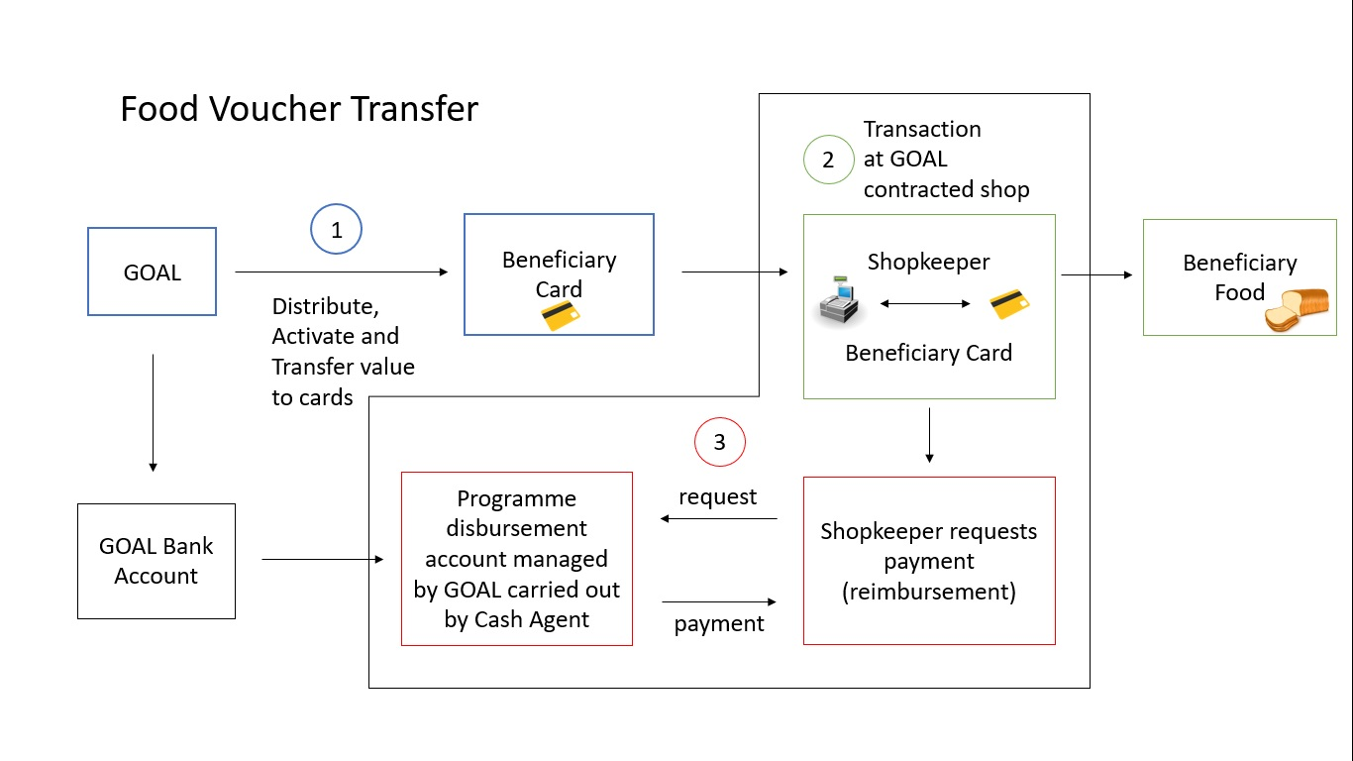

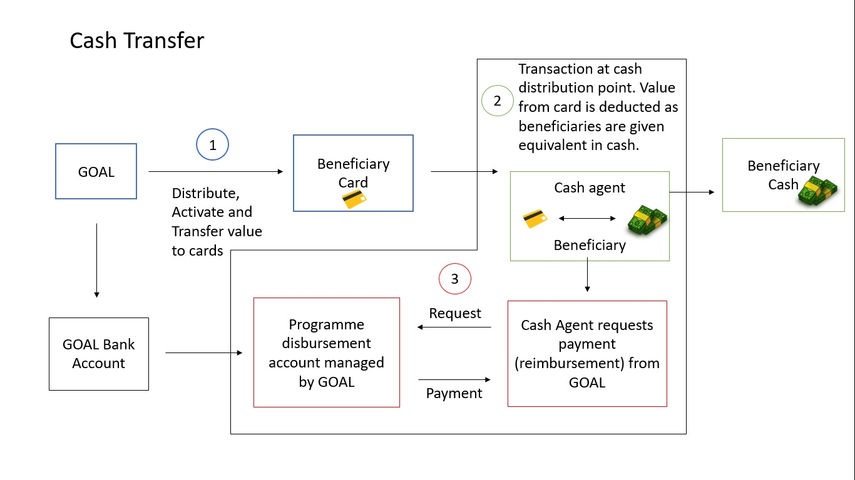
GOAL RESPONSIBILITIES
GOAL will have the responsibility to:
- Distribute the cards to beneficiaries.
- Set the means of verification for each beneficiary e.g. set the PIN (Personal identification number) code.
- Activate/deactivate the cards in the field with full flexibility to change the amounts and timelines of these processes. with controls in place for segregation of access levels i.e. not all staff should have permission to activate/deactivate cards.
- Determine the transfer value for each distribution round.
- Authorise and carry out the top up of the transfer value to the cards.
- Set expiration dates for the transfer value for each distribution round.
- Receive and manage complaints, requests and feedback from the community which includes replacing lost or stolen cards, reset means of verification e.g. PIN code.
- Select the shopkeepers and manage the relationship including issuing and management of contracts, install and activation of PoS devices, monitoring of the shopping period and use of the PoS devices.
- Deliver training on the e-voucher system to beneficiaries, shopkeepers and cash agents, using training materials/methodologies provided by the supplier.
- Manage all payment requests and approvals for payments for shopkeepers and cash agents.

HARDWARE AND SOFTWARE
GOAL’s current estimated quantities of Cards and PoS devices are as follows:
Type Of Hardware | Estimated Quantity | Delivery Location | INCO Delivery Terms
Cards | 36,750 | Antakya, Turkey | DDP
PoS devices | 850 | Antakya, Turkey | DDP

Details of any required software and additional hardware for the platform are requested in the Technical Information and Financial Offer Appendices to this ITT document. GOAL is seeking to compare a range of software pricing models to determine best value for money for our beneficiaries and donors.

TECHNICAL SUPPORT and TRAINING
Technical Support
- A dedicated focal point for GOAL.
- Support available 365 days/year with a response in less than 24 hours for critical issues. Critical issues are any issues that are would affect real time transactions e.g. PoS devices or cards not working, issues with card activation, top up, resetting beneficiary means of verification (e.g. PIN).
Training
- Training to staff (See estimated numbers in the table below) which at a minimum can be training of trainers (ToT) and the training may differ depending on the department. E.g. tailored training needed for programme implementation team, finance, management of information systems (MIS), management, compliance, depending on the roles and responsibilities of each department. Training of trainers is acceptable for each department.
- Training materials must be made available in Arabic and English for GOAL Staff, Shopkeepers and Cash Agents.
Estimated Staff Numbers Requiring Training
Location of staff | Number of staff requiring ToT | Number of additional staff requiring training
Turkey | 8 | 20
Syria | 20 | 200
Jordan | 1 | 1
Ireland | 1 | 0
Total | 30 | 221

SYSTEM SECURITY, DATA INTEGRATION and DATA MANAGEMENT
- Database to be hosted online under secure cloud platform e.g. Microsoft Azure Virtual Machine SQL Server.
- Database to be encrypted and be accessible via secure HTTPS protocol.
- Schedule backup to database to be daily for all data and have an Audit log to have an audit trail. GOAL needs full access to download and restore backups upon needed.
- GOAL must have full access to, and ownership of, all data, at all times. Access to this data must be made available through an online portal and must be exportable in excel format or equivalent.
- If possible; access to online portal for management users to be integrated with Microsoft Online Azure Active directory if this feature is available over the system. “that’s to avoid creating users on the system – GOAL users will be able to sign in using their work Email account”.
- Have potential to integrate with other software e.g. CommCare, PowerBI.

REPORTING
As well as standard reporting capabilities GOAL requires the system to track the following data fields:
- Purchases with food vouchers at a minimum level of food groups as per the Food and Agriculture Organisation (FAO) standard food groups (16 food groups).
- The voucher value and location distributed, redeemed, unredeemed.
- Data disaggregation by sex and age.

PROVISIONAL PROGRAMME TIMING
PREPARTION PHASE
- Provisional timeline for preparation phase is July 2020.
- Service provider to provide training of staff in Turkey, Jordan, Syria, Ireland (remote training is acceptable) which includes a simulation with a sample database of beneficiaries.
- Service provider to share all tools and set up access of GOAL staff according to their authorised access and responsibilities (which will be defined by GOAL).
- Service provider to procure and transport of PoS devices & cards to the delivery location(s) agreed with GOAL.
- Installation of PoS devices at GOAL contracted shops and cash agents.
- GOAL to provide training for cash agents and shopkeepers with or without assistance from service provider (this is not essential and depends on the service providers access at field level)
IMPLEMENTATION PHASE
The table below summarises GOAL planned distribution plan at time of writing. This will be subject to change.

Timeline | Jun-20 | Jul-20 | Aug-20 | Sep-20 | Oct-20 | Nov-20 | Dec-20 | Jan-21 | Feb-21 | Mar-21 | Apr-21 | May-21
MPCA (Multi-purpose cash assistance)
Distribution rounds |  | R1 |  |  | R2 |  |  | R3 |  |  | R4
Number of beneficiaries (households) |  | 5000 |  |  | 16300 |  |  | 26000 |  |  | 35000
Value of transfer per Beneficiary household |  | $90 |  |  | $60 |  |  | $60 |  |  | $60
Food Voucher
Distribution rounds |  | R1 | R2 | R3 | R4 | R5 |  | R6 | R7 | R8 | R9
Number of beneficiaries (households) |  | 5000 | 5000 | 5000 | 16300 | 16300 | 16300 | 26000 | 26000 | 26000 | 35000
Value of transfer per Beneficiary household |  | $60 | $60 | $60 | $60 | $60 | $60 | $60 | $60 | $60 | $60

Annex 2 – GOAL T&C’s

Annex 3 – FWA

Annex 4 – ELAN Vocab Guidelines

Beneficiaries are community members in North-West Syria who will be the end-users of the e-voucher system.
GOAL defines E-transfer as per the elan guidelines on vocabulary in a humanitarian context included as annex 4 to this EOI document.

